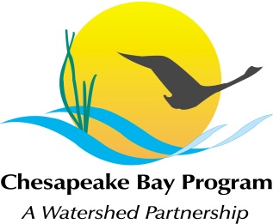
Maintaining Healthy Watersheds Conference Call
Thursday, February 16, 1:00-3:00
Call-in#: 866-299-3188, Code: 410-267-5731
Adobe Link: http://chesapeake1.adobeconnect.com/mhw

1:00 Welcome and Introductions Mark Bryer

Review Decision Framework Outline
End of March deadline, requested by the Management Board.
Goals: agree to work on the project and agree to participate in preparing the Decision Framework for the Management Board.

Discussion Question on Decision Framework
Does this decision framework outline make sense in the way it frames the project?

Discussion Questions for Project Implementation
Identification:
Will a compilation of the States’ existing definition and identification systems suffice for CBP GIT4 purposes? Ex: MD Tier II waters.
Can the states provide those layers, and is it sufficient for identification purposes?

Watershed condition status:
What data is available to track and report on the health status of the identified watersheds?
What could be done to improve tracking of watershed health status?

Threat characterization:
What information is available for characterizing threats to healthy watersheds?
Can it be made available for use in our communication efforts?

Protection Status:
Forms of protection: direct protection/ conservation, planning/ policy, anti-degradation, local engagement.
What existing data could be used to track and report the status of watershed health protection? (e.g., a “health assurance” index)
Consider TNC’s metric of secured riparian buffers.

Next Steps
- Agree to work on project as a priority for GIT 4
- States agree to provide data layers
- Primary participants agree to monthly conference calls and a potential workshop
- Look for funding to do pilot project (ex: land use planning info in PA)

3:00 Adjourn Bryer

If you have questions about this agenda, please contact Anna Stuart Burnett at 410-267-5737 or aburnett@chesapeakebay.net.

