Discussion Paper for Applying the CBP decision framework to the TMDL goal
Draft March 23, 2012

The Chesapeake Bay Program (CBP) Water-Quality Goal Implementation Team (WQ GIT) is working to implement nutrient and sediment reduction practices to achieve water-quality standards for the Bay Total Maximum Daily Load (TMDL). Many of the previous CBP activities to reduce nutrients and sediment, and the more recent development of the TMDL, have used adaptive-management principles. This discussion paper is an initial attempt to help the WQ GIT apply the new CBP decision framework and identify opportunities to improve information for decision making. Below are the major steps for the decision framework and associated activities. For each step beyond the goal –four items are discussed that were identified as the major factors affecting the CBP partners’ ability to achieve the goal:
- Understanding of ecosystem response.
- Identifying the sources and amounts of nutrient and sediment loads
- Describing the methods (water-quality practices and policies) to reduce the sources.
- Ensuring the capacity to implement the practices and polices
CBP Decision Framework Steps and Application for the Bay TMDL:
Articulate Program Goals:
The WQ GIT is using the decision framework to address the goal for the Bay TMDL: Restore water quality (water-quality standards for DO, clarity, SAV, and chlorophyll) in the bay and its tidal waters by reducing pollutants (nitrogen, phosphorus, and sediment). All practices will be implemented by 2025 with 60 percent of the practices implemented by 2017.
The CBP has conducted and used an extensive amount of science to support modeling and research to develop the water-quality standards and nutrient and sediment load reductions needed to achieve the standards.
Describe factors influencing goal attainment: There are four major factors that would affect the ability of the CBP partners to achieve the goal:
- Understanding of ecosystem response.
- Identifying the sources and amounts of nutrient and sediment loads.
- Describing the methods (water-quality practices and policies) to reduce the sources.
- Ensuring the capacity to implement the practices and policies.
Below is a brief summary for each factor and some of the uncertainties that need to be addressed to improve information for implementing the TMDL:
- Understanding of ecosystem response. The CBP is assuming that implementing practices for reducing nutrients and sediment will improve N, P, and S loads in rivers and achieve water-quality standards in the Bay. This understanding is based on the current science and the associated CBP modeling system. There are still some remaining uncertainties that need to be addressed to improve decision making, which include: (1) improve information on the effectiveness of BMPs in different hydrologic settings and the factors affecting the time it will take to see improvements (“lag times” between implementation and responses in water quality); (2) improve information on factors (in addition to nutrient and sediment reduction) affecting response of DO, clarity, SAV, and chlorophyll. For example, SAV is lost by high water temperatures, clarity is imparted by re-suspension of legacy sediment in the Bay, and chlorophyll does not respond to nutrient reductions in an entirely predictable manner. Therefore information on these factors needs to be improved.
- Identifying the sources and amounts of nutrient and sediment loads. This is currently represented through CBP models, USGS SPARROW models, and supporting monitoring and research. The sources are described in the TMDL document. Some topics to improve understanding and reduce uncertainty include refining information on the transport of loads through the watershed and better predicting future impacts of population growth and climate change in the watershed.
- Methods to identify practices to reduce the sources. The CBP has done extensive literature reviews of BMPs and the information in the CBP watershed model to simulate load reductions. However, the literature reviews did document a considerable amount of uncertainty about the performance of some BMPs. Some topics that need to be addressed to reduce uncertainty include a better understanding of the effectiveness and efficiency of practices due to variations in watershed properties (such as different types of soils), decline/change in BMP performance over time, and potential future impacts of climate change on BMP performance.
- Capacity to implement practices. The jurisdictions have described their capacity (funding, authorities, and sustainability) to implement nutrient and sediment reduction practices several times over the past 2 decades. These include the tributary strategies developed during the 1990’s and more recently in the Watershed Implementation Plans (WIPs) that were developed for the TMDL.

Assess current management efforts (and gaps): The overall management efforts needed for reducing nutrients and sediment are provided in the TMDL. More specific information on practices and policies for implementing the nutrient and sediment reductions are in WIPs. Some potential gaps for each of the major factors affecting implementation include:
- System Understanding: There is a large amount of science that was used for used the TMDL and associated water-quality standards and load reductions needed to achieve the standards. There is a gap in understanding of how long it will take to see water-quality improvements in the Bay and its watershed as the practices are implemented (lag times). The current models will need to be improved to better simulate the factors affecting lag times and the other factors affecting DO, clarity, SAV and chlorophyll (see previous discussion under factors affecting goals) Additionally, NOAA also suggested having improved information on where would we need to focus nutrient and sediment reductions that emphasize initial water-quality improvements in shallow water areas given their importance for fish and shellfish spawning and SAV habitat.
- Loads: The current management efforts to reduce nutrient and sediment loads are based primary on the suite of CBP models used to help develop the TMDL. The WIPs discuss more detailed efforts being developed to address each of the major sources sectors wastewater, ag, urban storm water, forests and air. The WQ GIT also has work groups addressing these source sectors. Overall there is a larger amount of uncertainty about sources and distribution of Nonpoint Source (NPS) loads than point source loads.
- Practices. The CBP has a long-term effort to improve information on the effectiveness of practices and use the results in the CBP WSM. Some gaps about practices that need to be addressed include: (1) improving information on efficiency of practices—their performance both spatially and over time, (2) the ability of the WSM to simulate factors (spatial differences) affecting BMP efficiency, and (3) improved tracking of BMP implementation.
- Capacity – The capacity of the jurisdictions to apply practices is described WIPs that were developed for the TMDL. The EPA has worked with the jurisdictions to ensure these capacities can be achieved and have established two-year milestones as a mechanism to assess if the practices are being implemented as planned. Potential gaps, based on previous CBP efforts, could occur due to shortfalls in federal, state, and local funding to carry out the practices. Also addressing air deposition and EPA capacity to reduce this source is a potential gap.
Develop Management Strategy:
- System understanding: The CBP also used an extensive amount of science to develop the water-quality standards needed to support key biological species in the Bay (oysters, crabs, and finfish). The CBP used its modeling system to assess different scenarios of nutrient and sediment reduction that are needed to achieve the water-quality standards. The CBP plans to have improve model to address the gaps discussed in the previous sections prior to the evaluation of the TMDL in 2017. The CBP also plans to have improved monitoring to assess nutrient and sediment changes in the watershed, and a report on lessons learned from BMPs and water-quality response. There needs to be additional information on BMP effectiveness through small watershed monitoring and assessment and improved information to focus management strategies to achieve water-quality response in different portions of the estuary that will provide greatest benefit to living resources.
- Loads: The WIPs and supporting work groups address each of the major source sectors for nutrients and sediment: wastewater, agriculture, urban storm water, forests and air. The CBP has monitoring to assess nutrient and sediment loads in the watershed and the WSM simulates reductions of loads as practices are implemented. The EPA and USDA have also used results from the USGS SPARROW model to identify “priority agricultural watersheds”, which are areas of high nutrient loading to the Bay, to focus water-quality practices.
- Practices. The CBP has a long-standing process to summarize the effectiveness of BMPs based on literature reviews. The CBP has plans to continue assessment of BMP efficiency, identifying new BMPs, and improve verification of implementation of practices. There is a gap to in small watershed monitoring to assess BMP effectiveness.
- Capacity-The Phase 2 WIPs discuss capacity to implement practices and EPA review helps assess the jurisdictions capacity to carry out the WIP. We want to have the decision framework provide improved information for development Phase 3 WIPs (by 2017) and implementing the associated 2-year milestones (2012-13; 2014-15; 2015-16).
Develop Monitoring Program—The CBP has monitoring programs to (1) track implementation of practices, (2) monitor nutrients and sediment in the watershed, (3) monitoring water-quality standards in the estuary. Results from the monitoring programs are used to update indicators to help assess progress toward implementation of practices and water-quality improvements. Many of the monitoring activities and assessment are provided by the CBP Scientific Technical Assessment and Reporting (STAR) team and partner science entities. The CBP conducted a review of its monitoring program in2009, by STAC, and plan future evaluation to determine if changes need to be made to address the needs of the goal teams. Findings from all of the monitoring programs will need to be used to improve model simulations (by 2015) to help develop the Phase 3 WIPs by 2017.
- System understanding: The CBP currently has an estuary monitoring program to assess attainment of the water-quality standards in the estuary. There are indicators for each standard (DO, Clarity/SAV, and chlorophyll) that use monitoring data to assess progress toward the standards. Some improvements for monitoring include:
  - Continuous DO may be needed to better assess achievement of the standard.
  - Monitoring of nutrients and sediment in the watershed has been implemented but there is still a need to enhance small watershed monitoring and assessment to better evaluation BMP efficiency,
  - Produce reports on lessons learned from BMPs and water-quality response.
- Loads: The CBP has monitoring of nutrients and sediment (and steam flow) in the watershed to support indicators of annual loads to the Bay and changes on long-term trends of nutrients and sediment. The indicators need to be improved to better compare water-quality monitoring results to nutrient and sediment allocation of the TMDL.
- Practices- the CBP has tracking of BMPs based on information provided by the jurisdictions. The BMP information is used in the WSM to predict the amount of nutrient and sediment load reductions that can be expected. The CBP implementing the NEIEN system for improved submission of BMP data from the jurisdictions and has a new reporting system—BAYTAS to help track implementation. The CBP is working with the jurisdictions and federal partners to improve verification of implementation of practices. The CBP also has planned on-going assessment of BMP efficiency based on literature reviews and a process to identify and approve new BMPs which can be used in the CBP WSM. There needs to be some improved information on how BMP effectiveness varies across the watershed. This would be partially fulfilled by small watershed monitoring and assessment for BMP effectiveness.
- Capacity-The capacity to implement practices is being evaluated by EPA review of the WIPs, and future efforts to measure implementation progress relative to annual progress and 2-year milestones. This would be supported by improved tracking of BMPs implementation.
Assess Performance—the indictors that have been developed for assessing restoration implementation and water-quality changes in the watershed and the Bay will be the primary tools to assess performance. These indicators will be updated annually, used to assess progress toward the 2-year milestones (2012-2103, 2014-2015, 2016-2017), and for the reevaluation in 2017. Some of the key indicators include:
- Restoration Efforts: Indicators for the reduction of nitrogen, phosphorous, and sediment by source, jurisdiction, and overall load reductions. These indicators are based on BMP date submitted by the jurisdictions and the CBP watershed model is used to estimate progress toward load reductions.
- Watershed monitoring: indicators of load (N, P, and S) to the Bay and flow-adjusted trends of nutrients and sediment. These indicators are based mostly on monitoring data collected as part of the CBP nontidal network.
- Estuary monitoring: indicators of dissolved oxygen attainment, chlorophyll-a, water clarity, and SAV abundance. These indicators are based primarily on the CBP estuary water-quality monitoring network.
- We also need set time lines for when the programmatic activities (model and monitoring improvements, etc.) that needs to be completed for the 2017 re-evaluation. This is where we would also include work plan development and input of MB
Management Adaptively –This section needs to be further defined to align with changes that can be made short term (annually and with the 2-year milestones) and longer-term for the 2017 re-evaluation.
- What progress had been made in implementing practices (annual progress runs and 2-year milestones)?
- What have we learned to better implement practices (summary document of lessons learned and need to have this done again prior to 2017 re-evaluation)?
- What are the changes in water quality and how does it inform implementation of practices (based on using monitoring data for annual updates of trends in nutrients and sediment and water-quality standards in the Bay)?
- What improvements are needed in modeling, monitoring, and science (based on comparison of monitoring and modeling results and action team(s) to improve models for 2017 re-evaluation)?
We need to consider some type of diagram showing both long and short term opportunists to manage should be shown. Here is an example from previous Executive Order science report.
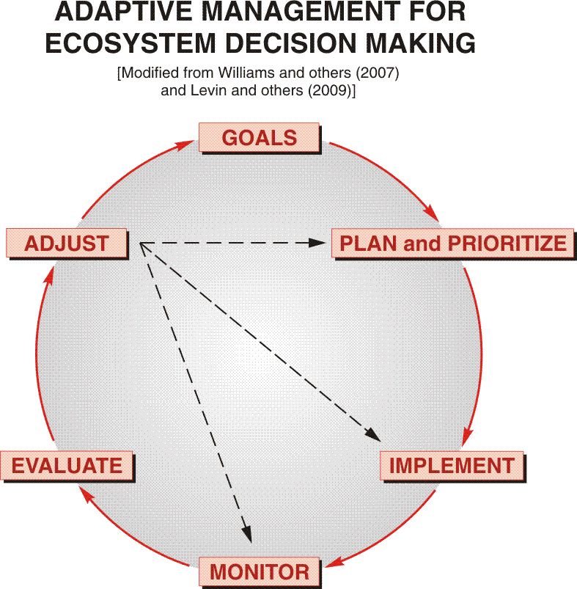

Next steps (March and April):
- Turn the notes into a document for the TMDL in the decision framework (Greg and Scott).
- Share with WQ GIT leadership
- Share with QW GIT
- Have them review and provide ideas
- Turn into material for ChesapeakeStat
- WQ GIT uses as part of their decision framework
The discussion paper reflects interaction between members of the CBP Decision Framework Workgroup (Greg Allen, Carin Bisland, Carl Hershner, Rich McEntee, and Scott Phillips) and WQ GIT leadership (Larry Merrill, Katherine Antos, and Rich Batiuk).

