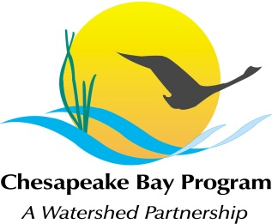
AGENDA
Maintain Healthy Watersheds Goal Implementation Team
US Fish and Wildlife Service, Annapolis, MD
September 24th, 10:00-3:00
Call-in#: 866-299-3188, Code: 267-5715
Adobe Link: https://epa.connectsolutions.com/git4/

10:00 Welcome, Introductions Mark Bryer

10:15 Updates
- Communications: Donnelle Keech, TNC
Chesapeake Watershed Forum Session, presentation to the Citizen Advisory Council
- STAC Workshop Report and Key Recommendations: Mike Fritz will summarize the key findings and recommendations from the March 2012 STAC workshop, the purpose of which was to explore the scientific basis for improving Bay watershed model estimation of the nutrient processing capacity of natural landscape features.
- Conservation Credits: Ann Swanson
- Eastern Brook Trout Joint Venture: Jennifer Greiner
- Harris Creek Pilot for Place-Based Collaboration among CBP Goal Teams: Bruce Vogt

11:15 Healthy Watershed Case Study Neil Kamman
“Mapping Vermont’s Critical Watershed Resource Areas: Data Integration using the Recovery Potential and Healthy Watersheds Approach.” Presentation
Website: http://www.vtwaterquality.org/

12:00 Lunch!

1:00 Healthy Watersheds Tracking Project John Wolf/ Anna Stuart Burnett
John Wolf, USGS, and Anna Stuart Burnett, CRC, will lead a discussion on progress to date and next steps for the Goal Team’s Healthy Watersheds Tracking Project.
William and Mary Project: Land Use Policies Dana Gilbert

2:00 Forest Restoration Strategy and Working Lands Conservation Strategy Craig Highfield
Craig Highfield, Alliance for the Chesapeake Bay, will lead a discussion on how the draft CBP Forest Restoration Strategy and pending Working Lands Conservation Strategy could relate to healthy watershed protection. Draft Strategy.

2:30 Agenda Topics for the December Goal Team Meeting Mike Fritz
Reflection on 2012 using the Team’s Adaptive Management Decision Framework
Discussion of Goal Team priorities for 2013

3:00 Adjourn

