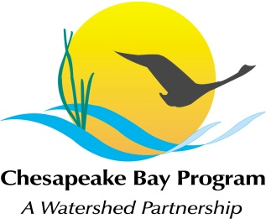
AGENDA
Maintain Healthy Watersheds Goal Implementation Team
US Fish and Wildlife Service, Annapolis, MD
December 10th, 10:00-12:30
Call-in#: 888-607-9643, Code: 27823251
Adobe Link: https://epa.connectsolutions.com/git4/

10:00 Welcome, Introductions Mark Bryer
Show brook trout video on CBP website.

10:15 Case Study: Wisconsin’s Healthy Watersheds Initiative Kristi Minahan
Wisconsin is conducting a Healthy Watersheds Initiative (HWI) in conjunction with EPA’s national effort. The goal of the HWI is to assess a range of statewide, watershed-level datasets to rank each watershed in the state on scales of “health” and “vulnerability”. These rankings can then be used to prioritize and target appropriate funding and management practices to specific watersheds. While other EPA programs focus on restoring impaired waters, the Healthy Watersheds Initiative uses the watershed approach for proactive protection and restoration, to avoid additional water quality impairments in the future. Wisconsin is one of the early states to adopt such a framework. This talk will describe the intent of the project, the data sets used for ranking, and potential uses of the watershed rankings by state agencies and other partners.

10:45 Measurable Outcome Statements Mark Bryer
Discuss several potential measurable outcomes for GIT 4 strategies.

11:15 2013 Work Planning Mike Fritz
Review and discuss the draft GIT 4 2013 Strategy using an adaptive management approach, including activities identified by partner states, EPA, and NGOs, as well as GIT4 collective activities.

State Activities State Partner Representatives
EPA Activities EPA Representative
NGO Activities TNC, etc.

Collective GIT4 Activities Mike Fritz and Donnelle Keech

12:25 Next Steps

12:30 Adjourn

