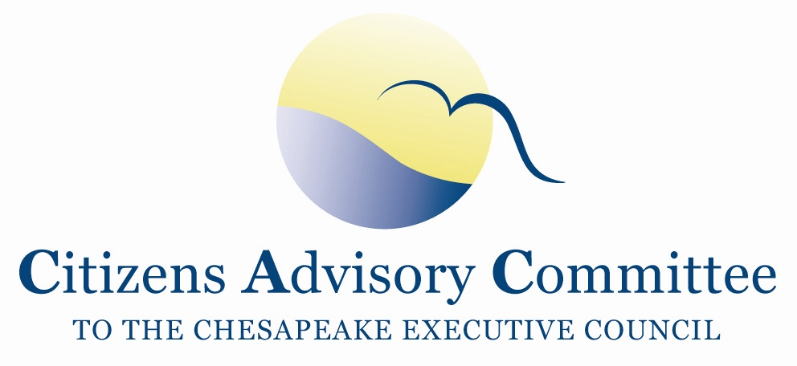

Citizens Advisory Committee
Meeting Agenda
February 21-22, 2013

_______________________________________________________________________________________________________________________________________

United Methodist Church
308 Hanover Street
Fredericksburg, VA 22401

Thursday, February 21- Fellowship Hall

11:00 a.m. Call to Order…………………………………………………………….…...John Dawes, Chair Welcome and Introductions

11:10 a.m. Chesapeake Bay Program updates………………………………..…….……Nick DiPasquale,
Director, EPA Chesapeake Bay Program
- General Updates
- Bay Program 2013 Priorities
- Issues for upcoming Principal Staff Committee (PSC) meeting on March 7, 2013
- Continuing resolution and funding
- Preview of 2012 Executive Order Action Plan results

12:00 a.m. Lunch (please bring cash for your pre-ordered lunches)

12:45 p.m. Chesapeake Bay Program Communications Office…………………...……..Margaret Enloe,
CBP Communications Director
- 2012 Year End Report, Bay Barometer briefing
- Recent Videos and Outreach
- Discussion and Feedback: Ideas for videos or other CBP communication pieces

1:30 p.m. Panel Discussion: Residential Stormwater Programs
- Rainscape Retrofits
John Tippett, Executive Director, Friends of Rappahannock
- READY program in Howard County
Jim Caldwell, Stormwater Manager, Howard County Office of Environmental Sustainability
- DC RiverSmart Program
Al Todd, Alliance for the Chesapeake Bay (on behalf of the DC partners)
- Chesapeake Bay RiverWise Program
Nissa Dean, VA Director, Alliance for the Chesapeake Bay
Tom Schueler, Executive Director, Chesapeake Stormwater Network

3:00 p.m. Break

3:15 p.m. Technical Report on Toxic Contaminants in the Chesapeake Bay and its Watershed: Extent, Severity and Potential Biological Effects ……………………………….Scott Phillips,
US Geological Survey, Chesapeake Bay Coordinator
Greg Allen, EPA Chesapeake Bay Program Office
CAC recommended Toxics be included in the draft Goal Implementation Team outcomes.

4:00 p.m. Member Discussion and Meeting Day Wrap-Up
- Are there Action Items associated with the day’s presentations?
- Preparation for the BMP verification discussion tomorrow
- Preliminary ideas for CAC’s 2013 recommendations to the Executive Council (EC). CAC will have one more meeting before the EC’s annual meeting proposed in June.

5:00 p.m. Meeting Recess

7:00 p.m. Dinner- The Bavarian Chef
Members will continue to discuss agenda topics and issues of importance in the Bay Watershed.

Friday, February 22- Fellowship Hall

8:30 a.m. Call to Order……………………………...………………………..………John Dawes, Chair

8:35 a.m. CAC Business Meeting
- Approval of CAC November 2012 meeting minutes
- Action Items since the last meeting
  - CAC Letters
  - Principal Staff Committee and Management Board
- Updates from Members and Staff
  - Discussion on CAC 2012 recommendations: how to proceed with EPA MOUs with Department of Education (DOE) and Bureau of Land Management (BLM) and Office of Surface Mining (OSM)
  - CAC identified “human/economic element” missing from draft GIT goals- What are possible measurable outcomes CAC may want to suggest the CBP consider?

9:15 a.m. Clean Water Act and the Chesapeake: Enforcement’s Critical Role in Restoring the Bay
Tarah Heinzen, Environmental Integrity Project
The Environmental Integrity Project (EIP) examined public data from EPA and the States on municipal and industrial sources in the Bay Watershed. The report looks at permits that lack numeric limits for TMDL pollutants, violations in enforcement and compliance databases and estimated pollution attributed to illegal discharges.

10:00 a.m. BMP Verification update…...…………………Nick DiPasquale, EPA Bay Program Director
Rich Batiuk, EPA Bay Program Associate Director
- Nick and Rich will discuss the Bay Program response to CAC’s Dec 17, 2012 letter to the Bay Program that listed concerns with BMP verification process
- Next Steps- Are there CAC members who wish to continue to engage in BMP verification through the decision making process?

11:00 a.m. CAC meeting de-brief discussion
- Action Items and Next Steps

Open the Floor for Citizen Remarks

Meeting Wrap-Up
- Discussion of CAC topics for May 2013

12:15 p.m. Adjourn
__________________________________________________________________________________________________Next CAC Meeting is May 30-31, 2013
Principals Staff Committee (PSC) is slated to meet in May 2013
Executive Council (EC) is slated to meet in June 2013

