Conference Line Access Info:

DC Conference Line
(866) 299-3188
Conference Code
267-985-6222

https://epa.connectsolutions.com/communications/

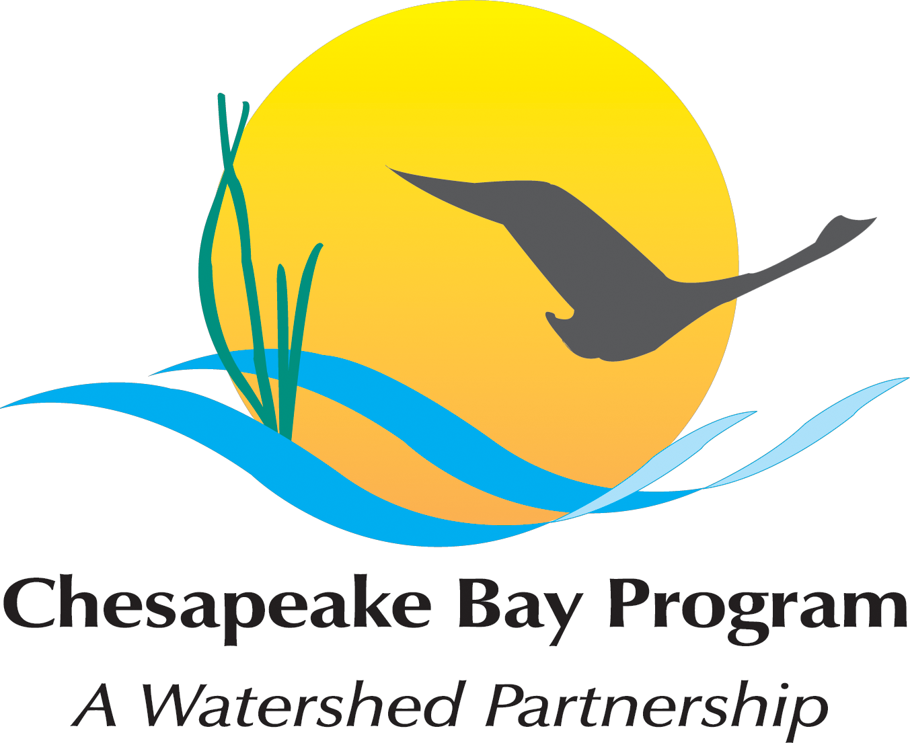
Chesapeake Bay Partnership
Quarterly Communications Meeting

January 17th, 2013
11:00 a.m. – 3:45 p.m.

Joe Macknis Memorial Conference Room (Fish Shack)
410 Severn Avenue, Suite 116
Annapolis, MD 21403

Agenda

- Welcome & Round Robin Updates (11:00 a.m. – 11:30 a.m.)
Brief Round Robin updates

- BMP Verification – Creating Communications Strategy (11:30 a.m. – 12:30 p.m.)

- Lunch Break (12:30 – 1 p.m.)

- Communications Calendar (1 – 2 p.m.) – Roundtable
– Filling in 2013 Calendar with your/Partner news, events, restoration efforts.
What will you be working on in 2013 that CBP Comm. can help you communicate?

- Rethinking CBP’s Media Strategy – (2 – 3 p.m.) - discussion/brainstorm

- Review of Actions and Decisions (3 – 3:15 p.m.)

- Conowingo Dam Communications - discussion (3:15 – 3:45 p.m.)
For those involved and interested in staying.

