Conference Line Access Info:

DC Conference Line
(866) 299-3188
Conference Code
267-985-6222

https://epa.connectsolutions.com/communications/

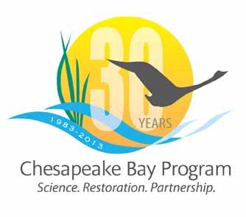

Communications Workgroup
Monthly Meeting

February 14th, 2013
9:45-11a.m.

Room 305 at CBPO in Annapolis

Agenda

- Round Robin Updates 9:45-10:10
Brief Round Robin updates

- 30 Yr logo & plan 10:10-10:20

- Communications Calendar – Roundtable 10:20-10:40
– Filling in 2013 Calendar with your/Partner news, events, restoration efforts.
What will you be working on in 2013 that CBP Comm. can help you communicate?

- Next steps in CBP’s Media Strategy 10:40-10:50

- BMP Verification Comm Strat – any concerns/questions? 10:50-11

