Conference Line Access Info:

DC Conference Line # 2
(866) 299-3188
Conference Code
(267)985-6222
https://epa.connectsolutions.com/comm/
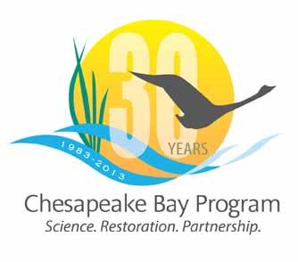

Communications Workgroup
Monthly Meeting

August 1, 2013
9:45-11a.m.

Department of Natural Resources
580 Taylor Avenue
Annapolis, MD 21403
C1 conference room on the ground floor
Agenda

- Round Robin / GIT Updates 9:45-10:15
– Ongoing: Fill in 2013 Calendar with Partner news, events, restoration
efforts that CBP Comm. can help you communicate?

- New EPA Administrator - Gina McCarthy 10:15-10:25
- Recent visit to Chesapeake Bay Program
- Video update for 30th year celebration 10:25-10:35

- New Agreement 10:35-10:50 - How do we communicate this to interested public?

- The Capital Gazette 10:50-11:00
- Bay restoration article

