Conference Line Access Info:

DC Conference Line #3
(866) 299-3188
Conference Code
267-5715
https://epa.connectsolutions.com/comm/
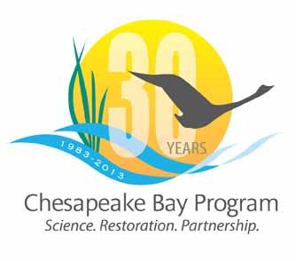

Communications Workgroup
Monthly Meeting

December 5, 2013
9:45-11a.m.

CBPO Conference Room 303

Agenda

- Round Robin / GIT Updates 9:45-10:15
– Ongoing: Fill in 2013 Calendar with Partner news, events, restoration efforts that CBP Comm. can help you communicate?

- Executive Council: Planning and information 10:15-10:25

- Extended Communications Workgroup Meeting in January 10:25-10:45

