Conference Line Access Info:

DC Conference Line
(410)-295-1398
Conference Code
123456

https://epa.connectsolutions.com/cbp

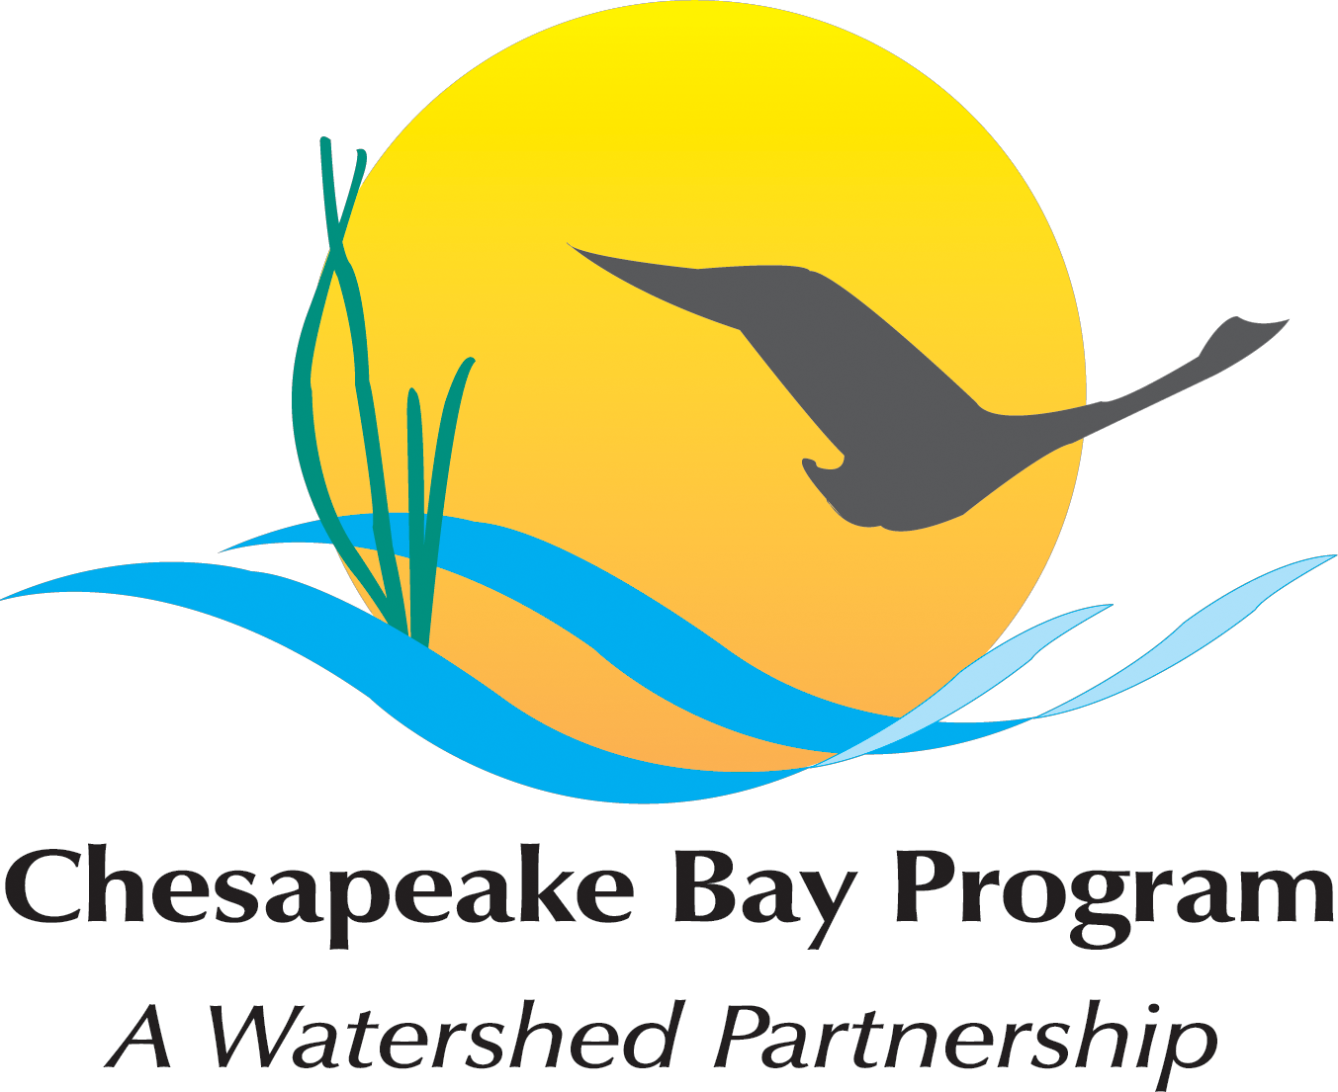
Chesapeake Bay Partnership
Joint Meeting of
Coordinators-Staffers and
the Indicators Workgroup

Thursday, December 5, 2013
11:00 a.m. – 12:00 p.m.
305a Conference Room
410 Severn Avenue, Suite 116
Annapolis, MD 21403

Agenda

- Welcome
- Welcome Julie Walker

- Web Page Updates (Committee members, meeting calendars)

- Indicators Discussion
- Approve 2014 IWG Workplan prior to submission to STAR;
- Discuss plans to have as many indicators as possible updated with 2013 data prior to May 2014;
- Discuss needs/plans related to development of any new/revised indicators for New Agreement Outcomes (and Management Strategies)
**Meeting materials are available on the CBP webpage:
http://www.chesapeakebay.net/calendar/event/21165

- Update on EC meeting
- Agenda, participants, etc.

- Agreement Status

- State of the Program

- Action Items, Next Meeting

