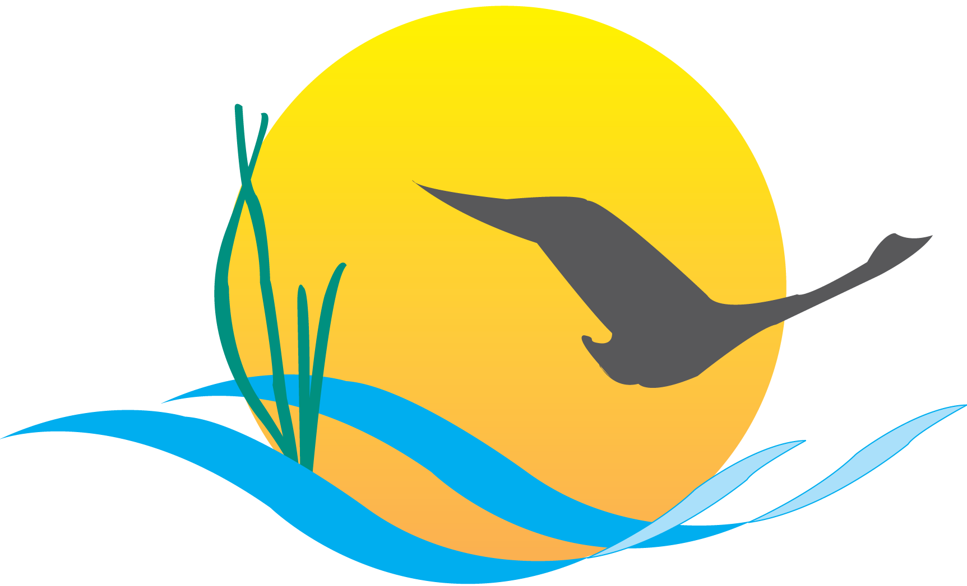

Communications Workgroup
Monthly Meeting
February 20, 2014
9:45AM-11:15PM

Attendees:

Mike Land, NPS (Chair) Chris Bekraft, DNR
Samantha Kappalman, MDE (Vice Chair) Darlene Pisani, DNR
Jessica Blackburn, Alliance, CAC, LGAC Kim Couranz, NOAA
Guy Stephens, UMCES Andrew Stacy, WVCA
Catherine Krikstan, Alliance, CBP Hannah Hamilton, USGS
Tom Zolper, CBF Bill Hayden, VA DEQ
Matt Ellis, STAC Jenna Valente, CBP, CRC
Mary Gattis, Alliance, LGAC

- Round Robin

CBP Communications:
- There are a couple of new blog posts up on www.chesapeakebay.net .
  - Report recommends Virginia strengthen chemical contaminant regulations
  - Wetland restoration could offset impacts of climate change
  - Science shows restoration work can improve local water quality
- Tentative blog posts are:
  - EPA’s ruling on waters of the U.S.
  - EPA’s Report to Congress
  - Photo Essay: Winter Wildlife
  - Restoration Spotlight: Waterfowl Habitat
DNR:
- Listening session for the Chesapeake Bay Agreement on 3/4/2014 from 3:00PM-8:00PM at St. Johns College in Annapolis, MD.
- Creating posters for the public listening sessions that D.C. will also be using for their listening session on 2/27/2014.

CBP web team/UMCES:
- Results from the ChesapeakeStat initial research and discovery phase will be in next week. The results will help the web team determine the direction and focus of the product.
- In the process of rebuilding the web team. There are currently three available positions.
CBF:
- Working on messaging and outreach around the 21 states joining the TMDL repeal.
VA DEQ:
- Governor Terry McAuliffe has appointed Russ Baxter as Virginia’s new Deputy Secretary of Natural Resources for the Chesapeake Bay.
CAC:
- Quarterly meeting will take place next week in Baltimore and will be listening to updates on leadership of the Chesapeake Bay Executive Council from Maryland’s Secretary Gill.
- There will also be updates from EPA Bay Program about the new Bay Agreement, environmental education.
- During the meeting CAC plans on narrowing down the priorities for the upcoming year.
WVCA:
- Sent out a press release earlier in the month about the public comment period for new agreement.
- Recently the Hampshire Review published an article on Chesapeake Bay confinement barns and their benefits.
- Working with the town of Moorefield to review their ordinances and assess opportunities for green infrastructure.
- Upcoming events:
  - Feeding and rotational grazing demonstration workshop.
  - Innovative nutrient management workshop for planters and farmers in the spring.
  - Pervious parking stormwater demonstration on newly acquired recreational access on the south branch of Potomac River.
MDE:
- In addition to helping with the public listening sessions, DEQ is working on the Color Maryland Green poster contest.
- Planning on hosting an event for the poster contest during Earth Week.
- Coordinating an annual tree planting in western Maryland on Arbor Day.
- Promoting the Stormwater 101 site.
USGS:
- Working with NOAA public affairs on a press release about the influences of human activity on the water quality in the Potomac River estuary. Plan on releasing it sometime next month.
NOAA:
- NOAA recently released grant opportunity for fisheries science research. Proposals are due by April 2nd.
- In the process of trying to get the April 10th Management Board meeting moved to Small Woods State Park for the DNR launch of informative signs about invasive catfish in the Chesapeake Bay.
- Maryland Oyster Restoration Workgroup is doing a second annual update on how restoration efforts, monitoring and planning are going in the mid-shore area on Eastern Shore (Harris Creek/Choptank River).
STAC:
- Nutrient Trading report: embargoed copy on 2/21, final report 2/28.
- Coastal Habitats report: embargoed copy will be out in mid-March, final report in late March.
- M3.2: Multiple Management Models report: embargoed copy will be out by late March, final report in late March or early April.
- STAC quarterly meeting is scheduled for 3/18-3/19 at the Westin Annapolis.
- Two workshops coming up:
  - Management Effect on Water Quality Trends on 3/25-3/26 at the Westin Annapolis.
  - Rescheduled: Peculiarities of Perviousness will now be in mid-to-late April.
LGAC:
- Upcoming meeting in Richmond, VA on 3/13-3/14. LGAC will be discussing indicators and preparing LGAC members to provide more input on indicators and communicating with local elected officials.

- New Insights Report
- The report is comprised of 40 case studies that focus on water quality improvements related to air pollution, wastewater treatment plants and agricultural runoff.
- There is also messaging about lag times and targeting and monitoring BMPs.
- The biggest take away from the report is that we have scientific evidence that our BMPs are improving local water quality in the Chesapeake Bay.
- The report was written by UMCES in partnership with STAR so CBP is helping with the release.
- In addition to the full report, there will be a tri-fold Executive Summary of the key points in a public-friendly manner.
- Both of those documents will be published and released on 2/25 at 10:00AM in the Fish Shack of the Chesapeake Bay Program Offices in Annapolis, MD.
- There will be a media call for those who can’t attend in person.
- Nick DiPasquale (CBP Director), Don Boesch (UMCES President), Scott Phillips (USGS), Bill Dennison (UMCES) and Rich Batiuk (EPA) will be speaking at the event.
- There will be a few localized press releases highlighting case studies in Baltimore, the Eastern Shore of Maryland, Virginia and D.C.
- CBP will be writing a number of blog posts about the report so please share, but also highlight and use the information in the report in your own ways.
- Report is full of a lot of localized information that could be good to create your own press stories.

- Executive Council Meeting
- What role does the Communications Workgroup have in the planning process?
- We have a communications person elected for the planning committee. Each jurisdiction will still have one vote but the planning team will be offered a new perspective.
- We would like to start playing a bigger role in the partnership and make sure that communications is represented.

- 2014 RAE Summit
- Everyone in the Communications Workgroup has an opportunity to plan presentations for this event.
- We would like to present a half day session that consists of several different communications presentations.
- Some examples of presentations topics are: How to build effective messages to engage an audience, communicating around bad press, web writing and social media press releases to make content more relevant.
- This is a good opportunity to get what we do out in front the nation and share our stories and skills with others

- Liaison
- GIT 2 and 4 still need liaisons so please contact either Mike Land, Samantha Kappalman, Margaret Enloe or Jenna Valente if you are interested in taking on one of those roles.

- Upcoming meetings
March:
- Invasive catfish communications/outreach in early April
- Chesapeake Bay Watershed Agreement
- Developing a CBP communications strategic plan based on the Agreement goals/strategies
- Indicators – review proposed plan for handling “extinct” indicators
April:
- Agreement and Executive Council plan
- Executive Council signing event – what should the media event look like?
- How do we ensure the best possible turnout by Executive Council members at the meeting and signing?
- What is our post-signing communications strategy?
- BMP Verification Update
- Outreach/communications strategy refresh

