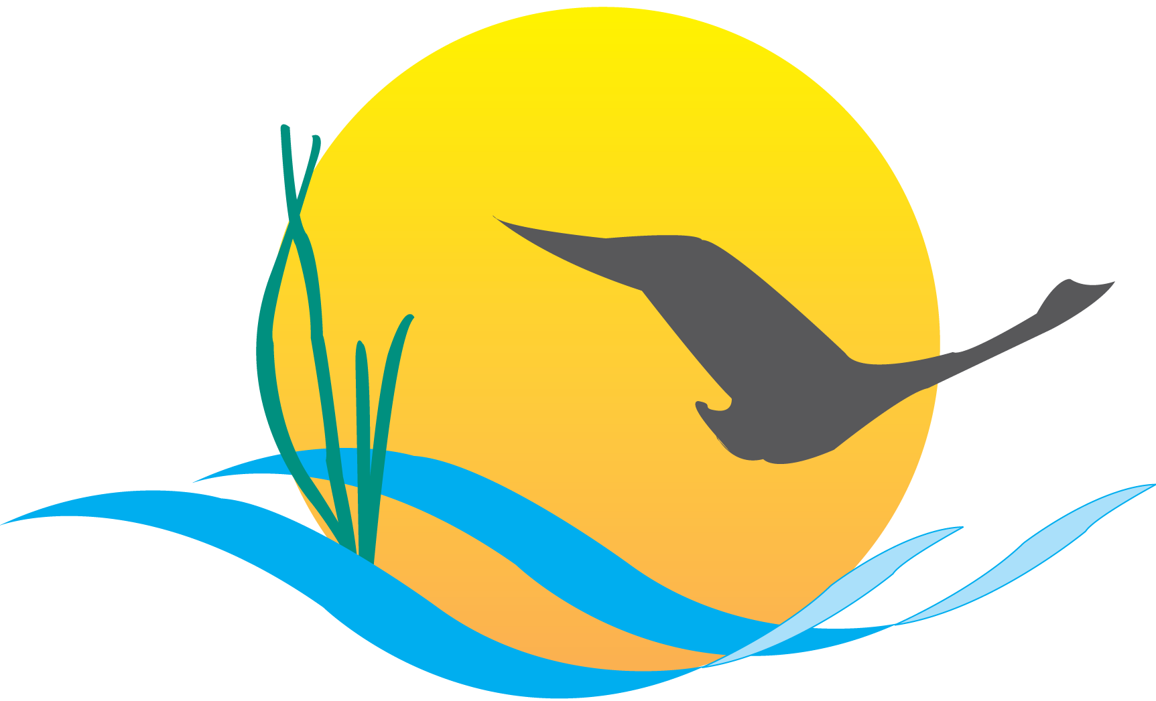
Conference Line Access Info:

DC Conference Line #2
(866) 299-3188
Conference Code
(267) 985-6222
https://epa.connectsolutions.com/comm/

Communications Workgroup
Monthly Meeting
April 3, 2014
9:45AM-11:00AM

Conference Room 305a
Chesapeake Bay Program Office

Agenda

- Round Robin / GIT Updates 9:45-10:10

- Bay Agreement Communications Strategy (All) 10:10-10:55

- Improving information sharing with stakeholders re: management strategies
- Addressing outreach planning
- What should the media event look like?
- How do we ensure the best possible turnout by Executive Council members at the meeting and signing?
- What is our post-signing communications strategy?

- Upcoming meetings 10:55-11:00
Upcoming Meetings:
- BMP Verification Update
- Outreach/communications strategy refresh

