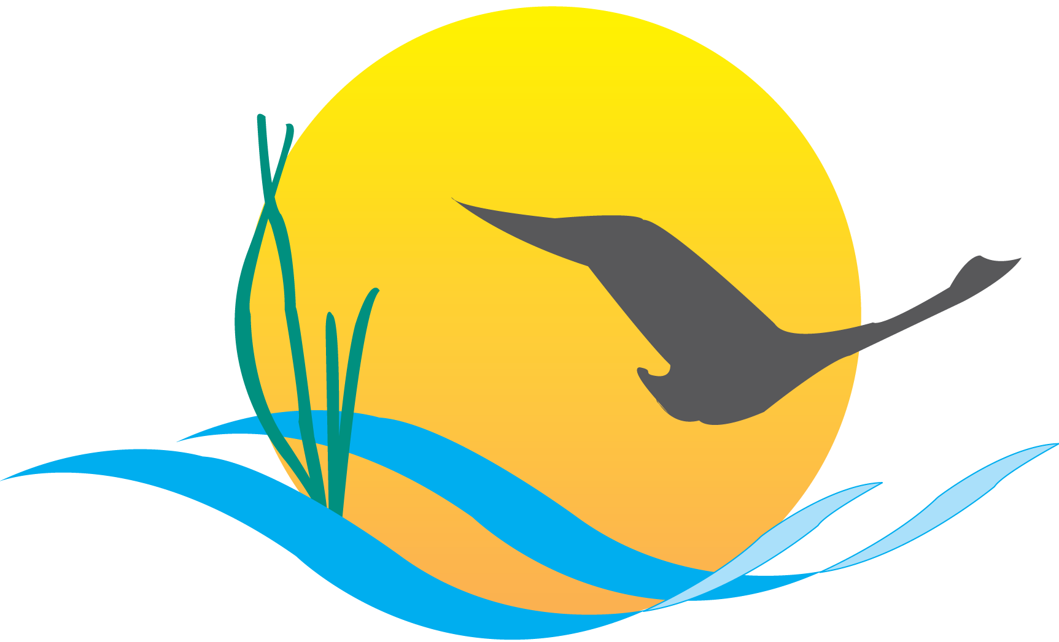
Conference Line Access Info:

DC Conference Line #2
(866) 299-3188
Conference Code
(267) 985-6222
https://epa.connectsolutions.com/comm/

Communications Workgroup
Monthly Meeting
May 1, 2014
9:45AM-11:00AM

Conference Room 305a
Chesapeake Bay Program Office

Agenda

- Round Robin / GIT Updates 9:45-10
(major points only, as next item will require significant time)

- Executive Council Communications 10:00-10:30
  - Press/Communications opportunities & messaging between now and EC
  - Press/Communications opportunities at EC event

- Continuing the brainstorm on a post-Agreement Communications Strategy 10:30-11:00
Upcoming Meetings:
- JUNE - BMP Verification
- Update – Rich Batiuk (tent)
- BMP Verif. Outreach/communications strategy - refresh
- CBP Recognition for Homeowner BMP Programs

