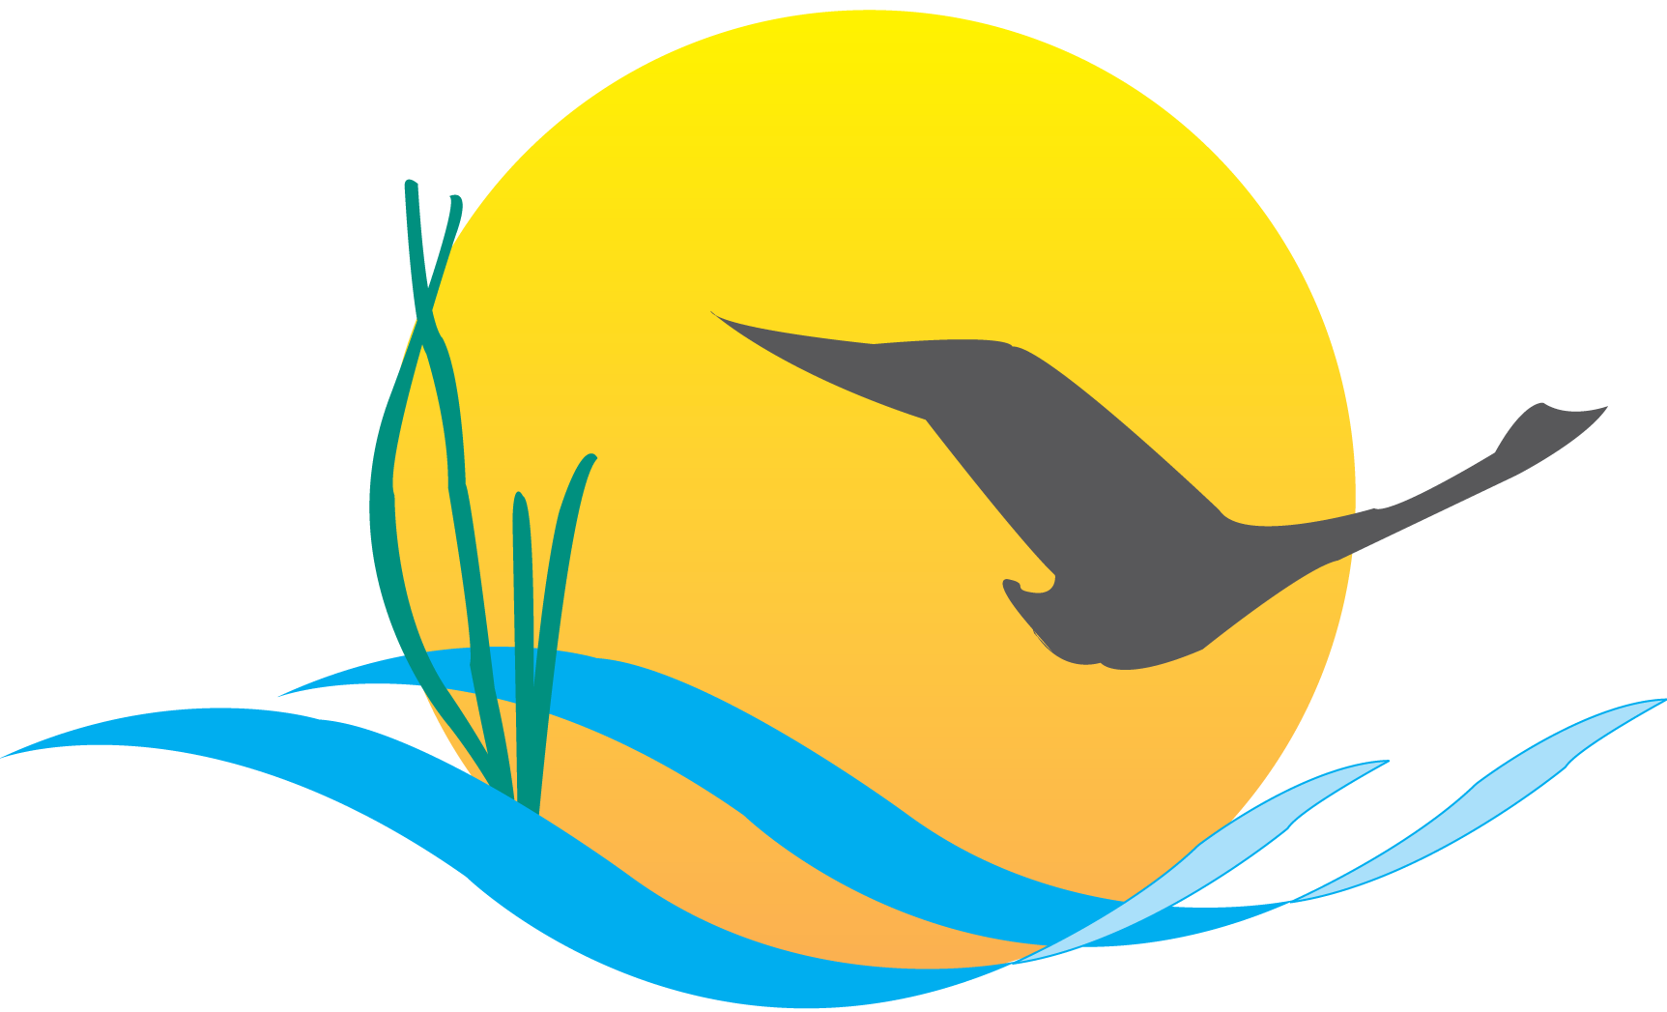
Conference Line Access Info:

DC Conference Line #2
(866) 299-3188
Conference Code
(267) 985-6222
https://epa.connectsolutions.com/comm/

Communications Workgroup
Monthly Meeting
June 5, 2014
9:45AM-11:00AM

Conference Room 305a
Chesapeake Bay Program Office

Agenda

- Round Robin / GIT Updates 9:45-10:00
(major points only, as next item will require significant time)

- Executive Council Communications 10:00-10:45
  - Agreement/EC update
  - Agreement web page update
  - Outcomes documents discussion

- CBP Editorial Calendar Update (Catherine) 10:45-11:00

Upcoming Meetings:
- JULY – Proposed meeting date: July 10
BMP Verification
- Update – Rich Batiuk
- BMP Verif. Outreach/communications strategy - refresh
- CBP Recognition for Homeowner BMP Programs

