Conference Line Access Info:

DC Conference Line #2
(866) 299-3188
Conference Code
(267) 985-6222
https://epa.connectsolutions.com/comm/
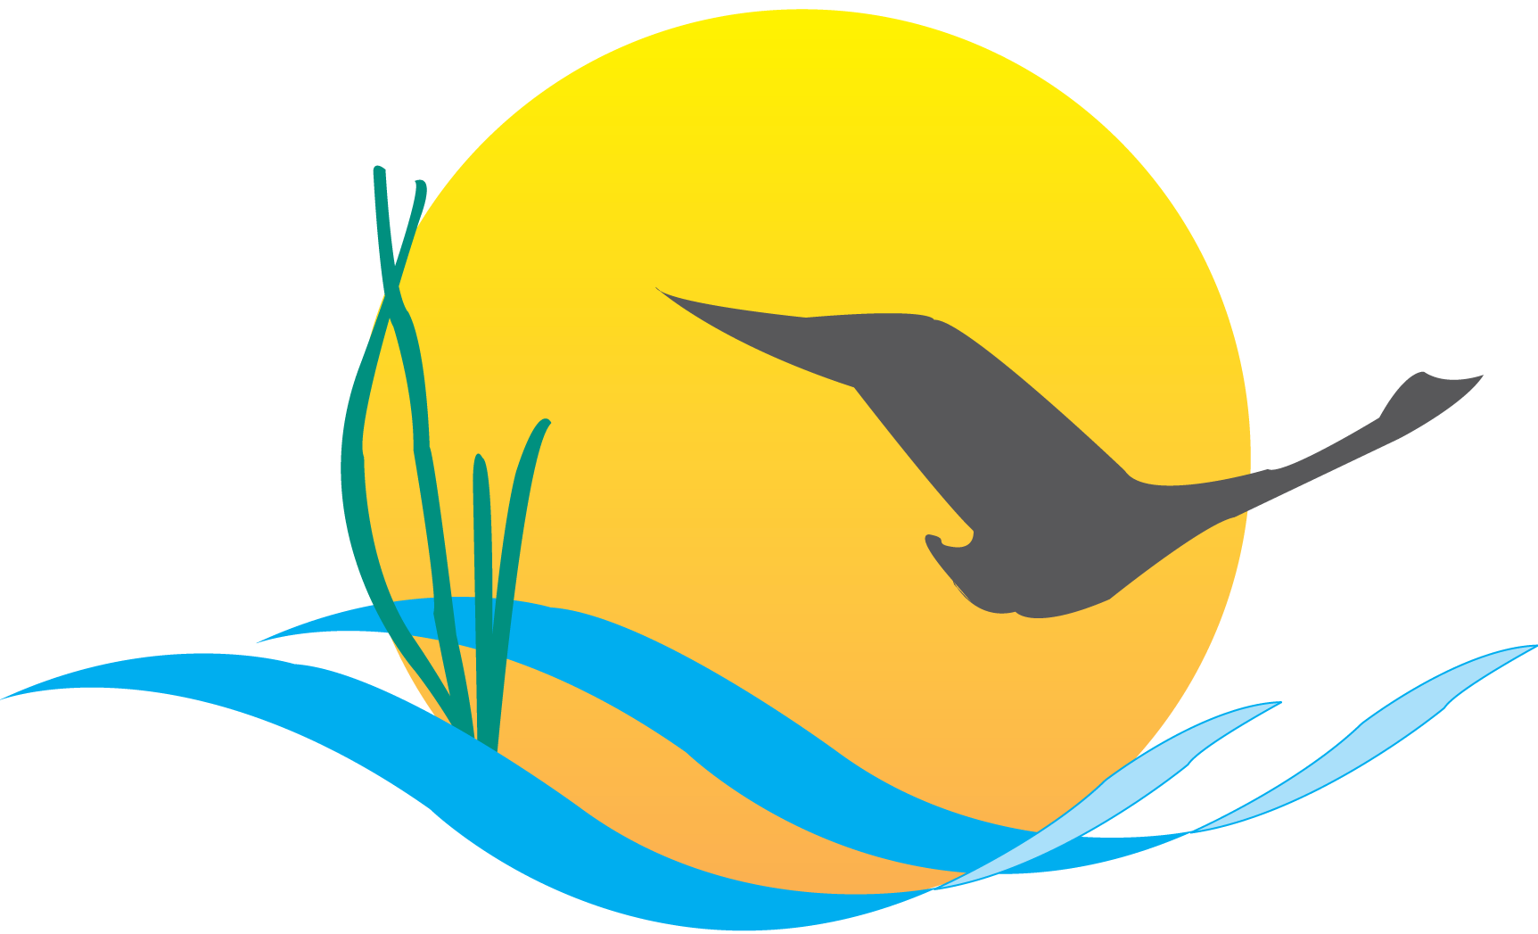

Communications Workgroup
Monthly Meeting
August 7, 2014
9:45AM-11:00AM

Conference Room 305a
Chesapeake Bay Program Office

Agenda

- Round Robin / GIT Updates 9:45-10:10
(major points only, as next items will require significant time)

- BMP Verification Framework Editorial Update 10:10-10:30
  - Communication strategy update

- Management Strategy Outreach 10:30-10:50

- Vice Chair Nominations 10:50-11:00
Upcoming Meeting: September 4th
Agenda items: Guy Stephens: CBP web product update

