Conference Line Access Info:

DC Conference Line #2
(866) 299-3188
Conference Code
(267) 985-6222
https://epa.connectsolutions.com/comm/
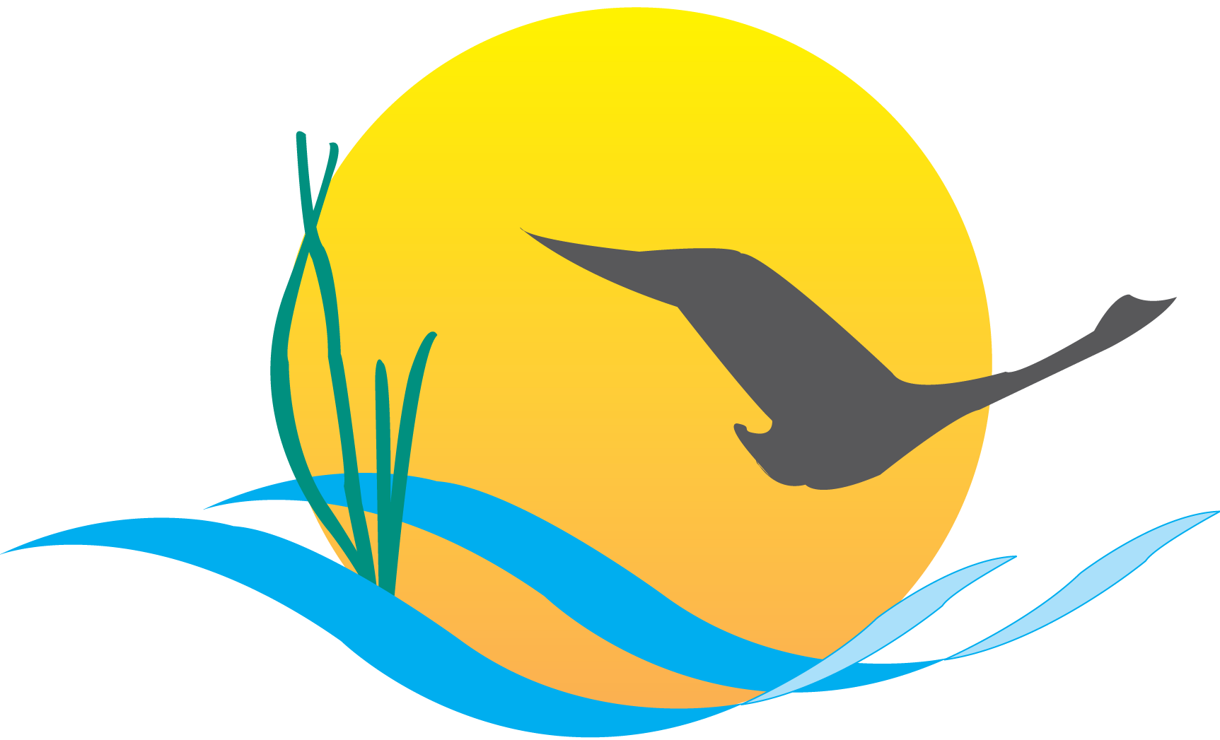

Communications Workgroup
Monthly Meeting
September 4, 2014
9:45AM-11:00AM

Conference Room 305a
Chesapeake Bay Program Office

Agenda

- Round Robin / GIT Updates 9:45-10:10
(major points only, as next items will require significant time)

- Management Strategy Communications Update 10:10-10:30

- CBP Web Product Update 10:30-11:00

Upcoming Meeting: October 2nd

