Conference Line Access Info:

DC Conference Line #2
(866) 299-3188
Conference Code
(267) 985-6222
https://epa.connectsolutions.com/comm/
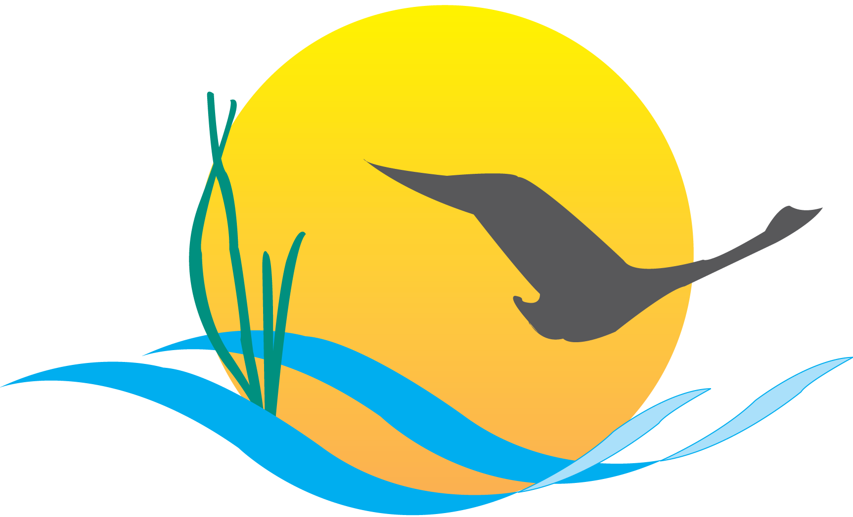

Communications Workgroup
Monthly Meeting
March 5, 2015
9:45AM-11:00AM

Fish Shack
Chesapeake Bay Program Office

Agenda

- Round Robin / GIT Updates 9:45-9:55

- Management Strategy Communications Update 9:55-10:20
(Margaret Enloe)

- Reducing Pollution Indicator Update 10:20-10:35
(Catherine Krikstan)

- ChesapeakeStat relaunch 10:35-11:00
(Catherine Krikstan)

Upcoming Meeting: April 2

