Conference Line Access Info:

DC Conference Line #2
(866) 299-3188
Conference Code
(267) 985-6222
https://epa.connectsolutions.com/comm/
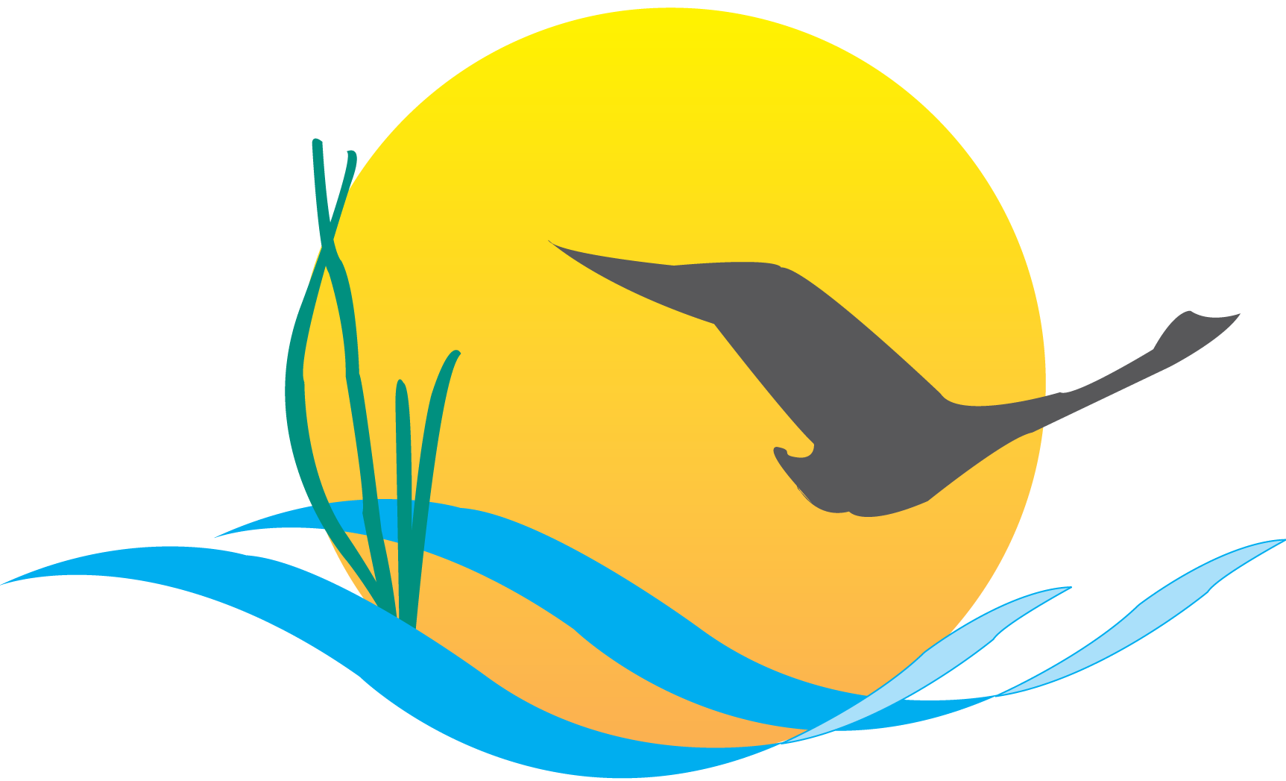

Communications Workgroup
Monthly Meeting
April 2, 2015
9:45AM-11:00AM

Fish Shack
Chesapeake Bay Program Office

Agenda

- Round Robin/GIT Updates 9:45-10:05

- E-Newsletter Best Practices Overview 10:05-10:25
(Jenna Valente)

- Maryland Sea Grant Presentation 10:25-10:45
(Jeff Brainard)

- GIT, Workgroup and Committee Liaisons 10:45-11:00
(All)

Upcoming Meeting: May 7

