Conference Line Access Info:

DC Conference Line #1
(866) 299-3188
Conference Code
410 267 5731
https://epa.connectsolutions.com/comm/
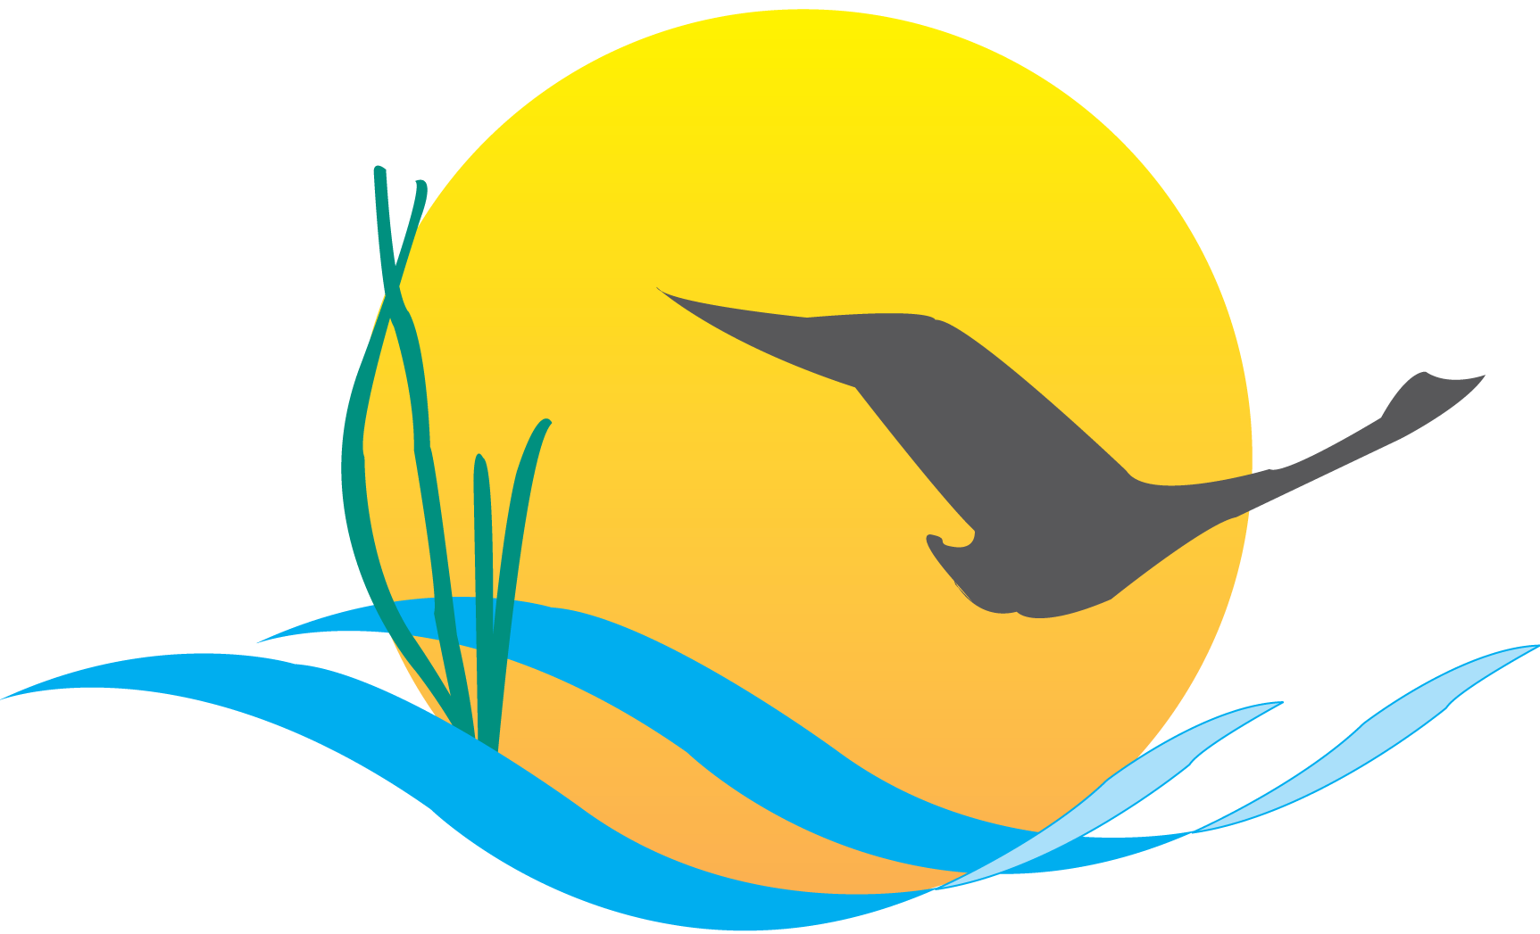

Communications Workgroup
Monthly Meeting
September 3, 2015
9:45AM-11:00AM

Fish Shack
Chesapeake Bay Program Office

Agenda

- Round Robin/GIT Updates 9:45-10:05

- CBP Editorial Calendar Review & Brainstorm Session 10:05-10:35
(Stephanie Smith)
- Land Use Data Development, Local Govt Review, CBP Use 10:35-11:00
(Peter Claggett, Rich Batiuk)

Details:
- An overview of the forthcoming high-res land cover and Phase 6 land use data sets: who is developing them, what purpose they will serve, who is expected to review them at the jurisdictional level and what these reviewers will be looking for
- Plans to notify/contact data set reviewers at the jurisdictional level (with input from LGAC and Comm. Wkgrp. re: who might be appropriate for the role)
- Plans to train data set reviewers
- Communications needs (which seems to consist primarily of letting oversight groups know our data sets are under improvement to better track our progress toward the Watershed Agreement)
Upcoming Meeting: October 1
CBP’s new Climate Change Coordinator – Zoe Johnson

