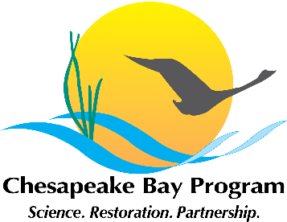**Stewardship Goal Implementation Team (GIT)**

**Meeting Agenda**

**National Park Service**

**410 Severn Avenue, Suite 314**

**August 3, 2015 12:30– 2:00**

Call-in#: 866-704-1637 Passcode: 269 490#

**Welcome / Introductions (Chuck Hunt, Chair)**

* Welcome Lauren Imgrund

**Plans to develop Work Plans (Amy, All)**

* Final template
* Schedule
* Workgroup plans / next steps

**2016 GIT support grant award process and schedule (Amy, All)**

* Schedule and process
* Project concept sharing

**Current GIT support grant award updates (Jaime Baxter)**

**Adjourn**

* Next meeting – September 14