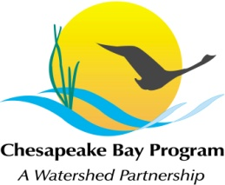
Stream Health Workgroup Meeting
Tuesday, July 7, 2015
9:00 - 11:00AM

Chesapeake Bay Program Office
Joe Macknis Memorial Conference Room
(Fish Shack, Green Building Suite #117)
410 Severn Ave, Annapolis, MD 21403

Conference Line: 866-299-3188 Code: 410 267 5731
Adobe Connect: https://epa.connectsolutions.com/streamhealthwg/ (Note: Enter as Guest)

9:00 Welcome (Rich Starr, FWS)
- Review June meeting minutes

9:10 Stream Health Outcome Management Strategy Biennial Work Plan (Neely Law, Rich Starr)
- Schedule
- Priority Management Strategies, Actions, Partner Responsibilities

10:45 Member Updates

10:55 Next Steps for the Workgroup

11:00 Adjourn

