Wetland Workgroup Meeting
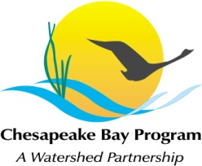
Chesapeake Bay Program
Conference Room 305
410 Severn Ave
Annapolis, MD 21403

Thursday, March 23rd, 2017
1:00 - 3:00PM

Conference Line: 866-299-3188 Code: 267-985-6222
Adobe Connect: https://epawebconferencing.acms.com/wetlandworkgroup
(Note: Enter as Guest with your name and affiliation)

1:00 Introductions from Wetland Workgroup members / Review of goals and agenda
- Action: At least one cool wetland update from your state or organization.

1:10 NFWF Chesapeake Bay Stewardship Fund’s Business Plan Refresh – Jake Reilly, NFWF (Tentative)

1:40 Upper Susquehanna Wetland Mapping Update – Patrick Raney, USC, & Sean MacFaden, University of Vermont

2:10 Discussion on USC mapping applicability to entire Bay watershed
Action: Document interest from group in expanding mapping to other parts of the watershed

2:30 Developing a scope for the next Wetlands Expert Panel – Jeremy Hanson, VT
Action: Workgroup input and interested volunteers to work with Jeremy on the scope of work between now and the next Workgroup meeting.

2:50 Request speakers for future meetings

3:00 Adjourn

Tentative 2017 Meeting dates
May 18 – Guest Speaker – Diane Prosser, USGS (Waterbird habitat and community integrity)
July 20 – Guest Speaker – Brittany Haywood, DNREC (Wetland outreach work in Delaware)
Sept 14
Nov 16
Each of these meetings will take place in CBP Conference Room 305, conference line: 866-299-3188, code: 267-985-6222.

