Wetland Workgroup Meeting
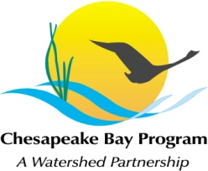
Chesapeake Bay Program
Conference Room 305
410 Severn Ave
Annapolis, MD 21403

Thursday, May 18th, 2017
1:00 - 2:30PM

Conference Line: 866-299-3188 Code: 267-5715
Adobe Connect: https://epawebconferencing.acms.com/wetlandworkgroup
(Note: Enter as Guest with your name and affiliation)

1:00 Introductions from Wetland Workgroup members / Review of goals and agenda
- Action: At least one cool wetland update from your state or organization.

1:15 Effects of local shoreline and subestuary watershed condition on waterbird community integrity in the Chesapeake Bay – Diann Prosser, USGS

2:00 Wetland Expert Panel Charge update – Jeremy Hanson, VT

2:15 Update on the WWG’s GIT Funding project: Increasing landowner participation in wetland restoration programs – Kyle Runion, CRC

2:20 Request speakers for future meetings

2:30 Adjourn

Tentative 2017 Meeting dates
July 20 – Guest Speaker – Brittany Haywood, DNREC (Wetland outreach work in Delaware)
Sept 14
Nov 16
Each of these meetings will take place from 1-3pm in CBP Conference Room 305, conference line: 866-299-3188, code: 267-985-6222.

