Workshop Summary
Climate Smart Habitat Restoration Workshop: SAV & Tidal Wetlands/Black Duck
A workshop in support of the CBT Project: Cross-Goal Climate Resiliency Analysis and Decision-Making Matrix and Implementation Methodology

National Conservation Training Center
Shepherdstown, WV
November 15-16, 2016

Introduction

Project Background
A goal of the Climate Resiliency workgroup is to develop a structured, science-based framework through which the principles of climate-smart adaptation planning can be effectively applied to the existing 29 management strategies in the Watershed Agreement. To further this goal, this project was initiated to work toward developing an analysis & decision-making matrix and implementation methodology for the Chesapeake Bay Program (CBP) that utilizes climate smart principles and can be applied to all Chesapeake Bay Agreement Goals and Outcomes. We are starting with the Adaptation Design Tool (West et al. 2017) that is being developed by EPA’s Global Change Impacts and Adaptation (GCIA) scientists with NOAA and Tetra Tech, as an ecosystem-specific application of the generic climate smart approach. This Tool worked in the context of coral reef management, and is highly applicable for incorporating climate change vulnerability considerations into other ecosystem types and resource management contexts. This project applies the tool for the CBP for the purposes of developing a tailored, CBP-specific climate-smart framework and associated set of climate change adaptation decision matrices.
Development and testing of a framework is proceeding through interactions with two ‘pilot’ goal Implementation teams (GITs) or workgroups which were identified during initial phases of the project – the SAV workgroup and the black duck-wetlands action team/workgroup. Objectives of this project are to:
- Advance climate resilience objectives for Chesapeake Bay Agreement, including application of Climate-Smart conservation.
- Use a regionally developed framework/methods to integrate climate change into CBP management strategies and actions.
- Engage with the 2 selected GITs/workgroups as case studies.
- Work toward development of a matrix methodology that will work across all Chesapeake Bay Agreement Goals and Outcomes through implementation by select CBP GITs & workgroups.

Workshop
A 2 -day workshop was convened at the USFWS National Conservation Training Center (NCTC) in Shepherdstown, WV on November 15-16, 2016. It was a benchmark activity in the process of developing a CBP matrix methodology. The objectives of the workshop were to have participating experts:
- Apply the Adaptation Design Tool to CBP restoration targets.
- Use Black Ducks/Wetlands & SAV groups as case studies.
- Run a set of strawman management actions as examples through the Adaptation Design Tool.
- Begin the process of refining the Tool for the CBP context.
Workshop participants included members of the CBP’s Submerged Aquatic Vegetation (SAV) (see Acronym table below for this and all other acronyms used in this report) and the Wetlands workgroups, and the Black Duck Action Team. It included interested participants from the Climate Change workgroup, the CBSSC (see acronym table below), the CRC, CBP staff and representatives of partnering agencies including MD DNR, VA DGIF, the US EPA, NOAA, and Tetra Tech. A list of workshop participants with contact information is provided in Attachment 1.
The goal of the project is to support the integration of climate smart principles throughout the CBP: at multiple levels, from place-based management actions to restoration strategies and development of partnerships. We are exploring the Adaptation Design Tool as basis for developing such a unified approach. At the workshop, we started with a set of relatively specific Chesapeake Bay restoration actions and took them, as examples (‘strawmen’), through the Design Tool, expecting that a broader understanding of how the process relates to the decision contexts within which Chesapeake Bay restoration takes place would emerge. The inputs and insights we gained are summarized in this report. We will use the information from this exercise to assess and revise the Tool for the CBP context.
To achieve objectives, the workshop started on the first day with an overview presentation recapping the approach and general principles of climate-smart conservation and of the process of utilizing the Adaptation Design Tool, all of which had been presented in more detail during a pre-workshop webinar (November 1, 2016). This was followed in subsequent morning and afternoon break-out sessions with facilitators leading each of the 2 case study groups in taking 2-4 strawman management/restoration actions through Activity 1 of the Adaptation Design Tool. On the second day of the workshop, further break-out group facilitation was used to explore Activity 2 of the Tool, and to discuss how to apply the Tool to work they do in their respective workgroups. The workshop was wrapped up with a full-group discussion of potential applications of this process to other groups and at other levels, including perceived roadblocks or issues, as well as potential project directions and recommended next steps. The workshop agenda is included for reference as Attachment 2. Presentations made at the workshop are included for reference in this summary (Attachment 3). Key messages from the workshop are summarized below. Acronyms used in this summary are defined in the following table. A compilation of notes from the workshop breakout sessions is included in Attachment 4.

Acronyms used in this summary report.
CRC | Chesapeake Research Consortium
CBSSC | Chesapeake Bay Sentinel Site Cooperative
CBP | Chesapeake Bay Program
ESA | Endangered Species Act
GCIA | Global Change Impacts and Adaptation
GIT | Goal Implementation Team
MD DNR | Maryland Department of Natural Resource
NCTC | National Conservation Training Center
ORD | Office of Research & Development
SAV | Submerged Aquatic Vegetation
U.S. EPA | United States Environmental Protection Agency
USFWS | United States Fish & Wildlife Service
USGS | United States Geologic Service
USACE | United States Army Corp of Engineers
VA DGIF | Virginia Department of Game & Inland Fisheries

Summary of Key Messages from the Workshop

Considerations for Modifying the Process and Tool
We need to be able to use this tool from the top down as much as from the bottom up. Consider how to take what we learned from this workshop to apply at a higher (broader) level, inform new goals and outcomes or revise our goals and outcomes.
- To envision what this tool can do to help the CBP and associated groups, recognize that the CBP makes decisions at different level.
- Continue discussions with workgroups about higher-level (goal, outcome, management strategy, management approach, work plan) applications of this process.
- The Adaptation Design Tool was not designed to answer the question of what is realistic as far the goals themselves, but rather organizes information that can be brought to bear on such questions, and helps identify trade-offs and other considerations.
- Consider GIT-level insights, overarching issues, what data and support are needed from the Climate Resiliency Workgroup.
Inputs on CBP goals & objectives:
- Many of the CBP environmental goals & outcomes, from 2014, may have to accept changes, including future (ongoing) habitat changes.
- Consider goals within a larger regional context rather than just bay-specific
  - NA LCC funded a synthesis of all the 13 northern state wildlife action plans, refreshed them to consider shifting distributions due to climate change that would cut across state boundaries.
  - Increase outreach to coastal communities, for issues like ESA; can help by connecting northern states to prepare for migration, how to plan for species coming in (shifting species distributions due to climate change).
  - Have CBP leadership appreciate the regional endeavor more, be aware that range shifts may occur.
- CBP goals dominated by water quality questions, TMDL’s. Complement with minimum wildlife daily needs. May not be able to save everything all the time, but try to assure sufficient habitat.
  - Example - Pocomoke river reconnection project – a climate smart choice, successful; reconnecting 4000 acres of floodplain.
- Consider pros/cons of species-based focus vs systems approach. Consider ‘conserving the stage’ rather than the species.
- Not a static landscape, need to incorporate dynamic changes in plans/goals.
- Consider how to trade off system level issues with ESA needs, the value of retaining populations, etc.
What would be other possibilities for applying this process? Prompted questions? A template? A facilitated process? An example should be provided.
- To facilitate ease of use of the tool, consider using a checklist rather than a table format.
  - The matrices are very time-intensive; a checklist might be a more useable format.
  - The table columns could become the checklist questions that each group asks themselves for their own projects.
  - Should include an example of how to help answer these questions.
  - Possibly two tables? A simplified one for folks with less expertise, and then a more comprehensive one for detailed expert audience.
- Understand what decisions the GITs are making, their needs, to understand how this process should be applied.
- Consider what the pathway is (‘How to draw the line’) from case studies (finer level) to the GIT’s planning continuum (higher level).
Consider how to facilitate greater collaboration between workgroups, and implications of that for using results of the Tool.
- Agencies are stove piped. There is collaboration, but perhaps this process can help bring forward common objectives. The way that agencies and institutions have been built is not conducive to collaboration.
- There are functional (process and ecological) interconnections across GITs, need cross-workgroup interactions as a formal process, coordinate with the existing cross-workgroup coordinator.
- Cross-GIT interactions and mapping cross-GIT priorities would provide a good lens for climate smart needs; e.g., which outcomes (across groups) are most critically affected by climate change?
- Identify shared priorities; could apply this process to that cross-GIT process to reprioritize actions with respect to climate change effects on those project, areas that are specific to multiple goals, etc.
- Goals & objectives for using the process – make things climate smart, or encourage collaboration?
- If one group is doing something that affects a primary stressor of another group, give credit for something that matters in the synergy process. For certain goals and outcomes, climate change could be very important, for others, not so much. For example, in terms of SAV, in an urban area, if the principle stressor is water quality, climate isn’t the biggest stressor, so shouldn’t be ranked as high.
- Consider working with other GIT and workgroups at their meetings to exchange information and coordinate actions regarding a process to incorporating climate change impacts.
- How would you apply what you’ve learned in the context of the workgroup?
  - If workgroups are familiar with this process, they can provide some input to partners regarding the effectiveness of these projects, and considerations for future projects.
  - How can the Climate Resiliency Workgroup help other workgroups?
Perceived benefits of the Tool.
- This process would help inter-group collaboration, move toward common goals and with a climate change lens.
- Makes consideration of climate change effects explicit, which groups have previously been thinking about but informally.
- Good at the higher level, making things climate smart through resilience, interconnectedness; but not good without making the actions climate smart as well.
Issues with using the Tool.
- Using this process to set priorities and thus ‘target’ restoration actions would be great, but for the wetlands workgroup, project identification is entirely opportunity driven.
How do we address an apparent disconnect or gap between projects being done and what is needed to achieve CBP goals?
  - The outcomes often have a numerical goal. The management strategies and work plans are the difficult part with no detailed steps of how to achieve those goals.
  - It might be best to talk to the workgroups about their outcomes, discuss on the ground projects and what could be done to get closer to achieving the goal.
  - Consider what is covered in each plan, and using the climate smart strategies as categories of possible additional actions to take, consider what other activities might be needed.
  - Need the Adaptation Design Tool’s second activity to help figure out how to achieve actual outcomes, e.g., what else needs to be done.
    - But this overall concept is outside the role of this workshop, though you can’t be completely climate smart without having these considerations.
Other Considerations.
- Include characterization of uncertainty; possibly general guidance similar to what USACE does regarding ranges of considerations for climate-related concerns.
- Monitoring helps to validate these projects and demonstrate success.
  - Much of the monitoring is short term, and a lot of these projects are aimed at long term success; need to think about ways in which monitoring should be utilized.
  - So much is dependent on monitoring, but monitoring is difficult to start and continue. Is there a way to deal with this, e.g., a “lighter” monitoring program without heavy institutional support?
- Sentinel site data can be used to help fill data gap/needs of other workgroups.

Wetland/Black Duck Goals, Considerations
- The CB Agreement sets out ambitious wetland restoration goals. Ability to implement projects is partly driven by access, whereas 90% of Chesapeake Bay wetlands are privately owned. STAC suggested looking at wetland function, using that instead of acreage goals.
- Climate smart could be specifically incorporated in the language of the black duck and other strategies.
  - Primary objective is to have a conservation landscape capable of supporting that number of ducks (not having that number of ducks).
  - Tension of choosing this as a poster species – a great poster bird, but because so much influences where they are found, maybe not a wise choice. Could create opportunity to look at other resident birds that are habitat dependent.
  - Could make sense to have a diff mascot. Saltmarsh sparrow using marshes to nest, affected by SLR.
  - The black duck group already has an adaptive management approach, incorporating climate into this adaptive management process would be the best way to bring climate into it.
    - Is there was a plan to make this happen, or what could the Climate Resiliency Workgroup do to help facilitate? Potentially put forward to the black duck group on two levels - implementation/field level and higher management level.
- Thinking more about restoring converted wetland back to native saltmarsh.
  - Is it wise to be giving up water control structures? Black rails doing well in coastal impoundments. Getting rid of them may doom that species.
  - Most of the time it’s about having populations of species the public would want (i.e. not just natural habitat).
  - Large impoundments, but a small overall percentage of total marsh.
  - Question is how long would native marsh last? Most are managed as freshwater impoundments, but could be high saltwater marsh as well. Not enough high marsh in Chesapeake Bay, see impoundments as the only option.
  - Why not adapt to these changes rather than fight them?

SAV Goals, Considerations
- The SAV Technical Synthesis 3 is coming out and will have climate considerations in it, a chapter on climate effects on SAV. Neither wetlands nor black ducks have anything similar.

Observations Regarding the Case Studies and Worksheets
- There was more comfort discussing the studies they felt were “real”. If the group felt they weren’t “real”, people got hung up on case studies vs. real-world projects.
- Some of the case studies were very large; needed to be broken out to get the insights intended with this tool.
- Doesn’t necessarily makes sense for workgroups to apply this tool to all actions in their work plans, e.g., some of the research and education/outreach efforts, which this tool was not designed for.
- There was a strong need to understand the current permitting situation.
- Historical data was a helpful component of developing management strategies. Historical data has strongly influenced the current standards, but now we’re in new territory with climate change.
- Need more information about how the columns work, etc.
- Hard when don’t have the right experts in the room to answer needed questions.

Worksheet 1A
- In tailoring the matrices for the CBP, revise the title of the stressor column (A3) to clarify differences between existing stressors in the environment and stressors specifically related to the management action and which the management action can address.
  - There could be a column for why we are trying to restore SAV, but the purpose for the general case study could ask what the original stressors of concern are.
- In completing this process, it is important to review points that are immediately urgent and perhaps less on points that are more uncertain. There may even be prioritization within each column as well.
- Some of the strawman actions used in the exercise, e.g., the conservation easement projects, are big, hard to do the specific thinking that is required for this process. It might have been easier (and might be recommended for the future) to examine pieces of such projects separately.

Worksheet 1B
- Use of this worksheet highlighted questions related to potential conflicts between the goals of one working group (or GIT) and another, or with broader CBP goals (e.g., water quality improvement). For example, is water quality improvement an overarching objective that should be considered in evaluating the success of, and the climate change effects on, habitat-specific (e.g., SAV) restoration actions?
  - SAV group discussed possibly creating a new column for “dependencies”.
- Use of this worksheet (particularly columns B3-B6) seemed useful in encouraging thought about what constitutes success, e.g., what relation immediate success of SAV restoration has to bigger-picture success of Chesapeake Bay water quality goals, and how climate change influences these (including in terms of resilient results).
- Making a connection between the actions and water quality could be helpful, but the purview of the workgroup is really confined to SAV. The goal of SAV restoration is to accelerate expansion of restoration.
- May also need columns for outreach and education.

Activity 2 (what to add to existing work plans)
- Existing set of projects too limited, partners do projects that are too site-specific; need to expand, consider climate change.
- Working on BMPs on how to aid marsh migration; think about degradation upstream.
- Think about how to use stateside data next to site specific data – this process would help.

Other Considerations
- Where does everyone go to get information? Described by Black Duck Chair as a morass of information
  - It’s easier to put information where people already go, and not train them to use a different resource
  - May be helpful to link body of knowledge to other workgroup sites?
- What else could be gained by further discussion among GIT chairs to develop linkages?
  - Some kind of facilitated discussion could be necessary to get the ball rolling
- The publication of TS3 (Technical Synthesis III of SAV in the Bay) guidelines will have climate integrated within it
  - The TS3 would be used as an input for climate considerations

Recommendations

Key Points from Workshop Related to Moving Forward with Method Development
- Design (modify) the tool to support introduction of climate smart principles at higher levels of organization/decision making as well as to actions (to ‘climatize’ a range of CBP practices and processes). Preliminarily suggesting the following 3 levels:
  - Goals/outcomes
  - Management Strategies
  - Work Plans/Key Actions
- Simplify format of the matrix method (Adaptation Design Tool) to the extent possible (e.g., potentially use a checklist instead of tables) and provide more guidance.
- Design (modify) the framework to encourage and help direct (facilitate) needed cross-group interactions/collaboration.

Next Steps

Draft 3 levels of matrices:
- Draft a set of questions for each level in a way that guides the user to gather or generate relevant and specific climate change, program, and environmental information in a step-wise, structured fashion (as in the Adaptation Design Tool tables).
  - For example, the action-level Adaptation Tool utilizes a series of questions about the stressors that are targeted by a restoration action and how those stressors and the action itself are affected by location-specific climate changes in a way the leads the practitioner to being able to recognize and define modifications of the action that would allow it to function effectively under anticipated climate change conditions (i.e. be climate smart).
  - A similar approach for the CBP goals/outcomes level might include:
    - Initial question(s) about the main stressors impacting the resource that is the target of the CBP (GIT or workgroup, etc.) goal under consideration.
    - Question(s) about the key climate change impacts on that resource target.
    - Question(s) about any relevant non-climate and climate change stressor interactions.
    - Question(s) about whether climate change influences are directly on the resource target or mediated through other ecosystem components (potentially relevant to whether the goal targets are directly management-sensitive or not).
      - An example this concept was derived from is the suggestion during the first workshop to ‘conserve the stage’, i.e. to manage (as a goal) for enough good black duck habitat rather than to manage for a specific number of black ducks.
    - Question(s) about uncertainties and the range of variation expected in the resource or ecosystem, or in thresholds and system changes that may be expected.
      - Would support climate-smart revisions to higher planning level goals/objectives or strategies including managing for change, or managing for a range instead of a single number.
- Questions should be reviewed, revised and expanded by the project team as needed.
- Questions can then be formatted (a guided checklist, tables/matrices, etc.) for ease of application.
- Interact with a variety of representatives of a range of GITs/workgroups/action teams to get inputs on relevant questions, question format, and method/process. The outreach/involvement should include but extend beyond the case study workgroups (black duck/wetlands and SAV) who participated in the first workshop.
- Need to include in this methods structure a prescribed (recommended) set of inter-group interactions/collaborations:
  - Some interactions identify or generate needs of one group from another at a higher level (goal to strategy), e.g., water quality needs of SAV or other fish/wildlife groups.
  - Identify ‘entry points’ in the planning process and in utilization of this framework where specific interactions between GITs/workgroups would generate information or actions useful to the

Revise the Action (Project)-Level Tables Based on Workshop Inputs
- Clarify ‘target stressors’ (Column A3, Worksheet 1A) with respect to typical CBP projects.
  - Clarify differences between existing stressors in the environment and stressors specifically related to the management action and which the management action can address.
  - For example, original stressors causing loss or impairment, versus what will be achieved (what condition addressed) by the action. In SAV restoration example, original stressors may have included nutrient and sediment runoff (poor water quality), but is replanting an SAV bed being done to improve water quality (though SAVs have water quality influence), or to provide fish/wildlife habitat, protection to marshes and shorelines, etc.?
  - A corollary question needing clarification is what metrics to use to measure project success. In the original conception of Worksheet 1A, such metrics would be linked to the stressors or conditions being addressed by the action.
  - Clarification might include an additional column (or question in a checklist) to define the proximal goal of the action (e.g., to create acres of habitat) in addition to documenting the original stressors.
  - Clarification may also include differentiating between stressors that contributed to the original loss and how the lost habitat affects the CB system.
- In worksheet 1A (or possibly 1B), may need an additional column called ‘dependencies’, to recognize influences of one group (e.g., water quality) on the success or functioning of an action of another group (e.g., SAV).
- May need column(s) for outreach, education.
- Need to revise and consider the more effective application of Activity 2 within a CBP-tailored action-level method, because the scope of existing projects is too limited to achieve stated goals.
  - This may integrate with the processes for the other levels.
- Improve guidance on what the content/intent of each column is supposed to be.
- (Potentially) revise format from table to checklist (consistent with what is done above for other levels).

Plan for the next workshop
- Include but extend beyond the case study workgroups (black duck/wetlands and SAV) who participated in the first workshop.
- Schedule to have enough time for a reasonable round of ‘one-on-one’ interactions with GIT/workgroup.
- Focus on broader development of the method rather than ‘going deeper’ with the existing case studies, including review/application of the 3 levels of ‘matrices’ (checklists), and the framework.

Next Steps
- Project timeline: synthesis and results write-up due by September 1, 2017.
- The next step is to move through another set of workshops in the spring that will serve to refine the tool and build off of what was completed during this workshop. Other ideas included following up via a webinar and continue to receive feedback on the process and tool.
  - What should the focus of this second set of workshops be? The organizers will be reaching out from the workshop regarding summaries and notes. The feedback may help to best determine what the best next step is in the context of the larger program.
  - What to accomplish during 2nd set of workshops – continue to refine matrix with black ducks and tidal wetlands? Further process with other groups? Or something else?
  - Hammer out next steps for applying this process more broadly.
- Different formats for the workshop being implemented were discussed. One was a reproduction of what was done here (those in more of the climate camp), and one that is lighter for those planners or managers who many not have the background to run through the entire process as well.
- Think about how to pare down the tool and the tables, then give guidance on how to apply it to other workgroups,
  - Make a goal for the climate group to work with a set number of workgroups on it in the future.
- Look at current management practices and processes and “climatize” it. See Attachment 5 for sample of “climatized” SAV management strategy. The concern from workgroups re: this process is that they aren’t open to reopening their management strategies to redefine them.
- Value in history of thought in developing strategies from this workshop.
- Understanding how to manage a risk and manage the process would be useful moving forward.
- This may be a paradigm shift and would involve more capacity building like adding additional trainings.

Attachment 1
CBP Climate Smart Habitat Restoration Workshop
Participant List

CBP Climate Smart Habitat Restoration Workshop
Participant List
Name | Affiliation | E-mail
Project Team
Zoe Johnson | NOAA | zoe.johnson@noaa.gov
Susan Julius | US EPA/ORD | Julius.Susan@epa.gov
Anna Hamilton | Tetra Tech | Anna.Hamilton@tetratech.com
Jennie Hoffman | Tetra Tech Team | hoffrau@gmail.com
Hope Herron | Tetra Tech | Hope.Herron@tetratech.com
Jordan West | US EPA/ORD | West.Jordan@epa.gov
David Gibbs | US EPA/ORD | gibbs.david@epa.gov
Melissa Merritt | CRC | mmerritt@chesapeakebay.net
Kyle Hinson | CRC | khinson@chesapeakebay.net
Participants – SAV Breakout Group
Brooke Landry | MD DNR | brooke.landry@maryland.gov
Jennifer Greiner | USFWS | jennifer_greiner@fws.gov
Andrew Wynne | EPA Region 3 | wynne.andrew@epa.gov
Christopher Spaur | USACE | Christopher.C.Spaur@usace.army.mil
Kristy Beard | NOAA | kristy.beard@noaa.gov
Mark Bennett | USGS | mrbennet@usgs.gov
Rebecca Swerida | MD DNR | rebecca.swerida@maryland.gov
Stan Kollars | Earthlink | kollars@earthlink.net
Bob Murphy | Tetra Tech | Bob.Murphy@tetratech.com
Kyle Runion | CRC | runion.kyle@epa.gov
Participants – Blacl Duck/Wetlands Breakout Group
Regina Poeske | US EPA/Region 3 | Poeske.Regina@epa.gov
Benjamin Lewis | VA DGIF | Benjamin.Lewis@dgif.virginia.gov
Bill Harvey | MD DNR | bill.harvey@maryland.gov
Darlene Finch | NOAA | Darlene.Finch@noaa.gov
Erin McLaughlin | MD DNR | erin.mclaughlin@maryland.gov
Gary Constanza | VA DGIF | gary.costanzo@dgif.virginia.gov
Josh Homyak | MD DNR | josh.homyack@maryland.gov
Mike Slattery | USFWS | michael_slattery@fws.gov
Nicole Carlozo (1) | MD DNR | nicole.carlozo@maryland.gov
Sarah Wilkins | Maryland Sea Grant/MD DNR | sarah.wilkins@maryland.gov

Attachment 2
CBP Climate Smart Habitat Restoration Workshop
Agenda

Chesapeake Bay Program
Climate Smart Habitat Restoration Workshop: SAV & Tidal Wetlands/Black Duck

A workshop in support of the CBT Project: Cross-Goal Climate Resiliency Analysis and Decision-Making Matrix and Implementation Methodology

National Conservation Training Center
698 Conservation Way
Shepherdstown, WV 25443

Main Room - Instructional East Room #114
Breakout Groups – Room #103 (SAVs) & 107 (Wetlands/Black Ducks)
Agenda
Day 1: Tuesday, November 15, 2016
9:30 – 10:00 AM | Sign-in, distribute materials Main Room (114)
10:00 – 10:15 AM | Welcome & Introduction to Workshop Main Room (114)  Zoe Johnson (CBP/NOAA) & Anna Hamilton (Tetra Tech)
 | [No formal break – refreshments available]
10:30 – 11:00 AM | Overview of Climate Smart, Adaptation Design Tool Main Room (114)  Anna Hamilton (Tetra Tech) & Jennie Hoffman (Adaptation/Insight)
10:45 AM – 12:00 PM | Breakout Groups: Work through Adaptation Design Tool/Activity 1 for 2-4 management actions  SAVs Room 103  Wetlands/Black Ducks Room 107  Facilitators: Jennie Hoffman (Adaptation/Insight) & Hope Heron (Tetra Tech)
12:00 – 1:20 PM | LUNCH (Cafeteria available on-site)
1:20 – 1:30 PM | Reconvene & Brief Check-in Main Room  Anna Hamilton (Tetra Tech)
1:30 – 2:45 PM | Continue Breakout Group Work  SAVs Room 103  Wetlands/Black Ducks Room 107  Facilitators: Jennie Hoffman (Adaptation/Insight) & Hope Heron (Tetra Tech)
2:45 – 3:00 PM | BREAK
3:00 – 4:00 PM | Continue Breakout Group Work  SAVs Room 103  Wetlands/Black Ducks Room 107  Facilitators: Jennie Hoffman (Adaptation/Insight) & Hope Heron (Tetra Tech)
4:00 PM – 5:00 PM | Reconvene, Brief Report-outs, Compare Key Outcomes Main Room  Anna Hamilton (Tetra Tech), Jennie Hoffman (Adaptation/Insight) & Hope Heron (Tetra Tech)
Day 2: Wednesday, November 16, 2016
9:00 – 9:20 AM | Recap of Key Outcomes from Activity 1 Matrices Main Room  Anna Hamilton (Tetra Tech)
9:20 – 10:15 AM | Breakout Groups: Explore Activity 2 of the Design Tool, Other types of management actions  SAVs Room 103  Wetlands/Black Ducks Room 107  Facilitators: Jennie Hoffman (Adaptation/Insight) & Hope Heron (Tetra Tech)
10:15 – 10:30 AM | BREAK
10:30 – 12:00 PM | Breakout Groups: Emerging Insights from the Design Tool exercise (information gaps, successes/issues, topics not covered, cross-over between workgroups)  SAVs Room 103  Wetlands/Black Ducks Room 107  Facilitators: Jennie Hoffman (Adaptation/Insight) & Hope Heron (Tetra Tech)
12:00 – 1:15 PM | LUNCH (Cafeteria available on-site)
1:15 – 2:00 PM | Breakout Groups: Decision context, applying results to decisions  SAVs Room 103  Wetlands/Black Ducks Room 107  Facilitators: Jennie Hoffman (Adaptation/Insight) & Hope Heron (Tetra Tech)
2:00 – 2:15 PM | BREAK (FLEXIBLE)
2:15 – 3:45 PM | Reconvene, Group Comparisons; Factors to Consider Across Grps Main Room  Anna Hamilton (Tetra Tech), Jennie Hoffman (Adaptation/Insight) & Hope Heron (Tetra Tech)
3:45 – 4:00 PM | Wrap Up: Project Timeline & Next Steps  Zoe Johnson (CBP/NOAA)

Attachment 3
Relative Wetland Vulnerabilities Workshop
Presentations
Presentations Included:
CBP Workshop Intro-Overview 11.14.16.pdf
CBP Workshop 2nd Day.pdf

CBP Workshop Intro-Overview 11.14.16.pdf
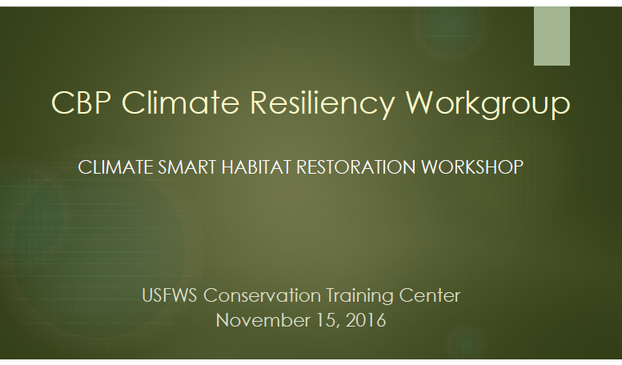
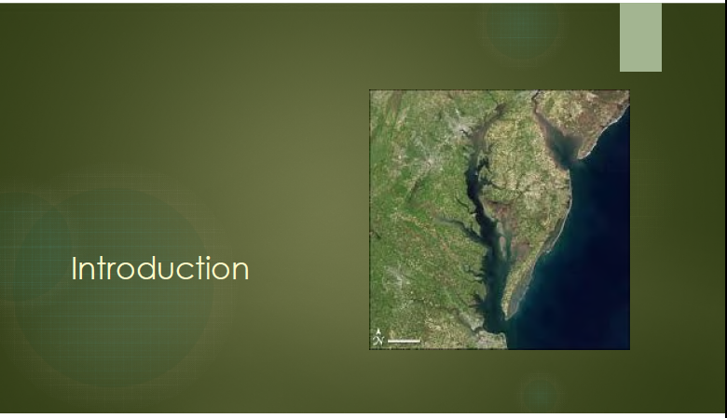
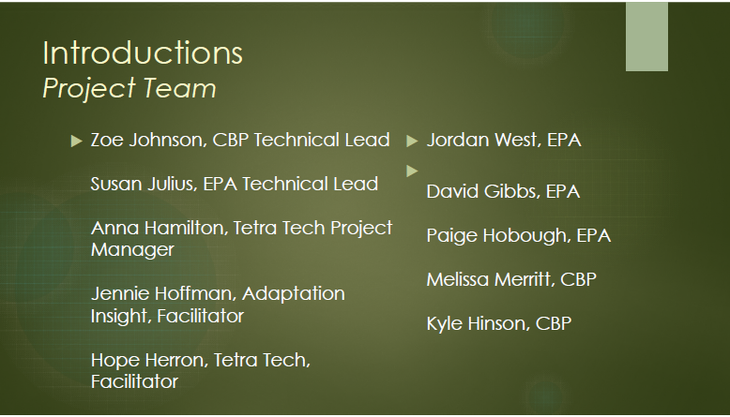
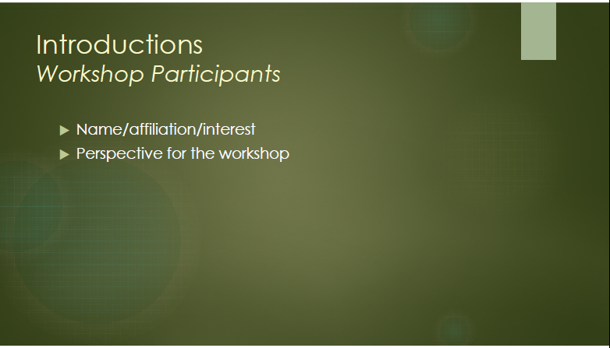
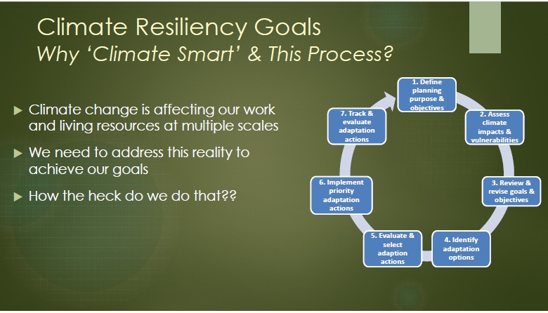
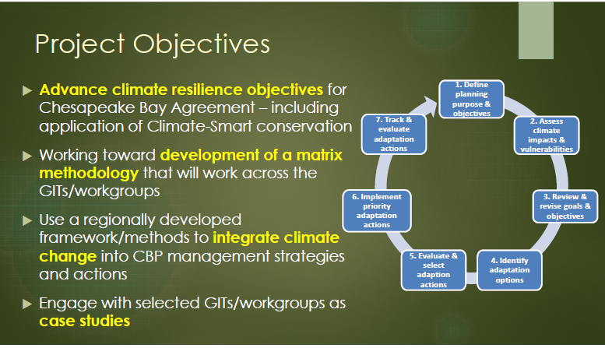
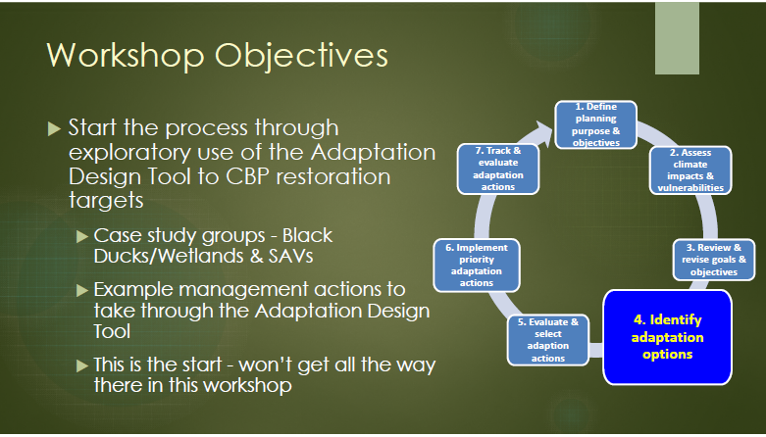
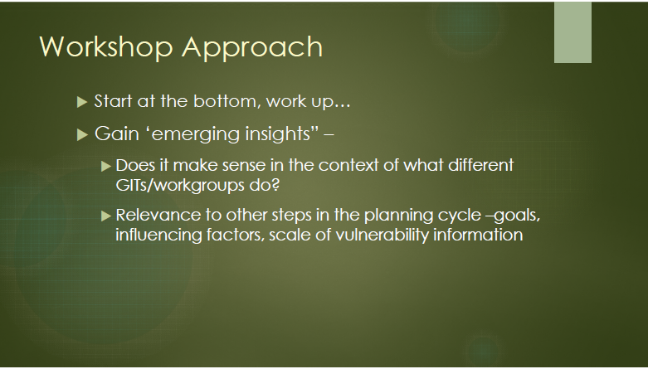
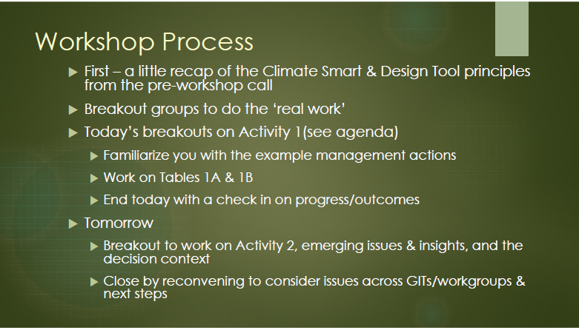
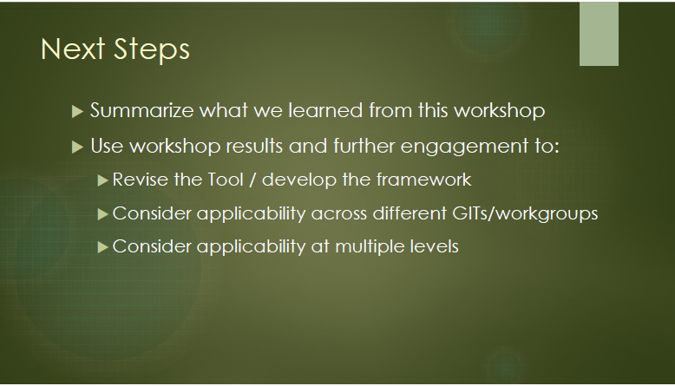
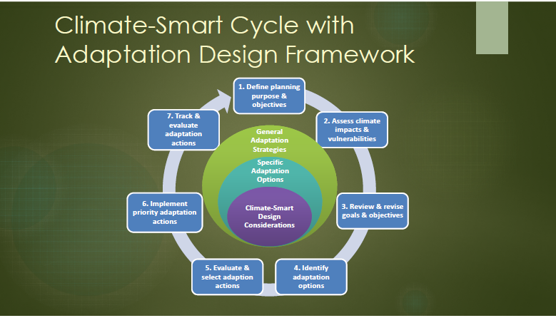
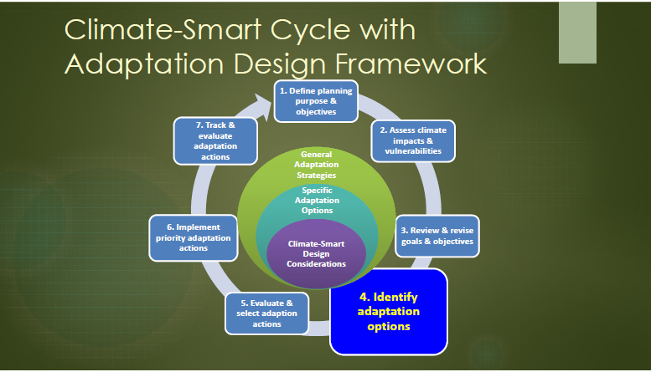
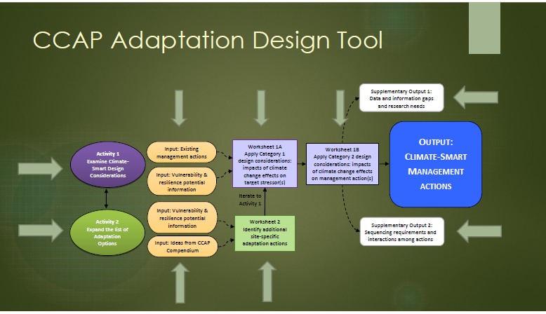
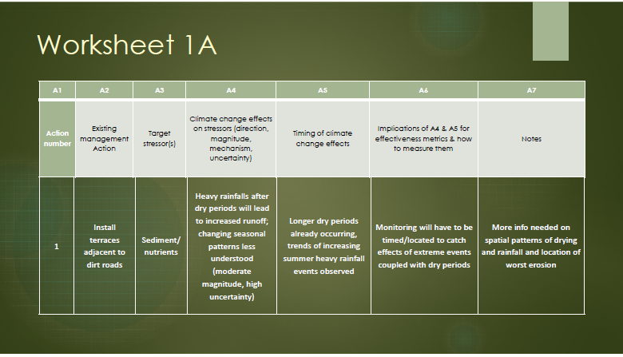
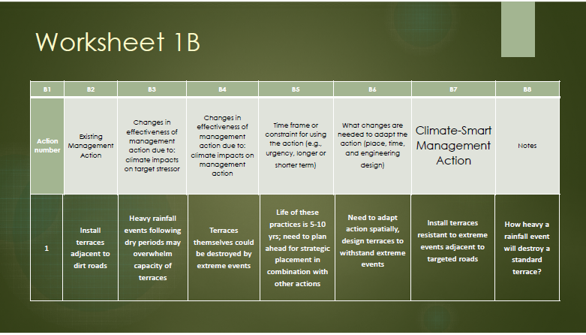
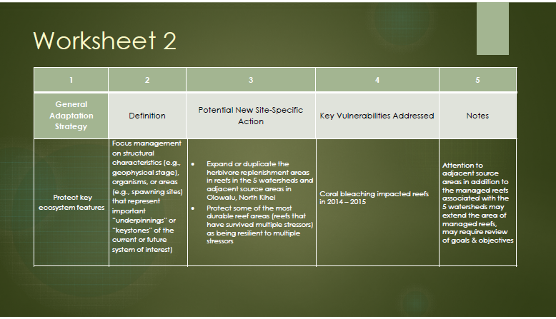
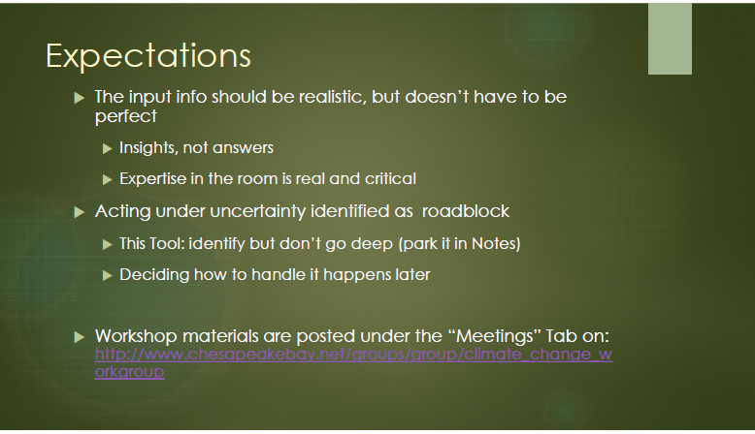
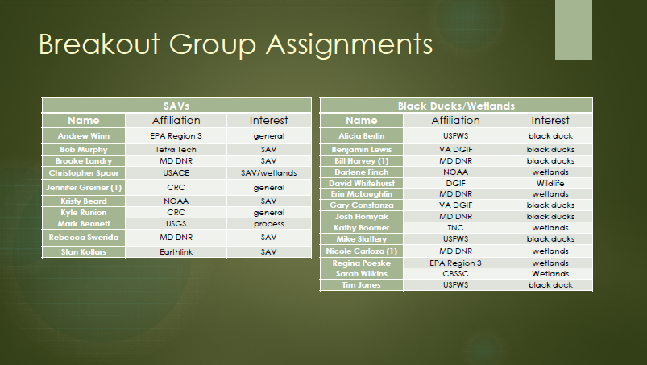

CBP Workshop 2nd Day.pdf

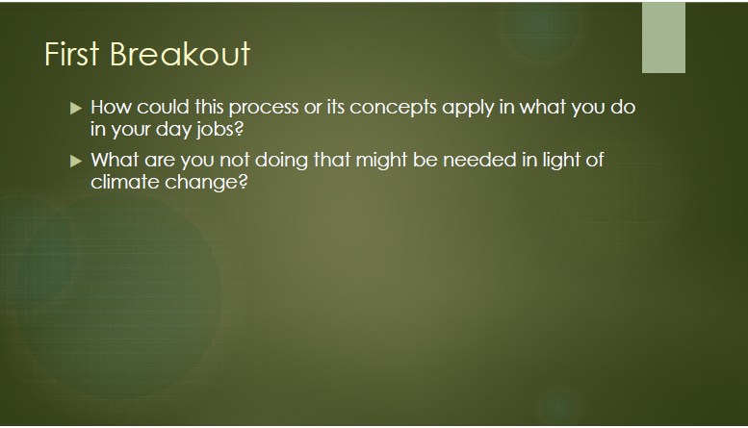
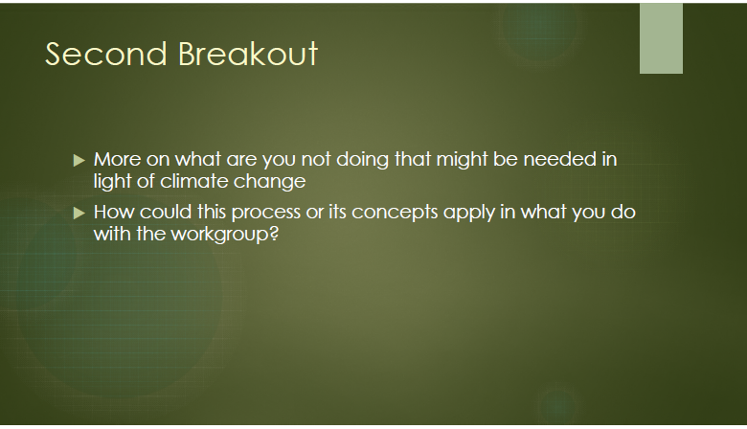
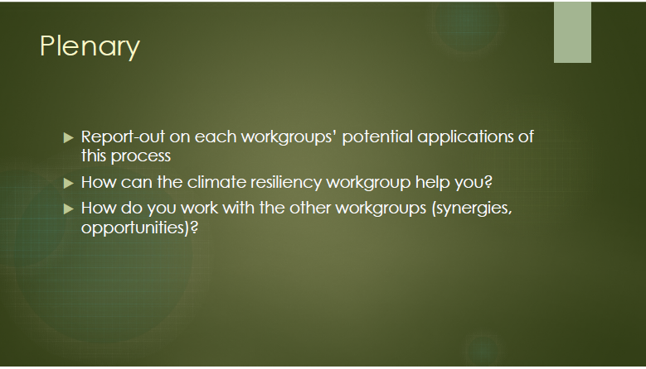

Attachment 4
Relative Wetland Vulnerabilities Workshop
Compilation of Breakout Session Notes

Compilation of Workshop Notes

Introductory Comments/Insights
- Important to begin from particular actions and work from the bottom up to capture emergent insights; in dealing with the specifics first we can begin to see how it applies to the whole cycle and the general context.
- The climate-smart framework allows us to park a lack of specific information that may not be currently known and still develop strategies that allow for resilient management in the face of uncertainty.
- The framework helps consider uncertainty within decision making. You can also act by trying to determine how the uncertainty affects your vulnerability.
  - The magnitude of uncertainty could help us to weight decisions in the framework cycle.
  - One focus of the workshop activities is to think about where the uncertainties are, and how they could possibly weight your decisions.
- The immediate goal is to figure out how this (climate change vulnerabilities and associated uncertainty) applies to your kinds of projects, and then move up to broader points of insight.
  - The goal is insight, not answers. The focus is really the process.

Compilation of Notes from the Breakout Group Discussions

SAV Workgroup

Taking Strawman Actions through Activity 1 of the Adaptation Design Tool Matrices
- The purpose of the Climate Smart general adaptation strategies is to provide a general understanding of management strategies. For adaptation in general, would want to try and reduce climate change stressors.
  - The purpose of these definitions is to put a climate stress on them, but are not necessarily prescriptive.
- The strength in the case studies is that they give us a common set to discuss and build from.

Strawman Action #1 Homeowner initiated SAV restoration project
Brief Project Description: An environmentally-minded homeowner with a large piece of property on Kirwans Landing Lane on Kent Island, MD expressed interest to DNR in restoring SAV along his shoreline. The homeowner is willing to pay for restoration materials (seeds, not manpower, though he and his friends will help) and has financed other restoration efforts. It is noted that SAV is naturally recovering in Eastern Bay. The strawman project is to implement SAV restoration, focusing on Ruppia maritima, along the shoreline of the property on Kirwans Landing Lane on Kent Island, MD. The primary method will be seeding of Ruppia. Associated habitat restoration could include removal of rip-rap and replacement with hybrid/natural shoreline. There is a large stand of invasive Phragmites on the property which he is actively controlling with aerially released herbicides in hopes of eradication. Kirwan Creek is a small tributary off Eastern Bay, south of Kent Island. The region is mesohaline; landuse in the watershed is primarily agricultural.
Breakout Group Discussion Notes:
- Everything was negative, and there could be some benefits such as changes in precipitation patterns (decrease in rainfall produces less sediment and greater clarity).
  - Could be counterbalanced by increased storm intensity.
- Focus on cownose rays which is independent of these direct factors, but could be important to understand species competition.
- A positive point indicator was the increase of CO₂ concentrations that could help to fertilize and compensate for the heat stress, specifically with regards to eelgrass.
- Macroalgae growth, as well as cyanobacteria are also points that must be accounted for.
- Question about the predictive ability of large storms to negatively affect SAV ecosystems.
  - Many people agreed that the large storms like Tropical Storm Lee and Hurricane Agnes have the capability to scour and deposit enormous amounts of sediment that harm SAV beds.
- Comment that the trends of water depth should also be examined and could alter the photic requirements of SAV beds.
- Question about the ‘wish list’ of SAV knowledge and the known data gaps.
  - Comment talked about the tolerance of species as one piece of a long list; mentioned the report “Managing Seagrasses for Resilience to Climate Change”.

Worksheet 1A (attached below)
- The overall objective is testing this process that allows us to determine how existing management actions could be tweaked or strengthened to adjust for climate change impacts
- Beyond global climate change issues, this is a point where local SAV is almost completely controlled by Bay-wide issues. Less capability for individuals to control success of local restoration because of factors outside of their control. It’s unclear at the Bay scale if restoration results in any difference from no action taken. Good educational opportunity, but important to lay out the tough path for the homeowner ahead of time.
- Part of the management strategy is outreach and education, a mandate of an additional 20 acres/year.
- Herbicide application was added to a target stressor in the worksheet; as was further stressors from recreational boating, septics.
- Surprise that temperature changes were not on the list of stressors, and although it could be a potential future threat, Ruppia is currently known to be a more resilient species of SAV.
- Sediment and nutrient runoff is likely a stressor, but the planting of SAV does not remove that stress.
  - The management action would focus on the propagule material, this is not dealing with the stressor but is more of an education and outreach opportunity.
  - The efforts of the landowner in the first example may best be served for education and outreach rather than habitat restoration of SAV.
- There was a large increase in SAV abundance in the study area in 2015, and the possibility of a positive feedback loop.
- These are existing stressors in the environment, not necessarily to the management action.
  - Originally, stressor column was used in a broader way, specific actions that were taken to address the stressor; in this case using SAV in a more general sense, key reason a positive habitat function. There could be a broader way of addressing this issue.
- The name of the column as target stressors should be revisited in tailoring this tool for the CBP.
- There could be a column for why we are trying to restore SAV, but the purpose for the general case study could ask what the original stressors of concern are.
- The propagation of moving more southern species to an environment within the Chesapeake Bay was also floated.
  - This raises issues of whether we have sufficient genetic or phenotypic variability to maintain an evolutionary potential. There needs to be an assessment of source propagules and understanding this for Ruppia and other species would be critical for integration. This could be mentioned in the climate change effects on propagation species, but then move it through the process as well.
- Climate change affects agricultural runoff and septic systems differently, and it was asked how impacts of climate change could affect septic runoff.
  - Higher water tables, and increased intensity could more rapidly overflow the septic systems.
  - Perhaps increased ground temperatures could increase biotic processes and encourage nitrification over longer time periods throughout the year, and could serve as a net benefit.
- Review of climate change effects on stressors, and the timing of climate change effects.
- One thing that is currently occurring is related to temperature stress, but has not produced noticeable (measureable) changes yet, and they may not impact the species prevalent in the study area.
- There may be an increased prevalence of shoreline hardening because of more frequent storm surge resultant from climate change, a perception of safety; a ripple effect occurs based on a single landowner implementing hardening.
  - Question of environmental peer pressure encouraging other landowners to remove hardening measures.
- Increased storm intensity should be considered despite overall decreases in precipitation in particular seasons.
- In completing this process, it is important to review points that are immediately urgent and perhaps less on points that are more uncertain. There may even be prioritization within each column as well.
- Column 6 - evaluation of implications for effectiveness - would we be interested in secondary effects beyond SAV planting?
- It can be helpful to ask about the expected efficacy, the assets, and the liabilities.
- To help determine effectiveness it is imperative to continue water quality monitoring and discharge measurements. Furthermore, SAV coverage, health, density, and persistence over time are also better qualifiers to help measure the efficacy of plantings. This is an important challenge outlined as it relates to long-term coverage.
- The capability of expanding coverage to other species is also important as part of the cycle.

Worksheet 1B (attached below)
- There was discussion of the role that herbicides may play as they runoff from Phragmites habitat to an aquatic environment. Also a tradeoff perceived between the ability of the species to hold soil and improve water quality for SAV.
- What is the capacity of SAV to adjust to sea level rise if they are given space?
  - If space is available, then they can adjust rapidly to changes in the photic zone.
- Improving education and outreach on living shorelines issues is a key component moving forward. Ideally this would occur during the permitting response, but discussion made it sound as if this was wanting.
- Extreme changes in salinity could affect Ruppia, but such changes could be unlikely.
- Longer growing seasons from earlier germination could potentially be positive; this was added to the column of the changes in effectiveness of management action due to climate impacts.
- In the time frame or constraints for using the action and implementation column, a point was added regarding the timing of the restoration actions (sequential or seasonal).
- There may be a list of changes that are needed, but it is also beneficial to determine how important they are to the end goal of the project.
- In ranking and prioritizing what’s needed, it’s important to break down some of the critical linkages.
- The risk isn’t too great not to take action because of climate change, but are there things that we should be working towards making management actions more resilient?
- A question asked about the long-term connectivity of SAV beds and the benefits of having large beds versus smaller scattered beds.
  - Research over the history of SAV bed data indicates that there is the potential for far greater SAV connectivity throughout the Bay.
- Could the optimal patch size be influenced differently by stronger storms moving forward?
  - What is the tipping point where some significant safety has been built into the management action?
- Are the changes that are needed to adapt the action outlined in column 6 meant to address the changes in effectiveness stated in columns 3 and 4? (yes).
- How did we initially define success? If success is two years of SAV growth, and after 5 years the water quality has worsened, then perhaps the way that we defined success wasn’t sufficient to produce resilient results.
- To encourage management actions that respond to dynamism of SAV growth, perhaps it would be better to support natural processes. Would this involve pieces like regular seeding or would you search for types of tipping points?
- Is there technical guidance that could be provided to encourage the success of the project in the case study?
  - Modification of agricultural land as part of the climate-smart management action was removed from column 7.
- Making a connection between the actions and water quality could be helpful, but the purview of the workgroup is really confined to SAV. The goal of SAV restoration is to accelerate expansion of restoration.
- The sixth column is really a stepping stone to the seventh which hits some of the key highlights outlined.
- Communicating priority issues to the landowner was added to the climate smart management action so that they further understand what to really look for. Additionally, the seeding and long-term monitoring was added to the column.
- If the principal benefit is education and the opportunity for involvement, then an assessment of how to best spend funds should also be taken into account so that others can also be involved elsewhere.
- It could also be important to ask if there are elements that could go beyond SAV restoration and help to produce some sort of research findings.
- We must tailor the species to the salinity regime as well based on the particular case study.

Strawman Action #2 (Scenario 4): SAV and conflicting uses of potential shallow water habitat
Brief Project Description: The shallow waters of the Chesapeake Bay and its tributaries are home to a number of SAV species, which function as habitat and a source of food for a number of recreationally and commercially important species. A number of fishery practices occur directly within and adjacent to SAV beds. These practices can potentially damage SAV. In the mesohaline portion of Maryland’s tidal waters, SAV is afforded protection from a few fishery practices, including hydraulic clam dredging and shellfish aquaculture. Commercial clammers use a hydraulic clam dredge to harvest mostly soft shell clams (and some hard clams in lower portions). Hydraulic dredges use jets of waters to stir up the bottom which can uproot SAV and cause turbidity. Oyster aquaculture can either be on bottom (on shell, in cages) or in the water column (floats). SAV impacts from aquaculture include direct burial, shading, and turbidity from harvesting. The strawman project is to designate SAV beds dominated by widgeon grass in the mesohaline portion of the Maryland Bay on the eastern shore, in the vicinity of the mouth of the Choptank and the Tred Avon Rivers, for implementation of fishing regulations. Regulations should include, but may not be limited to, protections from hydraulic clam dredge use and oyster aquaculture. SAV protection zones from clamming include some areas which have been vegetated for the last 3 years, and are updated every 3 years and delineated from the annual SAV aerial survey. SAV protection zones from shellfish aquaculture include all areas where SAV has been present for the past 5 years, and are updated annually and delineated from the annual SAV aerial survey.
Breakout Group Discussion Notes:

Worksheet 1A (attached below)
- Stressors include direct physical destruction from dredging, increased turbidity, and shading.
- Climate change effects on the stressors.
  - Increased magnitude of coastal storms
  - Location changes and time of year for clam dredging. Do clams and oysters perform less well at higher temperatures?
  - If oysters and clams perform better, then they could shade more
  - Water temperature increases also exacerbate the growth of phytoplankton and that could serve as a secondary effect.
- We can expect species (phytoplankton?) composition changes in a warmer environment as well.
- There are nutrient reduction effects that could be improved by increased aquaculture.
- What should the regulations be to help protect SAV? Implications for effectiveness could also include the siting policy guidelines and permit conditions based on the presence of SAV.
- Could filtering by aquaculture serve to benefit the photic zone for SAV?
- Capture in the notes the weighting of changing permitting and whether there are other routes to help provide those benefits as part of the process.

Worksheet 1B (attached below)
- Metrics to assess points could focus on trends that are not currently captured in regulations. Historic is all that is currently considered, not trends.
  - When someone applies to the state and Corps of Engineers for a permit for aquaculture, the lease area must be changed if there is documented presence of SAV within the past 5 years.
  - In the context of climate change, how could that number be altered? Some suggested that the full historical record of SAV extent should be what governs the regulation, but that could be politically untenable and hard to pass by aquaculture. Advocating for looking at future trends to incorporate climate change could benefit this planning.
- If policy or permitting is designed in a flexible manner, climate can be better incorporated into management decisions. It is important to remember that current regulations and policies could be used to adequately protect resources, and altering them could add in aspects that are unwanted.
- Climate change impacts could be altered for clam bed dredging based on modified habitat.
  - Clams were removed from consideration of this case study.
- Regarding oyster restoration:
  - It would be politically infeasible to limit oyster aquaculture to all points with prior SAV habitat.
  - How to bring in climate impacts on oyster aquaculture? There are impacts of depth of water, acidification, among others. There could potentially be less available shallow water area for oyster aquaculture.
  - Relationships to fisheries management to aquaculture were also added to the notes.
  - Would the climate smart management action include additional study or other options?
    - One of the major deficiencies could be an induced growth of SAV that may not be captured in the 5 year history.
  - The climate change impacts to both SAV and the oyster fisheries are intertwined and the impacts on both are necessary to identify for the species now
  - If we’re looking for management actions to continue this work, perhaps the VIMS survey should be of first importance.
  - Keep abreast of changes in oyster aquaculture, work with VIMS to acquire funding, and consider developing future projections of SAV trends.

Worksheet 1A. Examine Category 1 Climate-Smart Design Considerations: Climate change effects on Target stressors
SAVs
A1 | A2 | A3 | A4 | A5 | A6 | A7
Action number | Existing Management Action | Target Stressor(s) | Climate change effects on stressor(s): (direction, magnitude, mechanism, uncertainty) | Timing of climate change effects | Implications for effectiveness metrics and how to measure them | Notes
1 | Homeowner initiated SAV restoration project: SAV restoration along the shoreline of the property on Kirwans Landing Lane on Kent Island, MD. | - Sediment & nutrient runoff agricultural land  - Habitat destruction  - Armored (rip-rap) shoreline  - Invasive Phragmites  - Herbicides from invasive management  - Home owners use of dock and pier  - Septic systems | - Sediment & nutrient runoff from adjacent ag lands may increase with increasing rainfall/runoff projected for the winter. However, reduced rainfall & runoff during the summer may allow for a seasonal decrease in turbidity & eutrophication.  - Increased storm intensity and hurricanes threaten direct destruction of SAV habitat.  - SLR will increase water depths in SAV habitat, decreasing habitat suitability, and will be a particular problem where shoreline hardening prevents habitat migration.  - Success of Phragmites invasion may increase with climate change (particularly increasing temperatures). However, SAV abundance is positively correlated with presence of adjacent shoreline marsh (Patrick et al. 2014), and it is not clear whether it matters if that marsh is composed of native or invasive species.  - Groundwater changes, saltwater intrusion, microbe activity increase with temperature increase | - Seasonal timing of rainfall expected to change, with increased rainfall in winter, decreases in summer. Similar seasonal changes in sediment and nutrient delivery expected.  - SLR is already occurring and will continue to increase, threatening SAV (Zostera) habitat.  - More intense storms & hurricanes are already occurring & are likely to increase, though confidence in ability to project these changes is low. | Effectiveness metrics: Acres of SAV, positive SAV growth rates, inter-annual persistence of SAV beds. Measuring habitat metrics (e.g., water depth, turbidity, others) may also be valuable in identifying contributing factors influenced by climate change to any changes in SAV success.  Target(s) for effectiveness metrics: is there a desirable % SAV coverage to be achieved?  Implications for how to measure effectiveness metrics: Monitoring SAV status following major storms and subsequent recovery period would help distinguish chronic (press) from episodic (pulse) disturbances. | Other beneficial reasons for the project such as citizen involvement and education. Uncertainty of SAV restoration effectiveness.  Challenge and importance of long term monitoring and coverage.  Potential to expand considerations to other species.
4 | SAV and conflicting uses of potential shallow water habitat: Implement protective fishing regulations in designate SAV beds in the mesohaline portion of the Maryland Bay in the vicinity of the mouth of the Choptank and the Tred Avon Rivers. | - Direct physical damage from use of hydraulic clam dredges, where use of jets of waters to stir up the bottom can uproot SAV and cause turbidity.  - Direct damage from oyster aquaculture, where floats placed directly over SAV beds can cause direct burial, shading, and turbidity from harvesting.  - Shading | - Increased magnitude of coastal storms  - Location changes, time of year  - More direct sunlight results in more direct shading.  - Phytoplankton may become more intense | - More diverse species with increased temperature | Effectiveness metrics: Acres of SAV, area of aquaculture, historical record & future projections, how does it tie into the regulatory approach  Target(s) for effectiveness metrics  Implications for how to measure effectiveness metrics: | Uncertainty  What regulations are required to reach our desired protection?  Aquaculture permit condition already ensures protection for SAV  Spacing design to allow for SAV beds within aquaculture  Protection between permit and regulatory  How would you need to use policies and regulations to adequately protect

Worksheet 1B. Examine Category 2 Climate-Smart Design Considerations: Impacts of Climate Change on Management Actions
SAVs
B1 | B2 | B3 | B4 | B5 | B6 | B7 | B8
Action number | Existing management action | Changes in effectiveness of management action due to: climate impacts on target stressor | Changes in effectiveness of management action due to: climate impacts on management action | Time frame or constraint for using the action and implementation (e.g., urgency, longer or shorter term) | What changes are needed to adapt the action (place, time, and engineering design) | Climate-Smart Management Action | Notes
1 | Homeowner initiated SAV restoration project: SAV restoration along the shoreline of the property on Kirwans Landing Lane on Kent Island, MD. | - WQ of Ches Bay has been improving to the point of supporting some natural SAV recovery; however, increased introduction of sediments & nutrients especially in winter, and during larger episodic storms may degrade WQ, increase turbidity, encourage algal blooms and epiphyte growth, and thus decrease the viability of restored SAV beds  - Water depths of the SAV beds will (continue to) increase over time, reducing optimal habitat conditions, including for light penetration. This may be less of a problem if existing riprap is replaced with natural shoreline, but even mixed shoreline may inhibit shoreward migration of SAV.  - Phragmites may become more successful, making replacement with native marsh more difficult. Having bordering marsh is correlated with successful SAV beds, so removal of Phragmites, or a higher probability of native marsh loss, may threaten SAV success.  - SAV resilience/potential with sea level rise is high (with open habitat) | - More frequent/intense storms and hurricanes can be expected to do greater/more frequent physical damage to restored SAV beds, potentially destroying the SAV beds or at least decreasing the resilience of the SAVs.  - Earlier germination of seeds would likely be positive | - A current partnering opportunity  - Timing (sequential, seasonal) of the restoration actions | - Work with the WQ and other GITs/workgroups responsible for upland restoration of agricultural lands to minimize increases in sediment & nutrient runoff associated with climate changes in precipitation patterns and larger episodic storm event.  - Along shorelines selected for SAV replanting, restore natural shoreline/marsh where hard structures (riprap) currently exist, to the extent possible. | Implement SAV restoration, focusing on Ruppia maritima, along natural or restored (riprap removed) shorelines, including fringing marshes, of the property on Kirwans Landing Lane on Kent Island, MD. The primary method will be seeding and re-seeding of Ruppia. Encourage concomitant restoration of agricultural land in the adjacent watershed to minimize increases in sediment & nutrient runoff that is otherwise projected to occur due to climate change. Communicate to the landowner any priority issues. Define success by multiple time frames. Tailor species to salinity regime. | - Implementation of ‘living shoreline’ restorations, including ‘mixed shorelines’, reduces available habitat for (occupies the same space as) SAV, and the human demand for living shorelines are likely to increase with climate change increases in SLR and storm frequency & intensity.  - May need to develop more information/ research on the potential application of floating wave-attenuation or similar devices in SAV beds as a means of boosting the resistance of restored (or existing) beds to physical damage from storms.  - Benefits of Phragmites? Management strategies may differ
4 | SAV and conflicting uses of potential shallow water habitat: Implement protective fishing regulations in designate SAV beds in the mesohaline portion of the Maryland Bay in the vicinity of the mouth of the Choptank and the Tred Avon Rivers. | - Dredging in historical SAV areas illegal  - Dredging will affect nearby waterways ability to grow SAV | - Less habitat area for SAV. Depth considerations for oyster vs. SAV habitat. |  |  | Guidance to address how issues are changing and regulatory  Monitor and data gathering to inform future management actions | Broken into two different management actions between clams and other aquaculture  Water depth overlap with habitat use considerations  Relationship to fisheries management  New management action: work towards protection for expanding beds  Requires knowledge of oyster CC impacts in order to manage the interactions between the two. SAV workgroup should coordinate with the Fish GIT to stay informed here.  SAV beds growing to overlap with oyster lease area  Coordinate with VIMS regarding the updated funding cycle  New strategy: consider future projections with historical data

Black Ducks/Wetlands

Breakout 1: Taking Strawman Actions through Activity 1 of the Adaptation Design Tool Matrices
- One request to focus on things that are financially possible and feasible. In brainstorming, even with impractical options, it helps to open up to all ideas to whittle down the things that could surprisingly solve the problem.
- If you have projects that go after physical restoration, then you’re really going after the principal demise of the resource. But with SAV, nutrient loading is so large, if it’s not dealt with, no other options will work. This speaks to required prioritization of ideas.
- Determine how resilient these functions could remain in the future. Landscape connectedness at the heart of our decision-making.

Strawman Scenario #1: Chesapeake Rivers Conservation Phase II: Conservation easements and habitat protection & restoration.
Brief Project Description: The goal of the Chesapeake Rivers Conservation II partnership is to provide an additional 2,284 acres of permanently protected high quality stopover and nesting habitat for migratory waterfowl and neotropical migrants. It will add 386 acres of conservation easements to the Blackwater National Wildlife Refuge (the Green, Wells, and Wheatle tracts), secure perpetual conservation easements on another 1,898 acres of private lands (the Leese, Harding, and Quantico tracts), and restore important wetlands on another 38.5 acres (the Choptank Watershed Wetland Restoration Program). The project affects 856 acres of estuarine wetlands, 359 acres of palustrine forested wetlands, and 40 acres of palustrine emergent wetlands – all declining wetland types. Priority species that will benefit from these habitats include: Qaterfowl – American black duck, northern pintail, wood duck, and mallard; Neotropical Migrants – prothonotary warblers, Kentucky warblers, wood thrush, and worm-eating warblers; Others – American woodcock, Delmarva fox squirrel, Atlantic and shortnose sturgeon. This is Phase II of four anticipated NAWCA proposals that contribute to a long-term, landscape-scale effort to protect and restore wetland habitat in the Choptank, Nanticoke, Wicomico, and Pocomoke River watersheds, four of the most pristine watersheds of the Chesapeake Bay in Maryland, encompassing four Waterfowl Focus Areas for the Atlantic Coast Joint Venture (ACJV), primarily due to the large expanses of coastal marshes and submerged aquatic vegetation beds that provide excellent shelter and forage for migrating waterfowl like American black duck and several other high priority species. The Blackwater-Nanticoke River Focus Area alone supports 35% of all wintering waterfowl using the Atlantic Flyway. The major historical shift from forest to agriculture on the Delmarva Peninsula, and the accompanying wetland drainage, has resulted in significant opportunity to restore prior-converted agricultural lands.
Breakout Group Discussion Notes:

Worksheet 1A (attached below)
- Stressors –SLR, related stressors of salinity (question – are we going to parse out saltwater intrusion?), invasive species (Nutria, Phragmites).
- What are the predicted changes in agriculture for this area? Summers will be drier, will curtail some of the agricultural expansion. There might be a bigger increase of saltwater intrusion due to increased use of irrigation. Longer growing season, investment in (increasing demand for) irrigation –more pressure of increasing agriculture.
- Changes in runoff/precipitation would change habitat quality.
- Restoration funding by farm bill programs – disincentive for reducing agriculture. No political will to restrict irrigation or agriculture, can’t see what to do about that. Water withdrawals (not sure if it’s a problem here) can increase subsidence. National economics versus local agricultural decisions.
- Will we have an opportunity to engage with local land owners about where they want future conservation opportunities?
- This project was created with significant climate considerations in mind; looked at a series of climate global circulation models and suitability of habitat, avoiding areas of heavy climate impacts. Unsure what has changed. The worksheet questions can help target adjustments to the project.
- The ground we’re covering here will apply to the other scenarios; common theme discussed – apply to other projects.
- Other considerations - pore water salinity in the soils, vegetation distribution/abundance – relate to carrying capacity.
- Ecological flow paths, migration corridors – looked at where marsh migration could take place, where inundation would be less, chose parcels accordingly. Retire agricultural land in path of marsh migration. If irrigation increases value of marginal agricultural land, it increases the cost of conservation. In this particular project the agricultural people have irrigation mostly.

Worksheet 1B (attached below)
- The acquisitions in this example were either in terms of perpetuity or 30 year easements.
- Doing conservation easement same way may not be worth it because SLR will put it underwater; or it might be the best available habitat and still worth it. Maybe change some techniques, due to SLR.
- Sea level is going to rise, shave some idea of where it will be worse, could map a strategy for installing practices in the right places for black duck.; allow for a shifting mosaic of function.
- We are progressing to being more targeted/less opportunistic, though still need willing landowners, and only a few land owners willing.
- For black ducks not just acreage but habitat quality – are they producing the food/energy for ducks. In this case- what is being planned and what could be done differently?
- Most species do better in unfragmented areas, and there are factors that are added now, intactness scores, ecological integrity scores, etc. This could help find trends in ecological integrity of land.
- Patch size is one metric – characterize a successful habitat for black ducks, measure average size of patches with those qualities over time. Measure whether patch size increasing over time, e.g., habitats with more interior, less fragmentation.
- Score places based on ecological integrity, resilience, other factors, impacted scores, ecological flows, etc. not just acreage, but trends over times in these scores.
- One of the metrics is for the quality of the wetland for black ducks.
- If want to maintain some high marsh, will need to manage for it; e.g., with dikes/berms and water control structures. Perhaps do more experimental removal of trees to allow migration of high marsh.
- Don’t focus just on high marsh that isn’t threatened by something that could be prevented by purchasing an easement (e.g., a hunting tract), but on those threatened by development, etc.
- Can change the goal for that particular location, can help change objectives to better categorize the goals for the project.
- What specifically do you value in this tract? This brings us back to the objective column in the worksheet.
- Could consider trading one tract of land for another if one is more important based on existing habitat characteristics (e.g., presence of high marsh). There is no shortage in this example of people wanting to sell the property; but the prioritization is based on acquiring land most vulnerable to urbanization. A lot of these wetlands are located in agricultural land, which can compete with the incentives for conservation practices, or can actually increase the cost of those conservation practices.
- Is there any mechanism to account for the quality of marsh as time goes on, including climate change and runoff? No, these things are not taken into account.
- Wetlands are a cheap stormwater treatment option.
- NRCS design guidelines should be added to the worksheet, because that can be manageable. This idea involves a scope outside of just this project; a different conversation.
- These conservation easement projects are big, hard to do the specific thinking that is required for this process. Might have been easier to talk about just one restoration piece. This example was very difficult to focus on site-specific ideas and concerns.
- Would need engineering design changes to weirs, dikes, etc. to accommodate climate changes in rainfall/runoff.
- Consider policy shifts that would impact climate smart – farm bill restoration investments not generally targeted, typically opportunistic. A policy shift that accelerates targeting to follow climate smart considerations would be a big change.
- May not be able to target sites/actions, but maybe be more strategic in which ones we fund.
- Changes needed; get standard engineering design from NRCS, but making changes would require changing the standards, not just site-specific design. Also changes in how/where parcels are acquired.

Strawman Scenario #2: Nanticoke Watershed Improvement Project (Maryland): Phragmites eradication.
Brief Project Description:
Breakout Group Discussion Notes: The Nanticoke River, a major tributary of the Chesapeake Bay on the Delmarva Peninsula, is one of the most diverse and intact in the Chesapeake Bay watershed. The River’s coastal marshes are marshes are extremely productive and provide habitat for a wide variety of flora and fauna, including bald eagles, and numerous rare, threatened and endangered species, including Harper’s beakrush, Parker’s pipewort, wild lupine and box huckleberry, and unique plant communities - such as Atlantic white cedar non-tidal wetlands and xeric sand ridge forest. These fragile ecosystems and their biodiversity are threatened by the non-native, invasive perennial reed, Phragmites australis. Phragmites grows in wetlands and along roadsides and shorelines throughout the Chesapeake Bay watershed. Following hurricane Sandy in 2012, Phragmites began to invade the once pristine wetlands of the Nanticoke River. In order to perpetuate and improve waterfowl use of this River during migration, this project will seek to eradicate Phragmites on 1,500 acres of public and private lands along the Nanticoke River. It will improve the long-term health of marsh vegetative communities, resulting in more resilient tidal wetland systems, and will improve wetland habitat by increasing areas of wild rice, a high energy food for migrating waterfowl. Treatment of Phragmites flare-ups will use aerial and ground herbicide applications. The control work will be conducted by certified contractors specializing in wetland invasive plant management.
A helicopter will be used to apply herbicide as it is the most efficient and effective means of application. The broad-spectrum herbicide, glyphosate (which is commercially available as Rodeo®, among others), is known to control Phragmites and is approved by the U.S. Environmental Protection Agency for wetland use. Given historic results, the employment of glyphosate is preferred for this application. MD DNR staff and the helicopter pilot will use maps produced via GIS to fly transacts within the Nanticoke watershed and apply herbicide onto the selected stands of Phragmites that are monopolizing the landscape in important wildlife areas. The project will benefit current and future Refuge lands located within the Nanticoke River Unit of the Chesapeake Bay Marshlands National Wildlife Refuge Complex. All eradication operations will take place within the acquisition boundary of the Nanticoke Unit of the Refuge which will result in improved water quality and wetland function within the Nanticoke watershed and at the adjacent Blackwater Unit of the Chesapeake Marshlands NWR.

Worksheet 1A (attached below)
- Stressors- temperature, CO₂, nutrient addition make habitats more hospitable for Phragmites.
- What about SLR? Point beyond which inundation will help inhibit Phragmites; also can’t tolerate above a certain salinity.
- Runoff /sediments – Phragmites loves nutrients. Positive benefit of Phragmites. May/may not be positive to this project, but consider.
- Monotypic stands produce fewer Phragmites seeds.
- Not getting replacement where spraying for Phragmites, so marsh is breaking up. Maybe natural marsh rebuilding can’t keep up with SLR, maybe plant natives immediately. This brings up an idea of managing smaller areas, but managing it better with seeding, better success. Or perhaps leave water edge, spray behind it go to native; however, conventional thinking is that if don’t eradicate all of it, it just comes back.
- Listed Phragmites as a nuisance species so that landowners are required to deal with it as a noxious weed. But this idea died quickly. Phragmites is a good elevation builder, better at coping with SLR than natives. Will Phragmites elimination give us what we want?
- In terms of black duck habitat, how does native Phragmites help or contribute? Not very much according to the group.

Worksheet 1B (attached below)
- Removal of Phragmites – lead to loss due to erosion. Measure how much erosion is there post-eradication of Phragmites (the invasive plant, not the native). Metrics – amount of Phragmites, replacement with natives, how much erosion post eradication, density of native plants. There is native Phragmites.
- Temperature affects effectiveness of glyphosphate. As growing season expands, selectiveness to Phragmites would decrease. Could move spraying to later than October, when Phragmites is still growing but other (native) plants not so much. Also fly when can limit conditions of drift – storminess might affect this. Play the weather, don’t apply before rain (applied with a surfactant).
- Changes – monitor to make sure something else grows after eradication. Need a plan to minimize erosion (planting something else). Monitor how selective we are being to see if time of application shift is advisable.
- Dennis Whigham suggested leaving large areas of Phragmites, only treating smaller patches. This might not be the best project if it was surrounded in Phragmites. But because this project is early in the invasion of Phragmites, it might be better remediated.
- This project – at least add monitoring, if no colonization by natives, go in and plant.
- The use of climate data – need to know the SLR scenarios to have greater certainty about need for post eradication planting. Prioritize areas with slower SLR, use planting in higher SLR areas.
- Removing the Phragmites and roots is more effective than spraying, but it lowers marsh level, and replacement species must be planted. This is much more labor intensive. MD also has a fill in requirement for the 50-50 high-low marsh ratio. This is something to think about in terms of climate change and SLR; also a cost-benefit analysis issue.
- Need to evaluate the need for additional management/monitoring, to avoid budgeting all money for eradication.

Worksheet 1A. Examine Category 1 Climate-Smart Design Considerations: Climate change effects on Target stressors
Black Ducks-Wetlands
A1 | A2 | A3 | A4 | A5 | A6 | A7
Action number | Existing Management Action | Target Stressor(s) | Climate change effects on stressor(s): (direction, magnitude, mechanism, uncertainty) | Timing of climate change effects | Implications for effectiveness metrics and how to measure them | Notes
1 | Chesapeake Rivers Conservation Phase II: Conservation easements and habitat protection & restoration. | Loss of habitat due to:  - Residential development & habitat fragmentation  - Drainage of wetlands for agriculture | - There is little direct effect of climate changes on human residential development & habitat fragmentation, but the projected increase in frequency and intensity of rainstorms could increase effects of development, e.g.:  - Flashier runoff from impervious surfaces.  - Increased runoff of sediments from disturbed land (including agricultural lands contained within the project area).  - There is little direct effect of climate change on agricultural drainage in this area. | - Climate changes in precipitation, runoff, and severe storms are already occurring. | Effectiveness metrics: Acres of wetland habitat remaining undeveloped. Some measure of wetland function or quality, e.g species diversity, sediment accretion. Number of nesting or feeding waterfowl.  Targets for metrics:  Implications for how to measure metrics: Monitoring protocols with fixed timing or locations may need to be modified to account for shifts in habitat use or changes in phenology.
2 | Nanticoke Watershed Improvement Project (Maryland): Phragmites eradiation. | - Invasion by Phragmites australis |  |  | Effectiveness metrics:  Targets for metrics:  Implications for how to measure metrics:

Worksheet 1B. Examine Category 2 Climate-Smart Design Considerations: Impacts of Climate Change on Management Actions
Black Ducks-Wetlands
B1 | B2 | B3 | B4 | B5 | B6 | B7 | B8
Action number | Existing management action | Changes in effectiveness of management action due to: climate impacts on target stressor | Changes in effectiveness of management action due to: climate impacts on management action | Time frame or constraint for using the action and implementation (e.g., urgency, longer or shorter term) | What changes are needed to adapt the action (place, time, and engineering design) | Climate-Smart Management Action | Notes
1 | Chesapeake Rivers Conservation Phase II: Conservation easements and habitat protection & restoration. | - There is little direct effect of climate changes on development, but increases in frequency and intensity of rainstorms may increase effects of development and agriculture. | A variety of climate change impacts including flooding, salt marsh migration, salinity changes, large storm events, sea level rise, could affect quality, area, and location of wetlands & upland habitats intended for preservation | - The urgency comes primarily from the threat of development. | - Plantings need to account for changing climate conditions.
2 | Nanticoke Watershed Improvement Project (Maryland): Phragmites eradiation. |  |  |  |  | .

Attachment 5
CBP Climate Smart Management Strategy – SAV Case Study

CBP Climate Smart Management Strategy – SAV Case Study
Submerged Aquatic Vegetation (SAV) Outcome: Sustain and increase the habitat benefits of SAV (underwater grasses) in the Chesapeake Bay. Achieve and sustain the ultimate outcome of 185,000 acres of SAV Bay-wide necessary for a restored Bay. Progress toward this ultimate outcome will be measured against a target of 90,000 acres by 2017 and 130,000 acres by 2025.
Management Approach: The Partnership will work together to carry out the following actions and strategies to achieve the SAV outcome. These approaches seek to address the factors affecting our ability to meet the goal and the gaps identified above. The following four strategies have been identified as critical to the success of SAV restoration goals.
Management Approach #1: Advocate for actions that will Restore Water Clarity in the Bay
- Continue work to achieve water clarity/SAV standards in areas designated for SAV use
  - Consider WQ standards for different SAV populations (existing vs. recovering) and assess ongoing research that would support these efforts.
  - Continue dialogue about Bay-wide standards vs wider scale enhanced standards
- Continue to improve the SAV component of shallow water model
  - Consider climate change influence on turbidity.
- Explore linkages between climate change trends in water clarity and SAV
- Have CBP monitoring team to present mid-point assessment modeling results
  - Asses mid-point modeling results for WQ data gaps (shallow water)
Management Approach #2: Protect existing SAV considering historical trends and future climate change
- Evaluate and enhance current statues and regulations that protect existing SAV in the Bay also considering future climate change threats
  - Identify supporting data that can justify decisions
- Monitor SAV throughout the Bay, including the impacts of extreme events as a monitoring parameter
  - Develop climate monitoring parameters to detect ecological trends
Monitor stressors influence on SAV (secchi depth, chlorophyll a, climate change, and land use changes)
- Manage current and potential invasives that are considered detrimental to existing SAV populations. Work towards determining the economic value of SAV ecosystem services
  - Incorporate research that examines ecosystem services into strategic planning and consider future climate impacts
- Develop spatially explicit information on where to protect SAV taking into account climate change effects on environmental conditions
- Explore opportunities to protect key refugia in the gradient of salinity zones (e.g. Susquehanna Flats)
Management Approach #3: Restore Submerged Aquatic Vegetation
- Plant, at min, 20 acres of SAV seeds and propagules in appropriate high quality/clarity areas each year until the goal is reached with placement taking into consideration fisheries use, climate change considerations, and spatial proximity to other living resources
- Look for opportunities to optimize conditions that would allow for the natural or assisted restoration of SAV when possible and appropriate in the course of completing other non-SAV specific projects
- Develop spatially explicit information on where to restore SAV taking into account climate change effects and land use practices on environmental conditions
  - Ensure there is up-to-date, high resolution data (currently VIMS data) tool
    - Update current shoreline shapefile with latest data (1m res)
  - Assess future availability of migration corridors for SAV considering shoreline modification and SLR
Management Approach #4: Enhance Research, Citizen Involvement, and Education
- Advance knowledge in the fields of SAV biology, ecology, and genetics.
  - Identify gaps specific to climate change for research with a focus on applied responses that would support management decisions.
- Advance knowledge regarding the effects of human induced stressors on SAV, including those of climate change, associated feedback loops
- Advance knowledge of SAV restoration techniques in light of climate change stressors
- Complete and publish TS3
  - Collaborate with the climate workgroup to disseminate climate related chapters to appropriate partners
- Develop a communication strategy that enhances the public’s knowledge of and appreciation for SAV in the Bay, similar to the models used to advance oyster and other wildlife restoration efforts
  - Develop visualization tools as a communication strategy

