DRAFT

Guidance for Using Source Trackdown Studies to Reduce PCB Loads

**Prepared by Tetra Tech, Inc.**

**Prepared for the Water Quality, Toxic Contaminants Workgroup   
Chesapeake Bay Program**

**DRAFT: May 5, 2016**

Contents

1 Introduction 1

2 Literature Review and Expert Interviews 2

2.1 Literature Review Process 2

2.2 Results of Literature Review 2

2.2.1 Steps for a Comprehensive PCB Trackdown Study 2

2.2.2 PCB Sampling Methods 4

2.2.3 PCB Analysis Methods 6

2.2.4 Immunoassay Analysis Methods for Sediment 8

2.3 Expert Interviews 9

3 Success Stories 10

3.1 Success Story 1: Camden County Municipal Utility Authority (CCMUA), New Jersey 10

3.2 Success Story 2: PCB Trackdown in the Storm Sewers of Walker Drain, Ontario, Canada 12

3.3 Success Story 3: Linden Roselle Sewerage Authority, New Jersey 13

3.4 Success Story 4: PCB Trackdown in the Great Lakes, Ontario, Canada 16

4 PCB Trackdown Guidance 18

5 Conclusions 21

6 References 22

Appendix A A-1

Interview 1: Simon Litten A-1

Interview 2: John Colman A-3

Interview 3: Scott Abernethy A-5

Interview 4: Nadine Benoit A-9

Figures

Figure 1. PCB Street Soil Sampling Locations. 11

Figure 2. Homologue Patterns of Sediment Compared to Aroclor 1260. 13

Figure 3. Example of PCB Sources and Pathways. 15

Figure 4. Generalized Pathways of PCB Release to Sanitary Sewers. 15

Figure 5. Example of Monitoring Methods and SPMDs. 17

Figure 6. Four steps for the development of a PCB trackdown study. 18

Figure 7. PCB trackdown methodology. 21

# Introduction

Polychlorinated biphenyls (PCBs) are a group of synthetic organic compounds that were manufactured in the United States (U.S.) between 1930 and 1977 (NCDPH 2010). PCBs are made up of chemically-related chlorinated organic compounds, known as congeners. Although there are 209 possible congeners, in practice there are about 100 to 150 congeners present in the PCB formulations that have been in use and found in environmental samples (Arias-Thode et al. 2011, Batelle 2012). Commercial mixtures of PCBs went by the trade name “Aroclors” (NCDPH 2010, Arias-Thode et al. 2011, Batelle 2012). There approximately 12 different Aroclor commercial mixtures, each consisting of a different mixture of the 209 congeners. The number and location of chlorine atoms on a PCB congener imparts each congener’s unique chemical, environmental, biological, and toxicological properties.

The manufacture of PCBs in the U.S. was banned in 1977 because of persistence in the environment and evidence of adverse effects. PCBs were used in caulk, paint, sealants, gasket materials, and numerous other industrial applications (Batelle 2012). Old equipment containing PCBs is still in use today, therefore, releases to the environment are still occurring. In addition, historically contaminated upland sites and runoff from some industrial environments continue to contribute PCBs to aquatic systems.

This document includes a literature review and guidance for the *trackdown* of sources of PCBs to waterbodies that have a PCB Total Maximum Daily Load (TMDL). The Chesapeake Bay Program’s *Toxic Contaminants Policy and Prevention (P&P) Strategy* requires research on cost-effective tools for PCB “trackdown studies” and provision of a mechanism for municipalities to share information on lessons learned from Pollution Minimization Plans (PMP) development and implementation strategies. Trackdown studies are a high value method of effectively implementing TMDL PMPs. There are dozens of PCB TMDLs in the Chesapeake Bay watershed and this literature review and guidance document provides a summary of the available literature regarding PCB trackdown methodology and guidance for conducting a PCB trackdown study.

# Literature Review and Expert Interviews

A literature review was conducted to find PCB trackdown methods that would be useful in implementing TMDL PMPs. Once the literature was collected and reviewed, five of the authors were identified for potential interviews to elaborate on their findings and provide any additional useful information regarding PCB trackdown studies. The results of the literature review and the interviews are discussed in sections 2.1 through 2.3.

## Literature Review Process

The initial goal of the literature review was to identify methodologies for conducting PCB trackdown studies for waterbodies impaired by PCBs. Literature provided by the Water Quality, Toxic Contaminants Workgroup was used as a starting point, followed by a search of published articles, primarily peer-reviewed, using EBSCO and Google Scholar.

The literature search was focused on providing the broadest range of articles about the topic. Search terms were kept general, and included *PCB trackdown, PCB tracking, PCB source tracking, analytical method 1668a, upstream PCB sources, pollution minimization guidance/plans,* *ELISA (enzyme-linked immunosorbent assay),* and *PISCES (passive in-situ concentration extraction sampler)* in various combinations to identify potential relevant materials. PCB TMDLs were specifically excluded from the search because the literature review focused on how to track and identify upstream sources of PCBs rather than the loading of PCBs to waterbodies.

## Results of Literature Review

Forty-six articles and reports were identified. Of those, 36 were relevant to the trackdown of PCBs. Many of these articles provided information of various methodologies for sample and analysis of PCBs, while four articles provided success stories of tracking PCBs back to their original source beyond historical sediment loading. Summaries of the sampling and analysis techniques employed in the various studies are presented in sections 2.2.1 through 2.2.4 and summaries of the four success stories are presented in section 2.4. Most of the PCB trackdown studies have taken place on the east coast of the U.S. and Canada. None of the success stories occurred within the Chesapeake Bay watershed, however, Delaware, Maryland and Virginia—states within the watershed—provide specific guidance on PCB trackdown methodologies.

### Steps for a Comprehensive PCB Trackdown Study

The purpose of this literature review was to find literature that provides guidance for the steps to take to develop a comprehensive PCB trackdown study to support TMDL implementation and guidance on the methodologies used in the trackdown study. PCB trackdown is a fairly recent effort, but there is some PCB trackdown guidance available in the literature. Most studies only indicated that the sources were “historical”, “legacy” or “known” and often did not include specifics on how sources were tracked down. The studies tended to focus on sampling and laboratory methods. Belton (2007, 2008a, 2008b) was one of the few studies that provided a trackdown method back to the original sources. The existing guidance is described below.

Arias-Thode (2011) and Batelle (2012) provide six potential steps for conducting a PCB trackdown on navy bases. These methods focus on tracking PCB sources in sediment rather than water.

1. Evaluate a site’s potential for a trackdown study.
2. Develop a conceptual site model (CSM).
3. Develop a technically defensible sampling strategy. Determine how many samples will be used and the type of analyses to be performed.
4. Perform a Rapid Sediment Characterization (RSC): Dewatered sediment is extracted using solvent (e.g., methanol) and analysis of the extract is conducted by ELISA (Enzyme-linked Immunosorbent Assay) methods (section 2.2.4)
5. Perform an Advanced Chemical Analysis (ACF): Once a subset of samples has been selected for ACF, a forensic analysis for PCBs will include the characterization of more than 100 discrete PCB congeners (congeners that comprise >98% of the total and possible PCB contamination) using USEPA Method 680 or 1668 (section 2.2.3).
6. Perform data interpretation and reporting.

Litten (2007) recommends two strategies for designing trackdown field sampling: 1) top-down sampling that begins with a known source that is being confirmed or 2) bottom-up sampling that begins with very little knowledge and engages in a systematic hunt. The top down approach is preferred because it is faster and less expensive if the initial assumptions are correct. Trackdown is often looking for something unusual, such as unusually high PCB concentrations above background levels or unusual ratios of congeners suggesting an unusual source.

Maryland Department of the Environment (MDE) and Maryland’s Montgomery and Prince George’s counties (within Chesapeake Bay watershed) support Litten’s (2007) recommendations for top-down sampling (MDE 2014, MDE n.d.). Both Montgomery and Prince George’s counties have developed PCB TMDL restoration plans based on MDE’s approaches. The plans provide recommendations for PCB source identification and source monitoring. Trackdown studies should start with source targeting, which is the location and identification of PCB source(s) in a watershed (MDE 2014). A desktop analysis can be used to review existing federal, state, and local records to focus on locations that are likely to have PCB soil concentrations above background levels (MDE 2014, MDE n.d.). A Geographic Information System (GIS) analysis can also be employed to facilitate data storage as well as to perform geospatial analyses of the existing data. Available data that can be used to target source tracking include, but are not limited to:

* Fish/shellfish tissue data (tissue data can be used to identify PCB hotspots)
* NPDES permits (with SIC codes that indicate PCBs could be present)
* Regulated industrial facilities
* Industrial land use areas
* Identified contaminated sites (e.g., documented soil contamination, known PCB spills)
* High density urban areas
* Local, state, or independent monitoring data (monitoring data can be used to identify PCB hotspots)
* Storage/handling/disposal of PCB-containing equipment
* Sites that manufactured of PCB-containing materials
* Stormwater ponds (or other sediment-trapping BMPs)

The above information can be used to identify areas where PCB sources have been documented or are likely to exist. These areas can then be assessed to target sediment sampling at BMPs (e.g., stormwater ponds), industrial NPDES facilities (with SIC codes that indicate PCBs could be present), current and historic industrial land use areas, as well as water and sediment sampling from stormwater conveyance systems and waterways where PCBs are most likely to have been carried by stormwater.

### PCB Sampling Methods

As mentioned above, PCB trackdown studies can employ both water and sediment sampling. Desorption of sediment-bound PCBs may contribute significantly to the concentrations detected in water (USEPA 2011). PCBs adsorb strongly to sediment and soil, where they tend to persist for years. Some trackdown studies use only water quality samples from stormwater, surface water, or wastewater, while other studies use only sediment data. Still, other studies use both water and sediment quality sampling to support their trackdown efforts.

Much of the water quality sampling in the reviewed literature was conducted using grab samples, whole water sampling, or PISCES (Passive In-Situ Chemical Extraction Samplers). PISCES appeared to be a dominant sampling method in almost all studies. PISCES samplers absorb PCBs from the water column across a semipermeable membrane; therefore, these samplers collect a time-integrated sample (over the time of deployment) of the PCBs dissolved in the water that passes the sampling point (Breault et al. 2004).

Several papers by Simon Litten (1996, 2002, and 2003) include discussion of methodology for PCB trackdown studies in New York. These studies employ widespread watershed sampling to evaluate known and suspected sources of PCBs (Litten 1996). All three studies employed PISCES samplers for the water column although TOPS (Trace Organics Platform Sampler) and whole water grab samples were also used in the 2003 study. Litten (1996) presents findings of a PCB trackdown study in the Niagara River basin, while the 2002 and 2003 studies present results from PCB trackdown studies in New York/New Jersey Harbor. Litten (2007) indicated that grab water samples are suitable for collecting PCB data if PISCES samplers are not an available option.

PISCES samplers were also used in additional New York studies of PCB contamination in the upper Hudson River (Spodaryk et al. 2005), Cayuga Creek in Niagara County (Preddice et al. 2007), and the Richardson Hill Landfill (Gosier and Paul 2014). The main purpose of the Hudson River study was to track down secondary PCB sources to the river, which is heavily contaminated by PCBs discharged by General Electric plants (Spodaryk et al. 2005). The Cayuga Creek study was prompted by the discovery of elevated PCBs in fish tissue samples collected downstream from the Niagara Falls Air Reserve Station and the Niagara Falls International Airport (Preddice et al. 2007). The Richardson Hill Landfill study was conducted to provide a comprehensive assessment of the presence and magnitude of residual PCBs in sediment, surface water, and biota near the landfill (Gosier and Paul 2014). The study used PISCES sampling in the water column alongside a fish tissue and sediment sampling program to aid in identifying possible sources of PCBs to Herrick Hollow Creek.

Colman (2001) employed PISCES samplers in a PCB trackdown study in the Millers River basin in Massachusetts and New Hampshire. Sampling of the water column rather than streambed sediment was selected because (1) water column samples generally require less laboratory-analysis cleanup than do sediment samples, so that detection limits are lower; (2) water-column results can give a better indication of PCB bioavailability, because dissolved PCBs cross cell membranes and are likely to get into the food web; and (3) water-column results are not subject to variability associated with sediments of grain size and organic carbon content (Colman 2001). PISCES samplers were chosen over grab-sample extraction because of (1) time integration of ambient PCB concentrations that occurs during sampler deployment, (2) ease of field deployment, and (3) sensitivity of the method.

Botts et al. (2007) and NYSDEC (2001) provided insight on using PISCES samplers versus whole water sampling. PISCES and whole water sampling was undertaken to identify potential source areas of PCBs within the City of Lockport, New York sewer system (NYSDEC 2001). PISCES samplers were found to be efficient for trackdown sampling but provide only semi-quantitative data. For this reason the PISCES sampling was complimented with whole water samples (NYSDEC 2001).

In PCB trackdown case studies at Pennsylvania and New Jersey WWTPs (Botts et al. 2007) whole water sampling was generally preferred because of its relative ease, reliability, reproducibility and the quality of data for source identification (grab sampling can be substituted for twenty-four hour composite sampling if side-by-side results are shown to be comparable and storm runoff is being monitored). PISCES may be useful where PCBs are near background levels and turbulent flows can be avoided, but PISCES results were found to be less reproducible than whole water collection (Botts et al 2007). Side-by-sample collection of whole water and PISCES samples showed that PISCES underestimated the PCBs in the primary influent. Turbulence appeared to have a significant effect on PISCES sampling and more consistent results were obtained when PISCES was deployed at less turbulent locations.

Whole water was also the preferred sample type for tracking PCBs in sewers by the Linden Roselle Sewerage Authority (ASC 2012). Steps should be taken to either avoid locations where interfering sediment is present or sample in a way that excludes sediment. Sediment sampling may be useful if the origin of the sediment is considered; however, sediment samples may not characterize local conditions as sediment can be transported over relatively long distances in the sewer. Therefore, sediment collection should be limited to relatively small, well-defined service areas.

### PCB Analysis Methods

Once PCB samples have been collected there are multiple techniques that can be used for data analysis (Arias-Thode et al. 2011 and Batelle 2012). Before choosing an analytical method, it must be determined whether to sample total Aroclor, homolog groups, or individual congeners. Trackdown studies may use a combination of sample and data analysis methods to achieve their goals. Different data analysis options include:

* Immunoassay methods: A simple, rapid and relatively inexpensive option for collecting total Aroclor data. Recent advances in the environmental science have followed the medical field in the use of enzyme-linked immunosorbent assays (ELISA). ELISA methods can be employed in the field as near real-time “field analytics” or in the laboratory with more control. Immunoassays are a low cost option, but detection limits may be higher than laboratory techniques and only total concentration information is available.
* Total Aroclor laboratory methods: USEPA methods 608 and 8082 are generally used to provide total Aroclor data for most liquid and solid matrices. Method 608 is the simplest laboratory method for analyses of waters using gas chromatography for separation and electron capture detection.
* Comprehensive PCB congener methods: USEPA Method 1668 allows for the determination of over 150 different individual congeners and is becoming the preferred method for trackdown studies due to low detection limits for each congener. The method uses laboratory gas chromatography separations with mass spectrometry detection.

This section focuses on laboratory Method 1668, while immunoassay methods are discussed in more detail in Section 2.2.4. Congener analyses are recommended over Aroclor analyses because determining individual congener patterns can develop a fingerprint that can be used to discriminate various PCB sources (Arias-Thode et al. 2011). While the review of the literature shows Method 1668 to be the preferred methodology for PCB analysis, other methods were used as well. Method 1668 is the focus of this literature review because it has consistently been used in the more recent PCB trackdown studies within the last 10 to 15 years.

Historically, PCB analysis of environmental samples used Aroclor fingerprinting, which was inexpensive and did not need highly specialized analytical instruments (NCDPH 2010). The analysis involved matching the pattern derived from gas chromatography to the analyst’s best guess of the original Aroclors released to the environment. Limitations of this method include limited sensitivity to detect low Aroclor concentrations; Aroclor identification and quantitation impacted by the age of the release due to environmental weathering; and a release of multiple Aroclors increases the potential bias in identification and quantitation by complicating pattern matching.

An improved analytical method for PCB identification and quantitation, Method 1668, was developed by the USEPA in the late 1990s (NCDPH 2010). Method 1668 is used for congener-specific PCB analysis and was developed to determine chlorinated biphenyl congeners in environmental samples by isotope dilution and internal standard high resolution gas chromatography/high resolution mass spectrometry (HRGC/HRMS) (USEPA 2010). The method applies to aqueous, solid, tissue, and multi-phase matrices. This method is able to identify and quantify each of the 209 PCB congeners, unlike older methods that focused on Aroclor PCBs only (Muñoz 2007, NCDPH 2010). The availability of analytical methods capable of measuring all PCB congeners in environmental samples allows identifying previously unforeseen, non-Aroclor sources of these toxic chemicals (Muñoz 2007). The version of Method 1668 at the time of this literature review is Method 1668C, which replaces versions A and B (USEPA 2010). The method is referred to for the remainder of the document as “Method 1668”.

The advantages of Method 1668 are that it does not rely on pattern matching (fingerprinting) to the Aroclor, the identification and quantitation of congeners is not biased by weathering, and the method is more sensitive than the Aroclor method, providing detection limits 1,000 times or more lower than the Aroclor method (NCDPH 2010, DRBC 1998). Limitations of Method 1668 include the requirement of highly specialized, expensive analytical equipment (HRGC/HRMS); the need for a highly trained operator; and the expense of the analysis. Analysis costs ~$1,000 per sample compared to $150 per sample for the Aroclor method (NCDPH 2010, Arias-Thode et al. 2011).

All of Maryland’s reviewed PCB trackdown guidance (MDE 2014, MDE n.d.) recommends the use of USEPA Method 1668 or a similar method because, although it is expensive (~$900 per sample), it provides congener specific results and low detection levels necessary to identify the low PCB concentrations associated with a diffuse source (Tetra Tech 2014). The ability to identify a specific congener can aid in identifying a source because congeners can be specific to a particular use or industry. The state of Virginia’s guidance document, *Monitoring of Point Sources for TMDL Development Using Low-Level PCB Method 1668*,also recommends the use of USEPA Method 1668 for the monitoring of point sources for PCBs to determine individual congener concentrations in support of TMDL development (VDEQ 2009).

Delaware’s Department of Transportation (DelDOT) and New Castle County’s PMP for PCBs (included in their municipal separate storm sewer system (MS4) permit’s Storm Water Pollution Prevention and Management Program) suggests annual water sampling at outfalls with analysis of PCB congeners using USEPA Method 1668. Their purpose for using this method is that it is highly sensitive and specific and can achieve detection limits in the parts per quadrillion (ppq) range for individual PCB congeners (DelDOT and NCC 2014).

A PCB pilot sewer trackdown study conducted by the New Jersey Harbor Dischargers Group (NJHDG) at the Linden Roselle Sewerage Authority evaluated the most appropriate sampling and analytical techniques for tracking down PCB contamination (ASC 2012). The study compared whole water composite sampling with HRGC/low resolution mass spectrometry (LRMS) (modified Method 1668) and sediment grab sampling with immunoassay. The method of whole water sampling coupled with HRGC/LRMS analysis was found to have several advantages over the alternative method of sediment sampling and immunoassay (ASC 2012). The advantages included familiarity with the procedures, results that can be used to calculate the PCB loading to the treatment plant, and data that were ideal for tracking down sources based on homolog pattern.

As with the NJHDG study, water samples collected using both PISCES sampling and whole water sampling in Pennsylvania and New Jersey WWTPs as well as the City of Lockport, New York sewer system were analyzed for PCB congeners using USEPA Method 1668 (Botts et al. 2007, NYSDEC 2001). Botts et al. (2007) used a variation of EPA Method 1668 with LRMS in lieu of the more expensive HRMS. This method provided sufficient resolution and confirmation of detected congeners at a relatively affordable price (Botts et al. 2007).

As mentioned in section 2.2.2, several papers by Simon Litten (1996, 2002, and 2003) review methodology for PCB trackdown in New York. The 1996 study used USEPA Method 608 to calculate both water PCB concentrations and to depict relative homolog abundances (summation of individual congeners). PCB results were given Aroclor designations dependent on which homologs were most abundant. This enabled comparison between stream water sample and wastewater sample patterns to identify sources. As PCB analytical methods advanced, Litten (2002, 2003, and 2007) recommended using USEPA Method 1668 to analyze PCBs in water column and effluent data for all 209 PCB congeners. PCB congeners in harbor water samples and effluent samples were compared to identify sources of PCBs.

### Immunoassay Analysis Methods for Sediment

In addition to water quality sampling, sediment sampling and analysis by immunoassay can provide supporting data on PCB sources (Botts et al. 2007). Some studies choose to collect sediment rather than whole water samples because sediment is the affected media in the waterway and analysis of source sediment is key to understanding how pollutants are transported to an impaired waterway (Schmoyer 2007). Sediment samples are generally easier and less expensive to collect than whole water samples.

As mentioned in section 2.2.2, a PCB pilot sewer trackdown study conducted by the NJHDG at the Linden Roselle Sewerage Authority compared whole water composite sampling with HRGC/LRMS and sediment grab sampling with immunoassay (ASC 2012). Whole water composite sampling with HRGC/LRMS was found to be the preferred method; however, advantages of sediment sampling and immunoassay included the ability to rapidly monitor multiple locations, the simplicity of the analysis, and the low analytical cost.

As an alternative or a supplement to the analysis of water samples using Method 1668, discussed in section 2.2.3, immunoassay methods can also be successfully employed in PCB trackdown studies. Immunoassay is a simple, rapid and relatively inexpensive option for collecting PCB data (Arias-Thode et al. 2011 and Batelle 2012). The use of ELISA has been especially useful in recent studies. ELISA methods can be employed for field analysis of PCBs or in the laboratory with more control (Arias-Thode et al. 2011 and Batelle 2012). Immunoassays are a low cost option, but detection limits may be higher than laboratory techniques and only total concentration information is available.

ELISA can be optimized for speed, sensitivity, and selectivity, has a long shelf life and is relatively simple to use (NAVFAC 2001). Immunoassay tests use antibodies to bind with a target compound or class of compounds such as PCBs. Concentrations of the PCBs are identified through a colorimetric reaction. The determination of the PCBs’ presence is made by comparing the color developed by a sample of unknown concentration with the color formed by the standard containing the analyte at a known concentration. Immunoassay tests are not applicable to sites with unknown site conditions and contaminants. Sites with a single contaminant are the sites most suited for the immunoassay method. Immunoassays also cannot speciate between different Aroclor mixtures or individual congeners.

## Expert Interviews

Five PCB trackdown experts were identified using information collected during the literature review. The five experts were contacted via email and asked to provide answers to questions regarding PCB trackdown in general, as well as specific questions about their particular PCB trackdown studies. Four of the five experts responded and their answers to the questions are provided in Appendix A. The four experts are 1) Scott Abernethy from the Ontario Ministry of the Environment; 2) Nadine Benoit from the Ontario Ministry of the Environment; 3) Simon Litten, retired from NYSDEC for six years; and 4) John Colman from the USGS Northborough District Office in Massachusetts. The information from the interviewees has been taken into account and incorporated into the PCB trackdown guidance in section 4 where applicable.

# Success Stories

Four different PCB trackdown success stories were chosen to be presented here. These particular cases are considered “success stories” because they were able to go farther than identifying “historical loading from sediment” as the PCB source to an impaired waterbody. These trackdown studies were able to identify the original source of the historic PCB loadings to the associated waterbodies.

## Success Story 1: Camden County Municipal Utility Authority (CCMUA), New Jersey

A PCB source trackdown study was performed in the sewer collection system of the Camden County Municipal Utility Authority (CCMUA) in Camden, New Jersey as part of a PCB TMDL (Belton et al. 2007, 2008a, 2008b). The primary objectives of the trackdown study were to develop methods and identify PCB sources to storm drains and combined sewer outfalls (CSOs) in order to abate PCB transport to the Delaware River and reduce bioaccumulation in aquatic biota and fish, and decrease risk to human consumers (Belton et al. 2008b). The goals of the study were to evaluate the most appropriate sampling and analytical techniques for tracking down PCB contamination to the MUA collection system and to identify potential upland sources (Belton et al 2008a). Innovative sampling and analytical methods were explored in this study to identify PCB sources. These innovative techniques included (Belton et al. 2008a and 2008b):

* The use of Method 1668 to attain high sensitivity in sampling, including quantification of 124 separate PCB congeners as a means to identify unique source signatures
* The use of PISCES for sample integration over long time periods (14 days)
* The use of inexpensive immunoassay techniques (ELISA) for sampling PCBs in street soils
* The use of the New Jersey Department of Environmental Protection’s hazardous waste site’s electronic data collection system in conjunction with GIS to screen and isolate potential upland sources for further investigation.

The study was carried out in two phases. Phase 1 involved only in-sewer sampling of wastewater to identify sewersheds with PCB hotspots, while Phase 2 followed up on the Phase I sampling with additional in-sewer sampling as well as more detailed street soil sampling for PCBs in front of suspected source facilities.

Three types of sampling were performed in Phase I to gauge accuracy and cost-effectiveness at each sewer system interceptor: whole water 24-hour composite samples; single grab samples; and PISCES (Belton et al 2008b). All three sampling methods can effectively identify PCBs in a MUA waste stream; however, the benefits and disadvantages of each sampling approach should be weighed before choosing a sampling approach. The PISCES sampling advantage of long-term sampling is offset by the difficulty of deployment (i.e., keeping a bulk sampler in place within a confined turbulent pipe) and its limited ability to identify the more highly-chlorinated PCB congeners, which are usually transported on suspended solids. The 24-hour composite samples, which include both the aqueous and particulate wastewater fractions, allow the most confidence in quantitative analytical results and congener patterns that may be more complete. This approach may also add significantly to any follow-up trackdown activities since the more complete and time integrated congener patterns may be the best means to match with upland soils, sediments, or aqueous samples once a candidate site has been identified through desktop analysis. Grab samples, compared to the 24-hour composite samples, are also good at identifying the presence of PCBs in wastewater. The grab sample approach allows a quick, less expensive, and more practical method of sampling and identifying PCBs in wastewater and the relative patterns of PCB congeners.

The approach included identifying suspected PCB sources within the central Camden sewersheds identified in Phase I from a desktop analysis using readily accessible regulatory datasets and then to sample street soils at storm drains in front of the suspected PCB source facilities (Figure 1). Using this approach the potential PCB sources in CCMUA’s collection system were narrowed down from a countywide range of potential sources and municipalities to just a few specific neighborhoods, industry types and streets in Camden.

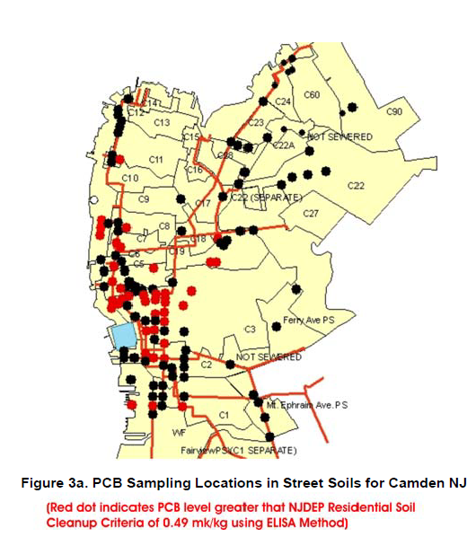

*Source*: Belton et al 2008b.

Figure 1. PCB Street Soil Sampling Locations.

The authors found that ELISA can be a powerful tool for tracking down nonpoint sources of PCBs to MUAs when used in conjunction with a careful desktop review of readily available datasets and with GIS-based data. ELISA proved to be quick, inexpensive, and accurate. Using ELISA, PCB concentrations in street soils near potential sources were identified by source categories (in decreasing order): HazMat sites, junkyards, metal shredders, aluminum smelters, paper and pulping, transportation facilities, gas pipelines, drum cleaning, metal manufacturing, general manufacturing, waste management, electrical transmission, aggregate processing (concrete), landfills, and background sites (cemeteries and city parks).

## Success Story 2: PCB Trackdown in the Storm Sewers of Walker Drain, Ontario, Canada

The purpose of this study was to identify the sources of high PCB concentrations in Walker Drain, a sewer drain in the Pottersburg Creek area, which is part of a subwatershed draining to Lake Erie in Ontario, Canada (Abernethy 2010). Water and sediment grab samples were collected over three days at 32 locations along Walker Drain and in its storm sewers. The sample results were used to help identify controllable PCB sources in the sewershed that can be targeted to reduce PCB inputs to the drain.

The sampling focused on locations with historical PCB contamination. Congener-specific PCB and total PCB analyses were conducted on water (82 congeners) and sediment (50 congeners) samples using gas chromatography-high resolution mass spectrometry (Abernethy, Ontario Ministry of the Environment, personal communication 2016), which can measure low levels of PCBs. The concentrations of the PCB congeners with the same degree of chlorination in each sample were combined into a homolog group. Homolog patterns were determined for each sample by determining the proportion of each homolog group as a percentage. The percentages of each homolog group in a sample were then graphed to identify any patterns and the patterns were compared to each other and to those of five known PCB Aroclors historically present in Pottersburg Creek sediment. By comparing the homolog patterns in water and sediment samples to known Aroclor patterns, PCB sources were identified by linking PCBs back to historically known industrial sites containing those Aroclors.

For example, one sample contained the most highly-chlorinated PCB congeners, which are found only in Aroclor 1260 (Figure 2), a major component of a PCB product known to be used by Westinghouse Canada Inc. that had formerly occupied an industrial site in the sewershed. Therefore, Westinghouse Canada was determined to be the source of PCBs to that location.

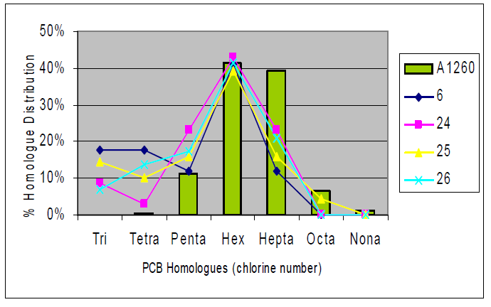

*Source*: Abernethy 2010.

Figure 2. Homologue Patterns of Sediment Compared to Aroclor 1260.

## Success Story 3: Linden Roselle Sewerage Authority, New Jersey

The New Jersey Harbor Dischargers Group (NJHDG) initiated a pilot study at the Linden Roselle Sewerage Authority (LRSA) wastewater treatment plant (WWTP) in 2001 to evaluate the most appropriate approach for tracking PCBs and determine if it is possible to identify and reduce significant PCB sources at LRSA (ASC 2006 and 2012). NJHDG sampled PCBs in LRSA’s main sewer lines and influent waste streams. Accepted methods of sampling (whole water composites and PISCES sampling) and PCB analysis (HRGC/LRMS - modified USEPA Method 1668) were applied. Whole water sampling was preferred over PISCES because of its relative ease, reliability and affordability. PISCES results were semiquantitative and collection of PCBs was considered to be less reproducible than whole water collection. Less costly, more rapid, sampling methods (grab samples of settleable solids and sewer sediment) and analytical methods (immunoassay - ELISA) were also performed for comparison.

The conventional method of whole water sampling coupled with HRGC/LRMS analysis was found to have several advantages over solely using the alternative method of sediment sampling and ELISA. These advantages include familiarity with the procedures, results that can be used to calculate the PCB loading to the treatment plant, and data that are ideal for “fingerprinting” sources based on homolog pattern. Advantages of sediment sampling and ELISA include the ability to rapidly monitor multiple locations, the simplicity of the analysis, and the low analytical cost.

Immunoassay of sewer sediment may be a valid trackdown approach, particularly when it is coupled with HRGC/LRMS analysis of whole water; however, there was concern about including sediment samples in the trackdown study because of uncertainty about whether or not sediments characterize local conditions since they may be transported over relatively long distances in the sewer (ASC 2006). Sediment sampling may be useful if the origin of the sediment is considered. Sediment collection should be limited to relatively small, well-defined service areas. Immunoassay may be used in lieu of HRGC/LRMS for total PCB analysis of sewer sediment and soil. However, immunoassay results should be periodically confirmed with HRGC/LRMS. HRGC/LRMS provides definitive information on the significance of the sample concentrations, as compared to a target threshold, and the PCB type, which is necessary to confirm that the source PCBs are the same as those in the treatment plant influent.

Overall, whole water composite sampling and PCB congener analysis by HRGC/LRMS was determined to be the preferred trackdown method at LRSA. HRGC/LRMS is preferred because it provides sufficient resolution for the total PCB concentrations typically observed in sanitary sewers, is about half the cost of HRGC with high resolution mass spectrometry (HRMS), and provides confirmation of detected congeners. Given concerns about the validity of using sediment for trackdown, the alternative techniques of sediment grab sampling and PCB immunoassay were not practiced in later phases of the LRSA study (ASC 2006 and 2012). For whole water sampling, steps should be taken to either avoid locations where interfering sediment is present or sample in a way that excludes sediment (ASC 2012).

The PCB homolog distributions were reviewed to assist in evaluating PCB sources (Figure 3). Results indicate that the majority of the PCBs in the sewers were sequestered in sediment in the bottom of sewers and soil on manhole benches (Figure 4). It is likely that the PCBs observed in the overlying sewer water were contributed from the sediment and soil. The PCBs in the sewer are weathered and originate from legacy sources. The study focused on isolating the PCB source(s) in the western industrialized area of the sewershed, where sampling showed to be a hot spot of PCBs (ASC 2012). The abundance of PCB homologs in the main western sewer were compared to known Aroclors from legacy industrial sites in the sewershed to identify historical sources including PCB contaminated properties, a major railroad corridor, and an electric utility substation.

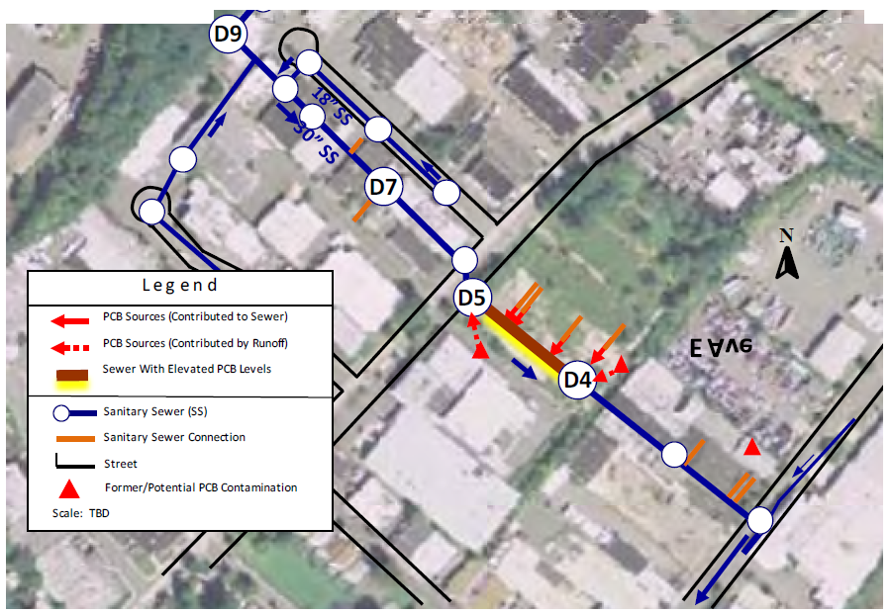

*Source*: ASC 2012.

Figure 3. Example of PCB Sources and Pathways.

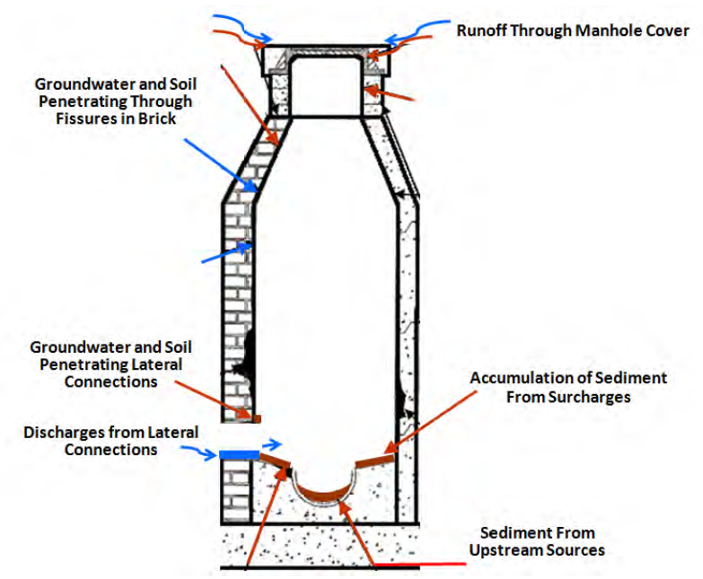

*Source*: ASC 2012.

Figure 4. Generalized Pathways of PCB Release to Sanitary Sewers.

## Success Story 4: PCB Trackdown in the Great Lakes, Ontario, Canada

*Project Trackdown* is an investigative environmental program aimed at tracking sources of PCB contamination in Great Lakes tributaries in Ontario, Canada (Benoit et al. 2013 and 2016). Project Trackdown has been carried out in three tributaries to Lake Ontario (Cataraqui River, Etobicoke Creek and Twelve Mile Creek) and two tributaries that flow into the Detroit River (Turkey Creek and Little River). The program has been successful at developing environmental triggers to differentiate potential source areas from background PCB conditions in urban areas, allowing efforts to focus on identifying active ongoing sources of PCB contamination. Project Trackdown uses a multimedia weight of evidence approach for identifying sources of PCBs to the environment. PCB concentrations in environmental media (sediment, water, suspended sediment and soil), passive samplers and/or exposed biota (mussels, young-of-the-year fish and benthic invertebrates) are used in combination to evaluate bioavailability and identify local anomalies within a tributary. These lines of evidence can be assessed with simple chemometric techniques and fingerprinting of PCB congener profiles, and, combined with anecdotal information such as land use history and tributary alterations, may be used to identify ongoing and locally controllable sources of PCBs to the Great Lakes.

Original guidance for Project Trackdown recommended a tiered approach to source tracking that used only one or two media at a time, resulting in studies that took years to complete. The tiered approach may allow for a more cost effective program, but experience in pilot watersheds showed that using multiple lines of evidence concurrently in the same areas within the same sampling season resulted in more expedient source determination. Having the same suite of sampling media at all sites allows for more efficient site prioritization by narrowing the search by eliminating sites as well as flagging anomalies.

The first steps of a complete trackdown study should consist of: 1) project planning, where appropriate tools are selected to maximize the likelihood of identifying source(s) using various lines of evidence and 2) scientific investigations focused on continually narrowing the geographical scope of the investigation by discounting non-source areas from potential source areas. These steps will lead to potential remediation of the contamination by engaging any existing responsible parties towards abatement and/or remediation actions and subsequent monitoring for improvements.

Source identification sampling media may include sediment and event-based water sampling, biota collections (fish, invertebrates), deployment and analysis of caged biota (mussels) and integrated passive samplers, and in some cases soil sampling (e.g., creek bank soils). Sediment sampling is a relatively easy and low-cost method for trackdown investigations because it works well as a screening tool in the initial stages of trackdown study. Depositional areas can be targeted in selected areas of the watershed, with the goal of reducing the geographical area of interest. A trackdown study should also consider that biological uptake is critical in source tracking because the need for remediation depends on whether the contamination is bioavailable to the food chain. Areas in which biological uptake is evident should be prioritized over those where contamination does not appear to be evident in organisms.

Contaminants such as PCBs can be difficult to detect in water and require either low-level analyses or large volumes of water. This study sampled during rain events using integrative passive samplers such as semipermeable membrane devices (SPMDs). SPMDs consist of thin-walled polyethylene strips containing a synthetic lipid such as triolein (Figure 5). When deployed in an aquatic environment, PCBs diffuse into SPMDs and accumulate. SPMDs can be used to calculate PCB concentrations in the water and the information is used to compare concentrations and congener patterns between sites. Soil sampling was been conducted in this study when riverbank erosion was identified as a potential pathway of contamination to the waterway.

The PCB data collected by the SPMDs were used to qualitatively compare concentrations and congener patterns between sites. The PCB data were analyzed using a congener-specific PCB analysis method for water that provides low detection limits using high resolution mass spectrometry. Congener-specific data are essential to PCB source tracking, both for finding similarities and showing potentially different sources. A comparison of congener profiles between sites can provide an indication of whether the PCBs originate from a common source. Using congener-specific analysis allows flexibility in interpreting data both from an empirical perspective, and for statistical and visual “fingerprinting”. The fingerprinting concept works best when comparing patterns among locations in the same medium because it avoids the issue of biotransformation and differential partitioning from water into sediment.

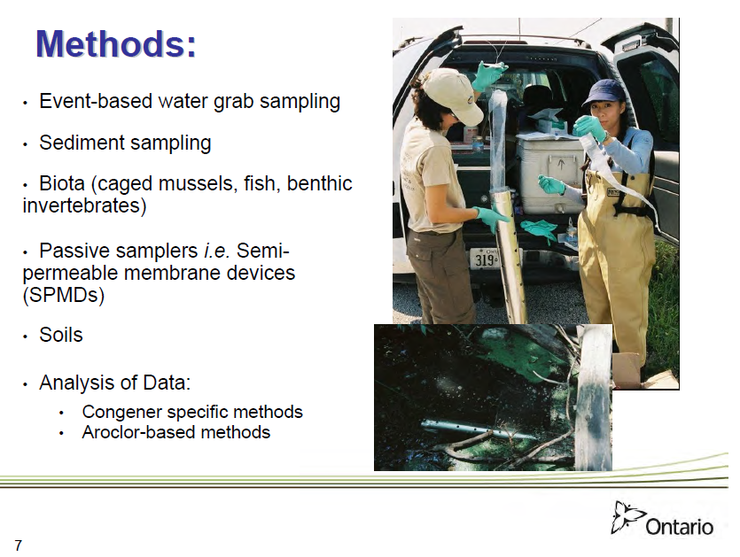

*Source*: Benoit et al. 2013.

Figure 5. Example of Monitoring Methods and SPMDs.

# PCB Trackdown Guidance

Four steps for the development of PCB trackdown studies to support TMDL implementation have been determined using the results of the literature, including the PCB trackdown success stories highlighted in section 3 and the expert interviews in Appendix A (Figure 6).

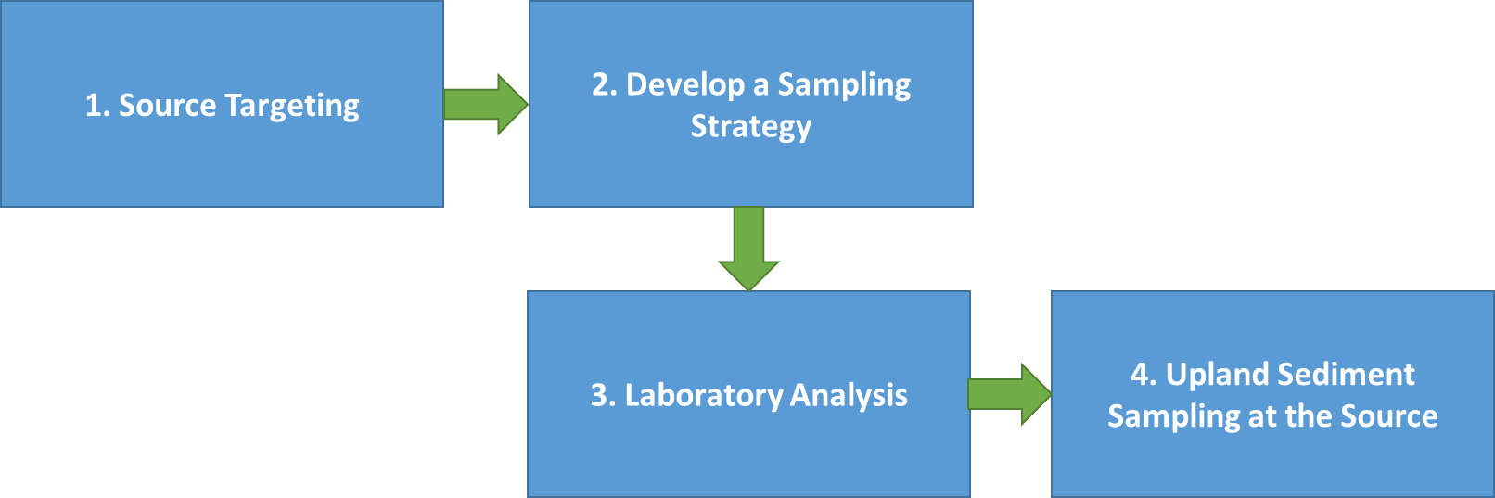

Figure 6. Four steps for the development of a PCB trackdown study.

Once a PCB TMDL has been developed for a watershed and PCB trackdown is part of a TMDL Implementation Plan or a municipality’s PMP, the following steps can be used as a guide to developing a PCB trackdown study within the impaired watershed.

1. **Source Targeting:** Source targeting for a PCB trackdown study can be conducted using a desktop analysis of available data, including GIS data sources. Source tracking efforts should focus on areas that are likely to have PCB soil concentrations greater than background levels. Available data that can be used to target source tracking include:

* Fish/shellfish tissue data (tissue data can be used to identify PCB hotspots)
* Local, state, or independent monitoring data (monitoring data can be used to identify PCB hotspots)
* NPDES permits (with SIC codes that indicate PCBs could be present)
* Regulated industrial facilities (with SIC codes that indicate PCBs could be present)
* Identified contaminated sites (e.g., documented soil contamination, known PCB spills)
* Sites where storage/handling/disposal of PCB containing equipment occurred
* Sites that manufactured PCB containing materials
* Industrial land use areas (GIS-analysis)
* High density urban areas (GIS-analysis)
* Stormwater ponds (or other sediment-trapping BMPs)

The above information can be used to identify areas where PCB sources have been documented or are likely to exist. These areas can then be used to target water and sediment sampling at particular sites, such as stormwater conveyance systems and waterways where PCBs are most likely to have been carried by stormwater.

1. **Develop a Sampling Strategy:** New data should be collected for a PCB trackdown study because pre-existing data typically represent different vintages of data collected at different points in time using different analytical methods and different laboratories (Arias-Thode et al. 2011). These factors tend to introduce variables that limit the comparability and comprehensive interpretation of the pre-existing data as a whole. The pre-existing data are best used in Step 1 above to identify the best locations for monitoring in Step 2.

The sampling strategy needs to determine how many samples will be collected, what type of sample will be collected (water or sediment), where samples will be collected, and how samples will be collected. This sampling step focuses on collecting PCB data in the impaired waterbody and any pathways to the impaired waterbody such as tributaries, stormwater systems, and WWTPs to identify PCB “hot spots”. Upland sampling at individual potential sources is discussed in Step 4. Site-specific knowledge gained from the desktop study in Step 1 should be used to locate sampling sites in the vicinity of known or suspected contaminant sources. Another possible method of sampling would be to take water column samples and/or sediment samples from the stormwater conveyance systems in the watershed as well as in the waterbody itself. This could provide a means of source tracking, if certain systems came back “hot” for PCBs. Stormwater samples (at outfalls) should be collected during a significant storm event. A multiple lines of evidence approach can also be taken where water, sediment, and biota are sampled, but if cost is an issue, sampling should focus on water sampling once sediment and biota data indicate a potential problem (Abernethy, Ontario Ministry of the Environment, personal communication April 27, 2016).

Water samples can be collected using passive samplers, whole water samples, or grab samples. The most common type of sampler used in the reviewed literature were passive samplers because they provide time-integrated sampling over several days. The most commonly used sampler was PISCES, but researchers may want to explore other options such as SPMDs and POCIS (Polar Organic Chemical Integrative Sampler) (Benoit et al. 2016; Litten, retired from NYSDEC, personal communication April 27, 2016; and Colman, USGS, personal communication April 27, 2016). PISCES uses a hexane membrane that can be a hassle when shipping to the lab because it contains a flammable liquid. The membrane inside the SPMD is made of a non-volatile lipid and POCIS has a polyethersulfate membrane encasing a solid phase sorbent. Both of these samplers are commonly used by USGS (Alvarez 2010). In addition, sediment sampling using ELISA (Enzyme-linked Immunosorbent Assay) methods can be a useful tool (see Section 2.2.4). ELISA is quick, inexpensive and accurate (Belton et al. 2008a).

1. **Laboratory Analysis:** Once data have been collected, the data need to be analyzed for PCBs. USEPA Method 1668 should be applied for analysis of PCBs in the collected samples. Method 1668 provides PCB congener data at low detection limits. PCB congener data allows for more specific comparison of PCBs between sites, resulting in greater confidence in source identification. Method 1668 was developed by the USEPA’s Office of Water’s Office of Science and Technology to determine chlorinated biphenyl congeners in environmental samples by isotope dilution and internal standard HRGC/HRMS. This method is applicable to aqueous, solid, tissue, and multi-phase matrices (USEPA 2010).
2. **Upland Sediment Sampling at the Source:** Once water or sediment sampling in the impaired waterbody, stormwater system, or WWTP has been completed and PCB “hot spots” have been identified, then additional upland sediment sampling should be employed at the potential PCB sources identified in Step 1 (Source Targeting) located near the hot spots (e.g., in street soils in front of suspected facilities). This will help to backtrack to the original source by matching PCB types located in hotspots in the watershed to PCB types found in the sediment at the potential upland sources.

# Conclusions

Although PCB trackdown is a fairly recent effort (in the last 15 to 20 years), there is literature available on various methodologies and case studies. Much of the literature was in agreement that water and sediment are the best matrices to sample for PCB trackdown studies. Passive water samplers such as PISCES and SPMDs were most commonly used for water column sampling although other methods may be used (e.g., whole water and grab samples). USEPA Method 1668 was the most common methodology for analyzing PCB congeners and is the recommended analysis method in almost all of the reviewed studies. Consensus was that method 1668 is expensive, but the results of low detection limits and PCB congeners as opposed to total Aroclors are worth the cost. Most studies stopped at identifying PCB hotspots in the watershed and identifying potential upland sources based on best professional judgement. Very few studies went beyond citing historic sediment contamination as the PCB source. Belton et al (2008a) is one of the few studies that identified specific upland PCB sources by including ELISA to sample sediment at potential sources and confirm that the PCBs at that sites matched the PCBs identified in the tributaries and point source outfalls discharging to the impaired waterbody. This is an important step in the trackdown methodology that has been included in this guidance (Figure 7).

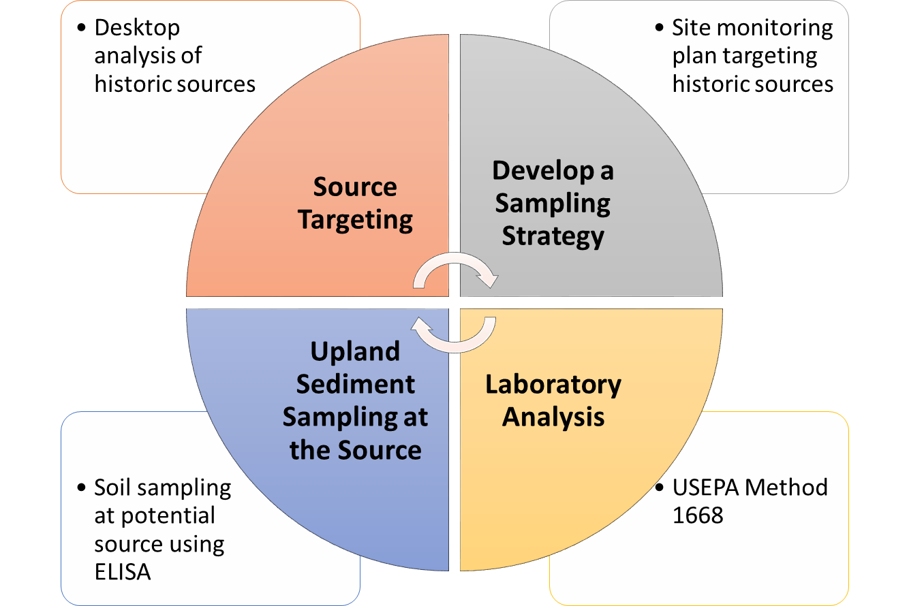

Figure 7. PCB trackdown methodology.

# References

Abernethy, S. 2010. *A PCB Trackdown in the Storm Sewers of Walker Drain*. Ontario Ministry of the Environment. Ontario, Canada.

Alvarez, D.A. 2010. *Guidelines for the use of the semipermeable membrane device (SPMD) and the polar organic chemical integrative sampler (POCIS) in environmental monitoring studies*. U.S. Geological Survey, Techniques and Methods 1–D4, 28 p.

ASC (Aquatic Sciences Consulting). 2006. *Tier 2 Report/Tier 3 Plan for the Phase IV Trackdown of Polychlorinated Biphenyls (PCBs) at the Linden Roselle Sewerage Authority*. Prepared for New Jersey Harbor Dischargers Group, by Aquatic Sciences Consulting, Woodbine, MD.

ASC (Aquatic Sciences Consulting). 2012. *Executive Summary Report: Phase V Trackdown of Polychlorinated Biphenyls at the Linden Roselle Sewerage Authority*. Prepared for New Jersey Harbor Dischargers Group, by Aquatic Sciences Consulting, Reston, VA.

Arias-Thode, M., S. Curtis, R. George, H. Halkola, J. Leather, I. Rivera-Duarte, and D. Cotnoir. 2011. *Pollutant Source Tracking (PST) Technical Guidance. Technical Document 3251*. Space and Naval Warfare Systems Center Pacific and Naval Facilities Engineering Command. San Diego, CA.

Battelle (Battelle Memorial Institute). 2012. *A Handbook for Determining the Sources of PCB Contamination in Sediments*. Technical Report TR-NAVFAC EXWC-EV-1302. Arlington, VA.

Belton, T., J. Botts, L. Lippincott, and E. Stevenson. 2007. An Industrial Ecology Approach to PCB Source Trackdown in Camden City, New Jersey. In Optimizing Contaminant Trackdown Focusing on Wastewater Treatment Plants and Related Systems: A Compendium for Practitioners of Contaminant Trackdown Efforts. New York Academy of Sciences.

Belton, T., J. Botts, L. Lippincott, and E. Stevenson. 2008a. Trackdown of Polychlorinated Biphenyls (PCBs). In a *Municipal Sewer System: Pilot Study at the Camden County Municipal Utility Authority (CCMUA)*. Division of Science, Research and Technology Research Project Summary. New Jersey Department of Environmental Protection. Trenton, NJ.

Belton, T., J. Botts, L. Lippincott, and E. Stevenson. 2008b. *PCB TMDLs, Pollution Minimization Plans and Source Trackdown in Camden City*. Division of Science, Research and Technology Research Project Summary. New Jersey Department of Environmental Protection. Trenton, NJ.

Benoit, N. D. Burniston, and A. Dove. 2013. *Approaches to Identifying, Tracking, and Addressing Sources of PCB Contamination in the Great Lakes*. Ontario, Canada.

Benoit N., A. Dove, D. Burniston, and D. Boyd. 2016. Tracking PCB Contamination in Ontario Great Lakes Tributaries: Development of Methodologies and Lessons Learned for Watershed Based Investigations. *Journal of Environmental Protection*. 7:390–409.

Botts J.A., J. Spadone, B. McKennac, A. Kricund, T. Beltone, R. Hindt and D. Dutton. 2007. PCB Minimization Plans and Source Trackdown. In *Optimizing Contaminant Trackdown Focusing on Wastewater Treatment Plants and Related Systems: A Compendium for Practitioners of Contaminant Trackdown Efforts*. New York Academy of Sciences.

Breault, R.F., M.G Cooke, and M. Merrill. 2004. *Sediment Quality and Polychlorinated Biphenyls in the Lower Neponset River, Massachusetts, and Implications for Urban River Restoration*. U.S. Geological Survey Scientific Investigations Report 2004-5109, 48 p.

Colman, J.A. 2001. *Source Identification and Fish Exposure for Polychlorinated Biphenyls Using Congener Analysis from Passive Water Samplers in the Millers River Basin, Massachusetts*. Water-Resources Investigations Report 00-4250. Northborough, MA.

DelDOT (Delaware Department of Transportation) and NCC (New Castle County). 2014. *Storm Water Pollution Prevention and Management Program* Final Draft NPDES Permit Number DE 0051071 State Permit Number WPCC 3063a / 96. Dover, DE.

DRBC (Delaware River Basin Commission).1998. *Study of the Loadings of Polychlorinated Biphenyls from Tributaries and Point Sources Discharging to the Tidal Delaware River. Delaware River Basin Commission*. West Trenton, NJ. June 1998.

Gosier, C.J. and E.A. Paul. 2014. *Richardson Hill Road Landfill: 2012 Contaminant Trackdown Study Field Investigation Report*. Albany, NY.

Litten, S. 1996. *Trackdown of Chemical Contaminants to the Niagara River from Buffalo, Tonawanda, and North Tonawanda*. New York State Department of Environmental Conservation. Albany, NY.

Litten, S. 2003. *Contaminant Assessment and Reduction Project Water (CARP)*. New York State Department of Environmental Conservation. Albany, NY.

Litten, S. 2007. Contaminant Trackdown in Urban Settings. In *Optimizing Contaminant Trackdown Focusing on Wastewater Treatment Plants and Related Systems: A Compendium for Practitioners of Contaminant Trackdown Efforts*. New York Academy of Sciences.

Litten, S., B. Fowler, and D. Luszniak. 2002. Identification of a novel PCB source through analysis of 209 PCB congeners by USEPA modified method 1668. *Chemosphere* 46(1457–1459).

MDE (Maryland Department of the Environment). 2014. *MS4 PCB TMDL Implementation Guidance Options for Developing Montgomery County’s Implementation Strategy*. PowerPoint presentation.

MDE (Maryland Deparment of the Environment). n.d. *MDE Recommendations for Addressing the PCB SW-WLA*. Maryland Department of the Environment. Baltimore, MD.

Muñoz, G. 2007. Processes that Inadvertently Produce PCBs. In *Optimizing Contaminant Trackdown Focusing on Wastewater Treatment Plants and Related Systems: A Compendium for Practitioners of Contaminant Trackdown Efforts*. New York Academy of Sciences.

NAVFAC (Naval Facilities Engineering Service Center). 2001. *Rapid Sediment Characterization of PCBs with ELISA an Immunoassay Technique A Rapid Sediment Characterization (RSC) Tool*. Tech Data Sheet. TDS-2086-ENV. Port Hueneme, CA.

NCDPH (North Carolina Division of Public Health). 2010. *Source Tracking of PCBs in Badin Lake to the Alcoa/Badin Facility PCB Releases*.

NYSDEC (New York State Department of Environmental Conservation). 2001. *City of Lockport Sewer System PCB Trackdown Project 1998–2000 Draft Summary Report*.

Preddice, T.L. and E. Trometer. 2007. *Tracking Sources of Contaminants in Cayuga Creek on the Niagara Falls Air Reserve Station, Niagara Falls, New York*. Prepared for U.S. Air Force. Falls, NY.

Schmoyer, B. 2007. Source tracing in the Lower Duwamish Waterway, Seattle, WA. In *Optimizing Contaminant Trackdown Focusing on Wastewater Treatment Plants and Related Systems: A Compendium for Practitioners of Contaminant Trackdown Efforts*. New York Academy of Sciences.

Spodaryk, J.G., T.L. Preddice, L.C. Skinner, R.J. Sloan and H. C. Rowell. 2005. *Upper Hudson River PCB Trackdown Using PISCES*. New York State Department of Environmental Conservation. Albany, NY.USEPA (United States Environmental Protection Agency). 2010. *Method 1668C Chlorinated Biphenyl Congeners in Water, Soil, Sediment, and Tissue by HRGC/HRMS*. United States Office of Water, EPA No. EPA-820-R-10-005. Washington, DC.

USEPA (United States Environmental Protection Agency). 2011. *PCB TMDL Handbook*. U.S. Environmental Protection Agency Office of Wetlands, Oceans and Watersheds. Washington, DC.

VDEQ (Virginia Department of Environmental Quality). 2009. *Virginia Guidance: Guidance for Monitoring Point Sources for TMDL Development Using Low-Level PCB Method 1668*. Richmond, VA.

# Appendix A

Interview Questions and Answers

## Interview 1: Simon Litten

**Retired for 6 years from New York State Department of Environmental Conservation**

***Papers Reviewed:***

* *Identification of a novel PCB source through analysis of 209 PCB congeners by US EPA modified method 1668 (2002)*
* *Trackdown of Chemical Contaminants to the Niagara River from Buffalo, Tonawanda and North Tonawanda (1996)*
* *Litten, S. 2003. Contaminant Assessment and Reduction Project Water (CARP). New York State Department of Environmental Conservation. Albany, NY.*

Simon Litten responded to questions by email on April 27, 2016

1. Is PISCES sampling always preferred over grab sampling?

The advantages of PISCES are temporal integration and the achievement of lower detection limits. In many environments there is enormous temporal variability so that a sample from a point in time may be highly unrepresentative. The resulting sample is much smaller and lighter than a L of water. However, it comes with serious disadvantages. The sample is hexane which, as a flammable liquid, is harder to ship. PISCES quantitation is much less straightforward and may not be accepted in enforcement cases. PISCES sampling requires separate trips to place and recover the units. There is the risk of losing the units and getting no sample. Operation of PISCES requires lab support where hexane can be stored, units cleaned, and polyethylene membranes soxhleted and replaced. I was extremely fortunate to have had a super-competent technician working for me.

You may want to investigate the work that Rainer Lohmann at the University of Rhode Island is doing with polyethylene as a passive sampler. He feels he can measure PCBs and even dioxins with PE. I have had only limited experience with PE. PE experiences biofouling (PISCES does not) and it is also subject to loss in the some turbulent environments like storm sewers. It can be easily shipped.

1. Is Method 1668 always preferred for sample analysis or might there be instances where a less sensitive yet less expensive laboratory method that looks for fewer congeners will suffice?

1668A is the gold standard. We found unexpected PCB congeners (3,3'-dichlorobiphenyl) that are very abundant in some environments and they would have been entirely missed by Aroclor analysis. 1668A is also highly valuable if you need clear homolog patterns. There are cheaper electron capture methods such as Green Bay that General Electric used in the upper Hudson remediation. It gives peaks that may cross homolog lines. I think an element of the choice between methods should be the level of effort put into taking the sample. If you are blanketing an area or making frequent grabs, cheaper analysis might be preferable but if the samples are from very large volumes of water (field concentration to achieve very low detection limits) or highly integrative, the value of the sample itself is greater and a pricier analysis might be preferable.

1. The Niagara River study results indicated that further sampling was to be undertaken at many of the sites. Did further investigations identify a controllable source where remediation was later undertaken?

Its been years since I've had anything to do with the Niagara. I understand that USEPA and USGS are still struggling with the questions of cross-channel heterogeneity - my original used of PISCES.

1. The CARP study’s conclusions suggest that significant unidentified PCB sources might exist. Was further source trackdown done to identify such sources since this paper was written in 2003?

I have been retired for 6 years so I don't know much about what further work has been done in the harbor area after CARP. However, there is a very good chance that CARP will restart and, if necessary, reexamine some of the areas that appeared to be on-going contaminant sources.

1. Additional thoughts:

Are you interested in the co-planar PCB congeners? If so, go with 1668A.  1668A will give you finer resolution for track down.

I would strongly favor temporal integration in situations like industrial effluents, storm or sanitary sewers, and in small flashy streams. Also in tidal situations.

## Interview 2: John Colman

**USGS Northborough District Office in Massachusetts**

***Paper Reviewed:***

* *Source Identification and Fish Exposure for Polychlorinated Biphenyls Using Congener Analysis from Passive Water Samplers in the Millers River Basin, Massachusetts (2001)*

John Colman responded to questions by email and phone on April 27, 2016.

Questions (note that John Colman did not directly answer the questions in order):

1. For a PCB source trackdown study for TMDL implementation, where assessing fish exposure isn’t a goal, would you recommend PISCES sampling or grab samples?
2. In the study, it was noted that sampler absorption rate was higher during the summer than fall, due to high flow dilution and low water temperature in the fall. If using PISCES sampling for a TMDL implementation trackdown study, would you recommend summer sampling? Would seasonality be a factor if using grab sampling?
3. Would rain events affect the sampling plan? Is it preferable to incorporate rain event and dry weather samples in the plan?
4. Do you know of any other good examples of site-specific PCB trackdown or source tracking studies other than this one?
5. Can you recommend any other papers, authors, or new methodologies (other than EPA Method 1668a) since 2001 that we should be looking into?

There have been more PISCES studies, one from his office:

Breault, R.F., Cooke, M.G. and Merrill, M., 2004. *Sediment quality and polychlorinated biphenyls in the Lower Neponset River, Massachusetts, and implications for urban river restoration*. US Department of the Interior, US Geological Survey.

John Hassett at Syracuse University invented PISCES and might be a good resource for you.

The thing about TMDLs though is load in needed. PISCES give you concentration not load. I actually determined load of PISCES in the Millers River MA using flow proportional sampling. That work is written up, including pictures of the samping equipment in:

Taggart, B.E., Colman, J.A., Cooke, M.G., 2003, Tracking polychlorinated biphenyls in the Millers River Basin, Massachusetts: U.S. Geological Survey Fact sheet FS 093-03, 6 p. <http://pubs.usgs.gov/fs/fs09303/>

For the load sampling, we collected large-volume samples over a long period of time--couple of weeks--sampling proportional to flow so that we could get loads by multiplying concentration by stream flow. So we just had one sample to analyze for the whole period of collection time. We concentrated the sample on a solid phase column and sent that in for analysis.

Notes from 4/27/2016 call:

In the Miller River study, PCBs were traced upstream until they didn’t appear anymore. This way the researchers knew that PCBs were appearing between particular monitoring locations. The Miller River study identified PCB concentrations that led back to a paper mill as the original PCB source. This was confirmed by soil sampling at the paper mill site. The method of soil sample is unknown. PISCES is a good water sampling approach because you can samples over 1 to 2 weeks; however, PISCES sampling doesn’t tell you how PCBs vary with flow. PCBs are collected on hexane membrane in a composite sample that is submitted to the lab for analysis. If you need to determine PCB loads, you would need to do composite sampling. Grab samples can be useful because they’re easier to employ, but they are a big hassle because you need such a large water sample. You would need multiple large samples as opposed to the PISCES samples that were sampled over multiple weeks with a much smaller sample volume. They can be shipped to the lab in one container vs multiple containers for grab samples. PISCES sampling also works better in warmer temperatures. The hexane membrane is harder and less porous in cold temperatures, which makes it more difficult for the PCBs to adhere to the membrane. Researcher must be aware that the characteristics of the PISCES hexane membrane change with flow and temperature. One major negative aspect of PISCES is shipping the hexane to a lab for PCB analysis. Hexane is highly flammable, so it is an issue. Another other option is POCIS, which is commonly used by USGS (Alvarez, 2010). POCIS has a fatty membrane rather than hexane. It is a similar method, but less dangerous to ship for analysis.

It is useful to use PISCES to fingerprint the PCBs and identify source, but use grab samples if you need to determine a PCB load. Another benefit of PISCES is that the lab does not need to do a lot of work on the sample because the PCB sample is provided in one container. With grab samples, there are multiple containers and the lab often needs to prepare the sample by removing sediment and other materials from the water sample.

## Interview 3: Scott Abernethy

**Ontario Ministry of the Environment**

***Paper Reviewed:***

* *A PCB Trackdown in the Storm Sewers of Walker Drain (2010)*

Scott Abernethy responded to questions by email on April 27, 2016.

1. Do you recommend always taking both water and sediment samples in a sewer trackdown study of this nature? Due to budgetary constraints, would exclusively using water samples suffice?

In retrospect I would have taken just water samples because our analytical method can detect ultra-trace concentrations (pg/L) and water flow was always present at each sampling site.  Sediment was not present at each site and it tended to be coarse sand.  Without prior knowledge one would logically focus on sediment and not water because PCB compounds are hydrophobic but in my case water samples were better for source tracking.

1. What testing method was used for sample analysis? Is there a list of the specific congeners for which the samples were analyzed?

METHOD TITLE: THE DETERMINATION OF POLYCHLORINATED BIPHENYL(PCBs)

CONGENERS IN AQUEOUS SAMPLES BY GAS CHROMATOGRAPHY-HIGH

RESOLUTION MASS SPECTROMETRY (GC-HRMS)

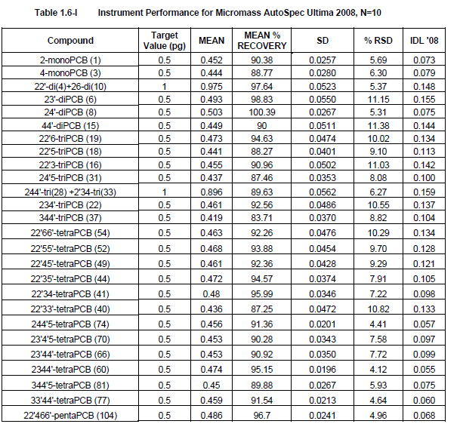

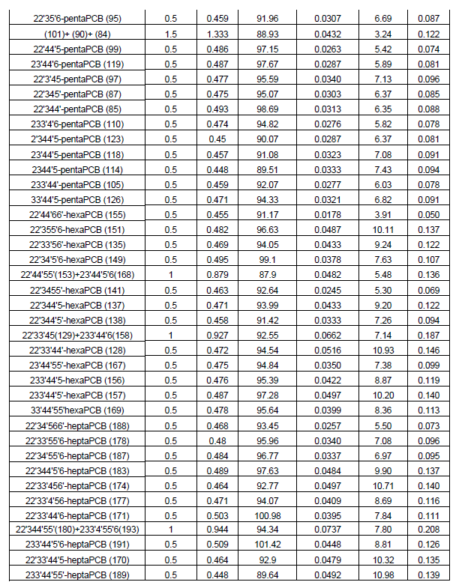

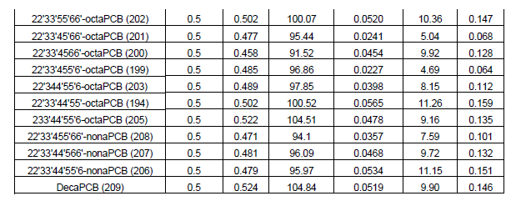

1. The study indicates that the creek sampling that showed levels of PCBs were highest in Walker Drain consisted of sediment, clam, fish, and water sampling. Are all four of these sample types always recommended? If not, which are the most useful and which could be eliminated?

It depends on the purpose of the monitoring.  Clams and fish demonstrate PCB bioavailability. Sediment is the environmental “sink” in an aquatic system.  Exceedence of guidelines for protection of aquatic life and fish-eating wildlife flag the potential for an impairment of the natural environment and may trigger a site-specific risk assessment and/or source tracking.  Ultra-trace detections of PCB in water were best for source tracking once the sediment, clams and fish data demonstrated a potential problem.

1. Do you know of any other good examples of site-specific PCB trackdown or source tracking studies other than this one or the Camden, NJ study (Belton et al. 2008, *Trackdown of Polychlorinated Biphenyls (PCBs) In a Municipal Sewer System: Pilot Study at the Camden County Municipal Utility Authority (CCMUA))*, with the goal of identifying a controllable source to reduce PCB inputs?

I attached a report, not sure if it is relevant. *(Note from Tt: The attached report was NYSDEC 2001, which we already included in the literature review.)*

1. Can you recommend any other papers, authors, or new methodologies since 2010 that we should be looking into?

No, once my project was over I stopped doing any further research in this regard.

## Interview 4: Nadine Benoit

**Surface Water Specialist, Great Lakes Monitoring Unit, Water Monitoring and Reporting Section, Environmental Monitoring and Reporting Branch, Ontario Ministry of the Environment and Climate Change**

***Paper Reviewed:***

*Tracking PCB Contamination in Ontario Great Lakes Tributaries: Development of Methodologies and Lessons Learned for Watershed Based Investigations (2016)*

Nadine Benoit responded to the interview questions by email on April 27, 2016.

Thank you for your inquiry.  I’ll endeavour to respond to your questions below, however, I’d like to caveat that by saying we in Ontario do not deal with TMDLs, but rather look to reduce or remove sources of contamination and can only speak to that goal (as in the paper JEP paper you have). The TMDL concept is one that comes from Trackdown studies in several states including work from Simon Litten (Black River NY), Thomas Belton and others. The N.Y. State Black River Project in Camden city was preceded by the Litten study in the mid 1990s <http://digitalcommons.brockport.edu/cgi/viewcontent.cgi?article=1065&context=tech_rep>  that might prove useful for you.

I’m sending you a list of useful references that I have come across over time for similar projects on the U.S. Side, some of which address the TMDL requirements. I’ve also cc’d my co-authors in case they have any other resources to share.

1. Should seasonal flow and temperature fluctuations be considered when selecting a timeframe for sampling?

That depends on what your goal is. If finding and tracking down sources to bracket a contamination area for removal, then you want to be able to get flow (for example, passive samplers will pick up more PCBs during high flow periods). Also, if you are using passive samplers such as SPMDs for your source tracking, then you want to be able to keep things as standard as possible across sites, so less temperature variation between sites. The SPMD/PE literature out there is vast and informative. In particular, the USGS has good guidance on using passive samplers.

1. Has Project Trackdown’s methodology been used by any entity outside of Ontario to identify PCB sources?

Similar concepts have been used – in fact we developed our trackdown methods based on what the NYDEC accomplished. Simon Litten’s work would show some of that. I’m not sure that other jurisdictions have done the same thing we have, but the important thing is to make sure you have established goals for what you want to do. A TMDL approach would require you to know about flows to attribute loads, so you would have to tailor your approach. The goal of our work was primarily to “find” PCBs to the point where we could engage responsible parties.

1. Do you know of any other good examples of site-specific PCB trackdown or source tracking studies with the goal of supporting source reduction/elimination or TMDL implementation?

See some of the resources I’ve attached. *Tt: See below*

1. Can you recommend any other recent papers, authors, or methodologies that we should be looking into?

See some of the resources I’ve attached. Tt: Any of the papers that were provided by Nadine Benoit and not reviewed as part of this literature review and guidance document are listed below as potential additional resources.

Additional Resources:

Brown, M. P., Werner, M. B., Sloan, R. J., and Simpson, K. W. 1985. Polychlorinated biphenyls in the Hudson River: Recent trends in the distribution of PCBs in water, sediment, and fish. Environ. Sci. Technol. 19:656-661.

Butcher, J. B., Garvey, E. A., and Bierman, V. J. 1998. Equilibrium partitioning of PCB congeners in the water column: Field measurements from the Hudson River. Chemosphere 36:3149-3166.

Du, S., T. Belton, and L. Rodenburg. 2008. Source Apportionment of Polychlorinated Biphenyls In the Tidal Delaware River. Environ. Sci. Technol. 42, 4044–4051.

Johnson, G. W., Jarman, W. M., Bacon, C. E., Davis, J. A., Ehrlich, R., and Risebrough, R. W. 2000. Resolving Polychlorinated Biphenyl Source Fingerprints in Suspended Particulate Matter of San Francisco Bay. Environ. Sci. Technol. 34:552-559.

King, R. S., Beaman, J. R., Whigham, D. F., Hines, A. H., Baker, M. E., and Weller, D. E. 2005. Watershed Land Use is Strongly Linked to PCBs in White Perch in Chesapeake Bay Subestuaries. Environ. Sci. Technol.

Li, J., Mgonella, M. K., Bzudek, P. A., and Christensen, E. R. 2005. PCB Congeners and Dechlorination in sediments of Upper Sheboygan River, Wisconsin. J. Great Lakes Res. 31:174-186.

Loganthan, B.G., K.N. Irvine, K. Kannan, V. Pragatheeswaran, and K.S. Sajwan. 1997. Distribution of Selected PCB Congeners in the Babcock Street Sewer District: A Multimedia Approach to Identify PCB Sources in Combined Sewer Overflows (CSOs) Discharging to the Buffalo River, New York. Arch. Environ. Contam. Toxicol. 33, 130-140.

Palmer, P. M., Wilson, L. R., Casey, A. C., and Wagner, R. E. 2011. Occurrence of PCBs in raw and finished drinking water at seven public water systems along the Hudson River. Environ Monit Assess. 175:487-499.

Petty, J. D., Jones, S. B., Huckins, J. N., Cranor, W. L., Parris, J. T., McTague, T. B., and Boyle, T. P. 2000. An approach for assessment of water quality using semipermeable membrane devices (SPMDs) and bioindicator tests. Chemosphere 41:311-321.

Petty, J. D., Orazio, C. E., Huckins, J. N., Gale, R. W., Lebo, J. A., Meadows, J. C., Echols, K. R., and Cranor, W. L. 2000. Considerations involved with the use of semipermeable membrane devices for monitoring environmental contaminants. J. Chromatogr. A 879:83-95.

Schneider, A. R., Porter, E. T., and Baker, J. E. 2007. Polychlorinated Biphenyl Release from Resuspended Hudson River Sediment. Environ. Sci. Technol.

USEPA 2004. Active Sources of PCBs contribute to Contamination of Delaware River Fish.

USEPA 1990. Guidance on Remedial Actions for Superfund Sites with PCB Contamination. Washington DC. EPA/540/G-90/007.