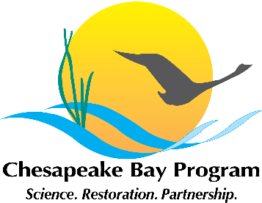
Diversity Themed Stewardship Goal Implementation Team Meeting
May 25th, 2017, 1:00 – 3:00PM
NPS Large Conference Room
410 Severn Avenue, Suite 314
Call-in#: 866-704-1637 Passcode: 269 490#

Purpose: Discuss and evaluate the topics for collaboration that were raised by each of the workgroups in the individual meetings that have been held over the past month. Using these topics, the group will craft an agenda for a full Stewardship GIT meeting comprised of all workgroup members focused to take place tentatively the summer of 2017.

1:00 Welcome / Introductions (Chuck Hunt, GIT Chair)

1:05 Strategy Review System / Management Board Meeting Feedback (John Griffin, All)
John will provide his thoughts and feedback on the process to prepare and execute the SRS meeting presentation to the Management Board on May 11th.
(Upcoming Stewardship Presentations: November - Citizen Stewardship, Public Access and Diversity. February - Environmental Literacy)

1:15 Review Collaborative Opportunities With Diversity Workgroup (All)
Group will highlight overarching diversity themed topics that were raised in discussions among each of the individual meetings.

2:00 Prioritize Collaborative Opportunities (All)
Group will prioritize the discussion topics that were raised and craft an agenda and plan for a broader GIT meeting.

3:00 Adjourn

