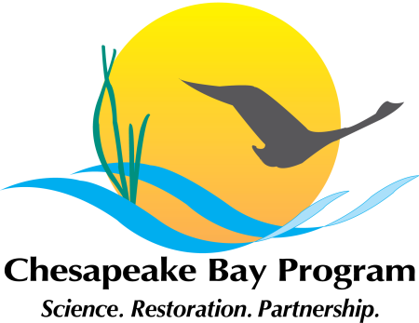
Chesapeake Executive Council
2014 Annual Meeting

AGENDA
9:45-10am Executive Council Members Arrive
10-11:40am Public Meeting – Gov’s Reception Room, State House
Welcome – EC Chair, Governor Martin O’Malley, MD
Future of Bay Restoration – Student Speakers
State of the Bay Program – Nicholas DiPasquale, CBP Director
CBP Advisory Committees’ Presentation of Recommendations
Citizens Advisory Committee (CAC) – John Dawes, Chair
Local Government Advisory Committee (LGAC) – The Hon. Sheila Noll, Chair Scientific, Technical, Advisory Committee (STAC) – Lisa Wainger, Vice Chair
Adjourn

12-1:30pm EC Private Lunch
Guests and visitors are encouraged to visit one of the many nearby restaurants in downtown Annapolis for a variety of lunch options.
1:30-2:30pm Press Conference – Susan B. Campbell Park
Annapolis waterfront (1 Dock Street, Annapolis)

