PRELIMINARY DRAFT
Agricultural and Forest Land Use Loading Rate Literature Review—Summary and Results



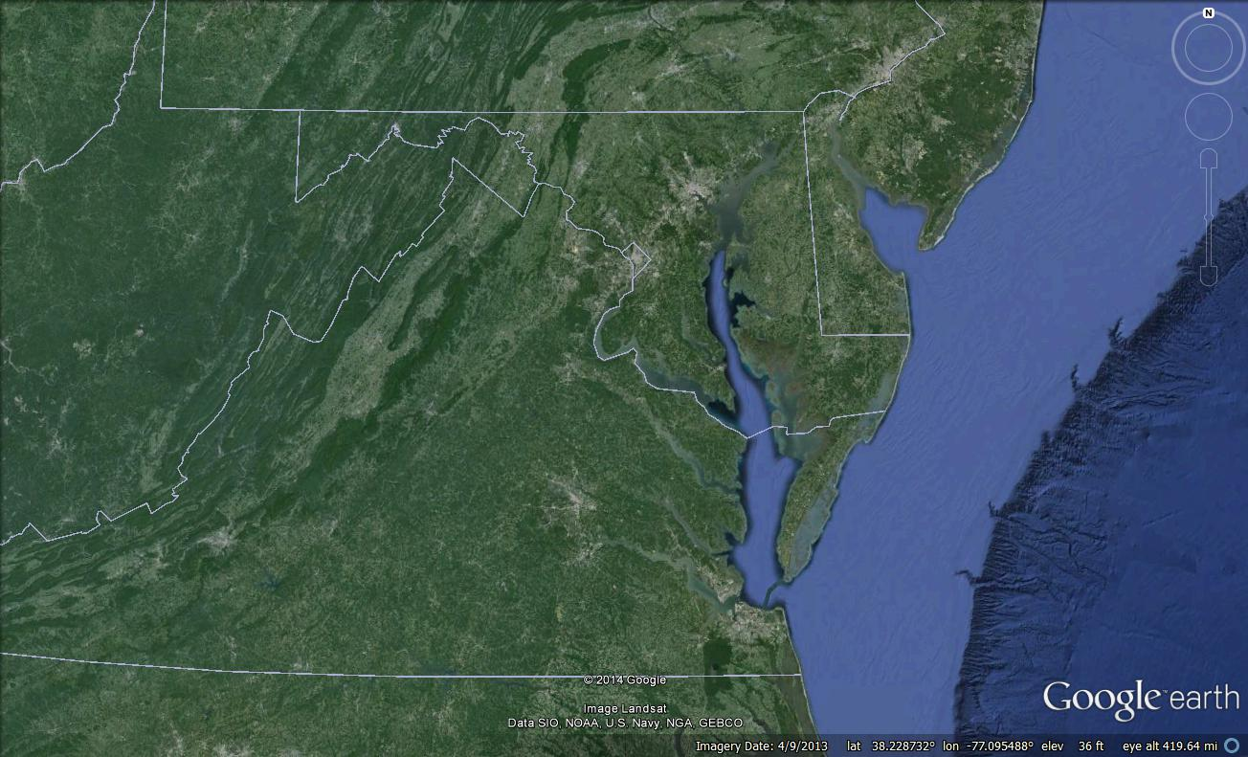
Prepared for:

Chesapeake Bay Program Office
410 Severn Avenue, Suite 109
Annapolis, MD 21403
Phone: 410-267-5770
Prepared by:

Tetra Tech, Inc.
10306 Eaton Place, Suite 340
Fairfax, Virginia 22030-2201
Phone: 703-385-6000
www.tetratech.com

January 13, 2015

Contents
1.0 Project Background and Purpose 1
2.0 Literature Search for Potentially Relevant Studies 5
3.0 Review and Data Entry for Relevant Loading Rate and Concentration Data 7
4.0 Quality Assurance/Quality Control 9
4.1 Agricultural Land Use Data 10
4.2 Forest Land Use Data 11
4.3 TMDL Data 11
5.0 Data Standardization and Processing 12
5.1 Forest Land Use Data 12
5.2 Agricultural Land Use Data 12
6.0 Analysis and Results 14
6.1 Descriptive Statistics 14
6.2 Hypothesis Testing 15
6.3 Forest Land Use Results 16
6.3.1 Descriptive Statistics 16
6.3.2 Box Plots 18
6.3.3 Histograms 19
6.3.4 Hypothesis Testing 19
6.4 Agricultural Land Use Results 20
6.4.1 Descriptive Statistics 20
6.4.2 Box Plots 21
6.4.3 Histograms 21
6.4.4 Hypothesis Testing 22
7.0 Relative Ranking of Unit Area Loading Rates 43
7.1 Scaling Data Geographically 43
7.2 Literature Loading Rates 44
7.3 Building Consensus 44
8.0 Summary and Conclusions 45
8.1 Forest Land Use Results Overview 45
8.2 Agricultural Land Use Results Overview 46
8.3 Potential Future Efforts 47
9.0 References 49
Attachment A: Parameter Standardization 50
Attachment B: Land Use Standardization 52
Attachment C: Data Summaries 59
Attachment C.1: Forestry Data from Literature Review 59
Attachment C.2: Forestry Data from TMDL Review 62
Attachment C.3: Forestry EoF Data from TMDL Review 63
Attachment C.4: Agricultural Data from Literature Review 64
Attachment C.5: Agricultural Data from TMDL Review 68
Attachment C.6: Agricultural EoF Data from TMDL Review 69
Attachment D: Box Plots 70
Attachment D.1: Forestry Loading Rate Box Plots from TMDL and Literature Reviews 70
Attachment D.2: Agricultural Loading Rate Box Plots from Literature Review 88
Attachment D.3: Agricultural Loading Rate Box Plots from TMDL Review 94
Attachment E: Histograms 102
Attachment E.1: Forestry Loading Rate Histograms from Literature Review 102
Attachment E.2: Forestry Loading Rate Histograms from TMDL Reviews 104
Attachment E.3: Agricultural Loading Rate Histograms from Literature Review 108
Attachment E.4: Agricultural Loading Rate Histograms from TMDL Review 123

Figures
Figure 1. Example box plot for TSS from TMDL review for all agricultural land uses. 15
Figure 2. Box plot of reported TP surface runoff loading rates by agricultural land use group. 27
Figure 3. Box plot of reported TN surface runoff loading rates by agricultural land use group. 27
Figure 4. Box plot of reported NO₃ shallow groundwater loading rates by agricultural land use group. 27
Figure 5. Box plot of reported NO₃ surface runoff loading rates by agricultural land use group. 28
Figure 6. Box plot of reported NO₃ tile drain/ditch loading rates by agricultural land use group. 28
Figure 7. Box plot of reported TSS surface runoff loading rates by agricultural land use group. 28
Figure 8. Box plot of reported total sediment surface runoff loading rates by agricultural land use group. 29
Figure 9. Box plot of TP surface runoff agriculture loads from reports published 1995-present vs. reports published pre-1995. 33
Figure 10. Box plot of NO₃ loads in tile drain/ditch flow from corn, grain–fall fallow from reports published 1995-present vs. reports published pre-1995. 33
Figure 11. Box plot of TP loading rates in surface runoff, runoff from nonmanured vs. manured land, all land use groups combined. 40
Figure 12. Box plots of TN loading in surface runoff from nonmanured vs. manured corn, grain – fall fallow land use group. 40
Figure 13. TP box plots from literature for all forest land uses (disturbed and undisturbed). 71
Figure 14. NO₃ box plots from literature for all forest land uses (disturbed and undisturbed) 72
Figure 15. TP box plots from literature for all forest land uses (disturbed and undisturbed) pre- and post-1990 and in and out of the CBW. 73
Figure 16. TN box plots from literature for all forest land uses (disturbed and undisturbed) pre- and post-1990 and in and out of the CBW. 74
Figure 17. TP box plots from literature for undisturbed forest land uses pre- and post-1990 and in and out of the CBW. 75
Figure 18. TN box plots from literature for undisturbed forest land uses pre- and post-1990 and in and out of the CBW. 76
Figure 19. NO₃ box plots from literature for disturbed forest land uses pre- and post-1990 and out of the Chesapeake Bay watershed. 77
Figure 20. TP box plots from literature for undisturbed forest land uses (EoF) pre- and post-1990 and in and out of the Chesapeake Bay watershed. 78
Figure 21. TN box plots from literature for undisturbed forest land uses (EoF) pre- and post-1990 and in and out of the CBW. 79
Figure 22. TP box plots from TMDL review for all forest land uses. 80
Figure 23. TN box plots from TMDL review for all forest land uses. 81
Figure 24. TSS box plots from TMDL review for all forest land uses. 82
Figure 25. TP box plots from TMDL review for barren and extractive land uses. 83
Figure 26. TSS box plots from TMDL review for barren and extractive land uses. 84
Figure 27. TP box plots from TMDL review for all forest land uses (EoF). 85
Figure 28. NO₃ box plots from TMDL review for all forest land uses (EoF). 86
Figure 29. TSS box plots from TMDL review for all forest land uses (EoF). 87
Figure 30. TP box plots for surface pathway from literature for agricultural land use categories on soils found and not found within CBW. 88
Figure 31. TP box plots for tile drain/ditch pathway from literature for agricultural land use categories on soils found and not found within CBW. 89
Figure 32. TP box plots for shallow groundwater pathway from literature for agricultural land use categories on soils found and not found within CBW. 89
Figure 33. TN box plots for surface pathway from literature for agricultural land use categories on soils found and not found within CBW. 90
Figure 34. NO₃ box plots for surface pathway from literature for agricultural land use categories on soils found and not found within CBW. 90
Figure 35. NO₃ box plots for tile drain/ditch pathway from literature for agricultural land use categories on soils found and not found within CBW. 91
Figure 36. NO₃ box plots for shallow groundwater pathway from literature for agricultural land use categories on soils found and not found within CBW. 91
Figure 37. TSS box plots for surface pathway from literature for agricultural land use categories on soils found and not found within CBW. 92
Figure 38. TSS box plots for tile drain/ditch pathway from literature for agricultural land use categories on soils found and not found within CBW. 92
Figure 39. TSS box plots for surface+subsurface pathway from literature for agricultural land use categories on soils found and not found within CBW. 93
Figure 40. Total sediment box plots for surface pathway from literature for agricultural land use categories on soils found and not found within CBW. 93
Figure 41. TP box plots from TMDL review for all agricultural land uses. 94
Figure 42. TN box plots from TMDL review for all agricultural land uses. 95
Figure 43. TSS box plots from TMDL review for all agricultural land uses. 96
Figure 44. TSS box plots from TMDL review for hay and pasture land uses. 97
Figure 45. TSS box plots from TMDL review for all agricultural land uses (EoF). 98
Figure 46. TP box plots from TMDL review for all agricultural land uses (EoF). 99
Figure 47. TSS box plots from TMDL review for all agricultural land uses (EoF). 100
Figure 48. TSS box plots from TMDL review for hay and pasture land uses (EoF). 101
Figure 49. Frequency of NO₃ counts per loading rate range from literature review for all forestry land uses. 102
Figure 50. Frequency of TN counts per loading rate range from literature review for all forestry land uses. 102
Figure 51. Frequency of TP counts per loading rate range from literature review for all forestry land uses. 103
Figure 52. Frequency of TSS counts per loading rate range from literature review for all forestry land uses. 103
Figure 53. Frequency of TP counts per loading rate range from TMDL review for all forestry land uses. 104
Figure 54. Frequency of TN counts per loading rate range from TMDL review for all forestry land uses. 104
Figure 55. Frequency of TSS counts per loading rate range from TMDL review for all forestry land uses. 105
Figure 56. Frequency of TSS counts per loading range from TMDL review for all forestry land uses. 105
Figure 57. Frequency of TP counts per loading rate range from TMDL review for all barren and extractive land uses. 106
Figure 58. Frequency of TN counts per loading rate range from TMDL review for all barren and extractive land uses. 106
Figure 59. Frequency of TSS counts per loading rate range from TMDL reviews for all barren and extractive land uses. 107
Figure 60. Frequency of TP counts per loading range for all pathways from literature review for all agricultural land uses. 108
Figure 61. Frequency of TN counts per loading range for all pathways from literature review for all agricultural land uses. 108
Figure 62. Frequency of NO₃ counts per loading range for all pathways from literature review for all agricultural land uses. 109
Figure 63. Frequency of TSS counts per loading range for all pathways from literature review for all agricultural land uses. 109
Figure 64. Frequency of total sediment counts per loading range for all pathways from literature review for all agricultural land uses. 110
Figure 65. Frequency of TP counts per loading range by pathway from literature review for all agricultural land uses. 111
Figure 66. Frequency of NO₃ counts per loading range by pathway from literature review for all agricultural land uses. 111
Figure 67. Frequency of TSS counts per loading range by pathway from literature review for all agricultural land uses. 112
Figure 68. Frequency of TP counts per loading range by land use category from literature review. 112
Figure 69. Frequency of TN counts per loading range by land use category from literature review. 113
Figure 70. Frequency of NO₃ counts per loading range by land use category from literature review. 113
Figure 71. Frequency of TSS counts per loading range by land use category from literature review. 114
Figure 72. Frequency of total sediment counts per loading range by land use category from literature review. 114
Figure 73. Frequency of TP counts per loading range by land use subcategory from literature review. 115
Figure 74. Frequency of TN counts per loading range by land use subcategory from literature review. 115
Figure 75. Frequency of NO₃ counts per loading range by land use subcategory from literature review. 116
Figure 76. Frequency of TSS counts per loading range by land use subcategory from literature review. 116
Figure 77. Frequency of total sediment counts per loading range by land use subcategory from literature review. 117
Figure 78. Frequency of TP counts per loading range by soils (Y=CBW, N=outside CBW) from literature review. 117
Figure 79. Frequency of TN counts per loading range by soils (Y=CBW, N=outside CBW) from literature review. 118
Figure 80. Frequency of NO₃ counts per loading range by soils (Y=CBW, N=outside CBW) from literature review. 118
Figure 81. Frequency of TSS counts per loading range by soils (Y=CBW, N=outside CBW) from literature review. 119
Figure 82. Frequency of total sediment counts per loading range by soils (Y=CBW, N=outside CBW) from literature review. 119
Figure 83. Frequency of TP counts per loading range by slope category from literature review. 120
Figure 84. Frequency of TP counts per loading range by study scale from literature review. 120
Figure 85. Frequency of TP counts per loading range by general precipitation from literature review. 121
Figure 86. Frequency of TP counts per loading range by delivery from literature review. 121
Figure 87. Frequency of TP counts per loading range by publication year from literature review. 122
Figure 88. Frequency of TP counts per loading range from TMDL review for all agricultural land uses (full range). 123
Figure 89. Frequency of TP counts per loading range from TMDL review for all agricultural land uses (scale capped at 25 lb/ac/yr). 123
Figure 90. Frequency of TN counts per loading range from TMDL review for all agricultural land uses. 124
Figure 91. Frequency of TSS counts per loading range from TMDL review for all agricultural land uses (full range). 124
Figure 92. Frequency of TSS counts per loading range from TMDL review for all agricultural land uses (scale capped at 10,000 lb/ac/yr). 125

Tables
Table 1 Current proposed agricultural land uses 1
Table 2 Current proposed nonagricultural land uses 3
Table 3. Highlights of TP data summary for forest land uses 16
Table 4. Highlights of TN data summary for forest land uses 17
Table 5. Highlights of NO₃ data summary for forest land uses 17
Table 6. Highlights of TSS data summary for forest land uses 18
Table 7. Results of Kruskal-Wallis and Mann-Whitney testing for TP for undisturbed forest 20
Table 8. Comparison of median pathway agricultural loading rates by Mann-Whitney/Kruskal-Wallace test 24
Table 9. Comparison of major agricultural land use category median loading rates by Mann-Whitney/Kruskal-Wallace test 24
Table 10. Comparison of agricultural land use group median loading rates by Kruskal-Wallace test 26
Table 11. Comparison of agricultural land use group median loading rates by scale by Mann-Whitney/Kruskal-Wallace test 29
Table 12. Comparison of agricultural land use group median loading rates by date range by Mann-Whitney test 31
Table 13. Comparison of agricultural land use group median loading rates by CBW soil by Mann-Whitney test 35
Table 14. Comparison of agricultural land use group median loading rates by general precipitation condition by Mann-Whitney/Kruskal-Wallace test 36
Table 15. Comparison of agricultural land use group median loading rates by slope category by Mann-Whitney/Kruskal-Wallace test 37
Table 16. Comparison of agricultural land use group median loading rates by manure use by Mann-Whitney test 39
Table 17. Comparison of agricultural land use group median loading rates by manure use, by Mann-Whitney test 42
Table 18. SPARROW coefficients where NLCD is used as the regression parameters 43
Table 19. Water quality parameter standardization for data from forest literature 50
Table 20. Water quality parameter standardization for data from agricultural and forest TMDLs 51
Table 21. Land use standardization for data from agricultural literature review 52
Table 22. Land use standardization for data from forest literature review 54
Table 23. Land use standardization for data from agricultural TMDL document review 55
Table 24. Land use standardization for data from forest TMDL document review 57
Table 25. TP loading rate statistics from literature review for all forest land uses (disturbed and undisturbed) 70
Table 26. NO₃ loading rate statistics from literature review for forest land uses (disturbed and undisturbed) 72
Table 27. TP loading rate statistics from literature review for all forest land uses (disturbed and undisturbed) pre- and post-1990 and in and out of the watershed 73
Table 28. TN loading rate statistics from literature review for all forest land uses (disturbed and undisturbed) pre- and post-1990 and in and out of the watershed 74
Table 29. TP loading rate statistics from literature review for undisturbed forest land uses pre- and post-1990 and in and out of the watershed 75
Table 30. TN loading rate statistics from literature review for undisturbed forest land uses pre- and post-1990 and in and out of the watershed 76
Table 31. NO₃ loading rate statistics from literature review for disturbed forest land uses pre- and post-1990 and in and out of the watershed 77
Table 32. TP loading rate statistics from literature review for undisturbed forest land uses (EoF) pre- and post-1990 and in and out of the watershed 78
Table 33. TN loading rate statistics from literature review for undisturbed forest land uses (EoF) pre- and post-1990 and in and out of the watershed 79
Table 34. TP loading rate statistics from TMDL review for all forest land uses 80
Table 35. TN loading rate statistics from TMDL review for all forest land uses 81
Table 36. TSS loading rate statistics from TMDL review for all forest land uses 82
Table 37. TP loading rate statistics from TMDL review for barren and extractive land uses 83
Table 38. TSS loading rate statistics from TMDL review for barren and extractive land uses 84
Table 39. TP loading rate statistics from TMDL review for all forest land uses (EoF) 85
Table 40. NO₃ loading rate statistics from TMDL review for all forest land uses (EoF) 86
Table 41. TSS loading rate statistics from TMDL review for all forest land uses (EoF) 87
Table 42. TP loading rate statistics from TMDL review for all agricultural land uses 94
Table 43. TN loading rate statistics from TMDL review for all agricultural land uses 95
Table 44. TSS loading rate statistics from TMDL review for all agricultural land uses 96
Table 45. TSS loading rate statistics from TMDL review for hay and pasture land uses 97
Table 46. TSS loading rate statistics from TMDL review for all agricultural land uses (EoF) 98
Table 47. TP loading rate statistics from TMDL review for all agricultural land uses (EoF) 99
Table 48. TSS loading rate statistics from TMDL review for all agricultural land uses (EoF) 100
Table 49. TSS loading rate statistics from TMDL review for hay and pasture land uses (EoF) 101

1.0 Project Background and Purpose
In October 2012, the Chesapeake Bay Program (CBP) Water Quality Goal Implementation Team (WQGIT) held a 2-day retreat to identify critical priorities for the midpoint assessment for the Chesapeake Bay Total Maximum Daily Load (TMDL). One of the high-priority issues the WQGIT identified was improving the resolution of land uses in the Chesapeake Bay Watershed Model (CBWM) to produce more accurate loading rates. The CBP has taken initial steps toward that goal. In November 2013, the CBP staff instructed Tetra Tech to perform an initial literature review and analysis of loading rates for urban land uses; the review was completed in March 2014. The staff later tasked Tetra Tech with performing a literature review and preliminary analysis of pollutant loading rates for agricultural and forestry land uses.

This document presents the findings of the literature review and subsequent analysis for agricultural and forestry land uses, which will be used in developing the Phase 6 CBWM. The results of the urban land use literature review and analysis are included in a separate document (Tetra Tech 2014).

The literature review focused on proposed Phase 6 nonurban land uses. Table 1 lists the current agricultural land uses proposed by the Agriculture Modeling Subcommittee as of June 2014.

Table 1 Current proposed agricultural land uses
Proposed Crop Land Use Group | Proposed Crop Land Use Group Subcategories
Corn, Grain–Fall Fallow | Corn for grain harvested area
Corn, Silage–Fall Fallow | Corn for silage or greenchop harvested area
Corn, Grain–Fall Small Grain | Corn for grain harvested area
Corn, Silage–Fall Small Grain | Corn for silage or greenchop harvested area
Soybean (Full Season)–Fall Fallow | Soybeans for beans harvested area
Soybean (Full Season)–Fall Small Grain | Soybeans for beans harvested area
Small Grain (wheat, barley, canola, rye, triticale, oats, spelt, emmer)–Sb Dbl Crop - Fall Fallow | - Barley for grain harvested area  - Canola harvested area  - Emmer and spelt harvested area  - Oats for grain harvested area  - Rye for grain harvested area  - Triticale harvested area  - Wheat for grain harvested area
Small Grain (wheat, barley, canola, rye, triticale, oats, spelt, emmer)–Forage Established | - Barley for grain harvested area  - Canola harvested area  - Emmer and spelt harvested area  - Oats for grain harvested area  - Rye for grain harvested area  - Triticale harvested area  - Wheat for grain harvested area
Forage Legumes (alfalfa and other legumes) for Hay and Greenchop | - Alfalfa hay harvested area  - Alfalfa seed harvested area  - Haylage or greenchop from alfalfa or alfalfa mixtures harvested area  - Red clover seed harvested area  - Vetch seed harvested area
Forage, Nonlegumes (orchardgrass, ryegrass, triticale, small grains, sorghum, wild hay) | - Fescue seed harvested area  - Orchardgrass seed harvested area  - Other field and grass seed crops harvested area  - Other haylage, grass silage, and greenchop harvested area  - Other managed hay harvested area  - Small grain hay harvested area  - Sorghum for silage or greenchop area  - Timothy seed harvested area  - Wild hay harvested area
Pastured Cropland and Pasture | - Cropland used only for pasture or grazing area  - Pasture and rangeland other than cropland and woodland pastured area
Specialty High Input, Low Cover | - Vegetables, other harvested area  - Potted flowering plants area  - Peppers, chile (all peppers, excluding bell) harvested area  - Peppers, bell harvested area  - Cut flowers and cut florist greens protected area  - Cut flowers and cut florist greens area  - Bedding/garden plants area  - Bedding/garden plants protected area
Specialty Medium Input, Low Cover | - Garlic harvested area  - Dry onions harvested area
Specialty Low Input, Low Cover | - Sunflower seed, oil varieties harvested area  - Sunflower seed, nonoil varieties harvested area  - Peas, Chinese (sugar and snow) harvested area  - Nursery stock protected area  - Nursery stock area  - Land in orchards area
Specialty High Input, High Cover | - Vegetable and flower seeds protected area  - Vegetable and flower seeds area  - Turnips harvested area  - Turnip greens harvested area  - Tomatoes harvested area  - Tobacco harvested area  - Sweet potatoes harvested area  - Sweet corn harvested area  - Spinach harvested area  - Sod harvested area  - Broccoli harvested area  - Brussels sprouts harvested area  - Radishes harvested area  - Bulbs, corms, rhizomes, and tubers—dry harvested area  - Bulbs, corms, rhizomes, and tubers—dry protected area  - Potted flowering plants protected area  - Popcorn harvested area  - Mustard greens harvested area  - Cauliflower harvested area  - Celery harvested area  - Chinese cabbage harvested area  - Collards harvested area  - Kale harvested area  - Head cabbage harvested area  - Cotton harvested area  - Foliage plants protected area  - Foliage plants area  - Escarole and endive harvested area  - Eggplant harvested area
Specialty Medium Input, High Cover | - Rhubarb harvested area  - Parsley harvested area  - Okra area  - Herbs, fresh cut harvested area  - Green onions harvested area  - Carrots harvested area  - Beets harvested area
Specialty Low Input, High Cover | - Short-rotation woody crops production area  - Short-rotation woody crops harvest area  - Peas, green southern (cowpeas)—black-eyed, crowder, and so forth harvested area  - Aquatic plants area  - Aquatic plants protected area  - Asparagus harvested area  - Peas, green (excluding southern) harvested area  - Peanuts for nuts harvested area  - Green lima beans harvested area  - Dry edible beans (excluding limas) harvested area  - Cut Christmas trees production area
Specialty Vines, High Input | - Watermelons harvested area  - Squash harvested area  - Pumpkins harvested area  - Potatoes harvested area  - Honeydew melons harvested area  - Cantaloupe harvested area
Specialty Vines, Medium Input | - Cucumbers and pickles harvested area
Specialty Vines, Low Input | - Snap beans harvested area
Pervious Farmstead (other land use) | - Cropland idle or used for cover crops or soil improvement but not harvested and not pastured or grazed area
Impervious Farmstead (impervious areas [roofs, paved roads and ditches, nursery protected areas, access roads], Low Input) | - Greenhouse vegetables protected area  - Other nursery and greenhouse crops area  - Other nursery and greenhouse crops protected area
Sources:
July 24, 2014, presentation (landuse_4_2.pdf) to the Agriculture Workgroup
scenariobuilder_crops_land_use_(ver_5)_with_VSU_spec_and_acreages_5-16-14.xlsx.

2 lists the current proposed nonagricultural land uses (Peter Claggett 2014, personal communication, July 28, 2014).

Table 2 Current proposed nonagricultural land uses
TMDL Level 1 | TMDL Level 2 | TMDL Level 3
Developed (Urban) | Impervious | Roads
Developed (Urban) | Impervious | Other
Developed (Urban) | Pervious | Turf
Developed (Urban) | Pervious | Urban tree canopy
Developed (Urban) | Construction (permitted area) | --
Developed (Urban) | Open space | --
Forested | Forests | Riparian/floodplain
Forested | Forests | Upland
Forested | Forests | Harvested
Forested | Forests | Disturbed (insect, fire)
Wetlands | Wetlands | Tidal emergent
Wetlands | Wetlands | Fresh emergent
Wetlands | Wetlands | Palustrine
Barren | Extractive (active mines) | –
Stream corridors | Urban | –
Stream corridors | Suburban/rural | –

Developed land uses, with the exceptions of urban tree canopy and construction, were researched as part of the earlier urban land use effort, so they were not included in the literature search. They are, however, included in the final comparisons. Loading rates for construction were reviewed by the Erosion and Sediment Control Expert Panel. Loading rates for urban tree canopy and wetlands were reviewed by the Urban Tree Canopy Expert Panel and Wetland Expert Panel, respectively.

Generally, the task involved analysis of the scientific literature and TMDL model reports to determine unique unit loading rate(s) (lbs/ac/yr) for distinct agricultural and forested land use areas and to distinguish as much as possible the rates for the specific land uses. If, during the review, individual land use loading rates or concentrations were found in articles or reports, the reviewers entered them into a spreadsheet for further analysis.

This report briefly describes the literature search and review, data entry, and quality assurance procedures followed for this task. Analyses of specific land use findings are documented through box plots, histograms, and a statistical analysis. Finally, the resultant land use categories are compared to develop relative loading rates across land uses.

2.0 Literature Search for Potentially Relevant Studies
Tetra Tech reviewed available literature in an effort to establish appropriate loading estimates for the CBWM. Tetra Tech reviewed many sources of information, including existing CBP documents, CBWM documentation, national databases, TMDL reports associated with calibrated and validated models, and scientific literature.

Internet keyword searches formed the backbone of the literature collection effort. Searches were conducted using multiple databases, including Web of Science, the National Agricultural Library (AGRICOLA), EBSCO Information Services, and the search engine Google Scholar. In addition to the general online search, Tetra Tech reviewed studies compiled and provided by Sally Claggett (U.S. Forest Service), Chris Brosch (Virginia Polytechnic Institute and State University), and Kristen Saacke-Blunk (Headwaters LLC). Tetra Tech also reviewed abstracts for the articles that were obtained to support development of efficiencies for Tier 2 nutrient management agricultural best management practices (BMPs) in support of the Nutrient Management Expert Panel. Tetra Tech also searched the websites for the Center for Watershed Protection (http://www.cwp.org/online-watershed-library-owl) and Water Environment Research Foundation (http://www.werf.org/i/a/ka/Stormwater.aspx).

Staff conducted an initial screening of articles identified through keyword searches based on the article citations to exclude irrelevant articles (e.g., articles that evaluated nonagricultural or nonforest land uses that focused on economics, or were based on studies outside the U.S.). For the remaining articles, staff reviewed abstracts to further reduce the list of candidate articles if it could be determined from the abstract that the article contained no relevant data. Articles remaining after the abstract review were logged on a data collection spreadsheet and assigned using a unique identifier to reviewers to conduct full-text reviews. Articles determined to contain relevant data after the full-text review were logged on the spreadsheet as described below.

When a document was found, staff logged document information into a spreadsheet titled LULR Data Collection File. The spreadsheet contains four tabs: Complete Reference List, Data Study Details, Loads_Concentrations, and Wish List. The Complete Reference List and Wish List tabs are described in this section and the Data Study Details and Loads_Concentrations tabs are described in section 3.0.

For forested land uses, the Complete Reference List tab was used to compile basic information regarding all the articles identified as potentially useful during the keyword searches. For agricultural land uses, the Complete Reference List tab was used to document articles determined to contain relevant data or references to other relevant articles. The information on the Complete Reference List tab includes the document title, file name for the downloaded article (if available), the document URL, and citation for the reference. For forested land uses, a column was added to assign the article, with a unique identifier, to a reviewer. For agricultural land uses, the unique identifier was retained from the full-text review process. Columns were added for review notes, including whether the reviewed document was useful.

The Wish List tab was used to store information about potentially useful studies and articles identified during the review process. For example, if a reviewer noticed additional articles in the references section that appeared to be relevant, the reviewer added them to the wish list to be located and downloaded for review. Additional studies included on the Wish List tab were checked against studies on the Complete Reference List and, if not already included in the review, they were acquired and evaluated as well. The Wish List tab also served to keep track of documents that were not found.

3.0 Review and Data Entry for Relevant Loading Rate and Concentration Data
As noted above, in the LULR Data Collection File, each study was assigned to a reviewer with a unique document identifier associating the document with the reviewer. Each reviewer then analyzed the assigned article to determine if it did include unique loading rates (lbs/ac/yr), concentration data, and runoff coefficients for specific categories of agricultural or forest land uses. Relevant studies were those in which runoff and nutrient/sediment concentrations were monitored for the unique land use, cover type, or source, and then reported. For studies having no relevant loading data for forested land uses, the reviewer entered a comment in the LULR Data Collection File indicating that the document was not useful or relevant. For reports and articles deemed to contain relevant loading rate data, the reviewer provided a synopsis of the study.

Throughout the literature review, reviewers made an effort to obtain information from primary sources (i.e., the original sources of the data). If an article summarized data from another study, article, or report, the original document was added to the Wish List so that the data would be obtained from the original source. The main reason behind this approach was to obtain data details from the original source that often are not available from sources that only summarize data.

The Data Study Details and Loads_Concentrations tabs in the LULR Data Collection File spreadsheet were used to compile unique loading rate and concentration data from the reviewed studies. The following descriptions provide details recorded on each tab for forested and agricultural land uses:
- Data Study Details tab: Descriptive information to characterize multiple aspects of each study, including a brief description of the study, standard citation information, a list of land uses addressed, the location of the study, the parameters addressed, the scale of the study (e.g., watershed vs. stream corridor), a series of columns to denote whether the study addressed factors such as sample location (in-stream vs. groundwater), modeling or monitoring, dry or stormwater monitoring, presence of BMPs, rainfall simulation or natural rainfall, and primary or secondary source of data. Also fields to note any potential concerns regarding data quality for the study.
- Loads_Concentrations tab for forested land uses: Forested land use-specific loading and concentration data. Each entry consisted of a report ID, land use, parameter, load or concentration values, unit, sample size and type, soil type, slope, rainfall (i.e., amount, comparison to average condition, method and intensity for simulation, and number of events), flow, percent impervious, and comments.
- Loads_Concentrations tab for agricultural land uses: Agricultural land use-specific loading and concentration data. To the extent the data were provided in the article, each entry consisted of a report ID; study scale and location; site and treatment identifiers; the timeframe for the reported data; land uses (as reported: cross-referenced to agricultural land use categories and sub-categories under consideration for the CBWM Phase 6); crop rotations, planting and harvest dates for each crop; crop yields; parameter; loss pathway (e.g., surface runoff, shallow groundwater); load or concentration values; a flag for values that were not reported on an annual basis; an indicator for whether load or concentration values were reported as edge-of-field (EoF) or in-stream (delivered to local watershed) loads; the area, flow, time frame, sample type, and sample size represented by the reported load or concentration; rainfall conditions (i.e., amount, comparison to average condition, method and intensity for simulations, and number of events); the number and type of animals for farmsteads; soil type; percent slope; tillage practices; erosion control measures, residue, and leaf cover for each crop; nutrient, grazing, irrigation, and drainage management practices and other relevant measures; manure type, form, and moisture content; for each crop and nutrient (N and P), the application rate basis and the form, rate, timing, and method of application for fertilizer, manure, and other nutrient sources; and comments.

While Tetra Tech attempted to include information related to special considerations (e.g., whether studies accounted for seasonal effects, impacts from groundwater, or extreme events), for forested land uses, those factors were typically not provided or discussed in the literature. Examples of special considerations include 1) whether sampling occurred during dry or storm conditions; 2) rainfall information (e.g., total rainfall, general rainfall conditions, and rainfall intensity); and 3) flow at the sample site. For agricultural land uses, those factors were provided for about one-half of the records entered on the data collection spreadsheet. The majority of the literature review studies did not discuss flow through BMPs. Many studies also did not discuss the type of sampling that was conducted. For forest studies, approximately one-half came from monitoring and one-third came from modeling. The remaining studies were a combination of both or the data were from a literature review. Most of the agricultural land use studies came from monitoring. Most of the data were related to in-stream measurements rather than edge-of-stream or EoF measurements.

In addition, while Tetra Tech tried to focus on recent data from Chesapeake Bay watershed (CBW) states, because of limited data, Tetra Tech included studies from across the contiguous county and a few from southern Canada and also included older (pre-1990) studies that contained relevant data.

Besides the literature search, Tetra Tech also conducted an extensive search for model reports related to nutrient and sediment TMDLs for water bodies in the CBW and nearby states. Tetra Tech relied primarily on individual state and EPA websites to identify and download potentially relevant TMDL reports. Generally, TMDLs addressed total nutrients rather than species (e.g., ammonia). When relevant data were available, reviewers entered them into the LULR Data Collection File. TMDL report information (e.g., report ID, title, file name, year, state) was recorded on the Data Study Details tab. Existing loading rates by land use were entered on the Loads_Concentrations tab, along with area, parameter, units, water body, and notes. The actual TMDLs were not entered, only the existing (or baseline) loads, which were mainly for the impaired water body, but occasionally reference water body loading rates were present, and thus entered. Occasionally, the TMDL report did not include loading rates (e.g., lb/ac/yr) but instead reported loads (e.g., lb/yr) and land use area (e.g., acres). Both pieces of information were entered on the Loads_Concentrations tab and then used to calculate the loading rate.

4.0 Quality Assurance/Quality Control
Data quality is an important aspect of any data analysis project. Tetra Tech employed several quality assurance/quality control (QA/QC) techniques to ensure the integrity of the data. First, as previously stated, Tetra Tech prioritized use of primary data to decrease the chance of repeating errors made when primary data were summarized by a secondary source. As part of the literature review, Tetra Tech looked for indications of data quality; however, the majority of documents did not have statements regarding data quality. It is worth noting that published literature incorporates a peer review process; whereas data derived from TMDLs have undergone agency reviews. Literature-derived data generally are assumed to be of good quality based on the peer-review process. Some literature identified that the data were collected under an established quality plan (e.g., a quality assurance project plan), while others simply stated that data were analyzed in a laboratory using EPA or other standard methods or that quality control samples (e.g., blanks) were collected. In addition, Tetra Tech logged reported data quality issues such as missed storm events, instrumentation problems, estimated concentrations, and comparability of analytical methods. Tetra Tech also noted any data quality concerns identified by the reviewer such as inconsistencies in values reported in narrative descriptions and figures, nonstandard analytical methods, and unclear or missing descriptions of analyses or parameters. That information was used throughout the review process to evaluate data quality; several data records were eliminated during QA/QC reviews based on relevance and data quality concerns. To the extent possible, Tetra Tech used companion articles (i.e., reports of results for different parameters or time periods from the same research study) to fill in missing or incomplete information on study methods or details. After data entry was complete, Tetra Tech reviewed the list of documents from which the data were obtained to ensure that the same data were not entered from two different literature sources by the same author using the same water quality study.

Tetra Tech’s principal goal in screening resources was to achieve reasonable assurance that all available useful sources were found. As noted earlier, Tetra Tech searched multiple databases and reviewed articles compiled by other individuals or for other purposes to obtain as complete a literature base as possible. Tetra Tech conducted keyword searches using every possible combination of four groups of keywords representing pollutant types, loss mechanisms and synonyms, land uses, and Chesapeake Bay jurisdictions (searches were run both with and without the geography keywords). Tetra Tech ran successive searches in multiple databases to identify the most comprehensive sets of results. The results of the searches were compiled and reviewed to eliminate duplicates. As described above, additional potential data sources were identified by reviewing the reference lists of the articles identified through the keyword searches. That process was repeated until no additional articles were identified from the original source. In addition, Tetra Tech searched for publications by specific authors identified through the keyword searches as having done multiple studies on relevant topics. Tetra Tech also performed a data record check to ensure error-free data entry for all records in the spreadsheet.

4.1 Agricultural Land Use Data
The quality control approach for collecting data on agricultural land uses focused on source selection, calculations, and data entry. Data entry occasionally required reviewers to interpret numerical values from plots or to perform calculations to obtain a required datum. For example, flows reported in centimeters (cm) were converted to volumes based on the contributing area, loading rates presented by season were summed to obtain annual loads, and so forth. Each reviewer identified papers for which either (1) calculations were made or (2) numeric values were interpreted from graphics before data entry. A total of 26 papers were identified, and calculations or chart interpretation was checked for each paper by a second reviewer. All mathematical errors or significant differences in chart reads were resolved.

Individual data records were checked for accuracy of data entry for the most critical 17 (of 168) columns on the Loads_Concentrations tab. The columns that were checked included the reported land use, parameter, and load or concentration. In addition, the reported land use was compared to the reviewer’s selection of the matching land use category and subcategory for those under consideration for CBWM Phase 6 to ensure that preliminary determination of the appropriate matches of literature and CB modeling land uses were reasonable.

The normalized loads and concentrations (in lb/acre/year and mg/L, respectively) that were automatically calculated on the spreadsheet were checked against the reported loads and concentrations and their associated units.

In some cases, reviewers calculated flow, so checks of data entry for reported flow and units also included checks on any calculations performed (in addition to the calculation checks described above). A matrix of original land uses and model land uses was developed as part of the process and is included in Attachment B.

Data entry for general precipitation condition (i.e., normal, wet, or dry) and tillage was checked to assess reviewer interpretation of the information. Consistency in interpretation of tillage (e.g., chisel plow interpreted as reduced tillage) was achieved through data entry reviews and frequent communication among individuals entering data. Follow-up checks on the entire data record were performed to ensure consistency across all records.

The goal of the data record check phase was to ensure error-free data entry for all records in the spreadsheet. To that end, Tetra Tech calculated an initial sample size for data record checks required to ensure 95 percent accuracy. Assuming 93 percent accuracy in the initial data entry and an allowable error of 5 percent, the initial sample size was calculated at 101 records. The assumptions for allowable error were not conservative because no error would be accepted in the end. The 101 records were randomly assigned to reviewers with the proviso that the person entering the data initially would not review his/her own records. Errors were found in initial data-record checking, so a second round was performed after making corrections. Corrections made in the first round included identification of systematic errors (e.g., indicators that a formula used was flawed, patterns of inconstant interpretation of tillage or land use category/subcategory matches). If errors appeared to be systematic, the individual responsible for initial data entry was required to check all data records for the paper against the noted error; thus the actual number of records checked in the first round exceeded the initial sample size. For the second round, 101 additional data records were checked and with minor tweaking the data set was determined to be essentially error-free.

Postprocessing of data for statistical analysis also included QA/QC procedures to confirm that data entry met the objectives. For example, pivot tables were used to list land use category and other variable values entered to the data set as a check to ensure that the same values were entered consistently and would not be interpreted as different values due to letter case (e.g., Corn vs. corn), spacing, cell format, or other attributes. All variables used to support data summaries, box plots, histograms, and hypothesis testing were checked as part of the process, with master files shared among individuals performing the analyses.

4.2 Forest Land Use Data
Using Excel’s random number function, Tetra Tech randomly identified 10 percent of the data that were entered into the data collection spreadsheets. To help assess data entry quality, additional records were selected from documents that were not represented in the original 10 percent random sample. A staff member who was not part of the original data entry process performed the data quality check.

There were 567 entries from the literature. Of these, 91 entries were selected for data entry check. The checks included the random 10 percent of entries and entries from documents not selected as part of the random sample. There were 12 entries that failed the data entry check. Five of the instances were calculations of the average study load when a range was reported in the document. The other seven entries listed an incorrect parameter. All entries that failed the data check were corrected along with any other incorrect entries from the same documents.

4.3 TMDL Data
Using Excel’s random number function, Tetra Tech randomly identified 10 percent of the data that were entered into the data collection spreadsheets from TMDL documents, including both forestry and agricultural land uses. To help assess data entry quality, additional records were selected from documents that were not represented in the original random sample. A staff member who was not part of the original data entry process performed the data quality check.

Of the 3,576 TMDL entries (land use-parameter pairs), 417 entries were selected for data entry checks. The checks included the random 10 percent of entries and entries from documents not selected as part of the random sample. Sixteen entries did not pass the data entry check because they all had an incorrect parameter listed. Those entries were corrected along with all entries from the same document.
5.0 Data Standardization and Processing
5.1 Forest Land Use Data
Because data were collected from numerous studies, authors, and sources, Tetra Tech standardized the data before proceeding with data analysis to ensure the most accurate results. Loading and concentration values were all converted to lb/ac/yr and mg/L, respectively. Parameters and land use categories listed by more than one name were each converted to a common name (e.g., NH₃ and ammonia were standardized to ammonia). Several TMDL reports provided only annual loads and land use areas and, in some cases, presented only daily or monthly loads. Tetra Tech used those values to calculate the standardized annual unit area loading rates. Attachment A provides a list of original parameter names and how they were standardized.

Similarly, Tetra Tech standardized land use names to simplify data analyses. During data entry, Tetra Tech recorded the land use as it was referred to in the literature. At the completion of data entry, there were more than 100 land use names. Attachment B provides a list of original land use names and their general and specific standardization categories.

The data analysis focused on only total nitrogen (TN), total phosphorus (TP), and total suspended solids (TSS). After the units, parameter, and land uses were standardized, Tetra Tech reviewed the nitrogen species data to determine cases in which TN was not provided by the source, but could be calculated using the nutrient species information. The same calculation was made in several cases in both literature- and TMDL-derived data.

5.2 Agricultural Land Use Data
Data standardization for agricultural land uses occurred both during and after data entry. Land use names, parameters, and reported loads and concentrations were standardized during data entry. Further standardization of land use names occurred after data entry was complete.

During data entry for agricultural land uses, reviewers matched the original land use with land use categories and subcategories under consideration for the CBWM Phase 6. The matches were considered preliminary pending finalization of the list of land uses and subcategories. During postdata entry QA reviews, Tetra Tech identified a number of reported land uses without direct matches to the proposed land use subcategories. To better characterize the data for consideration by modelers, Tetra Tech created several additional land use groups in consultation with CBP expert staff to add to the set of agricultural land use subcategories. In addition, postdata entry review revealed that many of the records for corn crops indicated that the report had not specified whether corn was harvested for grain or silage. Reviewers revisited the source articles to determine whether other clues in the documents (e.g., yield data, harvest information) could be used to associate the corn records with the land use subcategories under consideration. The original land uses and associated groups and subcategories are presented in Attachment B.

Parameters generally were entered as reported, including soluble versus particulate fractions, but data validation was used on the spreadsheet to ensure that each parameter was entered in a consistent format. For particulate fractions, reviewers noted instances in which nonstandard analyses were used (e.g., soil analysis or other nonstandard extraction on settled or filtered solids). For analyses run on filtered samples, the results were interpreted as dissolved fractions. Some documents analyzed for particulate nitrogen and reported the results as “total” because initial analyses showed insignificant concentrations of dissolved nutrients. Those results were entered in the spreadsheet as particulate nitrogen.

Reported loads and concentrations were standardized during data entry. To facilitate data analyses, formulae were used in the Excel spreadsheet to automatically convert reported loads to lbs/acre and concentrations to mg/L based on the reported units. Prior to data entry, the formulae were checked using both hand-calculated conversions and an online calculator to ensure that conversions to the standardized units were correct. As described above, the normalized values were also checked during the data records check.

In analyzing multiple nitrogen fractions, reviewers calculated total nitrogen as:

Total N = (NO₂ - N + NO₃ - N) + TKN
or
Total N = NO₃ - N + TKN

Soluble and particulate fractions were summed for TN when reported separately.

For documents that reported total phosphorus, reviewers checked the analytical method to ensure that an acid or Kjeldahl digestion was used. For total phosphorus determined from a single analysis, reviewers checked for use of a whole water (not a filtered) sample. For total phosphorus digestion and analysis run separately in filtrate and solids residue, total soluble phosphorus and total particulate phosphorus were summed to report total phosphorus in the spreadsheet. The analytical methods were checked in all cases for definitions of analytical fractions to ensure that results were accurately represented in the spreadsheet. As with nitrogen, for a document that reported total phosphorus based on a nonstandard extraction, the reviewer did accept the results as total phosphorus without detailed evaluation of the extraction chemistry.

6.0 Analysis and Results
6.1 Descriptive Statistics
Attachment C provides summaries of descriptive statistics for loading data for each monitoring parameter (i.e., TN, TP, and TSS) for both forestry and agriculture. Summaries include the following statistics:
- N: number of observations
- Mean
- StDev: standard deviation
- Minimum
- Q1: 25th percentile value
- Median
- Q3: 75th percentile value
- Skewness coefficient (values less than -1 or greater than +1 indicate a nonsymmetrical distribution)
Summaries of loading data for each monitoring parameter are provided for various subsets of the data that were used in the development of histograms and box plots as well as for hypothesis testing. Those summaries are discussed in section 7.3.1.

Box plots of loading data for each monitoring parameter are provided in Attachment D for both forestry and agriculture. An example plot is presented in Figure 1. Box plots are grouped by data source (e.g., literature vs. TMDLs), land use categories, and other factors ultimately included in hypothesis testing. Box plots show the following data attributes:
- Minimum and maximum values
- 25th (Q25) and 75th (Q75) percentile values (top and bottom of box)
- Median or 50th (Q50) percentile value (thick black line on box)
- Overall median for all data values used in the plot (red line)
- Lower and upper adjacent values where:
- Lower adjacent value is the smallest value greater than Q25 – 1.5×IQR
- Upper adjacent value is the largest value less than Q75 + 1.5×IQR
- IQR=Q75-Q25
- The vertical lines (whiskers) extend to the lower and upper adjacent values

The box plots were developed using the actual values and then the y-axis was converted to log scale to better display the range of data.

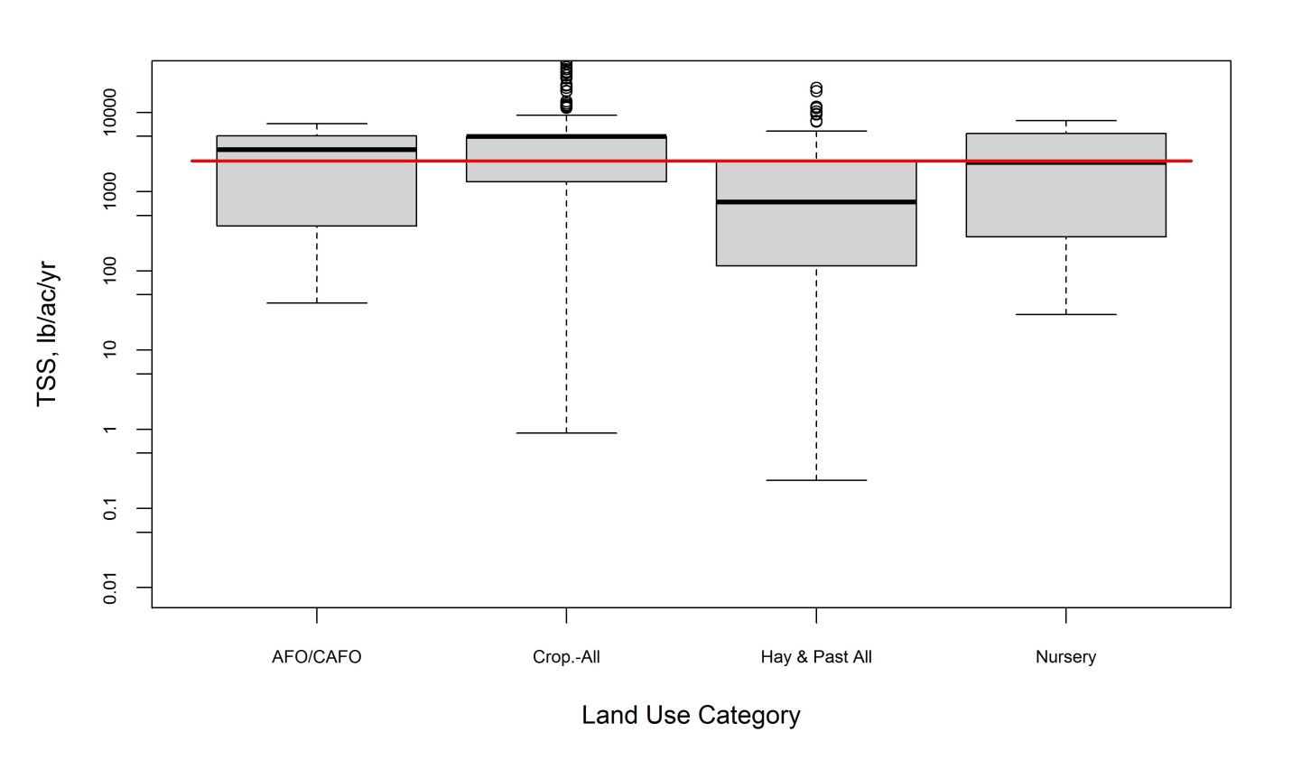
Figure 1. Example box plot for TSS from TMDL review for all agricultural land uses.

Histograms of loading data for each monitoring parameter are provided in Attachment E for both forestry and agriculture. Groupings are similar to those used for the box plots in Attachment D. Histograms show the count of records falling within each category listed on the x-axis.

6.2 Hypothesis Testing
Tetra Tech applied nonparametric tests to both the forestry and agriculture load data to determine if any differences existed between various groupings of the data. The Mann-Whitney test (also called the Wilcoxon Rank Sum test) and the Kruskal-Wallis test were used to test the hypothesis that two or more samples were drawn from the same distribution. The Mann-Whitney test is used for two samples and the Kruskal-Wallis test is used for two or more samples. The test statistic for both tests depends on the ranks of the observations in the combined sample, and no assumption about the distribution of the populations is made.

Requirements for applying the tests are:
- Samples from populations with distribution functions that have the same shape and variances that are equal.
- Samples that are random and independent.
- Each sample consisting of five or more measurements.

Tetra Tech tested all data sets to determine if they met those requirements before applying the nonparametric tests. In nearly all cases, there were violations of the assumptions of equal variance, distributions with the same shape, and random and independent samples. Tetra Tech did not perform the analysis if the sample size was too small (<5), but performed the analysis in all other cases. For this reason, it is essential that the magnitude of differences in median values for each tested group be considered when determining whether to accept a result of significant difference. All tests were performed at the 95 percent confidence level (α=0.05).

Test results are provided in tabular form in section 6.3 for forest land uses and in section 6.4 for agricultural land uses.

6.3 Forest Land Use Results
6.3.1 Descriptive Statistics
Data summaries for forest land uses are provided in Attachment C. They are presented by parameter (i.e., nitrate [NO₃], TN, TP, and TSS) for all forest land use data in the literature review and TMDL reports as well as by land use category with each associated source (literature and TMDLs). The tables in this section highlight some of the data presented in Attachment C for NO₃, TN, TP, and TSS.

TP loading rates ranged from 0.02 to 275.7 lbs/acre/year. The maximum TP loading rate was for undisturbed forest in the literature. The second highest observation of 23.88 lbs/acre/yr was found in a TMDL report for deciduous forest. The range of TP values in the literature was 0.02–275.7 lbs/acre/yr, the range for TP in the literature for EoF was 0–0.892 lbs/acre/yr, and the range for undisturbed forest in TMDL reports was 0–23.9 lbs/acre/year.

The range of median TP loading rates for forest was 0.005 lbs/acre/yr for coniferous forest to 2.05 lbs/acre/yr for clearcut forest. The minimum value was found in the TMDL review, while the maximum value was found in the literature review. In general, the median literature values appear to be larger than the values found in the TMDLs.

Table 3. Highlights of TP data summary for forest land uses
Land Use | TP Loading Rate from the Literature  (lbs/acre/yr) |  | TP Loading Rate from the Literature (EoF)  (lbs/acre/yr) |  | TP Loading Rate from TMDLs  (lbs/acre/yr)
 | Maximum | Median | Maximum | Median | Maximum | Median
Forest | 275.69 | 0.32 | 0.892 | 0.09 | 23.88 | 0.01
Clearcut | 30.5 | 2.05 | NA | NA | NA | NA
Harvested | 0.113 | 0.113 | NA | NA | 1.298 | 0.632
Disturbed | NA | NA | NA | NA | 0.119 | 0.099
Coniferous | 0.394 | 0.394 | 0.277 | 0.178 | 3.68 | 0.005
Deciduous | 0.334 | 0.334 | 0.170 | 0.063 | 23.8 | 0.007
Mixed | NA | NA | NA | NA | 5.780 | 0.007

TN loading rates ranged from 0.02 to 12.3 lbs/acre/year. Both of these TN loading rates were for undisturbed forest from TMDL reports. The range of TN values in the literature was 0.205–9.8 lbs/acre/yr, the range for TN from the literature for EoF was 0–10.17 lbs/acre/yr, and the range for undisturbed forest in the TMDL reports was 0.02–12.34 lbs/acre/year.

The range of median TN loading rates for forest was 0.13 lbs/acre/yr for mixed forest to 11.6 lbs/acre/yr for undisturbed forest. As with the TP data, the minimum value was from the TMDL review, while the maximum value was from the literature. Once again, the median literature values appear to be larger than the values found in the TMDLs; however, there are very few TN observations on the same land use types to make a clear determination.

Table 4. Highlights of TN data summary for forest land uses
Land Use | TN Loading Rate from the Literature  (lbs/acre/yr) |  | TN Loading Rate from the Literature (EoF)  (lbs/acre/yr) |  | TN Loading Rate from TMDLs  (lbs/acre/yr)
Land Use | Maximum | Median | Maximum | Median | Maximum | Median
Forest | 8.6 | 2.195 | 10.17 | 2.9 | 12.34 | 0.16
Clearcut | 9.814 | 2.230 | NA | NA | NA | NA
Harvested | NA | NA | NA | NA | NA | NA
Disturbed | NA | NA | NA | NA | NA | NA
Coniferous | NA | NA | NA | NA | 0.17 | 0.14
Deciduous | NA | NA | NA | NA | 0.46 | 0.15
Mixed | NA | NA | NA | NA | 0.16 | 0.13

There are no NO₃ data from EoF literature or TMDLs so only the data found in the literature search could be reviewed. NO₃ loading rates from the literature ranged from 0 to 31.3 lbs/acre/year. Both of these NO₃ loading rates were for undisturbed forest. The range of median TN loading rates for forest was 0.34 lbs/acre/yr for undisturbed forest to 22.28 lbs/acre/yr for harvested forest.

Table 5. Highlights of NO₃ data summary for forest land uses
Land Use | NO₃ Loading Rate from the Literature  (lbs/acre/yr) |  | NO₃ Loading Rate from the Literature (EoF)  (lbs/acre/yr) |  | NO₃ Loading Rate from TMDLs  (lbs/acre/yr)
 | Maximum | Median | Maximum | Median | Maximum | Median
Forest | 31.3 | 0.34 | NA | NA | NA | NA
Clearcut | 26.77 | 1.0 | NA | NA | NA | NA
Harvested | 28.07 | 22.28 | NA | NA | NA | NA
Disturbed | NA | NA | NA | NA | NA | NA
Coniferous | NA | NA | NA | NA | NA | NA
Deciduous | NA | NA | NA | NA | NA | NA
Mixed | NA | NA | NA | NA | NA | NA

TSS loading rates ranged from 0 to 12,417,771 lbs/acre/year. Both of these TSS loading rates were for harvested/disturbed forest found in TMDL reports. The next highest TSS loading rate was 5,572 lbs/acre/yr, also from a TMDL report. The range of TSS values in the literature was 0–660 lbs/acre/yr and the range for TSS from the literature for EoF was 8.9–2,625 lbs/acre/yr.

The range of median TSS loading rates for forest was 3.13 lbs/acre/yr for coniferous forest to 11,483 lbs/acre/yr for disturbed forest. The median literature values appear to be larger than the values found in the TMDLs except in the case of disturbed forest, which had extremely high loading rates in the TMDL.

Table 6. Highlights of TSS data summary for forest land uses
Land Use | TSS Loading Rate from the Literature  (lbs/acre/yr) |  | TSS Loading Rate from the Literature (EoF)  (lbs/acre/yr) |  | TSS Loading Rate from TMDLs  (lbs/acre/yr)
 | Maximum | Median | Maximum | Median | Maximum | Median
Forest | 522 | 69.9 | 36.42 | 24.28 | 5,572 | 9.6
Clearcut | 660 | 660 | 2,625 | 180 | NA | NA
Harvested | 0 | 0 | 180.5 | 97.1 | 2,610 | 977
Disturbed | NA | NA | NA | NA | 12,417,771 | 11,483
Coniferous | 522 | 522 | NA | NA | 37.5 | 3.13
Deciduous | 418 | 418 | NA | NA | 137.9 | 11.83
Mixed | NA | NA | NA | NA | 98.4 | 3.99

6.3.2 Box Plots
Several land uses had only limited data—sometimes only one or two data points. Land uses with fewer than three observations were not included in the box plots. Because of the large spread in some cases, y-axis limits were chosen that do not show complete boxes for all class variables (e.g., Figure 20 and Figure 21). For reference, Attachment B presents tables on how the land uses from TMDL reports and literature were aggregated.

Loading Rate Data Analysis Summary (Literature)
An overview of literature loading rate values for all forest land uses, both disturbed and undisturbed, is provided here. Disturbed forest land uses include harvested and clearcut. Undisturbed forest land uses include coniferous and deciduous forests. The median TP loading rates for undisturbed forest are generally lower than the loads for harvested/clearcut forest. However, only four observations for harvested/clearcut were made compared to 60 observations for undisturbed forest. The median nitrate values for clearcut and harvested forest are both higher than the median value for undisturbed forest (see Figure 13 and Figure 14). There were not enough TN or TSS data for a meaningful comparison between natural and disturbed forest.

Median TP and TN loads for all forest types (disturbed and undisturbed) from the literature did not show strong variation before or after 1990 or within or outside the CBW. Median TP loads prior to 1990 were slightly higher than post-1990 and median TP loads inside the watershed were slightly higher than outside the watershed (see Figure 15 and Figure 16). There were not enough TSS data for a meaningful comparison.

Comparison of median TP and TN loading rates for undisturbed forest showed little variation. The highest median TP loading rates occurred before 1990 and inside the watershed. TN median loading rates before and after 1990 were nearly identical, while loading rates outside the watershed were slightly higher than within the watershed (see Figure 17 and Figure 18). There were no studies with TP or TN loads from disturbed forest in the CBW, but nitrate loading rates in disturbed forest were lower post-1990 (see Figure 19).

The EoF literature review for undisturbed forest TP and TN loading rates showed little variation between study sites within and outside the CBW. The TP loads were slightly higher outside of the watershed (see Figure 20 and Figure 21).

Loading Rate Data Analysis Summary (TMDL Reports)
An overview of loading rate values from TMDL reports for all forest land uses, both disturbed and undisturbed, is provided here. TP and TSS median loading rates for harvested and/or disturbed forest exceeded all undisturbed forest types (i.e., coniferous, deciduous, and mixed). There were no TN data for disturbed forest. Median TN loading rates for undisturbed forest types were all similar (see Figure 22 through Figure 24).

Box plots for barren and extractive land uses show that extractive TP loads are higher than barren, but TSS loads are slightly lower (see Figure 25 and Figure 26). The barren and extractive loading rates are from TMDL reports rather than literature and those land uses do not tend to be the focus of TMDL model calibration, but are often the last item calibrated in modeling.

EoF loading rates from TMDL reports for forest land uses show that the median TP, nitrate, and TSS values for harvested or disturbed forest are generally higher than for undisturbed forest; however, the highest loading rates came from undisturbed forest (see Figure 27 through Figure 29).

6.3.3 Histograms
Histograms were developed to investigate the loading rate distributions. Plots were developed to look at different land uses (see Attachment E). The plots illustrate that none of the forest or barren/extractive data are normally distributed and are greatly skewed to the lower loading rates, except for barren and extractive TSS data, which have more variation.

6.3.4 Hypothesis Testing
The Kruskal-Wallis test was applied to various groupings of forestry data to determine if differences existed among any of the groups (α=0.05). Where differences were found, the Mann-Whitney test was applied to determine which groups were different.

Tetra Tech initially intended to test for differences between the undisturbed forest land uses and the different disturbed forest land uses (i.e., harvested and clearcut); however, the only data used for the Kruskal-Wallis test were all undisturbed forest TP and TN data. The data were tested to look for differences between data collected before and after 1990 and within and outside the CBW. The data included in the analysis are presented in the box plots in Figure 17 and Figure 18 of Attachment D. There were not enough observations for disturbed forest to make a comparison between the different forest types meaningful; therefore, this statistical analysis focuses on the undisturbed forest data.

Results from Kruskal-Wallis and Mann-Whitney testing are summarized in Table 7. The results indicate that TN loads for undisturbed forest data do not differ temporally or spatially; therefore, the TN results are not shown. TP loads pre- and post-1990 differ, but TP loads do not significantly differ within and outside the watershed.

Table 7. Results of Kruskal-Wallis and Mann-Whitney testing for TP for undisturbed forest
Group Medians*
(lb/ac/yr)
Forest  (Post-1990) | Forest  (Pre-1990) | Forest  (In watershed) | Forest  (Outside watershed)
0.2052a | 0.6067b | 0.4000ab | 0.1561a
* Group medians followed by the same letter(s) are not significantly different, P < 0.05.

There were violations of the Kruskal-Wallis test assumptions associated with equal variance, similar distribution, and random values, making the results somewhat inconclusive. Because of the large differences in medians where they were determined to be significant, the conclusion that differences exist is probably defensible despite violation of the requirements for the Kruskal-Wallis test. Care should be taken not to quantify the differences due to the violations. Visual observation of the box plots presented in Attachment D might be more useful than the Kruskal-Wallis test in determining differences between varying forest land use types. The plots suggest that the median TP loading rates for undisturbed forest are generally lower than the loads for harvested/clearcut forest. The comparison of median TP and TN loading rates for undisturbed forest shows only slight variation. The highest median TP loading rates occurred before 1990 and inside the watershed. TN median loading rates before and after 1990 were nearly identical, while loading rates outside the watershed were slightly higher than inside the watershed.

6.4 Agricultural Land Use Results
6.4.1 Descriptive Statistics
Summaries of agricultural load data obtained from the literature are provided in Attachment C.4. The greatest number of observations was found for TP (n=476), followed by NO₃ (464), TN (292), TSS (231), and total sediment (68). Skewness coefficients for the combined data for each monitoring parameter are high (3.0–7.5) and means exceed the medians by factors of 2.4–16, both indications of skewed distributions. Literature data are summarized by a range of factors including pollutant pathway (e.g., surface vs. tile drains), land use category and subcategory, soils (CBW soils or not), slope category, general precipitation, study scale, delivery (EoF vs. in-stream delivered to local water body), and publication period (pre-1995 or 1995–present). These groupings were applied to the box plots, histograms, and hypothesis testing described in sections 6.4.2 to 6.4.4.

Agricultural load data obtained from TMDL reviews are summarized in Attachment C.5 (in-stream delivered to local water body) and Attachment C.6 (edge of field). There are 1,744 observations for TSS in Attachment C.5, followed by TP (678) and TN (148), with an additional 186 EoF observations for TSS in Attachment C.6. Skewness coefficients for the combined data for each monitoring parameter are lowest for TN (1.6) and highest for TSS (14), both in Attachment C.5. Skewness in the data summarized in the two attachments is also indicated by means that exceed medians by a factor of 1.7–33. Data summaries are provided by land use category/subcategory in the attachments, and additional summaries applicable to box plots can be found in Attachment D.3.

6.4.2 Box Plots
Box plots, described in section 6.1, were created to compare distributions of parameter loads by various categorical groupings of the data. The comparisons informed decisions regarding the hypothesis testing summarized in section 6.4.4. Box plots for agricultural load data obtained from the literature are provided in Attachment D.2; box plots for data obtained from TMDLs are in Attachment D.3.

All box plots in Attachment D.2 compare distributions for studies conducted on soils found within the CBW (“Y:” x-axis labels) versus studies from soils not found within the CBW (“N:” x-axis labels), by land use category. The box plots further separate the data by pollutant pathway; Figure 30, for example, shows data for the surface pathway and Figure 31 and Figure 32 show data for tile drains/ditches and shallow groundwater, respectively. Only soils/land use combinations for which sufficient data were found (e.g., n=3 or greater) are included in the box plots.

Figure 31, for example, indicates that the tile drain/ditch TP load from commodity crops for soils within the CBW is greater than for commodity crops on soils not found in the CBW. Further examination of this and related patterns can be found in section 6.4.4.

Box plots in Attachment D.3 provided data for the surface pathway only, with individual boxes created for each reported land use category. Figure 41 and Figure 46, for example, indicate that TP loads are greater from animal feeding operations (AFOs) and concentrated animal feeding operations (CAFOs) than from either cropland or hay and pasture. Hypothesis testing based on this observation can be found in section 6.4.4.

6.4.3 Histograms
Histograms for load data from the literature are provided in Attachment E.3; histograms for load data from TMDLs are provided in Attachment E.4. The predominant shapes of the histograms support the general observation made from reviewing the data summaries and box plots that the distributions are skewed. Even when developed by land use category or subcategory level (see Figure 68 through Figure 77), histograms indicate that the literature data are skewed. Histograms developed from TMDL data tend to have multiple peaks due to the many repeated values found in the TMDLs. Still, the patterns generally indicate skewed distributions.

6.4.4 Hypothesis Testing
Tetra Tech employed nonparametric hypothesis testing to make inferences about the assembled data in support of export coefficients selection for specific CBW land uses. The principal questions investigated include:
- Do loading rates differ significantly among loss pathways (e.g. surface runoff vs. subsurface flow)?
- Do reported loading rates differ significantly among distinct land uses?
- Are factors such as study scale, date of research publication, soil type, precipitation condition, slope, and manure application significant influences on loading rates reported in the literature?

In all cases, the null hypothesis tested was H_{o}: data groups are all equal.

Because the data were heavily skewed, nonparametric statistical tests were used for hypotheses testing. Nonparametric tests do not require the data to conform to a particular (e.g., normal) distribution. However, nonparametric analysis does require independence of observations within groups and constant variance across groups. Data collected from hundreds of different studies across several decades in different locales likely satisfy the assumption of independent observations. However, as noted below, the data rarely showed constant variance across groups. Nevertheless, Tetra Tech proceeded with hypothesis testing. Results, however, must be interpreted with caution.

Tetra Tech used the Mann-Whitney test to determine if loadings differed significantly among loss pathways, specific land uses, or influencing factors. The Mann-Whitney test is a nonparametric alternative to the 2-sample t-test, which is based solely on the order in which the observations from the two samples fall. When more than two groups were compared (e.g., plot-field-watershed study scales), a Kruskal-Wallace test—an extension of the Mann-Whitney test analogous to the parametric analysis of variance test—was performed. Tests for equal variances among groups (H_{o}: group variances are all equal) included Brown-Forsythe and Levene’s. The H_{o} was accepted or rejected at the 0.05 significance level. In the following tables, the hypothesis that groups are equal is rejected if the reported P value is <0.05. All hypothesis testing was conducted in JMP v.10 statistical software (SAS Institute 2012).

The hypotheses were evaluated for TP, TN, NO₃, TSS, and total sediment. Some data standardization and preparation was required to conduct the analysis. Several new classification variables were created.
- As discussed elsewhere in this report, specific land use groups were defined either as specific community-based monitoring (CBM) land use subcategories or as descriptive categories based on findings in the literature.
- Records were grouped by publication date ranges of pre-1995 and 1995-present.
- Soils reported with each data record were classified as comparable to CBW soils (Y) or not (N), based on consultation with members of CBP expert panels.
- Slopes reported for each record were grouped into four categories: <2%, 2–6%, >6–10%, and >10%.
- Manure use was classified as Y if manure of any type was applied to the study site.

In general, data groups with n <10 were not included in the analyses. This requirement was occasionally relaxed in specific cases to illustrate an important pattern, but in no case were groups with n <5 included. In the summary tables in this section, only groups or cases for which adequate data exist were included. Groups or categories with insufficient data are not listed and cases in which too few records existed for either an entire case or a group category are designated as “no data.” In all tables, within each row, medians followed by the same letter(s) do not differ significantly at P < 0.05.

Loss Pathway
Comparison of loading rates by loss pathway is summarized in Table 8. Most reported pollutant loads were measured in surface runoff; for TN and total sediment, too few results were reported for shallow groundwater or tile drains/ditch losses to evaluate differences by loss pathway. Not surprisingly, TP losses in surface runoff were significantly higher than those measured in shallow groundwater and tended to be higher than losses in tile drains/ditches, although the difference was not statistically significant. Similarly, TSS losses were significantly greater in surface runoff than in tile drains/ditches. However, reported NO₃ losses in both shallow groundwater and tile drains/ditches were significantly higher than losses in surface runoff, and median NO₃ losses were highest in tile drain/ditch flow. This pattern is likely due to the greater mobility of NO₃ through soils compared to phosphorous or other nitrogen forms.

Thus, it was concluded that for most of the analyzed pollutants, that loading rates differ significantly among loss pathways. Consequently, subsequent analysis controlled for this influence by grouping records by loss pathway prior to testing for other influences.

Table 8. Comparison of median pathway agricultural loading rates by Mann-Whitney/Kruskal-Wallace test
Grouping | Group Medians (lb/ac/yr)
Parameter | Shallow Groundwater | Surface | Tile Drains/Ditches | Surface+Subsurface
ALL LAND USE GROUPS
TP | 0.15 a | 0.60 b | 0.12 b
TN | (no data) | (no data) | (no data)
NO₃ | 4.46 a | 1.02 b | 27.66 c
TSS |  | 325.2 a | 52.6 b | 3,012 c
Total sediment | (no data) | (no data) | (no data)
Note:
Within rows, group medians followed by the same letter(s) are not significantly different, P < 0.05.

Comparison across Land Use Categories
Comparison of loading rates across major CBM land use categories is summarized in Table 9 by loss pathway (where possible). The TBD category includes a variety of agricultural land uses that do not conform to the CBW model categories; it generally includes rangeland, native grasses, fallow, and bare soil. Loads of all constituents by all pathways tended to be higher from commodity crops than from forage and hay crops. Loads of TP, TN, NO₃, and TSS in surface runoff from commodity crops were significantly higher than loads from forage and hay crops. NO₃ loads in tile drain/ditch flow from commodity crops were significantly higher than losses in surface runoff.

The null hypothesis of no difference in loading rates among land use categories was rejected.

Table 9. Comparison of major agricultural land use category median loading rates by Mann-Whitney/Kruskal-Wallace test
 |  | Group Median (lb/ac/yr)
Parameter | Pathway | Commodity | Forage_and_Hay | TBD
TP | Surface | 0.99 a | 0.18 b | 0.31 b
TN | Surface | 6.94 a | 0.80 b | 1.23 b
NO₃ | Shallow groundwater | 4.99 a | 3.28 a | 7.69 a
NO₃ | Surface | 1.47 a | 0.28 b | 0.80 ab
NO₃ | Tile Drain/Ditch | 28.55 a | 0.89 b | (no data)
TSS | Surface | 522.8 a | 67.7 bd | 89.2 cd
Total sediment | Surface | 392.6 a | 120.4 a | (no data)
Note:
Within rows, group medians followed by the same letter(s) are not significantly different, P < 0.05.

Comparison of Loading across Land Use Groups
Comparison of loading rates across land use groups is summarized in Table 10 and in Figure 2 through Figure 8. These land use groups are described earlier in this report.

There are differences in reported loading rates across the land use groups (see group medians and following letters in Table 10). As a general overview, TP, TN, and NO₃ surface runoff losses from the different types of corn cropland tend to be higher than losses from cropland in small grains, and all those groups tend to export TP and TN at higher rates than forage and pasture. A similar pattern is shown for TSS loads (see Figure 7) with the exception that TSS loads from corn, grain–fall fallow are similar to those from small grains and pasture and significantly lower than TSS loading rates from corn, silage–fall fallow. This pattern may be due to the greater availability of crop residue for soil cover under corn grain production compared to corn silage production.

To the extent possible under data limitations, the analysis documented significant differences in subsurface NO₃ loading among some land use groups (see Figure 4 and Figure 6). Shallow groundwater and tile drain/ditch losses of NO₃ from corn, grain–fall fallow were significantly higher than from nonlegume forage. NO₃ loss rates in tile drain/ditch flow from corn, grain–fall fallow tended to be higher than rates from corn, grain–fall small grain, although the difference was not significant. This pattern might be attributed to fall uptake of remaining NO₃ by the grain crop compared to fallow.

In sum, the null hypothesis must be rejected meaning the loading rates differ significantly across land use groups. Specific differences for individual constituents are shown in Table 10.

Table 10. Comparison of agricultural land use group median loading rates by Kruskal-Wallace test
Group Median (lb/ac/yr)
Parameter | Pathway | Corn, grain–fall fallow | Corn, grain–fall sm. grain | Corn, silage–fall fallow | Corn, silage–fall sm. grain | Corn, unspecified | Corn-soybean rotation | Cotton, cotton rotation | Fallow-bare soil | Forage, Nonlegumes | Forage, legume | Misc. rotation | Mixture | Soybean, full season fall fallow | Past. cropland and Pasture | Small Grain–fallow | Sm Grain–forage established | Wheat rotation | Misc. rotation
TP | Surface | 0.95 ad |  | 1.16 ade |  | 1.29 a | 0.97 ac | 1.22  a | 0.54 ac | 0.25 be |  |  |  |  | 0.12  b | 1.70  a | 0.30 bce | 0.51 cd
TN | Surface | 16.33 a |  |  |  | 13.61 a |  |  | 1.96  b | 0.62 de |  |  |  |  | 0.54 ce | 5.13  b | 1.78 bcd
NO₃ | Shallow gw | 16.75 a |  | 1.90  bd | 1.98 bc |  |  |  | 7.69  c | 3.28 bc |  |  |  |  |  |  |  |  | 6.16 cd
NO₃ | Surface | 1.59  c | 2.94 ac | 3.84  ae | 2.89 ad |  |  |  | 1.50  c | 0.21  f | 1.74cd | 2.04cde | 3.48  b | 0.77 cdf | 0.08  f |  | 0.13  f
NO₃ | Tile drain | 29.05 a | 15.26 ab |  |  |  |  |  |  | 0.89  b |  |  |  | 29.44 a
TSS | Surface | 206.5 cd |  | 3192.2 a |  |  |  | 1490.8 a |  | 95.6 cde |  |  |  |  | 55.4  e | 258.7 abcde |  | 638.4 b
Total sed. | Surface | 889.5 a |  |  |  |  |  |  |  | 215.9 ac |  |  |  | 138.3 cd | 34.8 bd |  | 331.0 ad
Note:
Within rows, group medians followed by the same letter(s) are not significantly different, P < 0.05.

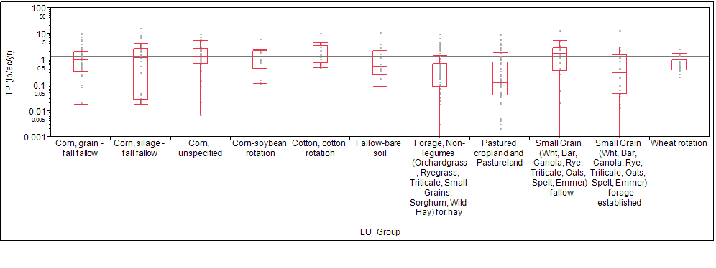

Figure 2. Box plot of reported TP surface runoff loading rates by agricultural land use group.
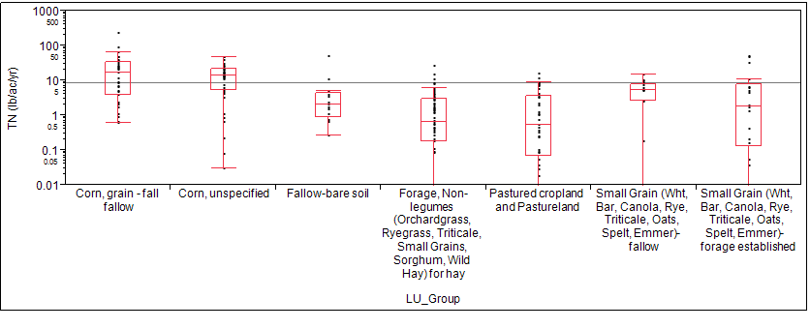
Figure 3. Box plot of reported TN surface runoff loading rates by agricultural land use group.

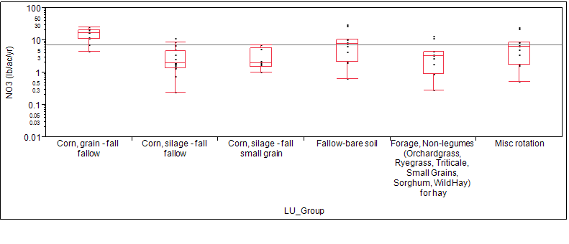
Figure 4. Box plot of reported NO₃ shallow groundwater loading rates by agricultural land use group.
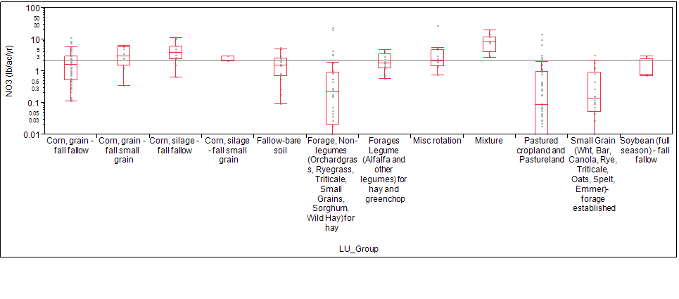
Figure 5. Box plot of reported NO₃ surface runoff loading rates by agricultural land use group.

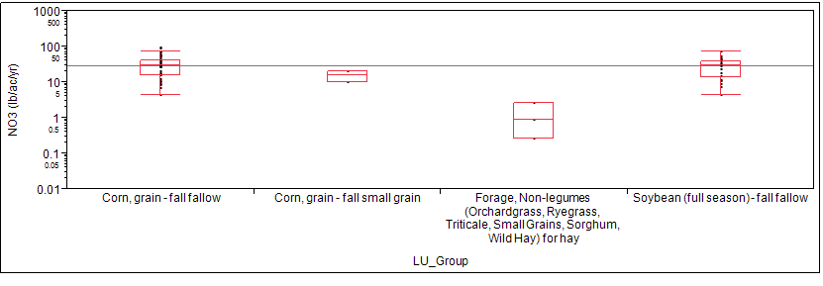
Figure 6. Box plot of reported NO₃ tile drain/ditch loading rates by agricultural land use group.

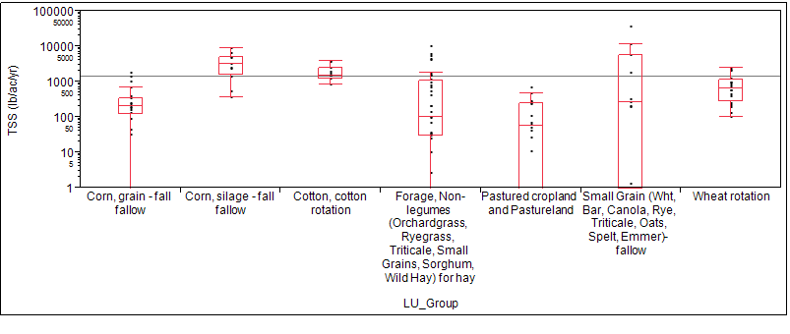
Figure 7. Box plot of reported TSS surface runoff loading rates by agricultural land use group.

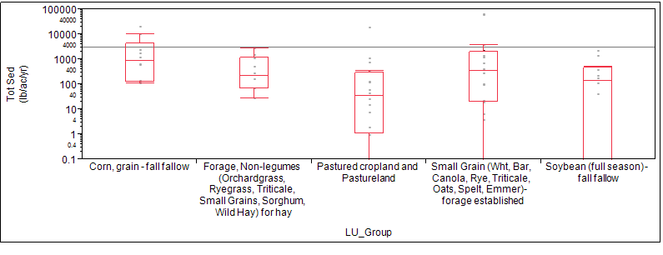
Figure 8. Box plot of reported total sediment surface runoff loading rates by agricultural land use group.

Study Scale
Load data reported in the literature were generated from studies conducted at three principal scales: plot, field, and watershed. It is frequently assumed that extrapolating plot-scale data to large drainage areas is subject to considerable limitation and uncertainty. Therefore, Tetra Tech evaluated the influence of study scale on the reported pollutant loading rates; results are summarized in Table 11.

Across all land use groups, loading rates for most constituents from studies conducted at different scales generally did not differ significantly. Significant differences were observed only for TP, where TP loads from plot studies were significantly lower than from either field or watershed scale studies; the pattern for low TP loads from plot studies was also shown in data from corn silage–fall fallow and from pastured cropland and pasture. However, median TP loads from corn, unspecified and forage, nonlegume plots were higher than from other scales, although the differences were not statistically significant.

Overall, the data do not indicate a significant difference or even a consistent pattern in loading rates determined from different study scales for most pollutants for which sufficient data were available. For most cases, the null hypothesis cannot be rejected, although for some specific land use groups and pollutants, significant scale effects were observed.

Table 11. Comparison of agricultural land use group median loading rates by scale by Mann-Whitney/Kruskal-Wallace test
 |  | Group Median (lb/ac/yr)
Parameter | Pathway | Plot | Field | Watershed
ALL LAND USE GROUPS
TP | Surface | 0.34 a | 0.52 b | 0.71 b
TN | Surface | 4.04 a | 1.23 b | 3.39 ab
NO₃ | Shallow gw | 1.71 a | 7.86 b | 4.46 b
NO₃ | Surface | 1.30 a | 0.80 a | 0.97 a
TSS | Surface | 224.8 a | 276.6 a | 547.8 a
Total sediment | Surface | 287.4 a | (no data) | 162.8 a
Corn, grain–fall fallow
TP | Surface | 0.52 a | 1.02 ab | 1.52 b
TN | Surface | (no data) | 8.66 a | 18.38 a
NO₃ | Surface | 2.22 a | 2.49 a | 0.58 b
TSS |  | (no data) | (no data) | (no data)
Total sediment |  | (no data) | (no data) | (no data)
Corn, silage–fall fallow
TP | Surface | 0.02 a | 3.10 b | 1.68 b
TN |  | (no data) | (no data) | (no data)
NO₃ |  | (no data) | (no data) | (no data)
TSS |  | (no data) | (no data) | (no data)
Total sediment |  | (no data) | (no data) | (no data)
Corn, unspecified
TP | Surface | 3.88 abc | 0.06 b | 1.47 c
TN |  | (no data) | (no data) | (no data)
NO₃ |  | (no data) | (no data) | (no data)
TSS |  | (no data) | (no data) | (no data)
Total sediment |  | (no data) | (no data) | (no data)
Forage, nonlegumes
TP | Surface | 0.69 a | 0.21 a | 0.22 a
TN |  | (no data) | (no data) | (no data)
NO₃ | Surface | 0.89 a | 0.45 ab | 0.04 a
TSS | Surface | 0.80 a | 136.5 b | 149.9 b
Total sediment |  | (no data) | (no data) | (no data)
Pastured cropland and pasture
TP | Surface | 0.04 a | 0.22 b | 0.13 b
TN |  | (no data) | (no data) | (no data)
NO₃ |  | (no data) | (no data) | (no data)
TSS | Surface | (no data) | 10.5 a | 245.3 a
Total sediment |  | (no data) | (no data) | (no data)
Small grain–fallow
TP | Surface | 0.04 a | 0.00 a | 2.54 b
TN |  | (no data) | (no data) | (no data)
NO₃ |  | (no data) | (no data) | (no data)
TSS |  | (no data) | (no data) | (no data)
Total sediment |  | (no data) | (no data) | (no data)
Wheat rotation
TP |  | (no data) | (no data) | (no data)
TN |  | (no data) | (no data) | (no data)
NO₃ |  | (no data) | (no data) | (no data)
TSS | Surface | (no data) | 704.8 a | 571.9 a
Total sediment |  | (no data) | (no data) | (no data)
Note:
Within rows, group medians followed by the same letter(s) are not significantly different, P < 0.05.

Date Range
The literature review obtained data from studies published 1968–2014. Because there is sometimes a tendency to deemphasize “old” research data, Tetra Tech tested the hypothesis that data from older studies (i.e., pre-1995) do not differ significantly from data published since 1995. Results of that comparison are summarized in Table 12.

As shown in Table 12, a strong pattern was observed for phosphorous and nitrogen loading rates to be significantly higher in research published since 1995 than in older work. The pattern was observed when all land use groups were combined as well as for most of the specific land use groups. Many of the differences were significant. For example, median TP loss in surface runoff across all land use groups published since 1995 was nearly four times higher than median TP losses reported in earlier research (see Figure 9). Median NO₃ loss in tile drain/ditch flow from corn, grain–fall fallow land in research since 1995 was double the loss reported before 1995 (see Figure 10). Although the data were scant, a similar pattern was not observed for TSS. Median total sediment load from all land uses did not differ significantly between the two date ranges, although more recent data tended to show higher loads.

The reasons for the pattern are not clear, but may involve differences in the sensitivity of analytical methods, changes in field monitoring equipment and protocols, the nature of the research questions investigated, or prevailing agricultural practices. The pattern being shown strongly for nutrients, but not for sediment, may result from TSS or other sediment analyses being simple procedures that have long been consistent or may suggest that long-term trends in nutrient applications, soil fertility, and soluble nutrient losses may be involved. Regardless of the reason, it is clear that the null hypothesis must be rejected and that “old” and “new” nutrient loading rates differ significantly.

Table 12. Comparison of agricultural land use group median loading rates by date range by Mann-Whitney test
Parameter | Pathway | Group Median (lb/ac/yr)
Parameter | Pathway | 1995-present | Pre-1995
ALL LAND USE GROUPS
TP | Surface | 0.83 a | 0.22 b
TN | Surface | 4.82 a | 2.41 b
NO₃ | Surface | 2.25 a | 1.83 b
NO₃ | Tile drain/ditch | 32.12 a | 16.06 b
TSS | Surface | 224.8 a | 489.4 a
Total sediment | Surface | 1,698.3 a | 164.6 a
Corn, grain–fall fallow
TP | Surface | 1.17 a | 0.47 b
TN | Surface | 18.38 a | 8.66 a
NO₃ | Surface | 4.82 a | 1.17 b
NO₃ | Tile drain/ditch | 33.37 a | 17.84 b
TSS |  | (no data) | (no data)
Total sediment |  | (no data) | (no data)
Corn, unspecified
TP | Surface | 1.47 a | 0.12 b
TN | Surface | 14.94 a | 0.74 b
NO₃ |  | (no data) | (no data)
TSS |  | (no data) | (no data)
Total sediment |  | (no data) | (no data)
Fallow/bare soil
TP |  | (no data) | (no data)
TN |  | (no data) | (no data)
NO₃ | Surface | 1.99 a | 0.54 b
TSS |  | (no data) | (no data)
Total sediment |  | (no data) | (no data)
Forage, nonlegumes
TP | Surface | 0.19 a | 0.32 a
TN | Surface | 0.26 a | 2.81 b
NO₃ |  | (no data) | (no data)
TSS | Surface | 119.6 a | 65.1 a
Total sediment |  | (no data) | (no data)
Pastured cropland and pasture
TP | Surface | 0.30 a | 0.09 b
TN | Surface | 1.07 a | 0.16 b
NO₃ | Surface | 0.24 a | 0.05 a
TSS | Surface | 170.6 a | 106.6 b
Total sediment |  | (no data) | (no data)
Small grain–fallow
TP | Surface | 1.96 a | 1.51 a
TN |  | (no data) | (no data)
NO₃ |  | (no data) | (no data)
TSS |  | (no data) | (no data)
Total sediment |  | (no data) | (no data)
Wheat rotation
TP | Surface | 0.62 a | 0.43 a
TN |  | (no data) | (no data)
NO₃ |  | (no data) | (no data)
TSS | Surface | 704.8 a | 571.9 a
Total sediment |  | (no data) | (no data)
Note:
Within rows, group medians followed by the same letter(s) are not significantly different, P < 0.05.

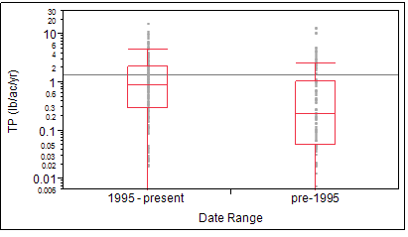
Figure 9. Box plot of TP surface runoff agriculture loads from reports published 1995-present vs. reports published pre-1995.

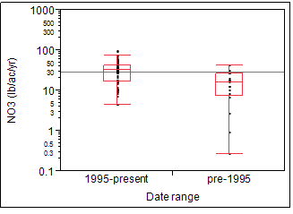
Figure 10. Box plot of NO₃ loads in tile drain/ditch flow from corn, grain–fall fallow from reports published 1995-present vs. reports published pre-1995.

Soil Order
Much of the research included in the database was conducted outside the CBW. Because soils can be a major influence on pollutant losses from agricultural land uses, Tetra Tech compared loading rates between research conducted on soils found within or comparable to the CBW vs. research conducted on non-CBW soils (at the order level). Results are summarized in Table 13.

Differences in loading rates between CBW and non-CBW soils were inconsistent. Across all land use groups, TP loads in surface runoff did not differ significantly between the soil groups, but TP loads in tile drain/ditch flow were significantly higher in CBW soil orders (1.26 lb/ac/yr) compared to non-CBW soils orders (0.09 lb/ac/yr). TN and TSS loads in surface runoff did not differ significantly between the two groups, but total sediment loads were significantly higher from non-CBW soils than from CBW soils. Surface runoff NO₃ loads were significantly higher from CBW soils than from non-CBW soils, but NO₃ losses in shallow groundwater did not differ.

Differences between soil groups for specific land use groups were varied and inconsistent. In some cases, no significant differences were documented between CBW and non-CBW soils. Surface runoff NO₃ loads from corn, grain–fall fallow, for example, were significantly higher on CBW soils, but TP and TN loads from CBW soils were significantly higher on non-CBW soils from the corn-unspecified group.

Overall, the null hypothesis cannot be broadly rejected. However, in a few specific cases, H_{o} can be rejected. The lack of a general or consistent pattern suggests that the importance of soil order in applying the literature loading values should be evaluated on a case-by-case basis.

Table 13. Comparison of agricultural land use group median loading rates by CBW soil by Mann-Whitney test
Parameter | Pathway | Group Median (lb/ac/yr)
Parameter | Pathway | CBW soil N | CBW soil Y
ALL LAND USE GROUPS
TP | Surface | 0.60 a | 0.61 a
TP | Tile drain/ditch | 0.09 a | 1.26 b
TN | Surface | 3.82 a | 3.00 a
NO₃ | Shallow gw | 4.46 a | 4.68 a
NO₃ | Surface | 0.80 a | 1.26 b
TSS | Surface | 383.6 a | 172.2 a
Total sediment | Surface | 1,237.4 a | 124.9 b
Corn, grain–fall fallow
TP | Surface | 0.67 a | 1.28 a
TN |  | (no data) | (no data)
NO₃ | Surface | 1.23 a | 2.94 b
TSS |  | (no data) | (no data)
Total sediment |  | (no data) | (no data)
Corn, unspecified
TP | Surface | 1.61 a | 0.06 b
TN | Surface | 14.94 a | 0.44 b
NO₃ |  | (no data) | (no data)
TSS |  | (no data) | (no data)
Total sediment |  | (no data) | (no data)
Forage, nonlegume
TP | Surface | 0.26 a | 0.18 a
TN | Surface | 0.42 a | 2.86 b
NO₃ | Surface | 0.18 a | 0.80 a
TSS | Surface | 35.2 a | 310.0 a
Total sediment |  | (no data) | (no data)
Pastured cropland and pasture
TP | Surface | 0.12 a | 0.12 a
TN | Surface | 0.54 a | 0.66 a
NO₃ |  | (no data) | (no data)
TSS | Surface | 0.0 a | 170.6 b
Total sediment |  | (no data) | (no data)
Note:
Within rows, group medians followed by the same letter(s) are not significantly different, P < 0.05.

General Precipitation Conditions
Because nonpoint source pollutant losses, either in surface or subsurface pathways, tend to be driven by precipitation, Tetra Tech tested for effects of general precipitation conditions (i.e., dry, normal, or wet) recorded during the studies on reported loading rates. Dry conditions were defined as those recording <90% of normal precipitation during the study period; wet conditions were those where >110% of normal rainfall was recorded. Results are summarized in Table 14.

Not unexpectedly, loading rates reported under wet conditions tended to be higher than those from normal or dry conditions, although the differences were not statistically significant in all cases. Differences between dry and normal conditions differed significantly in fewer cases and, in the case of NO₃ loading rates from corn-grain–fall fallow under dry conditions, were slightly (but not significantly) higher than losses under normal or wet conditions. This pattern may be due to lower NO₃ uptake from a drought-inhibited crop compared to normal crop growth. Reported TSS loading rates did not appear to differ significantly across the precipitation conditions.

Under some conditions, the null hypothesis must be rejected. In general, reported nutrient loads were higher in normal or wet conditions than in dry conditions.

Table 14. Comparison of agricultural land use group median loading rates by general precipitation condition by Mann-Whitney/Kruskal-Wallace test
Parameter | Pathway | Group Median (lb/ac/yr)
Parameter | Pathway | Dry | Normal | Wet
ALL LAND USE GROUPS
TP | Surface | 0.46 a | 0.25 a | 1.13 b
TN | Surface | 1.12 a | 2.41 ab | 4.52 b
NO₃ | Surface | 1.04 a | 0.45 a | 0.54 a
NO₃ | Tile drains/ditch | 12.49 a | 17.84 a | 37.92 b
TSS | Surface | 320.3 ac | 702.1 b | 255.0 bc
Total sediment | Surface | 20.1 a | 80.7 ab | 907.3 c
Corn, grain–fall fallow
TP |  | (no data) | (no data) | (no data)
TN |  | (no data) | (no data) | (no data)
NO₃ | Surface | 1.52 a | 1.08 a | 1.30 a
NO₃ | Tile drain/ditch | (no data) | 17.84 a | 41.88 b
TSS |  | (no data) | (no data) | (no data)
Total sediment |  | (no data) | (no data) | (no data)
Corn, unspecified
TP | Surface | 0.67 a | 1.16a | 2.81 b
TN | Surface | 5.98 a | 12.31 a | 25.25 b
NO₃ |  | (no data) | (no data) | (no data)
TSS |  | (no data) | (no data) | (no data)
Total sediment |  | (no data) | (no data) | (no data)
Forage, nonlegume
TP | Surface | 0.00 a | 0.46 b | 0.45 b
TN | Surface | 0.09 a | 1.25 b | 0.54 bc
NO₃ | Surface | (no data) | 0.51 a | 0.14 a
TSS |  | (no data) | (no data) | (no data)
Total sediment |  | (no data) | (no data) | (no data)
Pastured cropland and pasture
TP | Surface | 0.09 ab | 0.09 a | 0.24 b
TN | Surface | (no data) | (no data) | (no data)
NO₃ | Surface | (no data) | 0.96 a | 0.24 a
TSS |  | (no data) | (no data) | (no data)
Total sediment | Surface | (no data) | 16.5 a | 445.6 a
Small grain–forage
TP |  | (no data) | (no data) | (no data)
TN |  | (no data) | (no data) | (no data)
NO₃ | Surface | (no data) | 0.09 a | 1.18 b
TSS |  | (no data) | (no data) | (no data)
Total sediment | Surface | (no data) | 57.1 a | 2,895.1 b
Soybeans–fall fallow
TP |  | (no data) | (no data) | (no data)
TN |  | (no data) | (no data) | (no data)
NO₃ | Tile drain/ditch | (no data) | 27.66 a | 34.80 a
TSS |  | (no data) | (no data) | (no data)
Total sediment |  | (no data) | (no data) | (no data)
Note:
Within rows, group medians followed by the same letter(s) are not significantly different, P < 0.05.

Slope Category
Comparisons of reported loading rates among four slope categories are summarized in Table 15. Although some significant differences in loading rates existed among slope categories, the differences were not dramatic or consistent. There was, for example, no broad pattern of increasing losses with increasing slope. Surface runoff losses of TP, for example, were significantly higher from studies conducted at slopes of 2–6 percent than from slopes <2 percent; but loads from slopes >10 percent were significantly lower than those from slopes of 2–6 percent. Reasons for this pattern could include differences in land use categories on greater slopes or other factors.

For some cases (e.g., TSS loads in surface runoff), the null hypothesis cannot be rejected, meaning that no significant differences existed across slope categories. In other cases (e.g., TP loads in surface runoff), the null hypothesis must be rejected. However, differences in observed loading rates do not support a consistent inference about the influence of slope on loading rates.

Table 15. Comparison of agricultural land use group median loading rates by slope category by Mann-Whitney/Kruskal-Wallace test
Parameter | Pathway | Group Median (lb/ac/yr)
Parameter | Pathway | <2% | 2–6% | >6–10% | >10%
ALL LAND USE GROUPS
TP | Surface | 0.42 a | 0.99 b | 0.13 c | 0.60 a
TP | Tile drain/ditch | 0.09 a | 1.19 b | (no data) | (no data)
TN | Surface | 1.52 ab | 4.92. c | 0.62 a | 3.08 bc
NO₃ | Shallow gw | 6.82 a | 9.80 a | (no data) | (no data)
 | Surface | 1.36 a | 1.28 a | 0.13 b | 2.13 a
TSS | Surface | 348.0 a | 322.1 a | 136.5 a | 448.8 a
Total sediment | Surface | 2,052.0 a | 1,070.6 b | 109.3 c | 849.8 ab
Corn, grain–fall fallow
TP | Surface | 0.62 ad | 1.39 ac | 0.44 b | 0.66 bcd
TN | Surface | 20.43 a | 8.23 a | 23.25 a | (no data)
NO₃ | Surface | 2.35 a | 2.69a | 0.84 b | (no data)
TSS |  | (no data) | (no data) | (no data) | (no data)
Total sediment |  | (no data) | (no data) | (no data) | (no data)
Forage, nonlegume
TP | Surface | 0.38 a | 0.26 a | 0.17 a | (no data)
TN | Surface | 0.89 a | 0.54 a | 1.15 a | (no data)
NO₃ | Surface | 0.18 a | 0.089 b | 0.04a | (no data)
TSS |  | (no data) | (no data) | (no data) | (no data)
Total sediment |  | (no data) | (no data) | (no data) | (no data)
Pastured cropland and pasture
TP | Surface | 0.09 ab | 0.24 ac | 0.02 b | 0.16 c
TN | Surface | 0.09 a | 1.86 b | 0.04 ac | 5.42 b
NO₃ | Surface | 0.00 a | 0.27 b | 0.01 a | 4.54 c
TSS | Surface | (no data) | (no data) | (no data) | (no data)
Total sediment |  | (no data) | (no data) | (no data) | (no data)
Wheat rotation
TP | Surface | 0.40 a | 1.18 b | (no data) | (no data)
TN | Surface | (no data) | (no data) | (no data) | (no data)
NO₃ | Surface | (no data) | (no data) | (no data) | (no data)
TSS | Surface | 561.2 a | 1,063.9 a | (no data) | (no data)
Total sediment |  | (no data) | (no data) | (no data) | (no data)
Note:
Within rows, group medians followed by the same letter(s) are not significantly different, P < 0.05.

Manure Use
Tetra Tech evaluated the influence of manure application on reported pollutant loading rates because manure adds nutrients and influences soil properties on agricultural land. The evaluation considered only the addition of some form of manure to the study site, not nutrient application rates, methods, or timing. Results are summarized in Table 16.

When all land use groups were considered together, phosphorous and nitrogen losses in surface runoff tended to be significantly higher from study sites to which manure was applied than from sites that did not receive manure (see Figure 11). This result was true for some, but not all, individual land use groups. Median surface runoff TN loads from corn, grain–fall fallow, for example, were more than five times higher from land receiving manure than from nonmanured land (see Figure 12). Interestingly, NO₃ loads in shallow groundwater were significantly higher when no manure had been applied. This result may be due to the application of more soluble inorganic nitrogen fertilizers to nonmanured agricultural land compared to the slower rate of nitrification from manure nitrogen. Because of potential lag time, another possible cause could be historical management of the land prior to the research from which the data were obtained.

An opposite pattern was observed for TSS: TSS loads from manured land tended to be significantly lower from land that received manure compared to nonmanured land. It is unclear whether this pattern can be attributed to reductions of soil erodibility in response to manure application, to a tendency to apply manure more generously than inorganic nutrients, or to some other factors.

In this case, the null hypothesis can be rejected. In general, manure application tends to enhance reported phosphorous and nitrogen loading rates from agricultural land, while tending to reduce reported TSS loads.

Table 16. Comparison of agricultural land use group median loading rates by manure use by Mann-Whitney test
 |  | Group Median (lb/ac/yr)
Parameter | Pathway | Manure N | Manure Y
ALL LAND USE GROUPS
TP | Surface | 0.38 a | 1.25 b
TN | Surface | 2.14 a | 5.89 b
NO₃ | Shallow gw | 6.16 a | 1.82 b
NO₃ | Surface | 0.98 a | 2.41 a
TP | Surface | 361.6 a | 52.7 b
TP | Tile drain/ditch | 258.7 a | 8.9 a
Total sediment |  | (no data) | (no data)
Corn, grain–fall fallow
TP | Surface | 0.65 a | 1.43 a
TN | Surface | 5.08 a | 27.30 b
NO₃ |  | (no data) | (no data)
TSS | Tile drain/ditch | 228.4 a | 8.9 b
Total sediment |  | (no data) | (no data)
Corn, silage–fall fallow
TP | Surface | 1.27 a | 1.04 a
TN | Surface | (no data) | (no data)
NO₃ | Shallow gw | 2.67 a | 1.82 a
TSS |  | (no data) | (no data)
Total sediment |  | (no data) | (no data)
Corn, unspecified
TP | Surface | 0.36 a | 1.70 b
TN | Surface | 5.98 a | 15.26 b
NO₃ |  | (no data) | (no data)
TSS |  | (no data) | (no data)
Total sediment |  | (no data) | (no data)
Forage, nonlegume
TP | Surface | 0.18 a | 0.58 b
TN | Surface | 0.62 a | 0.54 a
NO₃ | Surface | 0.16 a | 1.34 a
TSS |  | (no data) | (no data)
Total sediment |  | (no data) | (no data)
Pastured cropland and pasture
TP | Surface | 0.09 a | 1.12 b
TN |  | (no data) | (no data)
NO₃ |  | (no data) | (no data)
TSS |  | (no data) | (no data)
Total sediment |  | (no data) | (no data)
Small grain–fallow
TP | Surface | 0.71 a | 2.36 a
TN | Surface | 2.50 a | 5.66 a
NO₃ |  | (no data) | (no data)
TSS |  | (no data) | (no data)
Total sediment |  | (no data) | (no data)
Note:
Within rows, group medians followed by the same letter(s) are not significantly different, P < 0.05.

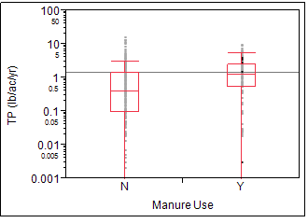
Figure 11. Box plot of TP loading rates in surface runoff, runoff from nonmanured vs. manured land, all land use groups combined.

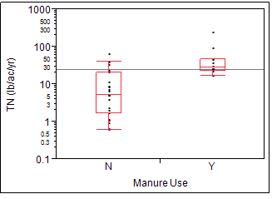
Figure 12. Box plots of TN loading in surface runoff from nonmanured vs. manured corn, grain – fall fallow land use group.
Tetra Tech also performed a limited number of hypothesis tests on the TMDL-derived agricultural load data. As noted for literature-based data, groups with <10 observations were generally excluded from the analyses, except for AFO/CAFO and nursery data. The results of the analyses are summarized in
Table 17. As noted above, due to violations of test assumptions, results must be interpreted with caution.

Clearly, TP loads from AFOs and CAFOs are much greater than those from cropland and hay/pasture. The small sample size for both AFOs/CAFOs (n=7) and nurseries (n=6), however, complicates interpretation of the results. The smallest TSS loads were reported for hay and pasture for both water body and EoF delivery. TSS loads from nurseries were not significantly different from those from hay and pasture for water body delivery.

Table 17. Comparison of agricultural land use group median loading rates by manure use, by Mann-Whitney test
Parameter | Delivery | Group Median (lb/ac/yr)
Parameter | Delivery | AFO/CAFO | All Cropland | All Hay/Pasture | Nurseries
TP | TMDL–Water body | 382 a | 0.78 b | 0.25 c | 97 a
TN | TMDL–Water body | (no data) | 9.51 a | 5.61 a | (no data)
TSS | TMDL–Water body | 3392 a | 4978 a | 741 b | 2342 a,b
TSS | TMDL–EoF | 14060 a | 11370 a | 3000 b | 16160 a
Note:
Within rows, group medians followed by the same letter(s) are not significantly different, P < 0.05.

7.0 Relative Ranking of Unit Area Loading Rates

The literature about forested and agricultural land uses provides a critical source of data for developing the loading rates for each land use. The literature reviews in conjunction with multiple models can be used to order the influence of different land uses. The targets vary geographically based on nutrient and hydrology inputs.

The land-to-water factors of the Spatially Referenced Regression on Watershed (SPARROW) model and the small streams work undertaken by the Interstate Commission on the Potomac River Basin (ICPRB) provide additional geographic variation based on watershed characteristics. Other variation, caused by BMPs and changes in animal numbers and acres of land use occur when the model scenarios are run, is not reflected in the calibration targets.

SPARROW is a spatial regression model and one of its primary strengths is spatial quantification of differences between land use loads. When SPARROW is run with land uses as the regression parameters, the regression coefficients are equivalent to loading rates at an edge-of-small-stream scale. The U.S. Geographical Survey (USGS) completed an initial run with National Land Cover Database (NLCD) land classes in November and December 2014 (Table 18). The large NLCD land use groups provide the primary information for ranking land use loading rates.

Table 18. SPARROW coefficients where NLCD is used as the regression parameters
Land Use | Nitrogen  (lb/acre) | Phosphorus (lb/acre)
Cropland | 24.02583 | 0.841825
Forest | 1.196007 | 0.065515
Pasture | 17.20183 | 0.477629
Point source | 0.007409 | 0.007693
Urban | 9.350863 | 0.503623
Wetland | 0 | 0.820798
Source: USGS November 2014 for nitrogen and December 2014 for phosphorus.

7.1 Scaling Data Geographically
Calibration targets are further refined to include variation by land segment using the hydrology, Annual Phosphorus Loss Estimator (APLE), nutrient inputs, and Recommendations for PQUAL Sensitivity to Inputs (Yactayo et al. 2014). Targets in Phase 6 are at the scale of EoF. If EoF data are not available, the information ICPRB uses to develop the small stream factor can be applied to determine EoF from the edge-of-stream scale. Refinement of the loading rates to the land-river segment scale will be completed as part of a separate project using the small stream work (<100 cubic feet per second) conducted by ICPRB, SPARROW land-to-water ratio, and i-Tree Hydro model.
7.2 Literature Loading Rates
The literature and TMDL loading rates are generally represented by the minimum, maximum, average, median, and 25th and 75th percentiles. Many of the land uses show the data to be skewed, so the median is used, except where noted otherwise.

The median is assumed to be the exported load from the median of the mass balance of inputs. To develop the relationship with the nutrient inputs including fertilizers, manures, and atmospheric deposition, the CBP sensitivity analysis will be incorporated by the CBP. APLE will be incorporated as recommended by CBP staff for calibrating phosphorus in agricultural land uses.

7.3 Building Consensus
The CBP Partnership provides critical information in addition to the full literature review. Input from the various workgroups and expert panels, in addition to workgroup documents and recommendations, and available literature are key sources of data for developing the loading rate targets. The Modeling Workgroup approves the final Phase 6 CBWM, including the targets. CBP has been asked for input at the following meetings, all in 2014:

CBP committees, goal implementation teams, workgroups, or action teams | Meeting Date(s)
Modeling Workgroup | 09/15/14
Agricultural Modeling Subcommittee | 09/16/14 and 12/16/14
Land Use Workgroup | 09/25/14
Modeling Quarterly Review | 09/30/14
Forestry Workgroup | 10/01/14
Watershed Technical Workgroup | 10/02/14
Agricultural Workgroup | 10/09/14 and 10/22/14
Urban Workgroup | 10/21/14 and 12/16/14
Wetlands Expert Panel | 11/12/14

8.0 Summary and Conclusions
8.1 Forest Land Use Results Overview
Out of the 216 forestry-related documents that Tetra Tech reviewed, we identified 80 of them (e.g., articles and reports) that contained useful land use data. The result of our in-depth review was finding more than 500 entries concerning various land uses and parameters, with most of the data coming from in-stream rather than EoF concentrations. From 64 TMDL reports, more than 1,300 entries were obtained. On the basis of the histograms, neither data set was a normal distribution (e.g., data are skewed).

The available data for some forest land use categories were limited, making specific recommendations difficult because of the possibility that the data represented only extremes within those land uses. Data for disturbed forest categories (e.g., harvested and clearcut) and specific forest types (e.g., coniferous and deciduous) were especially scarce. More data are needed to support conclusions regarding loading rates from those specific forest land uses as opposed to general undisturbed forest.

The range of TP loads from the literature and TMDLs was 0.02–275.7 lbs/acre/yr. Review of data from both sources showed that the median TP loading rates for undisturbed forests were generally lower than for harvested/clearcut forests, which was expected. Even with the limited number of data sources, the results suggest that forest and harvested or clearcut forest be separated into independent land uses in the CBWM. It was difficult to make direct comparisons between literature values and TMDL values since data was not always available for the same land use type from each data source (see Table 3 through Table 6 and Attachment C). There also were too few observations about disturbed forest TP loads from both data sources to make a meaningful comparison. Median TP loads for undisturbed forest were the only loads found to significantly differ pre- and post-1990—loads were higher before 1990—but TP loads do not significantly differ within and outside the watershed.

The range of TN loads from the literature and TMDLs was 0.02–12.3 lbs/acre/yr. The only land use for which there was data available for comparison from the two sources was undisturbed forest. The maximum TMDL loads were higher than those that the literature contained; however, the median loads were lower. The median TN loads for undisturbed forest showed little variation for any of the different land uses, pre- or post-1990; or within or outside the CBW. There were not enough TN data available for disturbed forests to make any meaningful comparison between disturbed and undisturbed forest.

The range of NO₃ loads from the literature and TMDLs was 0–31.3 lbs/acre/yr. There was no NO₃ data found in the TMDLs, so only data from the literature were reviewed. The median nitrate values for both clearcut and harvested forest are both higher than for undisturbed forest, which was expected. There were not enough NO₃ data to analyze loads pre- and post-1990 or within or outside the watershed.

The range of TSS loads from the literature and TMDLs was 0–12,417,771 lbs/acre/yr. The literature contained only eight TSS observations and nine EoF observations, while the TMDL reports contained 335 TSS observations. This lack of TSS data made comparisons between the literature and TMDL reports difficult. As with TP, TSS median loading rates for disturbed forest exceeded loadings for undisturbed forest. There were not enough TSS data to analyze loads pre- and post-1990 or within or outside the watershed.

8.2 Agricultural Land Use Results Overview
Tetra Tech found a wide range of annual loading rates in the agricultural literature. Commodity crops tended to have greater loading rates than forage and hay, with median annual TP loads of about 0.2 for forage and hay and about 0.9 lb P/ac/yr for commodity crops. Median rates for TN, NO₃, TSS, and total sediment were also higher for commodity crops than for forage and hay, by factors ranging from 3 to 8. Similarly, loads of TP, TN, and TSS were also greater for cropland than for hay and pasture in data obtained from TMDLs.

Tetra Tech employed nonparametric hypothesis testing to make inferences about the assembled data in support of TP, TN, NO₃, and TSS export coefficients selection for specific CBW land uses. This analysis assessed potential differences in loading rates among loss pathways and land use groups, and tested the influence of study scale, date of research, soil type, precipitation, slope, and manure application on loading rates reported in the literature.

Hypothesis testing on literature-derived data had the following principal results:
- For most of the analyzed pollutants, reported loading rates differ significantly among surface runoff, shallow groundwater, and tile drain/ditch flow loss pathways.
- Reported TP, TN, NO₃, and TSS loading rates tend to be significantly higher from commodity crop land uses than from forage and hay land uses.
- Significant differences in reported loading rates were documented across land use groups. Median loading rates and significant differences among the specific land use groups were reported for each loss pathway to the extent allowed by available data. As a general pattern, TP, TN, NO₃, and TSS loading rates in surface runoff from the different types of corn cropland tend to be higher than losses from croplands in small grains, and all those groups tend to export TP and TN at higher rates than forage and pasture.
- Overall, the data do not indicate a significant difference or a consistent pattern in loading rates determined from plot, field, or watershed study scales for most pollutants for which sufficient data were available. However, for some specific land use groups and pollutants, significant scale effects were observed.
- A strong pattern was observed for reported TP, TN, and NO₃ loading rates to be significantly higher in research published since 1995 than in older work. Many of the differences were very large. A similar pattern was not observed for TSS.
- Differences in reported loading rates between studies done on CBW vs. non-CBW soils were varied and inconsistent. Overall, loading rates reported from CBW and non-CBW were not dramatically different. However, significant differences were observed for some specific land use groups. Consequently, the importance of soil order in applying the literature loading values should be evaluated on a case-by-case basis.
- Loading rates reported under wet conditions (i.e., precipitation >10 percent above normal) tended to be significantly higher than rates reported from normal or dry conditions, although the differences were not significant in all cases. Few significant differences were observed between rates reported for dry vs. normal precipitation conditions.
- Differences among loading rates reported for different slope conditions were varied and inconsistent. Differences in observed loading rates do not support a consistent inference about the influence of slope on loading rates.
- Significant differences were observed in loading rates reported from studies with and without manure application. In general, manure application tended to enhance reported phosphorous and nitrogen loading rates from agricultural land, while tending to reduce reported TSS loads.

The principal results of hypothesis testing on TMDL-derived data involved comparison of loads from land use categories. Unlike the literature-derived data, the TMDL data included loads for AFOs/CAFOs and for nurseries. Small sample sizes for these two additional land use categories, however, dictate that caution be used when interpreting the findings for them. Results of nonparametric analysis showed that TP loads from AFOs and CAFOs are much greater than those from cropland and hay/pasture. TP and TSS loads from cropland were greater than those from hay and pasture, consistent with findings from the literature-based data analyses. Cropland TN loads were also greater than those from hay and pasture, but the results were not statistically significant. TSS loads from nurseries were not significantly different from those from AFOs/CAFOs or cropland. TSS loads from hay and pasture were lowest among all the categories.

8.3 Potential Future Efforts
While Tetra Tech conducted an in-depth literature search, it is possible there still might be literature available for review that was not found. In addition, there were several articles and books that we were unable to obtain for the literature review. Because of time and resources, Tetra Tech focused the TMDL report search and review on the watershed and surrounding states. The search could be expanded to other states. In addition, the focus was on literature with available data in tabular form or listed in the text. Some literature sources contained plots, but did not have loading values that could be easily retrieved from the document. It could be possible to contact the author to obtain the data used to develop the graphics.

Additional analysis could be conducted on the existing data. Examples of additional analyses include:
- Looking at different nitrogen and phosphorus species for analysis. While not a lot of data are available for different species, some species data could be useful. For example, ammonia, nitrate, or organic phosphorus could be used to compare forest and brush/scrub from TMDLs. Nitrate concentrations could be used to look at the difference in forest and harvested forest in the literature.
- Performing statistical analyses on land uses that had fewer than 5 data points.

Because some land uses are underrepresented with limited data, land use-specific monitoring could be beneficial, although it is difficult to identify a watershed that drains only one land use type. Additional monitoring could be tailored to look at the water quality of streams affected by single land uses.

9.0 References
Agriculture Modeling Subcommittee. June 2014. Current proposed agricultural land uses.
Peter Claggett. 2014. Current proposed nonagricultural land uses. Personal communication, July 28, 2014.
Tetra Tech. 2014. Land Use Loading Literature Review Task Summary and Results. Technical Memorandum March 31, 2014. Prepared for Chesapeake Bay Program, U.S. Environmental Protection Agency, by Tetra Tech, Inc., Fairfax, VA.
Yactayo, G., R. Tian, G. Shenk, L. Linker, G. Bhatt. 2014. Recommendations for PQUAL Sensitivity to Inputs. Unpublished paper, Chesapeake Bay Program. Annapolis, MD.

Attachment A: Parameter Standardization

Table 19. Water quality parameter standardization for data from forest literature
Original Parameter | Standardized Parameter
Ammonia | Ammonia
Ammonium | Ammonium
dissolved inorganic nitrogen | DIN
Dissolved nitrite plus nitrate plus dissolved ammonia | DIN
Dissolved ammonia | Diss. Ammonia
Dissolved nitrogen | Diss. N
Dissolved nitrate | Diss. Nitrate
Dissolved organic phosphate | Diss. Org. P
Dissolved Phosphorus | Diss. T. Phos
soluble phosphorus | Diss. T. Phos
Total dissolved phosphorus | Diss. T. Phos
total soluble phosphorus | Diss. T. Phos
Dissolved nitrite plus nitrate | Dissolved NO2+NO3
Dissolved Kjeldahl N | DKN
Dissolved organic nitrogen | DON
Dissolved organic nitrogen (DON) | DON
Inorganic nitrogen | Inorg. N
Nitrate | Nitrate
Nitrite | Nitrite
nitrate-nitrite | NO2+NO3
Nitrite and nitrate | NO2+NO3
Organic N | Organic N
Organic nitrogen | Organic N
Organic phosphorus | Organic P
Orthophosphate | Orthophosphate
Orthophosphorus | Orthophosphate
Phosphate | Orthophosphate
Phosphate phosphorus | Orthophosphate
Particulate nitrogen | Particulate Nitrogen
Particulate Phosphorus | Particulate Phosphorus
Sorbed phosphorus | Particulate Phosphorus
Soil loss | Soil Loss
Dissolved orthophosphate | Soluble Phosphate
dissolved reactive phosphorus | Soluble Phosphate
soluble reactive phosphorus | Soluble Phosphate
SRP | Soluble Phosphate
TKN | TKN
Total Nitrogen | TN
Total Phosphorus | TP
TP | TP
Sediment | TSS
suspended sediment | TSS
TSS | TSS

Table 20. Water quality parameter standardization for data from agricultural and forest TMDLs
Original Parameter | Standardized Parameter
Ammonia | Ammonia
BOD | BOD
Dis N | Diss. N
NH3 | Ammonia
Nitrite plus Nitrate | NO2+NO3
NOX | NO2+NO3
Organic Nitrogen | Organic N
Organic Phosphorus | Organic P
ORN | Organic N
ORP | Organic P
Phosphate | Orthophosphate
Phosphorus | TP
PO4 | Orthophosphate
Sed | TSS
Sediment | TSS
Sediments | TSS
TN | TN
TN (lb/d) | TN
Total N | TN
Total P | TP
Total Phosphorus | TP
TP | TP
TP (lb/d) | TP
TSS | TSS

Attachment B: Land Use Standardization

Table 21. Land use standardization for data from agricultural literature review
CBW Land Use Category | Land Use Group  CBW subcategoryª or other group name | Examples of literature-defined land uses included in land use group
Commodity | Corn rotation* | - Corn in rotation  - Corn, oats  - No-till corn–wheat rotation
Commodity | Corn, grain–fall fallow | - Continuous corn for grain  - Corn for grain, rotation
Commodity | Corn, silage–fall fallow | - Corn silage  - Continuous corn (silage)
Commodity | Corn, grain–fall small grain | - Continuous corn for grain–rye cover  - No-till corn–wheat rotation
Commodity | Corn, silage–fall small grain | - Corn silage with winter rye cover crop
Commodity | Corn, unspecified* | - Corn (Zea mays L.)  - Continuous corn
Commodity | Corn–soybean rotation* | - Corn (Zea mays L.)–Soybean (Glycine max L.) Rotation  - Corn–soybean rotation
Commodity | Cotton/cotton rotation* | - Cotton  - Cotton, oats, sorghum rotation
Commodity | Misc. rotation* | - Beans (Phaseolus vulagaris L.) -Wheat (Triticum aestivum L.)  - Mixed grass, cotton, oats, sorghum  - Row and vegetable crops, hay, and pasture  - Soybeans, corn, sorghum, wheat
Commodity | Small grain rotation* | - Small grain rotation  - No-till soybean–rye rotation  - Oats in rotation  - Conventional-till rye–corn–wheat rotation
Commodity | Small grain–fallow | - Small grain rotation  - Wheat
Commodity | Small Grain–forage established | - Wheat  - Wheat/grazing
Commodity | Small Grain–Soybean double crop–fall fallow | - Oats in rotation  - Wheat
Commodity | Sorghum* | - Grain sorghum  - Sorghum
Commodity | Soybean (full season)–fall fallow | - Soybeans
Commodity | Soybean (full season)–fall small grain | - Soybeans with rye cover crop
Commodity | Wheat rotation* | - Forage Sorghum (Sorghum bicolor L. Moench) - Wheat (Triticum aestivum L.) Double Crop  - Wheat–sorghum  - No-till wheat–soybean–rye rotation  - Wheat (Triticum aestivum L.) - Corn (Zea mays L.) - Sorghum (Sorghum bicolor L.)  - Rye, corn, wheat rotation
Forage and Hay | Forages, Legume | - Alfalfa  - Alfalfa hay in rotation
Forage and Hay | Forage, Nonlegumes | - Coastal bermudagrass  - Kentucky bluegrass  - Native grass  - Fescue
Forage and Hay | Forage, mixed* | - Alfalfa and bromegrass hay  - Orchard grass with alfalfa
Forage and Hay | Pastured cropland and Pasture | - Grazing  - Blue grama and buffalo grass  - Range  - Pasture
Mixture | Mixture* | - 31% Cropland, 27% Forest, 18% Pasture, 10% Non-Ag, 9% Other, 4% Inactive Ag Land, 2% Farmstead  - 63.4% Agriculture, 26% Forest, 1.1% Urban  - Agriculture (row crops, pasture, hay)
Specialty and Other | Apple orchard* | - Apple orchard
TBD | Fallow/bare soil* | - Continuous bare soil  - Fallow
Note:
* A non-CBW group name.
ª List does not include CBW land use categories/subcategories for which loading data were not found.

Table 22. Land use standardization for data from forest literature review
Original Land Use | Standard
Clear cut | Clearcut
Clearcut | Clearcut
clearcut and burned | Clearcut
Clearcut and cultivated | Clearcut
Clearcut harvesting | Clearcut
Coniferous | Coniferous forest
Coniferous forest | Coniferous forest
Deciduous | Deciduous forest
Deciduous forest | Deciduous forest
Forest | Forest
Forest (pre-harvest) | Forest
Forest (Regrowth after clearcut and burned) | Forest
Forest (regrowth after clearcut) | Forest
Mature Hardwood | Forest
No harvesting | Forest
Preserved forest | Forest
Undisturbed Forest | Forest
Wooded | Forest
Woodlands | Forest
Woods | Forest
Forest/rural open | Forest/rural open
Forest/shrubland | Forest/shrubland
Depleted Forest | Harvested
Forest (altered by cutting) | Harvested
Forest (post-harvest) | Harvested
Harvested | Harvested
Logged | Harvested
Patch cut | Harvested
Selection harvesting | Harvested
Thinned Forest | Harvested
Managed Forest | Managed Forest
Mixed forest | Mixed forest
Riparian Forest Buffer System | Riparian Forest Buffer
Stream corridor | Stream corridor
Undeveloped | Undeveloped
Upland forest | Upland forest
Wood/range | Forest/shrubland

Table 23. Land use standardization for data from agricultural TMDL document review
Original Land Use | Standardized Land Use | Generalized Land Use
AFO | AFO | AFO/CAFO
Animal Feeding Operations | AFO | AFO/CAFO
Ag/Pasture | Agriculture | Agriculture
Ag_2 | Agriculture | Agriculture
Agriculture | Agriculture | Agriculture
Inactive Farmland | Agriculture | Agriculture
Pasture/Crop | Agriculture | Agriculture
Pasture/Hay/Livestock | Agriculture | Agriculture
Pasture/Rangeland | Agriculture | Agriculture
Pastures/CAFOs | Agriculture | Agriculture
CAFO | CAFO | AFO/CAFO
cattle grazed pasture | Cattle-Grazed pasture | Hay and Pasture
Cattle-Grazed pasture | Cattle-Grazed pasture | Hay and Pasture
Conservation till | Conservation till | Cropland
conservation tillage | Conservation till | Cropland
Conventional till | Conservation till | Cropland
Conventional tillage | Conservation till | Cropland
conventional tillage | Conventional tillage | Cropland
crop/pasture | Crop/pasture | Cropland
crop | Cropland | Cropland
Crop | Cropland | Cropland
Cropland | Cropland | Cropland
Cultivated | Cropland | Cropland
Cultivated crop | Cropland | Cropland
Harvested Crop | Cropland | Cropland
Farmstead | Farmstead | Farmstead
hay | Hay and Pasture | Hay and Pasture
hay | Hay and Pasture | Hay and Pasture
Hay & Pasture | Hay and Pasture | Hay and Pasture
Hay and Pasture | Hay and Pasture | Hay and Pasture
Hay Pasture | Hay and Pasture | Hay and Pasture
Hay/Past | Hay and Pasture | Hay and Pasture
Hay/Pasture | Hay and Pasture | Hay and Pasture
Pasture/Hay | Hay and Pasture | Hay and Pasture
Pasture–Hay | Hay and Pasture | Hay and Pasture
Hi till cropland | High till row crop | Cropland
High till row crop | High till row crop | Cropland
Hightillage | High till row crop | Cropland
HighTillageCropland | High till row crop | Cropland
Row Crop high till | High till row crop | Cropland
Row crop-high till | High till row crop | Cropland
row crops high till | High till row crop | Cropland
High Till with manure | High till with manure | Cropland
High Till without manure | High till without manure | Cropland
High Till | High tillage | Cropland
High Till | High tillage | Cropland
high tillage | High tillage | Cropland
Low till (with manure) | Low till (with manure) | Cropland
Low tillage | Low till row crop | Cropland
Low Till | Low till row crop | Cropland
Low till row crop | Low till row crop | Cropland
low tillage | Low till row crop | Cropland
Low-till cropland | Low till row crop | Cropland
Lowtillage | Low till row crop | Cropland
LowTillageCropland | Low till row crop | Cropland
Row Crop low till | Low till row crop | Cropland
Row crop-low till | Low till row crop | Cropland
row crops low till | Low till row crop | Cropland
Nursery | Nursery | Nursery
Nursey | Nursery | Nursery
Orchards | Orchards | Nursery
Natural grass | Pasture | Hay and Pasture
Pasture | Pasture | Hay and Pasture
Pasture | Pasture | Hay and Pasture
Pasture 1 | Pasture | Hay and Pasture
Pasture 2 | Pasture | Hay and Pasture
Pasture 3 | Pasture | Hay and Pasture
pasture fair | Pasture | Hay and Pasture
pasture good | Pasture | Hay and Pasture
Pasture/Grass | Pasture | Hay and Pasture
Pastureland | Pasture | Hay and Pasture
improved pasture | Pasture improved | Hay and Pasture
Improved pasture | Pasture improved | Hay and Pasture
pasture improved | Pasture improved | Hay and Pasture
Overgrazed pasture | Pasture overgrazed | Hay and Pasture
pasture overgrazed | Pasture overgrazed | Hay and Pasture
Pasture–Overgrazed | Pasture overgrazed | Hay and Pasture
unimproved pasture | Pasture unimproved | Hay and Pasture
pasture poor | Pasture unimproved | Hay and Pasture
pasture unimproved | Pasture unimproved | Hay and Pasture
pastureunimproved | Pasture unimproved | Hay and Pasture
unimproved pasture | Pasture unimproved | Hay and Pasture
riparian pasture | Riparian pasture | Hay and Pasture
Row Crop | Row Crop | Cropland
Row Crop | Row Crop | Cropland
Row Crops | Row Crop | Cropland
RowCrop | Row Crop | Cropland
Trampled pasture | Trampled pasture | Hay and Pasture
Table 24. Land use standardization for data from forest TMDL document review
Original Land Use | Standardized Land Use | Generalized Land Use
barren | Barren | Barren
disturbed forest | Disturbed forest | Forest-Disturbed
forest | Forest | Forest
Bare Rock/Sand/Clay | Barren | Barren
Barren | Barren | Barren
Barren | Barren | Barren
Barren (Constuction) | Barren | Barren
Barren land | Barren | Barren
Brush/Scrub | Brush/Scrub | Brush/Scrub
Brushland/Rangeland | Brush/Scrub | Brush/Scrub
Coal Mines | Coal Mines | Extractive
Coal_Mines | Coal Mines | Extractive
CONIF FOR | Coniferous Forest | Forest
CONIF FOREST | Coniferous Forest | Forest
CONIF_FOR | Coniferous Forest | Forest
CONIF_FOREST | Coniferous Forest | Forest
Conifer Forest | Coniferous Forest | Forest
Coniferous | Coniferous Forest | Forest
Coniferous Forest | Coniferous Forest | Forest
DECID FOR | Deciduous Forest | Forest
DECID FOREST | Deciduous Forest | Forest
DECID_FOR | Deciduous Forest | Forest
DECID_FOREST | Deciduous Forest | Forest
Deciduous | Deciduous Forest | Forest
Deciduous Forest | Deciduous Forest | Forest
DeciduousForest | Deciduous Forest | Forest
Disturb. Forest | Disturbed forest | Forest-Disturbed
disturbed forest | Disturbed forest | Forest-Disturbed
Evergreen Forest | Evergreen Forest | Forest
EvergreenForest | Evergreen Forest | Forest
Extractive | Extractive | Extractive
Forest | Forest | Forest
Forest | Forest | Forest
Forest disturb | Disturbed forest | Forest-Disturbed
Forest disturbed | Disturbed forest | Forest-Disturbed
Forest_1 | Forest | Forest
Forest_2 | Forest | Forest
Forest_3 | Forest | Forest
Forest-disturbed | Disturbed forest | Forest-Disturbed
Forested | Forest | Forest
harvest forest | Harvest forest | Forest-Harvest
Harvested Forest | Harvest forest | Forest-Harvest
Mixed For | Mixed Forest | Forest
Mixed Forest | Mixed Forest | Forest
MIXED_FOR | Mixed Forest | Forest
Mixed_forest | Mixed Forest | Forest
MixedForest | Mixed Forest | Forest
Quarries/StripMines/GravelPits | Extractive | Extractive
Quarry | Extractive | Extractive
Regulated contruction | Barren | Barren
Regulated Extractive | Extractive | Extractive

Attachment C: Data Summaries

Output Variables
- Parameter/Variable: The variable for which the following statistical parameters apply.
- N: Number of observations
- Mean: Arithmetic mean of observations
- StDev: Standard deviation of observations
- Minimum and Maximum: Minimum and maximum values
Note: Due to rounding by statistical software, minimum values may appear as zero when they are actually slightly greater than zero.
- Q1 and Q3: 25th and 75th percentile values, respectively, of observations
- Median: Median value of observations
- Skewness: Coefficient of skewness
As a simple rule of thumb, values less than -1 (negative skew) and greater than 1 (positive skew) indicate an asymmetric distribution.

Attachment C.1: Forestry Data from Literature Review
Key:
- F = Forestry
- Clear = Clearcut
- Harv = Harvest
- After = Data collected after 1990
- Before = Data collected before 1990
- In = Data collected within the CBW
- Out = Data collected outside the CBW
- Varies = Data collected both within and outside the CBW
- In-After = Data collected in the CBW after 1990

All Data
Parameter N Mean StDev Minimum Q1 Median Q3 Maximum Skewness
Nitrate 360 6.16 9.85 0.004 0.123 0.553 5.42 31.3 1.4
TN 429 2.84 2.40 0.205 1.23 2.20 3.81 11.6 1.5
TP 435 18.1 50.0 0.02 0.16 0.33 0.81 275 3.7
TSS 66 238 256 0 21.4 69.9 522 660 0.54

By Land Use Category/Subcategory
Variable Category N Mean StDev Minimum Q1 Median Q3 Maximum Skewness
Nitrate F 24 4.76 9.75 0.00 0.04 0.34 1.79 31.3 2.0
F-All 46 6.35 9.98 0.00 0.23 1.02 7.66 31.3 1.4
F-All(After) 26 0.834 1.42 0.004 0.070 0.272 0.986 5.71 2.6
F-All(Before) 20 13.5 11.7 0.01 1.47 13.7 25.1 31.3 0.08
F-All(In) 6 0.095 0.120 0.004 0.010 0.055 0.173 0.321 1.7
F-All(Out) 29 8.44 11.2 0.01 0.25 1.00 22.1 31.3 0.90
F-All(Varies) 11 4.27 7.66 0.01 1.04 1.87 4.55 26.8 3.0
F-Clear 13 5.00 8.15 0.01 0.24 1.00 8.95 26.8 2.0
F-Clear(After) 8 0.479 0.398 0.009 0.225 0.340 0.888 1.13 0.83
F-Clear(Before) 5 12.2 9.63 2.55 3.48 13.5 20.4 26.8 0.79
F-Clear(Out) 12 3.19 5.08 0.01 0.24 0.78 3.94 14.0 1.8
F-Clear(Varies) 1 26.8 * 26.8 * 26.8 * 26.8 *
F-Harv 6 16.8 12.1 0.25 2.02 22.3 26.0 28.1 -0.84
F-Harv(After) 2 1.43 1.67 0.25 * 1.43 * 2.61 *
F-Harv(Before) 4 24.5 2.81 21.9 22.1 24.0 27.4 28.1 0.68
F-Harv(Out) 6 16.8 12.1 0.25 2.02 22.3 26.0 28.1 -0.84
F-Harv/Clear 19 8.73 10.8 0.01 0.25 2.55 21.9 28.1 0.85
F-Harv/Clear(After) 10 0.668 0.769 0.009 0.230 0.340 1.03 2.60 2.0
F-Harv/Clear(Before) 9 17.7 9.54 2.55 8.95 21.9 26.1 28.1 -0.63
F-Harv/Clear(Out) 18 7.73 10.2 0.01 0.25 1.84 16.0 28.1 1.0
F-Harv/Clear(Varies) 1 26.8 * 26.8 * 26.8 * 26.8 *
F(After) 13 0.220 0.283 0.004 0.018 0.095 0.344 0.981 1.8
F(Before) 11 10.1 12.6 0.01 1.04 1.95 24.4 31.3 0.76
F(In-After) 18 0.095 0.113 0.004 0.012 0.055 0.123 0.321 1.4
F(In) 6 0.095 0.120 0.004 0.011 0.055 0.173 0.321 1.7
F(Out) 11 9.60 13.0 0.01 0.10 0.52 24.4 31.3 0.8
F(Varies) 7 1.15 0.850 0.009 0.228 1.16 1.95 2.38 0.02
F_All(In-After) 18 0.095 0.113 0.004 0.012 0.055 0.123 0.321 1.4
TN F 45 2.67 2.04 0.205 1.32 2.20 3.57 8.60 1.5
F-All 48 3.11 2.66 0.205 1.40 2.23 4.10 11.6 1.6
F-All(After) 35 3.13 2.82 0.205 1.20 2.23 4.28 11.6 1.4
F-All(Before) 13 3.08 2.31 1.23 1.90 2.20 3.27 9.81 2.4
F-All(In) 24 2.45 2.04 0.205 0.681 1.83 4.10 8.60 1.2
F-All(Out) 7 3.86 3.16 1.13 1.78 2.48 8.40 8.47 1.1
F-All(Varies) 17 3.75 3.12 1.23 1.90 2.23 4.58 11.6 1.7
F-Clear 1 9.81 * 9.81 * 9.81 * 9.81 *
F-Clear(Before) 1 9.81 * 9.81 * 9.81 * 9.81 *
F-Clear(Varies) 1 9.81 * 9.81 * 9.81 * 9.81 *
F-Harv/Clear 1 9.81 * 9.81 * 9.81 * 9.81 *
F-Harv/Clear(Before) 1 9.81 * 9.81 * 9.81 * 9.81 *
F-Harv/Clear(Varies) 1 9.81 * 9.81 * 9.81 * 9.81 *
F(After) 33 2.72 2.29 0.205 1.17 2.23 4.00 8.60 1.4
F(Before) 12 2.52 1.17 1.23 1.84 2.16 2.91 5.58 1.8
F(In-After) 72 2.45 2.02 0.205 0.68 1.83 4.10 8.60 1.1
F(In) 24 2.45 2.04 0.205 0.68 1.83 4.10 8.60 1.2
F(Out) 7 3.86 3.16 1.13 1.78 2.48 8.40 8.47 1.1
F(Varies) 14 2.44 1.10 1.23 1.78 2.16 2.82 5.58 2.0
F_All(In-After) 72 2.45 2.02 0.205 0.681 1.83 4.10 8.60 1.1
TP F 57 22.1 56.0 0.02 0.14 0.32 0.89 276 3.3
F-All 64 20.2 53.1 0.02 0.13 0.32 1.78 276 3.5
F-All(After) 32 1.32 5.36 0.025 0.098 0.212 0.502 30.5 5.6
F-All(Before) 32 39.1 70.5 0.1 0.2 0.6 50.6 276 2.3
F-All(In) 7 0.392 0.202 0.025 0.286 0.400 0.562 0.610 -0.93
F-All(Out) 20 1.76 6.77 0.04 0.08 0.16 0.38 30.5 4.5
F-All(Varies) 37 34.0 66.8 0.1 0.2 0.6 37.0 276 2.5
F-Clear 3 10.9 17.0 0.21 0.21 2.05 30.50 30.5 1.7
F-Clear(After) 2 15.4 21.4 0.2 * 15.4 * 30.5 *
F-Clear(Before) 1 2.05 * 2.05 * 2.05 * 2.05 *
F-Clear(Out) 2 15.4 21.4 0.2 * 15.4 * 30.5 *
F-Clear(Varies) 1 2.05 * 2.05 * 2.05 * 2.05 *
F-Conif 1 0.394 * 0.394 * 0.394 * 0.394 *
F-Conif(After) 1 0.394 * 0.394 * 0.394 * 0.394 *
F-Conif(Out) 1 0.394 * 0.394 * 0.394 * 0.394 *
F-Decid 1 0.334 * 0.334 * 0.334 * 0.334 *
F-Decid(After) 1 0.334 * 0.334 * 0.334 * 0.334 *
F-Decid(Out) 1 0.334 * 0.334 * 0.334 * 0.334 *
F-Harv 1 0.113 * 0.113 * 0.113 * 0.113 *
F-Harv(After) 1 0.113 * 0.113 * 0.113 * 0.113 *
F-Harv(Out) 1 0.113 * 0.113 * 0.113 * 0.113 *
F-Harv/Clear 4 8.22 14.9 0.11 0.14 1.13 23.4 30.5 2.0
F-Harv/Clear(After) 3 10.3 17.5 0.1 0.1 0.2 30.5 30.5 1.7
F-Harv/Clear(Before) 1 2.05 * 2.05 * 2.05 * 2.05 *
F-Harv/Clear(Out) 3 10.3 17.5 0.1 0.1 0.2 30.5 30.5 1.7
F-Harv/Clear(Varies) 1 2.05 * 2.05 * 2.05 * 2.05 *
F(After) 26 0.284 0.249 0.025 0.094 0.205 0.405 0.977 1.3
F(Before) 31 40.3 71.3 0.1 0.2 0.6 53.5 276 2.2
F(In-After) 21 0.392 0.192 0.025 0.286 0.400 0.562 0.610 -0.77
F(In) 7 0.392 0.202 0.025 0.286 0.400 0.562 0.610 -0.93
F(Out) 16 0.267 0.274 0.036 0.085 0.156 0.379 0.977 1.8
F(Varies) 34 36.8 69.0 0.1 0.2 0.4 44.8 276 2.4
F_All(In-After) 21 0.392 0.192 0.025 0.286 0.400 0.562 0.610 -0.77
TSS F 6 184 226 0 16.1 69.9 444 522 0.99
F-All 8 220 269 0 5.4 69.9 496 660 0.83
F-All(After) 8 220 269 0 5.4 69.9 496 660 0.83
F-All(In) 1 63.1 * 63.1 * 63.1 * 63.1 *
F-All(Out) 7 243 282 0 0 77 522 660 0.58
F-Clear 1 660 * 660 * 660 * 660 *
F-Clear(After) 1 660 * 660 * 660 * 660 *
F-Clear(Out) 1 660 * 660 * 660 * 660 *
F-Conif 1 522 * 522 * 522 * 522 *
F-Conif(After) 1 522 * 522 * 522 * 522 *
F-Conif(Out) 1 522 * 522 * 522 * 522 *
F-Decid 1 418 * 418 * 418 * 418 *
F-Decid(After) 1 418 * 418 * 418 * 418 *
F-Decid(Out) 1 418 * 418 * 418 * 418 *
F-Harv 1 0.000002 * * * * * * *
F-Harv(After) 1 0.000002 * * * * * * *
F-Harv(Out) 1 0.000002 * * * * * * *
F-Harv/Clear 2 330 467 0 * 330 * 660 *
F-Harv/Clear(After) 2 330 467 0 * 330 * 660 *
F-Harv/Clear(Out) 2 330 467 0 * 330 * 660 *
F(After) 6 1845 226 0 16.1 69.9 444.0 522 0.99
F(In-After) 3 63.1 0 63.1 63.1 63.1 63.1 63.1 *
F(In) 1 63.1 * 63.1 * 63.1 * 63.1 *
F(Out) 5 208 244 0 11 77 470 522 0.65
F_All(In-After) 3 63.1 0 63.1 63.1 63.1 63.1 63.1 *

Attachment C.2: Forestry Data from TMDL Review
All Data
Parameter N Mean StDev Minimum Q1 Median Q3 Maximum Skewness
TN 158 1.44 3.23 0.020 0.117 0.160 0.936 12.3 2.9
TP 608 0.219 1.74 0.0003 0.003 0.010 0.036 23.9 12

By Land Use Category/Subcategory
Variable Category N Mean StDev Minimum Q1 Median Q3 Maximum Skewness
TN F 60 1.85 3.62 0.020 0.123 0.160 1.49 12.3 2.4
F-All 60 1.85 3.62 0.020 0.123 0.160 1.49 12.3 2.4
F-Conif 12 0.126 0.047 0.020 0.088 0.140 0.160 0.17 -1.2
F-Decid 15 0.193 0.136 0.070 0.110 0.150 0.220 0.46 1.4
F-Mixed 11 0.116 0.042 0.030 0.080 0.130 0.160 0.16 -0.86
TP F 215 0.199 1.69 0 0.003 0.010 0.036 23.9 13
F-All 223 0.207 1.66 0 0.003 0.010 0.067 23.9 13
F-Conif 49 0.086 0.524 0.0003 0.002 0.005 0.010 3.68 7.0
F-Decid 54 0.466 3.247 0.001 0.004 0.007 0.030 23.9 7.4
F-Disturbed 3 0.098 0.022 0.076 0.076 0.099 0.119 0.1191 -0.18
F-Harv/Disturbed 8 0.437 0.417 0.076 0.104 0.311 0.644 1.30 1.4
F-Harv 5 0.640 0.408 0.221 0.311 0.632 0.973 1.30 1.2
F-Mixed 51 0.152 0.825 0 0.002 0.007 0.017 5.78 6.7
TSS F 305 53.0 326 0 2.5 9.6 21.9 5572 16
F-All 335 7031 86029 0 3 11 43 1241771 13
F-Conif 69 5.14 6.62 0.010 0.132 3.13 7.14 37.5 2.2
F-Decid 75 19.6 25.3 0.02 7.14 11.8 18.5 138 3.1
F-Disturbed 14 165986 402181 419 2055 11483 18397 1241771 2.4
F-Harv/Disturbed 30 77976 281993 25 693 1464 11380 1241771 3.8
F-Harv 16 968 662 25 634 977 1405 2610 0.70
F-Mixed 70 7.39 13.4 0.01 0.31 3.99 9.47 98.4 5.0

Attachment C.3: Forestry EoF Data from TMDL Review
All Data
Parameter N Mean StDev Minimum Q1 Median Q3 Maximum Skewness
TSS 60 3304 2724 260 620 3500 6000 6000 -0.01

By Land Use Category/Subcategory
Variable Category N Mean StDev Minimum Q1 Median Q3 Maximum Skewness
TSS F 15 608 235 260 420 620 720 1000 -0.06
F-All 30 3304 2747 260 610 3500 6000 6000 -0.01
F-Harv_All 15 6000 0 6000 6000 6000 6000 6000 *

Attachment C.4: Agricultural Data from Literature Review
All Pathways (All Data)
Variable N Mean StDev Minimum Q1 Median Q3 Maximum Skewness
TP 476 1.40 2.18 0 0.117 0.568 1.71 16.1 3.0
TN 292 9.29 18.2 0 0.60 3.76 11.1 237 7.5
NO3 464 7.56 13.5 0 0.446 2.05 7.15 95.5 3.0
TSS 231 1366 3256 0 37 290 1334 35328 6.2
Total Sed 68 3113 10639 0 26 187 1295 61560 4.9

By Pathway
Variable Pathway N Mean StDev Minimum Q1 Median Q3 Maximum Skewness
TP Shallow GW 8 0.17 0.11 0.06 0.07 0.15 0.27 0.35 0.53
Surface 439 1.48 2.24 0 0.14 0.62 1.90 16.1 2.93
Drains/Ditches 29 0.55 0.69 0 0.08 0.21 1.19 2.44 1.52
TN Surface 292 9.29 18.2 0 0.60 3.76 11.1 237 7.50
NO3 Shallow GW 67 7.42 7.47 0.24 1.78 4.46 11.0 29.8 1.36
Surface 318 2.18 3.34 0 0.21 1.13 2.87 26.1 3.63
Drains/Ditches 79 29.3 19.9 0.27 12.5 27.7 38.4 95.5 1.06
TSS Surface 195 1497 3482 0 60 328 1450 35328 5.94
Surface+Subsrfc 6 3106 1976 437 1304 3012 5177 5521 -0.04
Drains/Ditches 30 162 208 0 8.9 52.6 264 740 1.50
Tot Sed Surface 68 3113 10639 0 26 187 1295 61560 4.87

By Land Use Category
Variable LU_Cat_Match N Mean StDev Minimum Q1 Median Q3 Maximum Skewness
TP Commodity 272 1.65 2.29 0 0.30 0.93 2.12 16.1 2.99
Forage_and_Hay 165 0.82 1.51 0 0.08 0.19 0.71 9.37 3.13
Mixture 12 3.41 2.57 0.26 1.20 3.06 5.68 8.32 0.56
TBD 27 1.57 3.15 0 0.18 0.36 1.51 13.3 3.05
TN Commodity 143 14.0 23.6 0 3.01 6.94 16.7 237 6.45
Forage_and_Hay 115 2.66 4.44 0 0.18 0.80 3.42 26.4 3.28
Mixture 13 23.5 11.8 6.33 15.8 25.4 30.6 46.4 0.36
Specialty Etc 1 0.81 * 0.81 * 0.81 * 0.81 *
TBD 20 5.19 11.3 0 0.13 1.33 3.75 48.3 3.38
NO3 Commodity 300 10.3 15.8 0 1.17 2.98 11.3 95.5 2.42
Forage_and_Hay 120 1.73 3.56 0 0.04 0.34 1.78 23.2 3.87
Mixture 9 9.46 5.24 2.63 5.61 8.55 13.1 19.7 0.80
TBD 35 4.05 6.68 0 0.27 1.61 4.91 29.8 2.91
TSS Commodity 154 1353 2473 0 95 364 1516 16966 3.51
Forage_and_Hay 52 817 1858 0 27 68 654 9827 3.29
Mixture 6 961 592 290 402 868 1570 1806 0.44
TBD 19 3099 8335 0 0 89 1543 35328 3.63
Tot Sed Commodity 41 4467 13269 0 66 393 1914 61560 3.93
Forage_and_Hay 27 1056 3673 0 15 120 509 19182 4.98

By Land Use Subcategory
Variable LU_Group N Mean StDev Minimum Q1 Median Q3 Maximum Skewness
TP Corn-soybean rotation 16 1.5 1.5 0.11 0.45 0.96 2.2 6.2 2.1
Corn rotation 1 0.27 * 0.27 * 0.27 * 0.27 *
Corn, grain-fall fallow 79 1.4 2.0 0 0.11 0.60 1.9 9.9 2.6
Corn,grain-fall sm grain 7 1.3 0.75 0.70 0.77 1.0 1.7 2.8 1.4
Corn,silage-fall fallow 36 1.9 3.0 0.02 0.04 1.3 2.0 16 3.4
Corn,silage-fall sm grain 6 4.1 4.0 0.35 0.88 3.4 6.9 11 1.2
Corn, unspecified 38 2.0 2.1 0.01 0.69 1.3 2.6 9.5 1.9
Cotton rotation 13 2.3 2.6 0.46 0.73 1.2 3.3 9.9 2.3
Fallow-bare soil 13 1.7 2.90 0.09 0.27 0.54 2.2 10 2.8
Forage, mixed 5 0.26 0.22 0.09 0.10 0.13 0.49 0.60 1.1
Forage, Non-legumes 85 0.83 1.5 0 0.09 0.25 0.67 9.4 3.4
Forages Legume 4 0.71 1.0 0.02 0.02 0.30 1.8 2.2 1.7
Misc rotation 2 4.6 1.0 3.8 * 4.6 * 5.3 *
Mixture 15 2.8 2.6 0.26 0.80 1.4 4.6 8.3 0.85
Pastured crop/Pasture 81 0.77 1.5 0 0.05 0.13 0.69 8.7 3.1
Sm grain rotation 4 0.59 0.57 0.04 0.09 0.52 1.2 1.3 0.6
Small Grain-Fallow 25 2.2 2.7 0 0.36 1.7 2.8 13 3.1
Small Grain-Forage 20 1.8 3.8 0 0.04 0.30 1.4 12 2.7
Small Grain-Soybean DC FF 6 1.9 1.3 0.58 0.90 1.4 3.0 4.1 1.1
Wheat rotation 20 0.75 0.59 0.20 0.39 0.51 0.94 2.5 1.8
TN Apple orchard 1 0.81 * 0.81 * 0.81 * 0.81 *
Corn-soybean rotation 3 3.08 0.25 2.9 2.9 3.0 3.4 3.4 1.3
Corn,grain-fall fallow 35 26 42 0.60 3.8 16 33 237 4.1
Corn,grain-fall sm grain 7 7.3 3.7 3.8 4.0 6.5 9.0 14 1.2
Corn,silage-fall fallow 4 20 5.7 12 14 22 25 26 -1.2
Corn, unspecified 38 15 12 0.03 5.2 13 21 47 2.0
Cotton rotation 8 8.6 3.3 3.7 5.4 8.8 12 12 -0.3
Fallow-bare soil 13 6.2 13 0.27 0.89 2.0 4.5 48 3.4
Forage, mixed 4 1.4 0.41 1.1 1.1 1.3 1.8 2.0 1.7
Forage, Non-legume 74 2.6 4.8 0 0.18 0.62 3.0 26 3.7
Forages Legume 2 4.3 0.90 3.6 * 4.3 * 4.9 *
Mixture 16 21 12 4.2 8.6 20 27 46 0.40
Pastured crop/Pasture 41 2.5 3.8 0 0.07 0.54 3.7 16 1.8
Sm grain rotation 3 1.6 0.80 0.80 0.80 1.5 2.4 2.4 0.33
Small Grain-Fallow 18 5.4 3.7 0 2.5 5.1 7.6 14 0.54
Small Grain-Forage 18 9.1 15 0 0.13 1.8 7.6 48 2.0
Small Grain-Soybean DC FF 1 3.8 * 3.8 * 3.8 * 3.8 *
Wheat rotation 6 5.3 3.4 2.1 2.3 4.4 8.4 10 0.87
NO3 Corn-soybean rotation 3 0.5 0.06 0.45 0.45 0.54 0.56 0.56 -1.4
Corn rotation 1 0.33 * 0.33 * 0.33 * 0.33 *
Corn,grain-fall fallow 136 14 19 0.11 1.4 5.0 20 95 1.9
Corn,grain-fall sm grain 10 5.7 5.9 0.35 2.0 4.1 7.3 20 2.0
Corn,silage-fall fallow 31 3.9 3.2 0.24 1.7 2.6 5.0 11 1.2
Corn,silage-fall sm grain 12 2.9 1.7 1.0 1.9 2.5 3.0 7.1 1.7
Corn, unspecified 8 0.32 0.36 0.02 0.05 0.19 0.52 1.1 1.5
Cotton rotation 8 3.1 1.9 0.89 1.2 2.9 4.9 5.9 0.3
Fallow-bare soil 29 4.9 7.1 0.09 0.80 2.0 5.9 29 2.7
Forage, mixed 5 0.28 0.06 0.21 0.22 0.26 0.34 0.37 0.65
Forage, Non-legumes 54 2.2 4.6 0 0.04 0.49 2.7 23 3.4
Forages Legume 13 2.2 1.4 0.56 1.2 1.7 3.4 4.7 0.86
Misc rotation 26 5.6 7.0 0.51 1.6 2.6 6.2 26 2.2
Mixture 11 8.4 5.3 2.6 4.0 8.2 12 20 0.99
Pastured crop/Pasture 54 1.1 2.6 0 0.01 0.08 0.93 144 3.7
Small Grain-Fallow 8 0.66 0.62 0 0.02 0.58 1.3 1.6 0.41
Small Grain-Forage 22 0.57 0.84 0 0.05 0.13 0.92 3.1 1.9
Small Grain-Soybean DC FF 1 1.4 * 1.4 * 1.4 * 1.4 *
Sorghum 4 4.1 0.9 3.4 3.4 3.8 5.1 5.4 1.4
Soybean-Fall Fallow 26 25 187 0.69 8.5 28 37 72 0.56
Soybean-Fall sm grain 2 20 14 9.9 * 20 * 30 *
TSS Corn-soybean rotation 6 68 126 52 58 67 80 85 0.17
Corn rotation 1 255 * 255 * 255 * 255 *
Corn,grain-fall fallow 46 236 358 0 14 144 285 1742 2.7
Corn,grain-fall sm grain 8 555 671 46 128 271 786 2065 2.0
Corn,silage-fall fallow 24 2655 2409 70 442 2358 4812 8933 0.87
Corn, unspecified 8 955 1611 1 6 207 1957 4363 1.8
Cotton rotation 11 1852 1027 804 1208 1491 2456 3813 1.1
Fallow-bare soil 7 3061 4402 89 277 1445 5763 12000 1.8
Forage, mixed 5 22 12 3.6 13 23 31 37 -0.73
Forage, Non-legumes 36 1117 2171 0 29 99 1055 9827 2.6
Forages Legume 3 12 20 0.4 0.4 0.9 36 36 1.7
Misc rotation 2 14885 2943 12804 * 14885 * 16966 *
Mixture 8 761 627 12 297 609 1358 1806 0.69
Pastured crop/Pasture 18 141 192 0 0 55 248 702 1.8
Sm grain rotation 1 1.1 * 1.1 * 1.1 * 1.1 *
Small Grain-Fallow 13 4649 9839 0 1 259 5477 35328 2.9
Small Grain-Forage 4 1386 1154 366 390 1250 2520 2680 0.25
Small Grain-Soybean DC FF 6 3241 3923 335 472 1677 6192 10472 1.6
Sorghum 4 1117 593 598 636 977 1740 1918 1.0
Wheat rotation 20 885 740 99 287 638 1145 2402 1.0
Tot Sed Corn,grain-fall fallow 10 3691 6517 105 131 890 4217 20167 2.3
Cotton rotation 2 4818 2902 2766 * 4818 * 6870 *
Forage, Non-legumes 10 647 866 27 69 216 1150 2714 1.8
Forages Legume 1 268 * 268 * 268 * 268 *
Pastured crop/Pasture 16 1361 4762 0 1 35 298 19182 4.0
Small Grain-Fallow 1 1338 * 1338 * 1338 * 1338 *
Small Grain-Forage 16 8144 20359 0 19 331 1934 61560 2.5
Soybean-Fall Fallow 12 413 680 0 0 138 470 2189 2.1

By Soils
Variable CBW_Soil N Mean StDev Minimum Q1 Median Q3 Maximum Skewness
TP N 267 1.29 1.84 0 0.178 0.535 1.70 10.5 2.7
Y 209 1.56 2.54 0 0.097 0.638 1.77 16.1 3.0
TN N 169 8.63 12.1 0 0.535 3.82 11.5 64.7 2.1
Y 123 10.2 24.2 0 0.68 3.67 11.0 237 7.2
NO3 N 261 10.2 16.7 0 0.50 2.05 11.0 95.5 2.3
Y 203 4.12 6.21 0 0.357 1.96 4.81 41.8 2.8
TSS N 152 1215 2066 0 37 316 1406 12000 2.8
Y 79 1656 4781 0 37 236 1102 35328 5.3
Tot Sed N 14 4719 6957 105 234 1237 7674 20167 1.7
Y 54 2696 11417 0 13 125 686 61560 5.0

By Slope Category
Variable Slope_Cat N Mean StDev Minimum Q1 Median Q3 Maximum Skewness
TP <2% 85 1.01 1.67 0 0.091 0.339 0.937 9.95 2.9
2-6% 249 1.72 2.26 0 0.312 0.999 2.21 16.1 2.8
>6-10% 75 1.10 2.64 0 0.032 0.132 0.671 13.3 3.7
>10% 40 0.657 0.696 0.062 0.115 0.362 0.937 2.23 1.2
Not Reported 27 1.65 10.1 0 0.18 1.52 5.18 47.1 3.0
2-6% 162 8.54 10.4 0 1.08 4.92 12.1 48.3 1.9
>6-10% 63 11.4 33.4 0 0.10 0.62 6.12 237 5.4
>10% 12 5.05 4.76 1.09 1.49 3.08 8.05 16.1 1.4
Not Reported 16 21.2 12.3 0.81 12.1 20.3 26.9 46.4 0.35
NO3 <2% 100 7.56 11.9 0 0.54 2.35 8.07 54.4 2.3
2-6% 131 4.26 6.84 0 0.446 1.87 4.19 41.8 2.9
>6-10% 84 1.23 4.09 0 0.029 0.143 1.13 26.6 5.8
>10% 12 3.87 4.48 0.23 0.33 2.13 6.48 14.4 1.4
Not Reported 137 14.9 19.3 0.21 1.90 5.53 25.1 95.5 1.9
TSS <2% 108 1056 1775 0 55 277 918 8933 2.3
2-6% 83 1458 2973 0 36 322 1703 16966 3.5
>6-10% 17 2986 8699 1 35 137 745 35328 3.6
>10% 14 1691 2780 23 28 449 2220 9827 2.3
Not Reported 9 670 643 4 133 439 1224 1806 0.8
Tot Sed <2% 4 2810 2893 268 535 2052 5844 6870 1.3
2-6% 15 1724 4870 0 0 210 1071 19182 3.8
>6-10% 40 3457 13216 0 16 109 736 61560 4.3
>10% 8 4322 7229 105 124 850 8131 20167 1.9
Not Reported 1 1695 * 1695 * 1695 * 1695.1 *

By General Precipitation
Variable Precip_Cond N Mean StDev Minimum Q1 Median Q3 Maximum Skewness
TP Dry 43 0.946 1.21 0 0.089 0.446 1.22 3.86 1.4
Normal 124 1.02 1.56 0 0.089 0.451 1.27 9.37 3.0
Wet 92 2.07 2.61 0 0.357 1.15 2.61 12.7 2.3
Not Reported 217 1.44 2.36 0 0.117 0.483 1.73 16.1 3.1
TN Dry 36 5.39 7.33 0 0.18 1.12 8.59 25.5 1.5
Normal 94 8.01 11.4 0 0.44 3.29 11.3 64.7 2.5
Not Reported 80 13.2 29.4 0 1.08 4.16 16.0 237 6.0
Wet 82 8.70 12.3 0 0.61 4.52 10.1 49.0 2.0
NO3 Dry 53 3.95 5.42 0 0.236 1.52 5.86 23.2 1.7
Normal 151 6.70 11.6 0 0.134 1.21 8.21 72.4 2.7
Not Reported 169 4.69 5.79 0.001 1.33 2.86 5.12 29.8 2.3
Wet 91 16.4 23.2 0.01 0.38 1.81 33.0 95.5 1.4
TSS Dry 36 544 612 0 105 316 792 2407 1.6
Normal 35 1386 1533 0 187 779 2309 5978 1.3
Not Reported 127 1450 4083 0 24 190 919 35328 5.6
Wet 33 1917 2555 0 157 277 4743 8933 1.2
Tot Sed Dry 8 253 482 0 0 20 404 1369 2.3
Normal 28 360 686 0 6 81 333 2714 2.6
Not Reported 2 1169 744 642 * 1169 * 1695 *
Wet 30 6575 15451 1 163 907 2989 61560 3.1

By Scale
Variable Scale N Mean StDev Minimum Q1 Median Q3 Maximum Skewness
TP Plot 88 0.742 1.46 0 0.040 0.116 0.724 10.5 4.2
Field 124 1.37 2.33 0 0.178 0.451 1.56 16.1 3.6
Watershed 264 1.64 2.26 0 0.214 0.793 2.30 13.3 2.6
TN Field 47 7.14 12.6 0 0.18 1.23 8.66 64.7 2.8
Plot 33 7.86 10.0 0.01 2.40 4.04 8.71 48.3 2.6
Watershed 212 9.99 20.1 0 0.54 4.20 11.9 237 7.4
NO3 Field 102 3.93 5.50 0 0.256 1.767 5.06 25.7 2.0
Plot 170 14.1 19.3 0 0.97 3.88 25.9 95.5 1.8
Watershed 192 3.68 6.28 0 0.277 1.485 4.10 41.8 3.2
TSS Field 73 1395 2941 0 35 277 1321 16966 3.5
Plot 89 1064 2080 0 18 193 716 12000 3.0
Watershed 69 1724 4565 10 97 572 1523 35328 6.3
Tot Sed Field 2 1169 744 642 * 1169 * 1695 *
Plot 20 1977 4835 0 56 187 1311 20167 3.3
Watershed 46 3691 12552 0 21 163 1210 61560 4.3

By Delivery
Variable Delivery N Mean StDev Minimum Q1 Median Q3 Maximum Skewness
TP Delivered 13 3.21 2.57 0.257 1.03 2.28 5.30 8.32 0.68
EoF 463 1.35 2.14 0 0.112 0.535 1.70 16.1 3.2
TN Delivered 14 23.4 11.4 6.33 16.2 23.2 28.9 46.4 0.42
EoF 278 8.58 18.2 0 0.54 3.38 9.12 237 7.9
NO3 Delivered 9 9.46 5.24 2.63 5.61 8.55 13.1 19.7 0.80
EoF 455 7.52 13.6 0 0.446 1.95 6.50 95.5 3.0
TSS Delivered 6 961 592 290 402 868 1570 1806 0.44
EoF 225 1377 3297 0 36 277 1275 35328 6.2
Tot Sed EoF 68 3113 10639 0 26 187 1295 61560 4.9

By Publication Year
Variable Era N Mean StDev Minimum Q1 Median Q3 Maximum Skewness
TP Pre-1995 163 1.14 2.23 0 0.07 0.26 1.13 13.3 3.7
1995-Present 313 1.54 2.14 0 0.20 0.73 2.05 16.1 2.8
TN Pre-1995 139 8.46 23.2 0 0.27 2.77 7.49 237 7.5
1995-Present 153 10.0 11.9 0 1.07 5.08 16.3 47.1 1.4
NO3 Pre-1995 223 2.68 5.81 0 0.13 0.78 2.20 41.8 3.8
1995-Present 241 12.1 16.7 0 1.77 4.72 15.7 95.5 2.2
TSS Pre-1995 112 1828 3928 0 55 489 2176 35328 6.1
1995-Present 119 931 2398 0 36 193 705 16966 4.7
Tot Sed Pre-1995 60 2952 11050 0 19 165 1143 61560 4.9
1995-Present 8 4322 7229 105 124 850 8131 20167 1.9

Attachment C.5: Agricultural Data from TMDL Review
Key:
- A = Agriculture
- Crop = Cropland
- Past = Pasture
- ConsTill = Conservation Tillage
- HiTill = High Till
- LoTill = Low Till

All Data
Parameter N Mean StDev Minimum Q1 Median Q3 Maximum Skewness
TN 148 11.6 12.1 0.900 3.00 6.25 15.2 46.3 1.6
TP 678 12.2 93.7 0.01 0.20 0.37 1.07 1494 12
TSS 1744 14240 130109 0 254 2035 4978 2245910 14

By Land Use Category/Subcategory
Variable Category N Mean StDev Minimum Q1 Median Q3 Maximum Skewness
TN A_All 78 12.2 12.1 0.90 3.39 7.63 16.9 46.3 1.5
Crop_All 17 12.5 10.5 2.00 5.65 9.51 16.1 44.4 2.0
Hay/Past 14 4.07 3.26 0.90 1.97 3.00 5.98 13.3 2.0
Hay/Past_All 38 12.6 14.3 0.90 2.92 5.61 15.9 46.3 1.4
Nursery 1 17.8 * 17.8 * 17.8 * 17.8 *
TP A_All 293 13.9 100 0.01 0.22 0.46 1.29 1494 11
AFO/CAFO 7 401 516 20 24 383 417 1494 2.0
ConsTill 7 0.809 0.218 0.496 0.720 0.720 1.07 1.12 0.33
Crop_All 113 5.42 45.8 0.16 0.43 0.78 1.43 488 10
Hay/Past 98 0.852 5.94 0.008 0.103 0.202 0.28 59.0 9.9
Hay/Past_All 139 0.961 5.19 0.008 0.150 0.249 0.48 59.0 10
HiTill 2 3.77 2.42 2.06 * 3.77 * 5.47 *
LoTill 2 1.44 0 1.440 * 1.440 * 1.44 *
Nursery 6 83.7 55.0 0.7 34.1 96.8 130 132 -0.60
Past-Improved 5 0.312 0.021 0.274 0.296 0.318 0.324 0.326 -2.1
Past-Overgrazed 1 1.646 * 1.646 * 1.646 * 1.65 *
Past-Unimproved 5 0.525 0.068 0.474 0.480 0.512 0.578 0.644 1.9

Variable Category N Mean StDev Minimum Q1 Median Q3 Maximum Skewness
TSS A_All 744 11960 115248 0 351 2460 4978 2245910 15
AFO/CAFO 13 3039 2748 39 256 3391 5611 7213 0.33
ConsTill 6 2602 67142 375 1419 58194 100677 184268 1.3
Crop_All 346 5983 13298 1 1325 4978 4978 184268 8.6
Hay/Past 148 359 682 0.2 42.6 114 366 5261 4.3
Hay/Past_All 363 18525 164337 0 115 741 2460 2245910 11
HiTill 36 13502 14982 50 1860 6268 27170 46573 0.95
LoTill 35 4727 5732 30 792 2141 7762 22429 1.7
Nursery 14 2788 2719 28 256 2342 5584 7857 0.53
Past-Grazed 4 474962 548764 45 45 462522 962319 974759 0.01
Past-Improved 7 172 212 12.9 22.4 98.1 196 624 2.1
Past-Overgrazed 7 5451 7452 176 1058 1865 10252 20494 1.8
Past-Trampled 8 3628 3621 148 353 2750 7154 9640 0.72
Past-Unimproved 13 308895 752806 32 312 1249 14902 2245910 2.3

Attachment C.6: Agricultural EoF Data from TMDL Review

All Data
Parameter N Mean StDev Minimum Q1 Median Q3 Maximum Skewness
TSS 186 10052 11101 60 2550 5940 15085 60800 2.3

By Land Use Category/Subcategory
Variable Category N Mean StDev Minimum Q1 Median Q3 Maximum Skewness
TSS AFO/CAFO 15 16423 15693 580 3240 14060 24520 60800 1.6
Crop_All 32 11400 6728 1500 5770 11370 15640 24840 0.34
Hay/Past 15 3607 1988 640 1600 4000 5160 6360 -0.16
Hay/Past_All 47 7071 10929 60 1440 3000 6360 60800 3.1
HiTill 13 14183 8327 2520 5940 15780 21020 24840 -0.19
HiTill_manure 2 13430 3125 11220 * 13430 * 15640 *
HiTill_nomanure 2 13430 3125 11220 * 13430 * 15640 *
LoTill 8 6795 4898 1500 1965 5630 11940 13140 0.23
LoTill_manure 7 10334 3852 4900 6720 9460 14900 14900 -0.06
Nursery 13 17618 16457 580 4090 16160 24520 60800 1.5
Past-Trampled 15 16423 15693 580 3240 14060 24520 60800 1.6
Pasture 17 1878 1602 60 440 1700 2770 6400 1.3

Attachment D: Box Plots
Attachment D.1: Forestry Loading Rate Box Plots from TMDL and Literature Reviews
See Attachment B for land use category definitions.
Figures show:
- Median (black line)
- 25th/75th percentile range (gray box)
- Overall median loading rate (red horizontal line)
- Lower and upper adjacent values (the vertical lines [whiskers]
- Lower adjacent value is the smallest value greater than Q25 – 1.5xIQR
- Upper adjacent value is the largest value less than Q75 + 1.5xIQR, where IQR=Q75-Q25
- Round circles show minimum and maximum outliers

Table 25. TP loading rate statistics from literature review for all forest land uses (disturbed and undisturbed)
Land Use | Count | Loading Rate (lb/acre/yr)
Land Use | Count | Minimum | Average | Maximum | 25th percentile | Median | 75th percentile
Forest | 57 | 0.02 | 22.06 | 275.69 | 0.14 | 0.32 | 0.89
Forest–All | 64 | 0.02 | 20.22 | 275.69 | 0.13 | 00.32 | 1.78
Forest–Clearcut | 3 | 0.21 | 10.92 | 30.50 | 0.21 | 2.05 | 30.50
Forest–Coniferous | 1 | 0.39400 | 0.39400 | 0.39400 | * | 0.39400 | *
Forest–Deciduous | 1 | 0.39400 | 0.33400 | 0.33400 | * | 0.39400 | *
Forest–Harvested | 1 | 0.11300 | 0.11300 | 0.11300 | * | 0.11300 | *
Forest–Harvested/Clearcut | 4 | 0.11 | 8.22 | 30.50 | 0.14 | 1.13 | 23.39
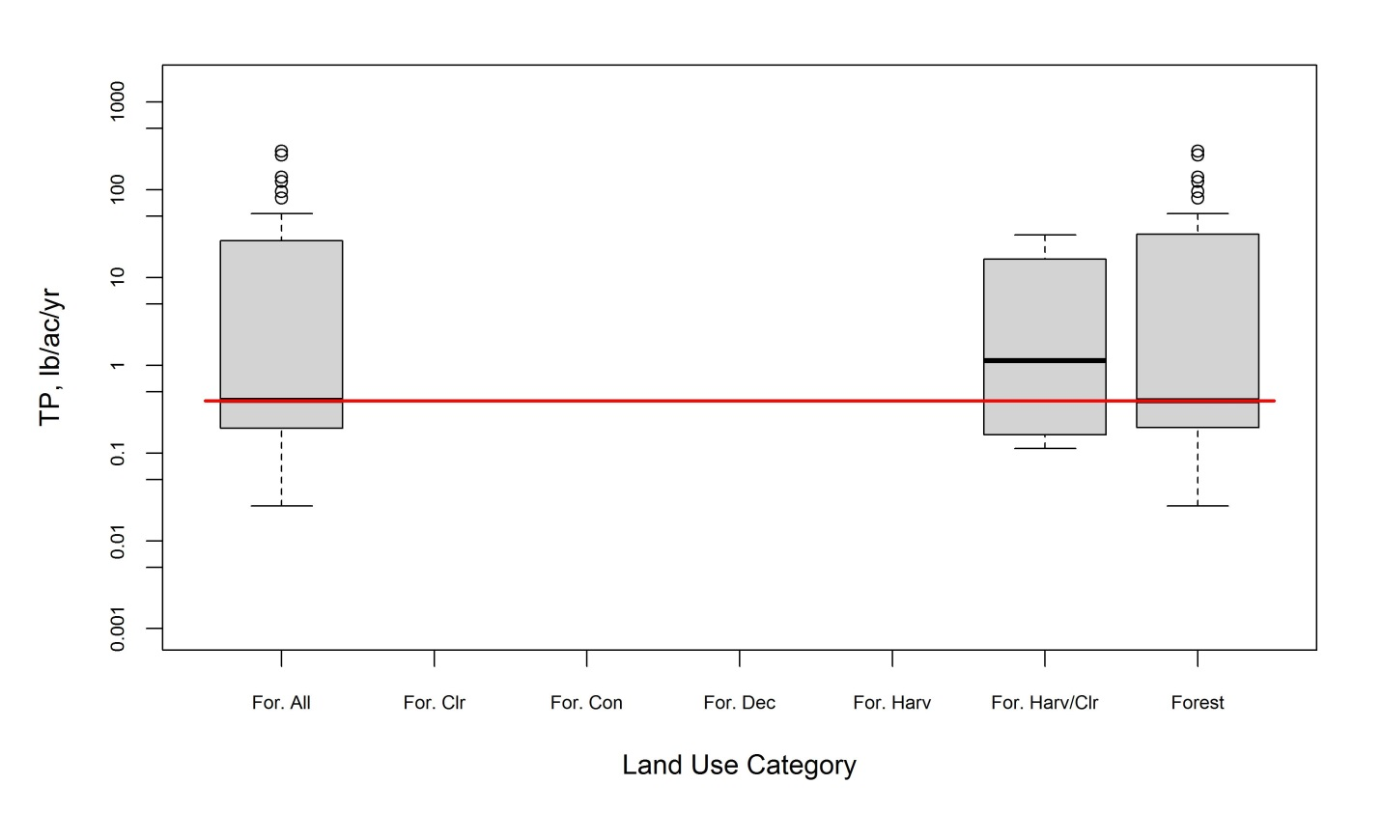
Figure 13. TP box plots from literature for all forest land uses (disturbed and undisturbed).

Table 26. NO₃ loading rate statistics from literature review for forest land uses (disturbed and undisturbed)
Land Use | Count | Loading Rate (lb/acre/yr)
Land Use | Count | Minimum | Average | Maximum | 25th percentile | Median | 75th percentile
Forest | 24 | 0 | 48024 | 489124 | 0 | 0 | 25
Forest–All | 46 | 0 | 25060 | 489124 | 0 | 1 | 22
Forest–Clearcut | 13 | 0.01 | 5.00 | 26.77 | 0.24 | 1.00 | 8.95
Forest–Harvested | 6 | 0.25 | 16.81 | 28.07 | 2.02 | 22.28 | 26.03
Forest–Harvested/Clearcut | 19 | 0.01 | 8.73 | 28.07 | 0.25 | 2.55 | 21.89

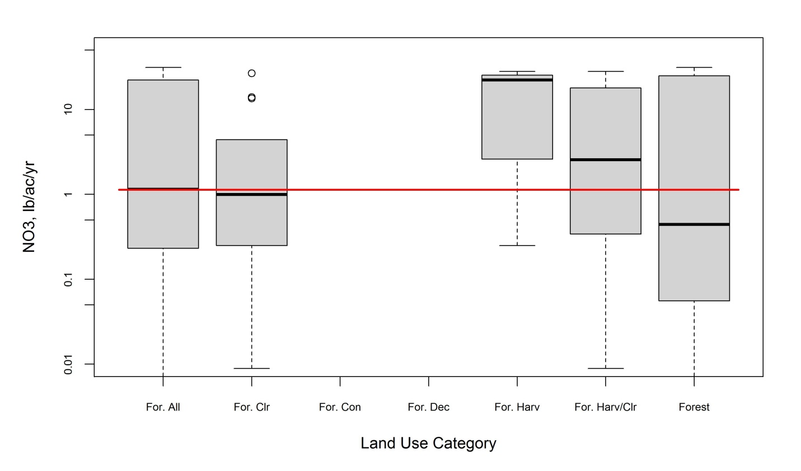
Figure 14. NO₃ box plots from literature for all forest land uses (disturbed and undisturbed)

Table 27. TP loading rate statistics from literature review for all forest land uses (disturbed and undisturbed) pre- and post-1990 and in and out of the watershed
Land Use* | Count | Loading Rate (lb/acre/yr)
Land Use* | Count | Minimum | Average | Maximum | 25th percentile | Median | 75th percentile
Forest–All | 64 | 0.02 | 20.22 | 275.69 | 0.13 | 0.32 | 1.78
Forest–All (Afterª) | 32 | 0.025 | 1.323 | 30.500 | 0.098 | 0.212 | 0.502
Forest–All (Before^{b}) | 32 | 0.1 | 39.1 | 275.7 | 0.2 | 0.6 | 50.6
Forest–All (In^{c}) | 7 | 0.0250 | 0.3918 | 0.6100 | 0.2855 | 0.4000 | 0.5621
Forest–All (Out^{d}) | 20 | 0.04 | 1.76 | 30.50 | 0.08 | 0.16 | 0.38
Forest–All (Varies^{e}) | 37 | 0.1 | 34.0 | 275.7 | 0.2 | 0.6 | 37.0
Forest–All (In-After^{f}) | 21 | 0.0250 | 0.3918 | 0.6100 | 0.2855 | 0.4000 | 0.5621
Notes:
a. After = data collected after 1990.
b. Before = data collected before 1990.
c. In = data collected within the CBW.
d. Out = data collected outside of the CBW.
e. Varies = data collected both in and out of the CBW.
f. In-After = data collected in the CBW after 1990.

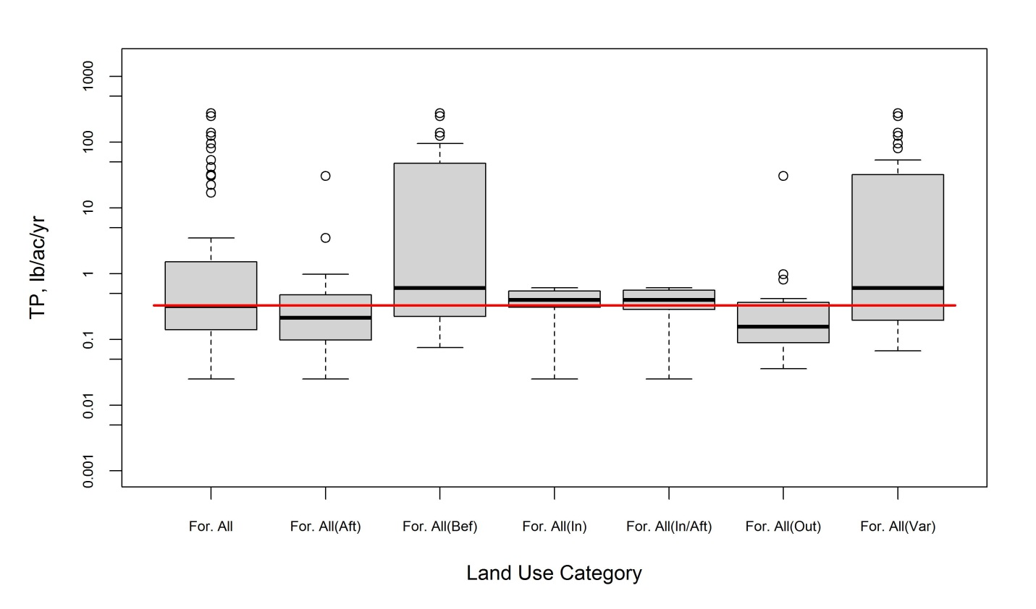
Figure 15. TP box plots from literature for all forest land uses (disturbed and undisturbed) pre- and post-1990 and in and out of the CBW.

Table 28. TN loading rate statistics from literature review for all forest land uses (disturbed and undisturbed) pre- and post-1990 and in and out of the watershed
Land Use | Count | Loading Rate (lb/acre/yr)
Land Use | Count | Minimum | Average | Maximum | 25th percentile | Median | 75th percentile
Forest–All | 48 | 0.205 | 3.113 | 11.599 | 1.399 | 2.230 | 4.097
Forest–All (Afterª) | 35 | 0.205 | 3.126 | 11.599 | 1.200 | 2.230 | 4.283
Forest–All (Before^{b}) | 13 | 1.231 | 3.079 | 9.814 | 1.900 | 2.195 | 3.270
Forest–All (In^{c}) | 24 | 0.205 | 2.446 | 8.600 | 0.681 | 1.827 | 4.097
Forest–All (Out^{d}) | 7 | 1.13 | 3.86 | 8.47 | 1.78 | 2.48 | 8.40
Forest–All (Varies^{e}) | 17 | 1.231 | 3.746 | 11.59 | 1.900 | 2.230 | 4.581
Forest–All (In-After^{f}) | 72 | 0.205 | 2.446 | 8.600 | 0.681 | 1.827 | 4.097
Notes:
a. After = data collected after 1990.
b. Before = data collected before 1990.
c. In = data collected within the CBW.
d. Out = data collected outside of the CBW.
e. Varies = data collected both in and out of the CBW.
f. In-After = data collected in the CBW after 1990.

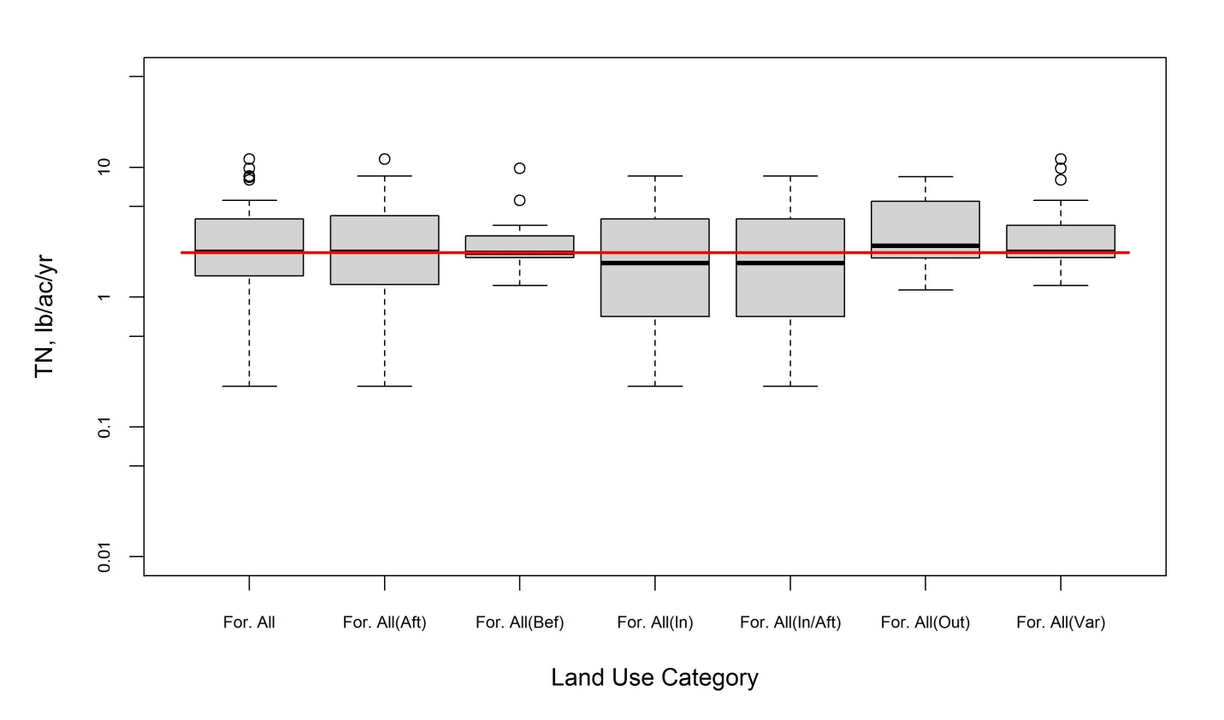
Figure 16. TN box plots from literature for all forest land uses (disturbed and undisturbed) pre- and post-1990 and in and out of the CBW.

Table 29. TP loading rate statistics from literature review for undisturbed forest land uses pre- and post-1990 and in and out of the watershed
Land Use | Count | Loading Rate (lb/acre/yr)
Land Use | Count | Minimum | Average | Maximum | 25th percentile | Median | 75th percentile
Forest | 57 | 0.02 | 22.03 | 275.69 | 0.14 | 0.32 | 0.89
Forest (Afterª) | 26 | 0.0250 | 0.2836 | 0.9770 | 0.0937 | 0.2052 | 0.4048
Forest (Before^{b}) | 31 | 0.1 | 40.3 | 275.7 | 0.2 | 0.6 | 53.5
Forest (In^{c}) | 21 | 0.0250 | 0.3918 | 0.6100 | 0.2855 | 0.4000 | 0.5621
Forest (Out^{d}) | 7 | 0.0250 | 0.3918 | 0.6100 | 0.2855 | 0.4000 | 0.5621
Forest (Varies^{e}) | 16 | 0.0357 | 0.2668 | 0.9770 | 0.0848 | 0.1561 | 0.3790
Forest (In-After^{f}) | 34 | 0.1 | 36.8 | 275.7 | 0.2 | 0.4 | 44.8
Notes:
a. After = data collected after 1990.
b. Before = data collected before 1990.
c. In = data collected within the CBW.
d. Out = data collected outside of the CBW.
e. Varies = data collected both in and out of the CBW.
f. In-After = data collected in the CBW after 1990.

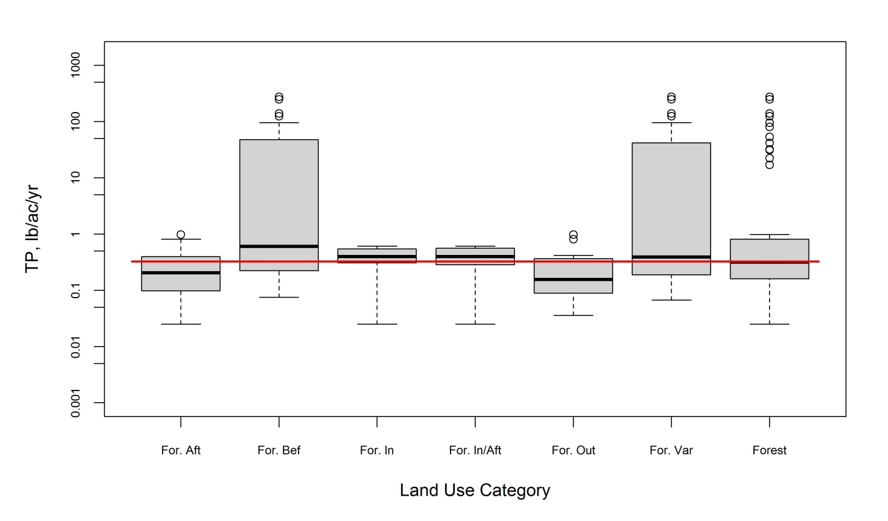
Figure 17. TP box plots from literature for undisturbed forest land uses pre- and post-1990 and in and out of the CBW.

Table 30. TN loading rate statistics from literature review for undisturbed forest land uses pre- and post-1990 and in and out of the watershed
Land Use | Count | Loading Rate (lb/acre/yr)
Land Use | Count | Minimum | Average | Maximum | 25th percentile | Median | 75th percentile
Forest | 45 | 0.205 | 2.666 | 8.600 | 1.319 | 2.195 | 3.573
Forest (Afterª) | 33 | 0.205 | 2.720 | 8.600 | 1.167 | 2.230 | 4.001
Forest (Before^{b}) | 12 | 1.231 | 2.518 | 5.585 | 1.842 | 2.164 | 2.913
Forest (In^{c}) | 72 | 0.205 | 2.446 | 8.600 | 0.681 | 1.827 | 4.097
Forest (Out^{d}) | 24 | 0.205 | 2.446 | 8.600 | 0.681 | 1.827 | 4.097
Forest (Varies^{e}) | 7 | 1.13 | 3.86 | 8.47 | 1.78 | 2.48 | 8.40
Forest (In-After^{f}) | 14 | 1.231 | 2.445 | 5.585 | 1.784 | 2.164 | 2.815
Notes:
a, After = data collected after 1990.
b. Before = data collected before 1990.
c. In = data collected within the CBW.
d. Out = data collected outside the CBW.
e. Varies = data collected both within and outside the CBW.
f. In-After = data collected within the CBW after 1990.

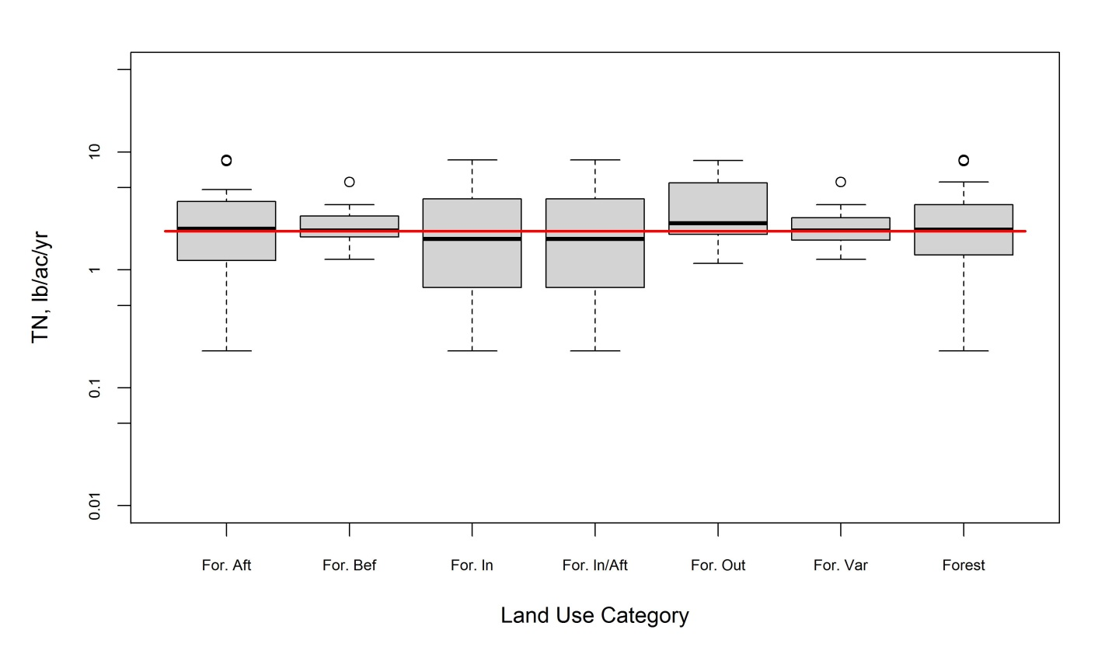
Figure 18. TN box plots from literature for undisturbed forest land uses pre- and post-1990 and in and out of the CBW.

Table 31. NO₃ loading rate statistics from literature review for disturbed forest land uses pre- and post-1990 and in and out of the watershed
Land Use | Count | Loading Rate (lb/acre/yr)
Land Use | Count | Minimum | Average | Maximum | 25th percentile | Median | 75th percentile
Forest–Harvested/Clearcut | 19 | 0.01 | 8.73 | 28.07 | .025 | 2.55 | 21.89
Forest–Harvested/Clearcut (Afterª) | 10 | 0.009 | 0.668 | 2.605 | 0.230 | 0.340 | 1.033
Forest–Harvested/Clearcut (Before^{b}) | 9 | 2.55 | 17.69 | 28.07 | 8.95 | 21.89 | 26.06
Forest–Harvested/Clearcut (Out^{c}) | 18 | 0.01 | 7.73 | 28.07 | 0.25 | 1.84 | 15.95
Forest–Harvested/Clearcut (Var^{d}) | 1 | 26.766 | 29.766 | 26.766 | * | 26.766 | *
Notes:
a. After = data collected after 1990.
b. Before = data collected before 1990.
c. Out = data collected outside the Chesapeake Bay watershed.
d. Var = data collected both within and outside the Chesapeake Bay watershed.

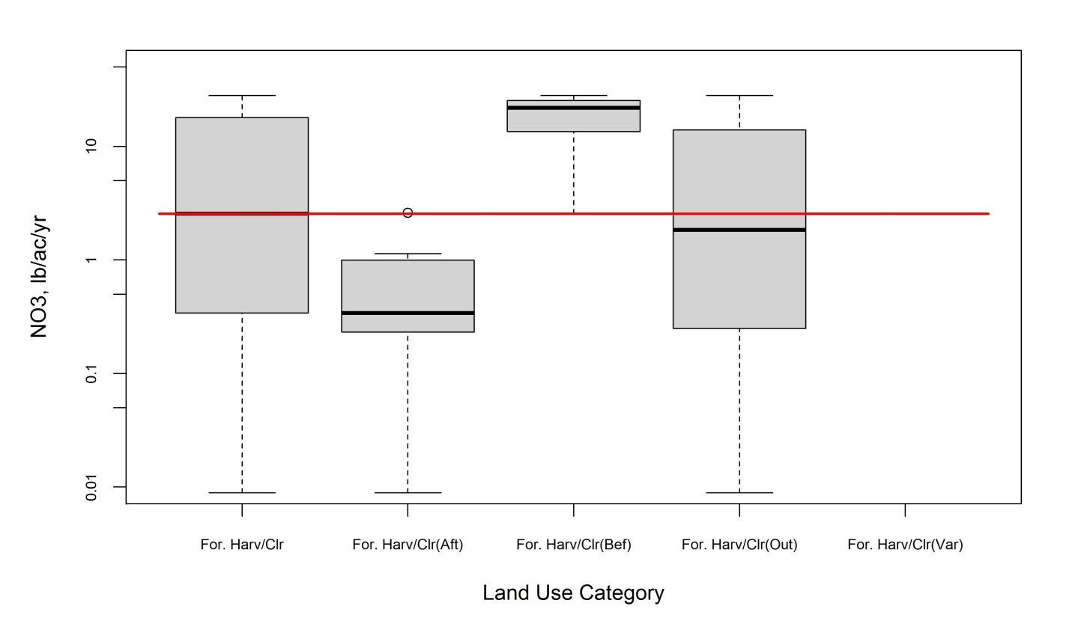
Figure 19. NO₃ box plots from literature for disturbed forest land uses pre- and post-1990 and out of the Chesapeake Bay watershed.

Table 32. TP loading rate statistics from literature review for undisturbed forest land uses (EoF) pre- and post-1990 and in and out of the watershed
Land Use | Count | Loading Rate (lb/acre/yr)
Land Use | Count | Minimum | Average | Maximum | 25th percentile | Median | 75th percentile
Forest | 25 | 0.0000 | 0.1498 | 0.8922 | 0.0521 | 0.0900 | 0.1874
Forest (Afterª) | 22 | 0.0000 | 0.1491 | 0.8922 | 0.0469 | 0.0896 | 0.1865
Forest (Before^{b}) | 3 | 0.0892 | 0.1546 | 0.1963 | 0.0892 | 0.1784 | 0.1963
Forest (In^{c}) | 14 | 0.0000 | 0.0943 | 0.2766 | 0.0335 | 0.0535 | 0.1717
Forest (Out^{d}) | 4 | 0.089 | 0.323 | 0.892 | 0.096 | 0.156 | 0.718
Forest (Varies^{e}) | 7 | 0.0669 | 0.1615 | 0.3957 | 0.0892 | 0.0999 | 0.2106
Notes:
a. After = data collected after 1990.
b. Before = data collected before 1990.
c. In = data collected within the Chesapeake Bay watershed.
d. Out = data collected outside the Chesapeake Bay watershed.
e. Varies = data collected both within and outside the Chesapeake Bay watershed.

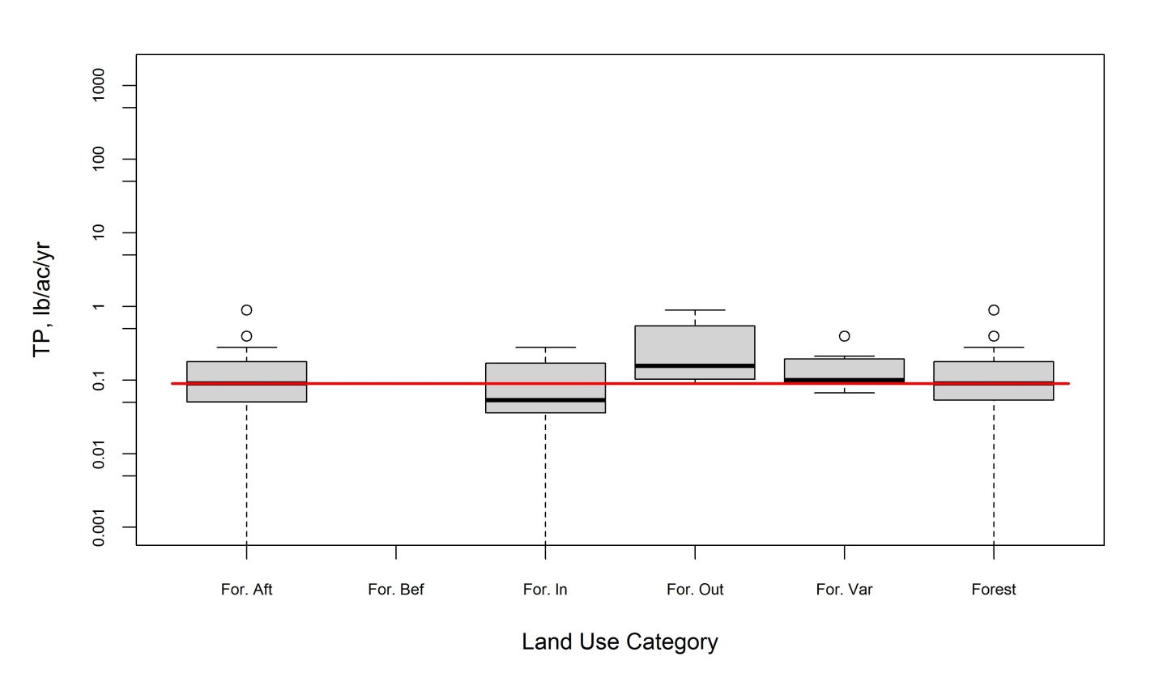
Figure 20. TP box plots from literature for undisturbed forest land uses (EoF) pre- and post-1990 and in and out of the Chesapeake Bay watershed.

Table 33. TN loading rate statistics from literature review for undisturbed forest land uses (EoF) pre- and post-1990 and in and out of the watershed
Land Use | Count | Loading Rate (lb/acre/yr)
Land Use | Count | Minimum | Average | Maximum | 25th percentile | Median | 75th percentile
Forest | 14 | 0.000 | 3.104 | 10.171 | 1.912 | 2.900 | 3.636
Forest (Afterª) | 11 | 0.000 | 3.297 | 10.171 | 2.079 | 3.123 | 3.836
Forest (Before^{b}) | 3 | 1.392 | 2.397 | 3.569 | 1.392 | 2.230 | 3.569
Forest (In^{c}) | 4 | 0.000 | 2.273 | 3.846 | 0.353 | 2.623 | 3.844
Forest (Out^{d}) | 4 | 1.39 | 4.19 | 10.17 | 1.56 | 2.60 | 8.41
Forest (Varies^{e}) | 6 | 2.230 | 2.934 | 3.569 | 2.471 | 2.967 | 3.381
Notes:
a. After = data collected after 1990.
b. Before = data collected before 1990.
c. In = data collected within the Chesapeake Bay watershed.
d. Out = data collected outside the Chesapeake Bay watershed.
e. Varies = data collected both within and outside the Chesapeake Bay watershed.

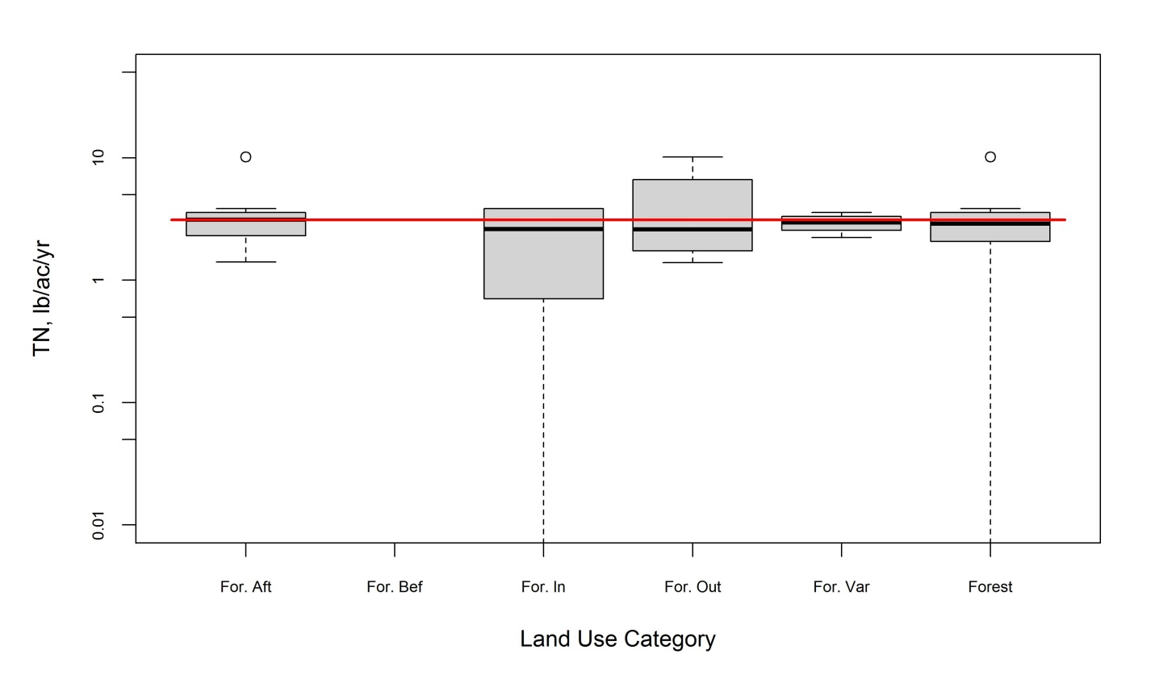
Figure 21. TN box plots from literature for undisturbed forest land uses (EoF) pre- and post-1990 and in and out of the CBW.

Table 34. TP loading rate statistics from TMDL review for all forest land uses
Land Use | Count | Loading Rate (lb/acre/yr)
Land Use | Count | Minimum | Average | Maximum | 25th percentile | Median | 75th percentile
Forest | 215 | 0.000 | 0.199 | 23.880 | 0.003 | 0.010 | 0.036
Forest–All | 223 | 0.000 | 0.207 | 23.880 | 0.003 | 0.010 | 0.067
Forest–Coniferous | 49 | 0.0003 | 0.0855 | 3.6800 | 0.0017 | 0.0046 | 0.0100
Forest–Deciduous | 54 | 0.001 | 0.466 | 23.880 | 0.004 | 0.007 | 0.030
Forest–Disturbed | 3 | 0.0757 | 0.0978 | 0.1191 | 0.0757 | 0.0987 | 0.1191
Forest–Harvest | 5 | 0.221 | 0.640 | 1.298 | 0.311 | 0.632 | 0.973
Forest–Mixed | 51 | 0.000 | 0.152 | 5.780 | 0.002 | 0.007 | 0.017
Hay and Pasture | 98 | 0.008 | 0.852 | 58.970 | 0.103 | 0.202 | 0.282

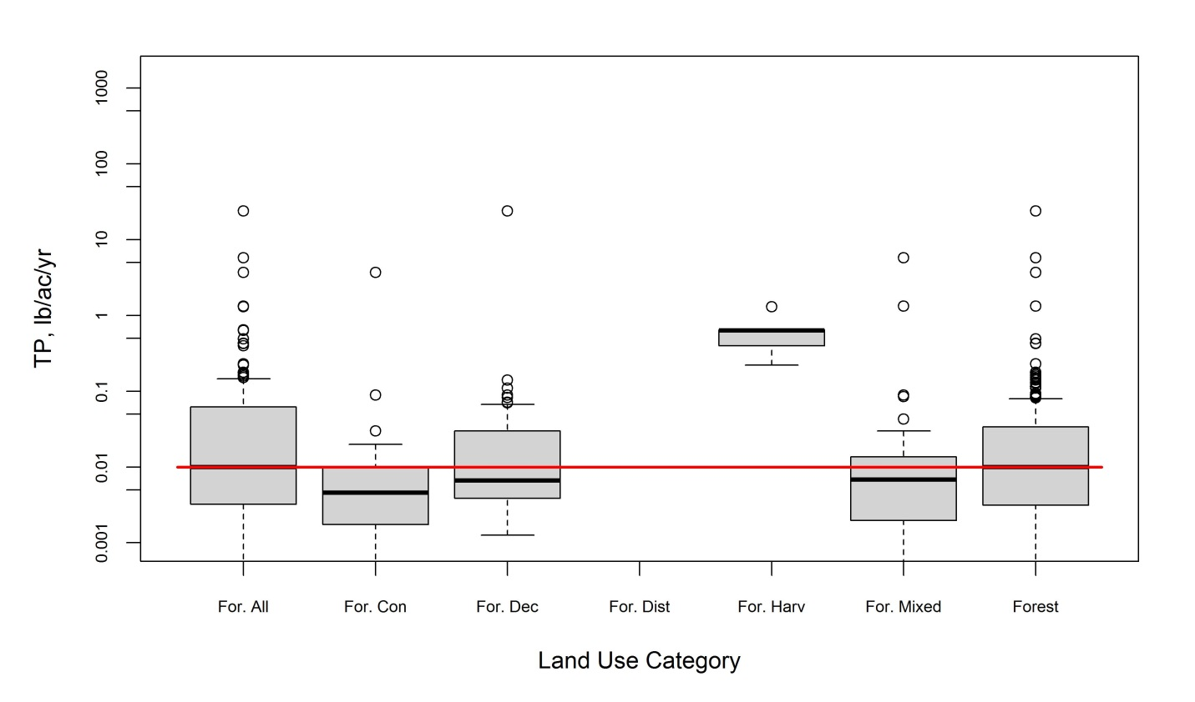
Figure 22. TP box plots from TMDL review for all forest land uses.

Table 35. TN loading rate statistics from TMDL review for all forest land uses
Land Use | Count | Loading Rate (lb/acre/yr)
Land Use | Count | Minimum | Average | Maximum | 25th percentile | Median | 75th percentile
Forest | 60 | 0.020 | 1.854 | 12.343 | 0.123 | 0.160 | 1.494
Forest–All | 60 | 0.020 | 1.854 | 12.343 | 0.123 | 0.160 | 1.494
Forest–Coniferous | 12 | 0.0200 | 0.1258 | 0.1700 | 0.0875 | 0.1400 | 0.1600
Forest–Deciduous | 15 | 0.0700 | 0.1933 | 0.4600 | 0.1100 | 0.1500 | 0.220
Forest–Mixed | 11 | 0.0300 | 0.1164 | 0.1600 | 0.0800 | 0.1300 | 0.1600
Hay and Pasture | 14 | 0.900 | 4.070 | 13.340 | 1.967 | 3.005 | 5.979

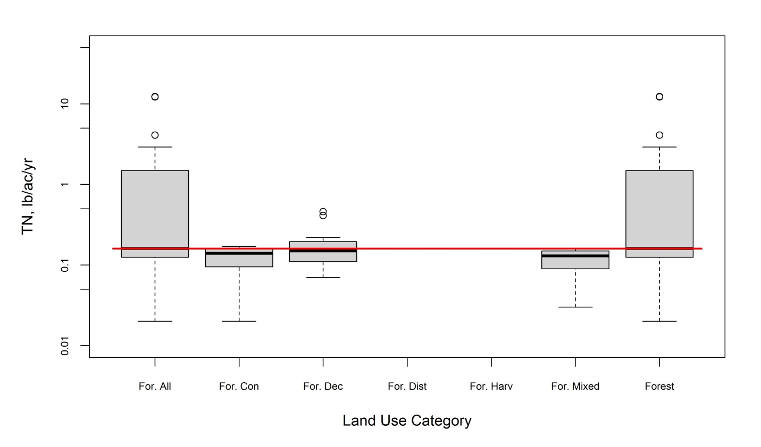
Figure 23. TN box plots from TMDL review for all forest land uses.

Table 36. TSS loading rate statistics from TMDL review for all forest land uses
Land Use | Count | Loading Rate (lb/acre/yr)
Land Use | Count | Minimum | Average | Maximum | 25th percentile | Median | 75th percentile
Forest | 305 | 0.0 | 53.0 | 5572.5 | 2.5 | 9.6 | 21.9
Forest–All | 335 | 0 | 7031 | 1241771 | 3 | 11 | 43
Forest–Coniferous | 69 | 0.010 | 5.138 | 37.513 | 0.132 | 3.130 | 7.135
Forest–Deciduous | 75 | 0.02 | 19.652 | 137.86 | 7.14 | 11.83 | 18.50
Forest–Disturbed | 14 | 419 | 165986 | 1241771 | 2055 | 11483 | 18397
Forest–Harvest | 16 | 25 | 968 | 2610 | 634 | 977 | 1405
Forest–Mixed | 70 | 0.01 | 7.39 | 98.44 | 0.31 | 3.99 | 9.47
Hay and Pasture | 148 | 0.2 | 359.3 | 5260.9 | 42.6 | 113.8 | 365.8

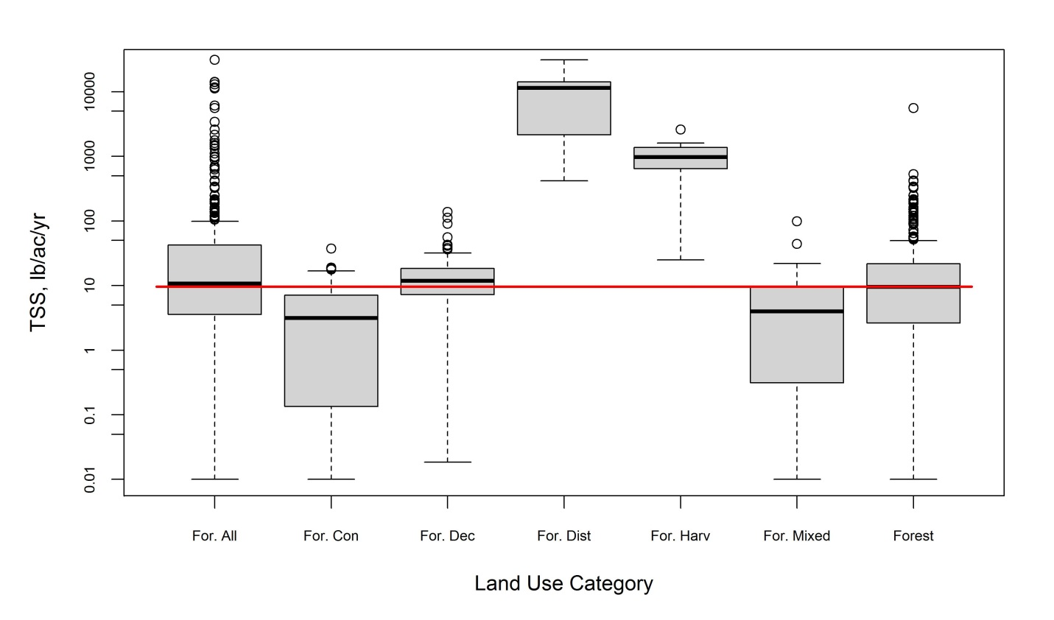
Figure 24. TSS box plots from TMDL review for all forest land uses.

Table 37. TP loading rate statistics from TMDL review for barren and extractive land uses
Land Use | Count | Loading Rate (lb/acre/yr)
Land Use | Count | Minimum | Average | Maximum | 25th percentile | Median | 75th percentile
Barren | 9 | 0.250 | 1.642 | 6.537 | 0.340 | 0.451 | 2.962
Extractive | 7 | 0.20 | 9.51 | 37.59 | 2.22 | 5.66 | 9.58

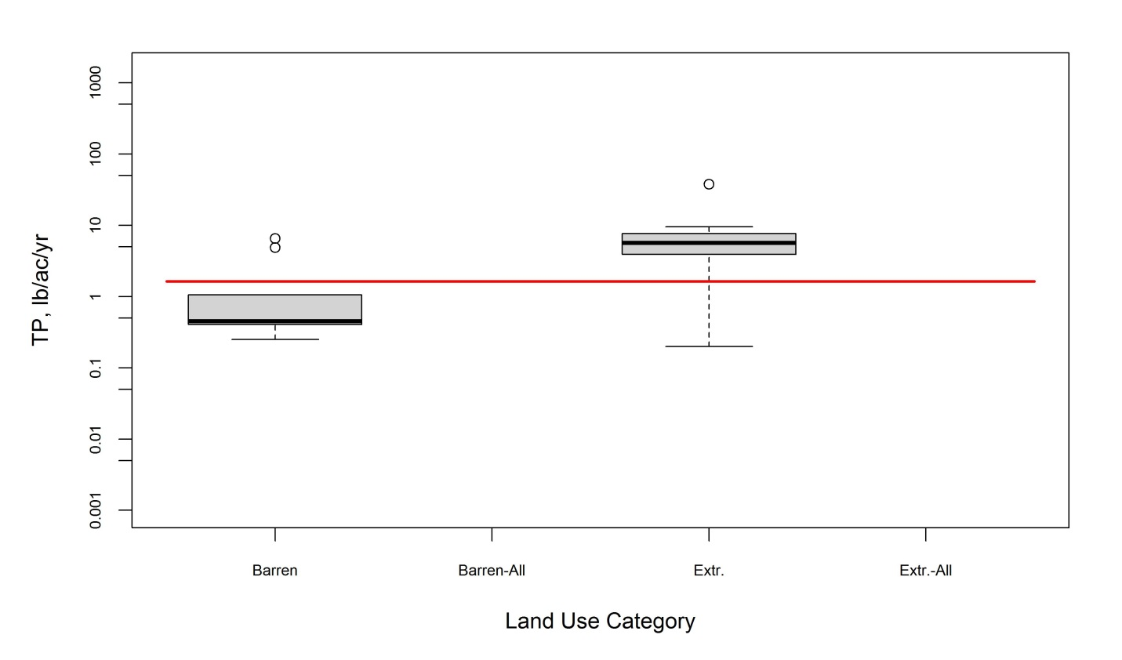
Figure 25. TP box plots from TMDL review for barren and extractive land uses.

Table 38. TSS loading rate statistics from TMDL review for barren and extractive land uses
Land Use | Count | Loading Rate (lb/acre/yr)
Land Use | Count | Minimum | Average | Maximum | 25th percentile | Median | 75th percentile
Barren All | 12 | 10360 | 21340 | 25000 | 14020 | 25000 | 25000
Extractive All | 15 | 20000 | 20000 | 20000 | 20000 | 20000 | 20000

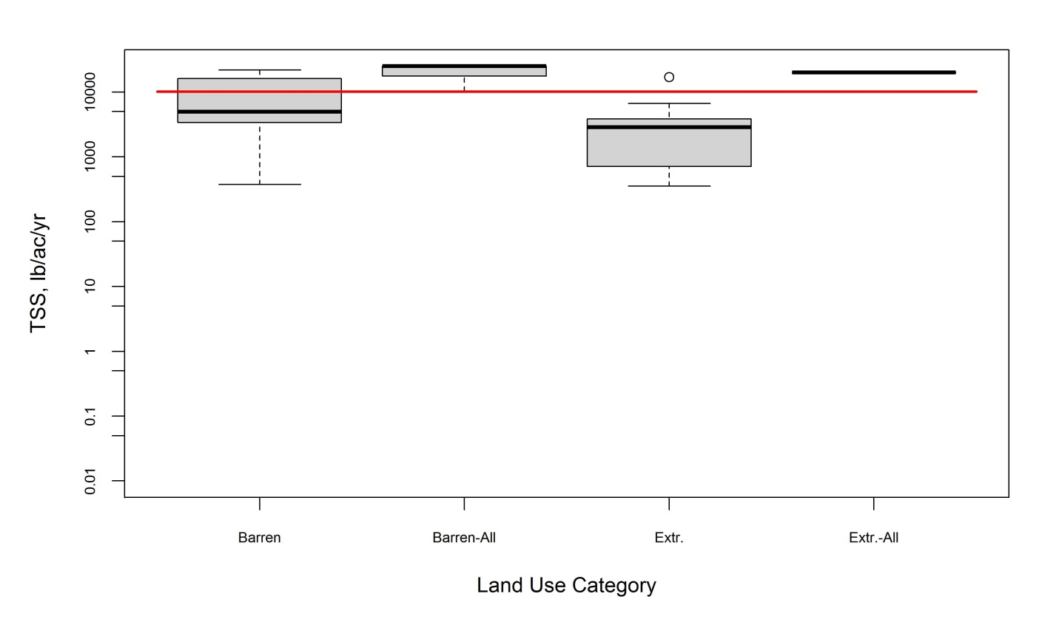
Figure 26. TSS box plots from TMDL review for barren and extractive land uses.

Table 39. TP loading rate statistics from TMDL review for all forest land uses (EoF)
Land Use | Count | Loading Rate (lb/acre/yr)
Land Use | Count | Minimum | Average | Maximum | 25th percentile | Median | 75th percentile
Forest | 57 | 0.02 | 22.06 | 275.69 | 0.14 | 0.32 | 0.89
Forest–Harvested/Clearcut | 4 | 0.11 | 8.22 | 30.50 | 0.14 | 1.13 | 23.39
Forest–Harvested/Disturbed | 8 | 0.076 | 0.437 | 1.298 | 0.104 | 0.311 | 0.644
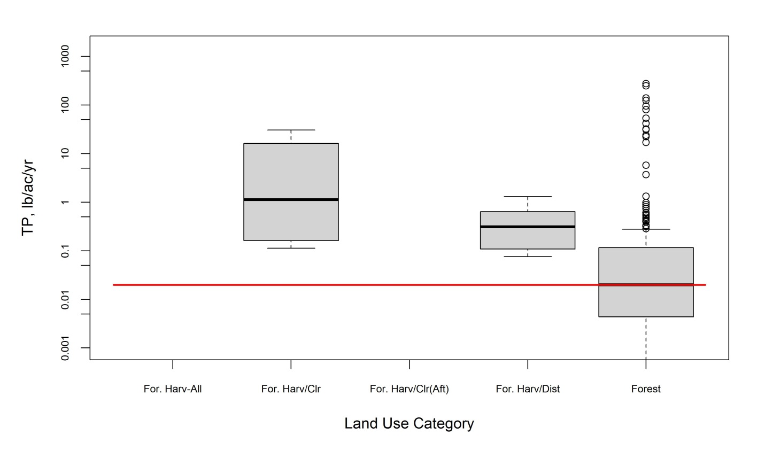
Figure 27. TP box plots from TMDL review for all forest land uses (EoF).

Table 40. NO₃ loading rate statistics from TMDL review for all forest land uses (EoF)
Land Use | Count | Loading Rate (lb/acre/yr)
Land Use | Count | Minimum | Average | Maximum | 25th percentile | Median | 75th percentile
Forest | 24 | 0.00 | 4.76 | 31.26 | 0.04 | 0.34 | 1.79
Forest–Harvested/Clearcut | 19 | 0.01 | 8.73 | 28.07 | 0.25 | 2.55 | 21.89

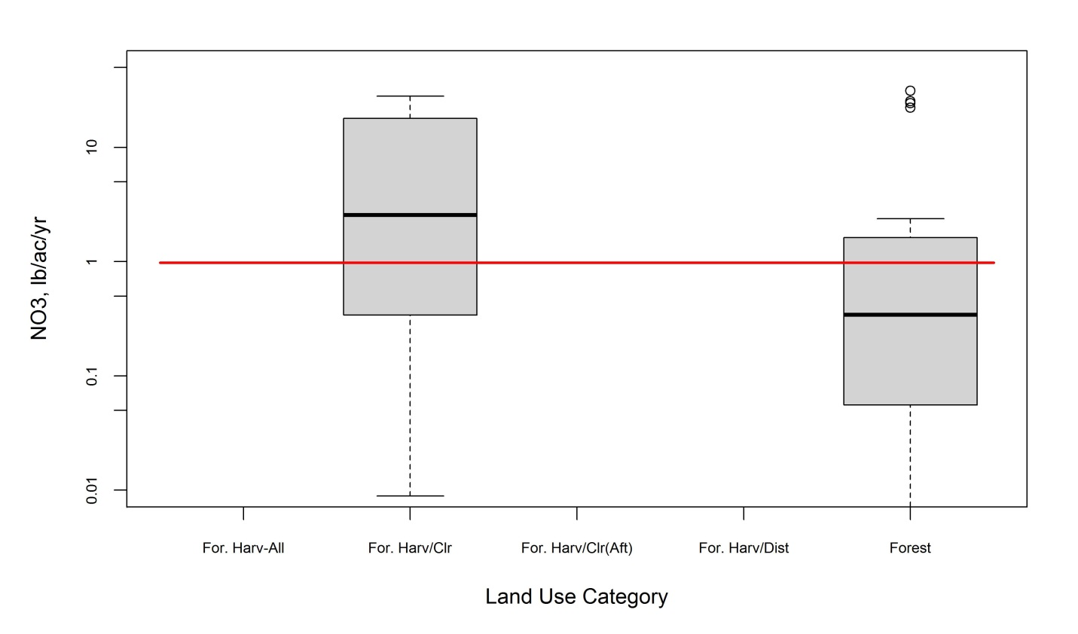
Figure 28. NO₃ box plots from TMDL review for all forest land uses (EoF).

Table 41. TSS loading rate statistics from TMDL review for all forest land uses (EoF)
Land Use | Count | Loading Rate (lb/acre/yr)
Land Use | Count | Minimum | Average | Maximum | 25th percentile | Median | 75th percentile
Forest | 305 | 0.0 | 53.0 | 5572.5 | 2.5 | 9.6 | 21.9
Forest–Harvested/Disturbed | 30 | 25 | 77976 | 1241771 | 693 | 1464 | 11380

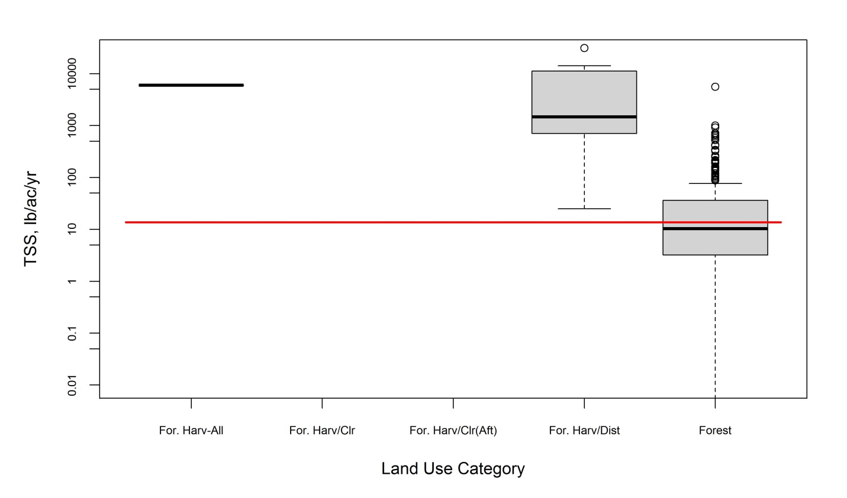
Figure 29. TSS box plots from TMDL review for all forest land uses (EoF).

Attachment D.2: Agricultural Loading Rate Box Plots from Literature Review
See Attachment C for summary statistics associated with box plots. All box plots in this section compare distributions for studies conducted on soils found within the CBW (“Y:” x-axis labels) versus studies from soils not found within the CBW (“N:” x-axis labels), by land use category. In addition, separate plots are provided by pollutant pathway. See Attachment B for land use category definitions.

Key:
- N = Study on soil not found in CBW
- Y = Study on soil found in CBW
- Commodity = Commodity crops
- For & Hay = Forage and hay
- Mixture = Mixture of agricultural land use categories
- Spec & Oth = Speciality and other crops
- TBD = To be determined (could not find a match for CBW model land use categories)
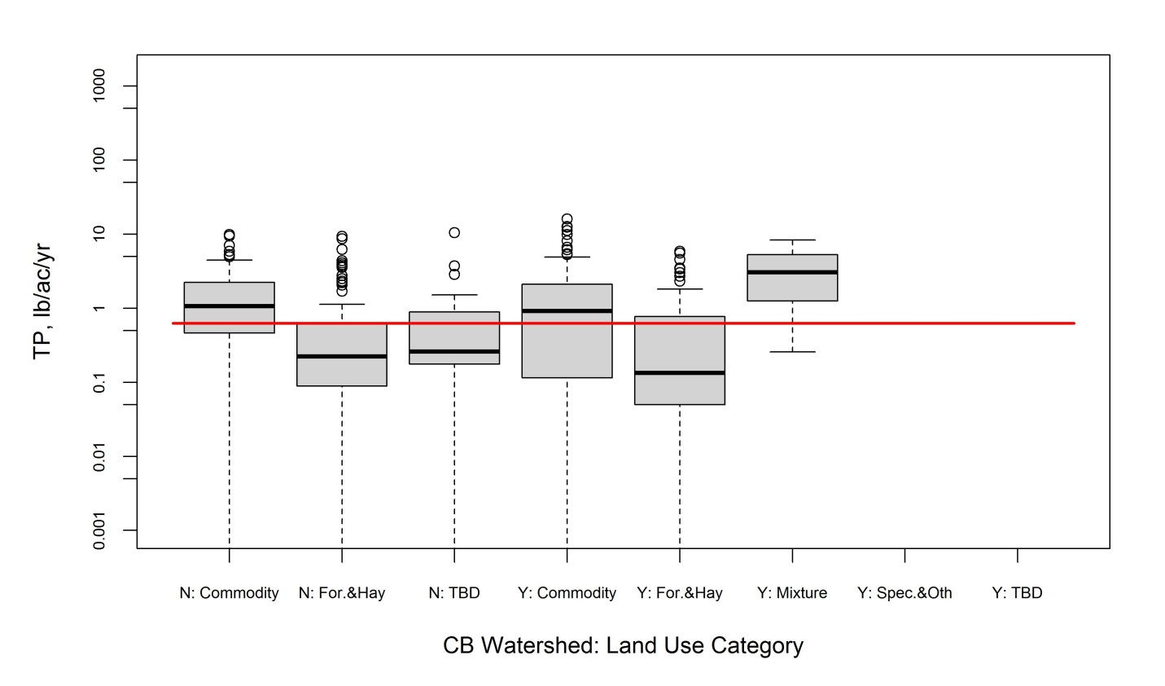
Figure 30. TP box plots for surface pathway from literature for agricultural land use categories on soils found and not found within CBW.
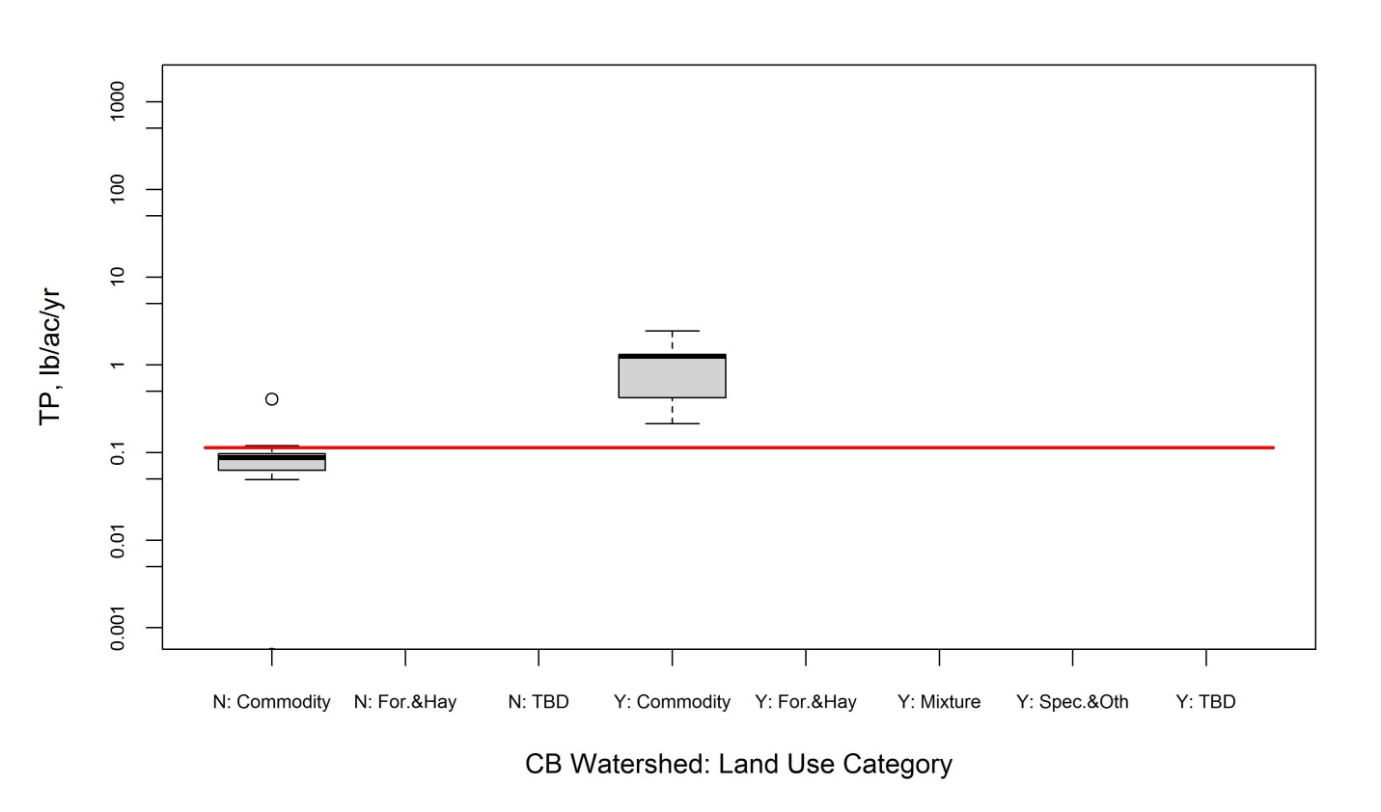
Figure 31. TP box plots for tile drain/ditch pathway from literature for agricultural land use categories on soils found and not found within CBW.

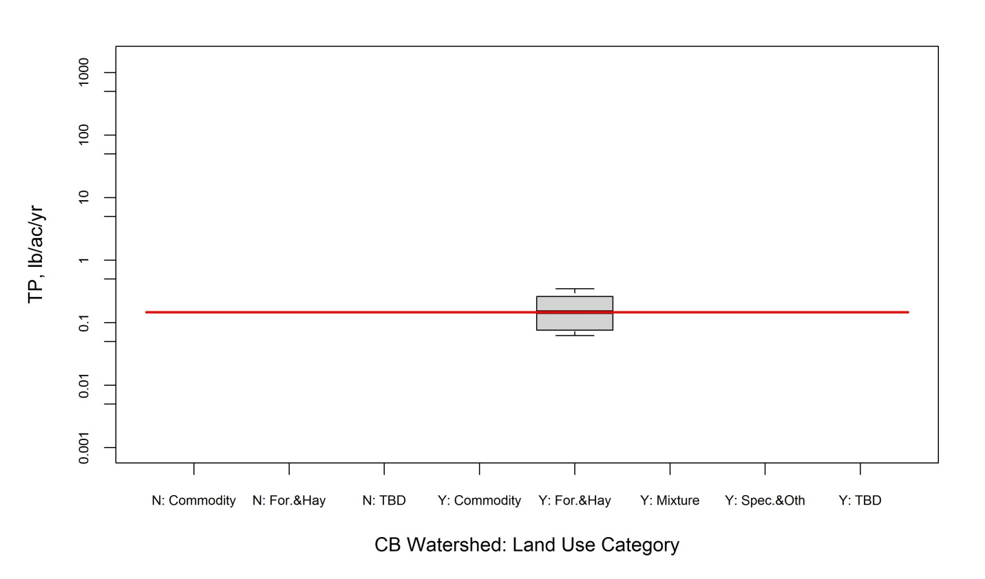
Figure 32. TP box plots for shallow groundwater pathway from literature for agricultural land use categories on soils found and not found within CBW.

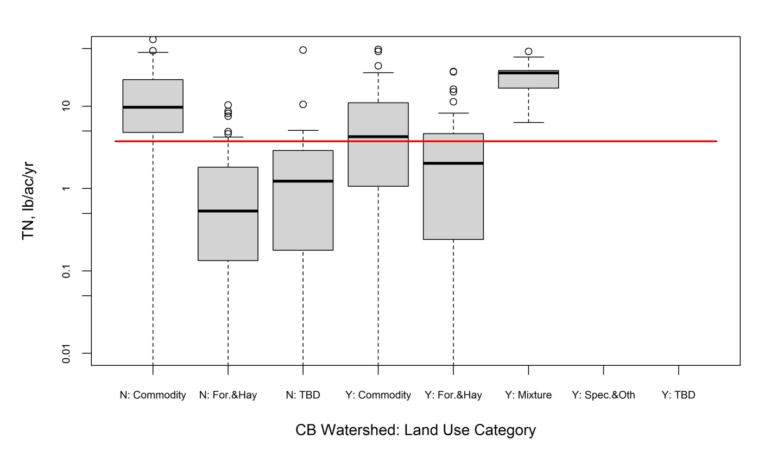
Figure 33. TN box plots for surface pathway from literature for agricultural land use categories on soils found and not found within CBW.

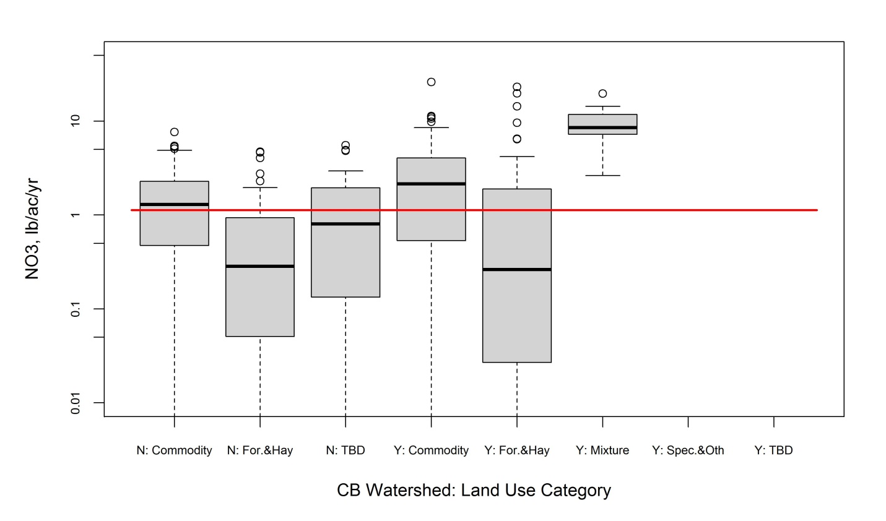
Figure 34. NO₃ box plots for surface pathway from literature for agricultural land use categories on soils found and not found within CBW.

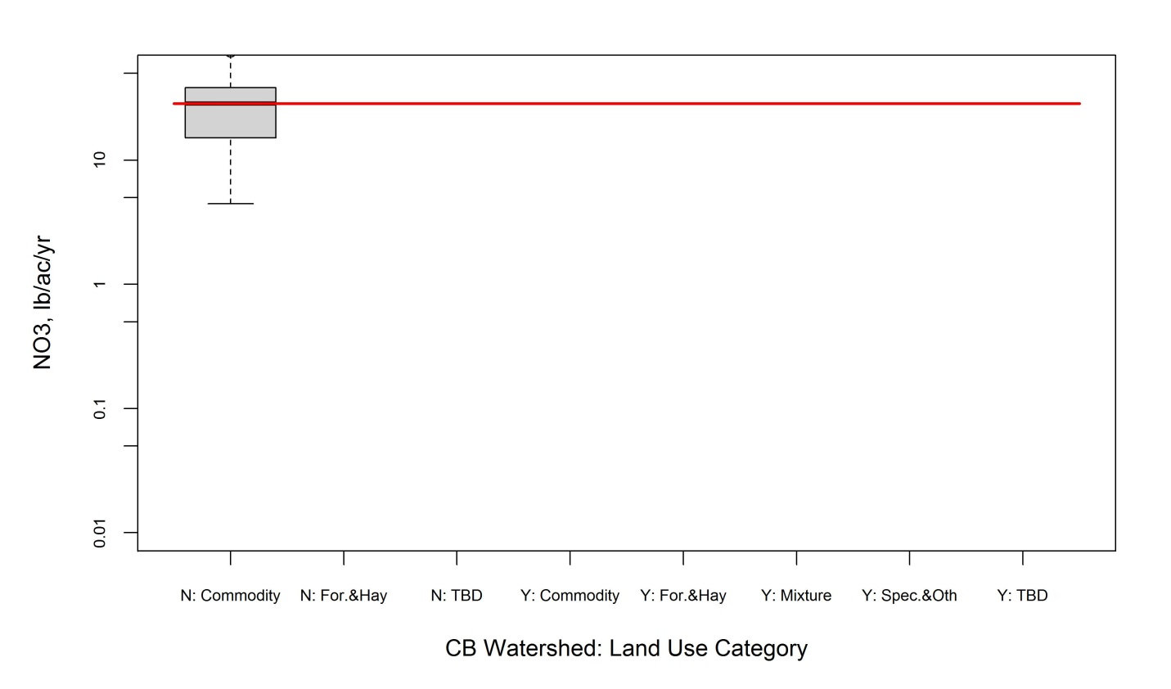
Figure 35. NO₃ box plots for tile drain/ditch pathway from literature for agricultural land use categories on soils found and not found within CBW.

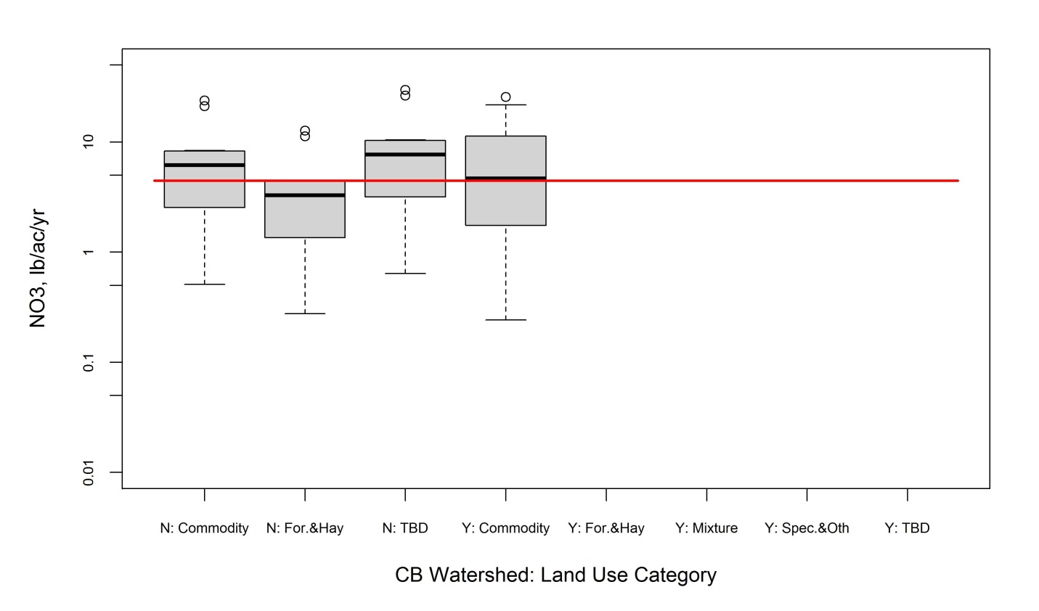
Figure 36. NO₃ box plots for shallow groundwater pathway from literature for agricultural land use categories on soils found and not found within CBW.
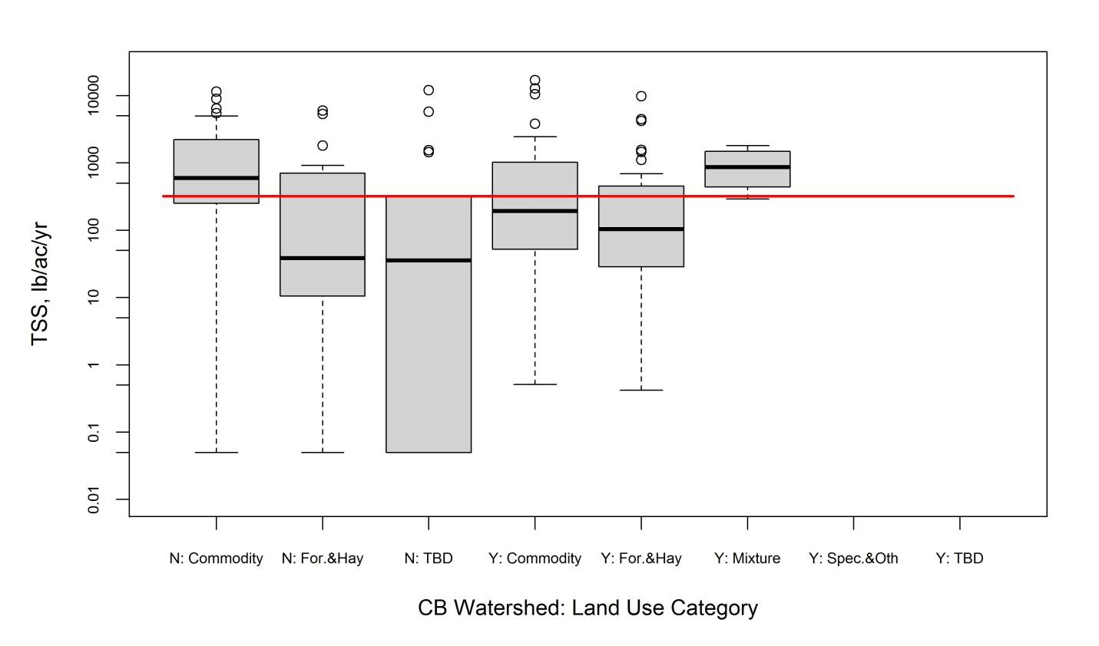
Figure 37. TSS box plots for surface pathway from literature for agricultural land use categories on soils found and not found within CBW.

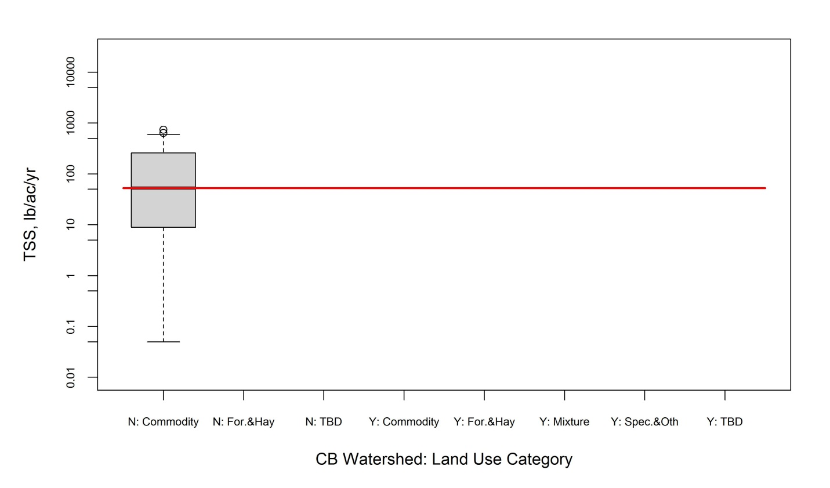
Figure 38. TSS box plots for tile drain/ditch pathway from literature for agricultural land use categories on soils found and not found within CBW.

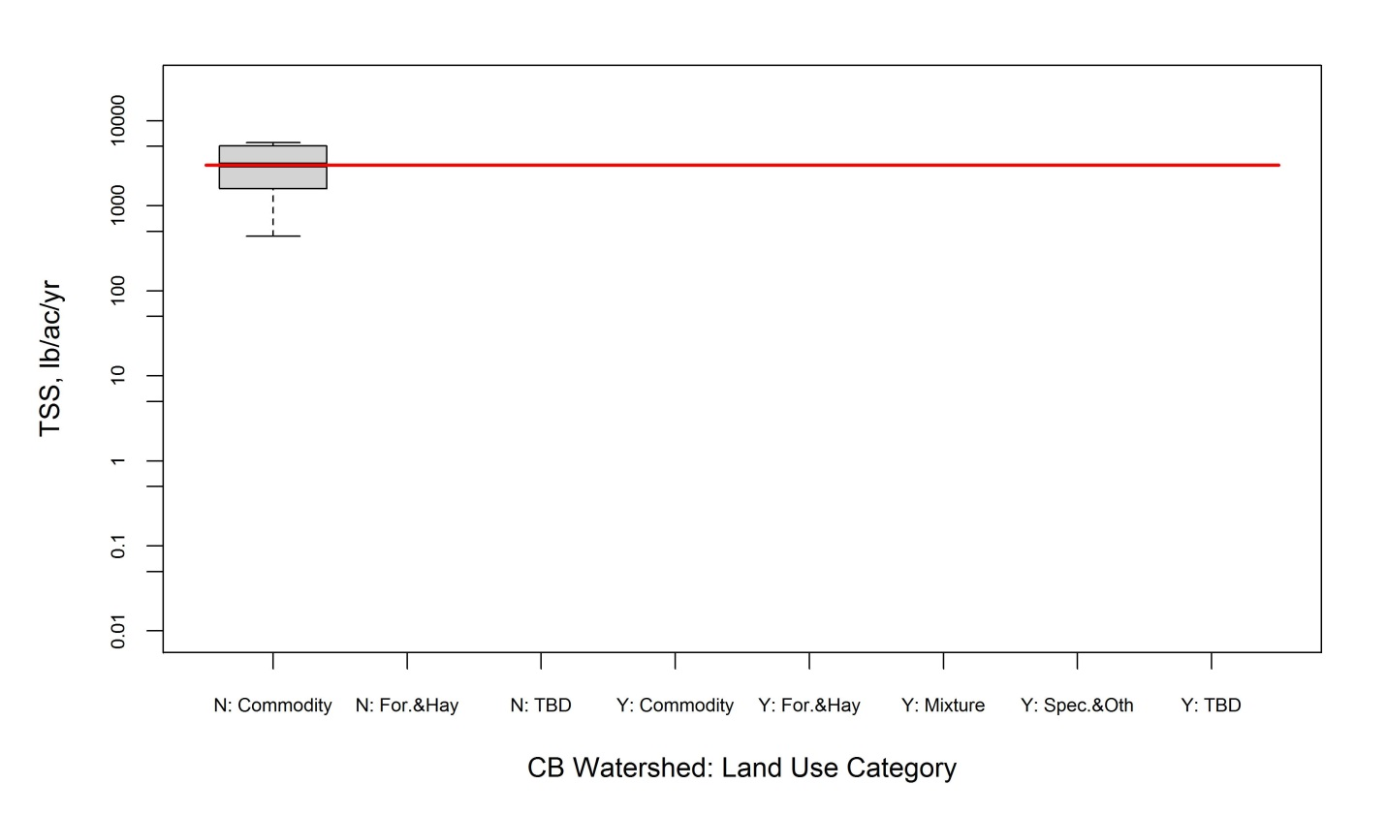
Figure 39. TSS box plots for surface+subsurface pathway from literature for agricultural land use categories on soils found and not found within CBW.

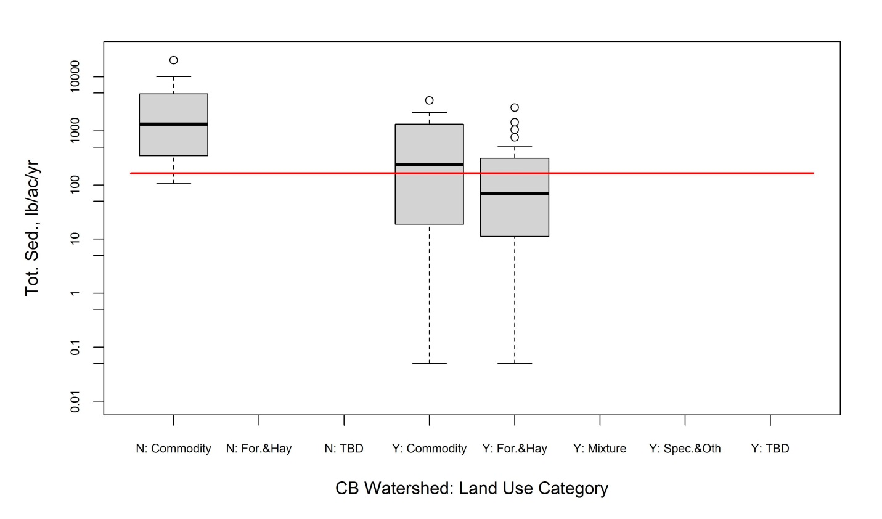
Figure 40. Total sediment box plots for surface pathway from literature for agricultural land use categories on soils found and not found within CBW.
Attachment D.3: Agricultural Loading Rate Box Plots from TMDL Review
See Attachment B for land use category definitions.

Table 42. TP loading rate statistics from TMDL review for all agricultural land uses
Land Use | Count | Loading Rate (lb/acre/yr)
Land Use | Count | Minimum | Average | Maximum | 25th percentile | Median | 75th percentile
AFO/CAFO | 7 | 20 | 401 | 1494 | 24 | 383 | 417
Cropland All | 113 | 0.16 | 5.42 | 488.24 | 0.43 | 0.78 | 1.43
Hay and Pasture All | 139 | 0.008 | 0.961 | 58.970 | 0.150 | 0.249 | 0.485
Nursery | 6 | 0.7 | 83.7 | 132.4 | 34.1 | 96.8 | 130.7

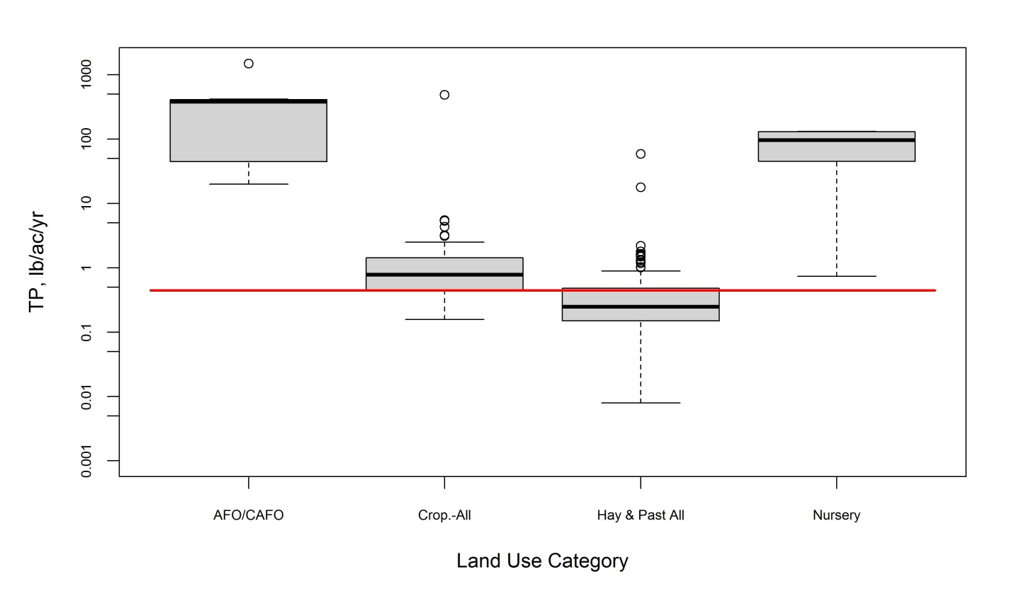
Figure 41. TP box plots from TMDL review for all agricultural land uses.

Table 43. TN loading rate statistics from TMDL review for all agricultural land uses
Land Use | Count | Loading Rate (lb/acre/yr)
Land Use | Count | Minimum | Average | Maximum | 25th percentile | Median | 75th percentile
Cropland All | 17 | 2.00 | 12.50 | 44.41 | 5.65 | 9.51 | 16.14
Hay and Pasture All | 38 | 0.90 | 12.64 | 46.34 | 2.92 | 5.61 | 15.93
Nursery | 1 | 17.825 | 17.825 | 17.825 | * | 17.825 | *

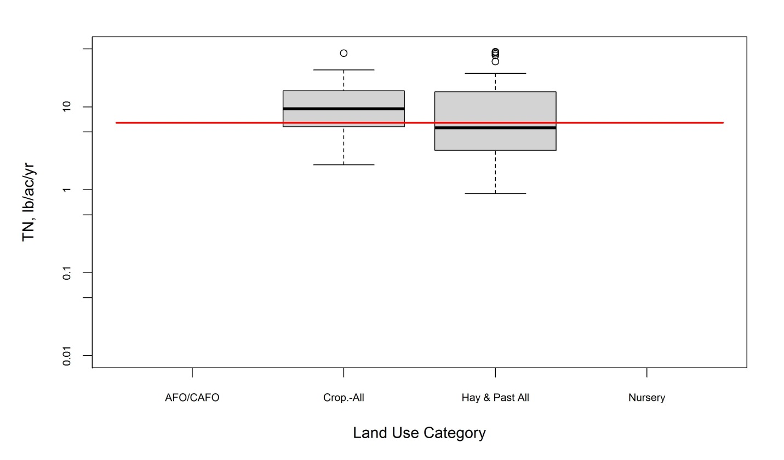
Figure 42. TN box plots from TMDL review for all agricultural land uses.

Table 44. TSS loading rate statistics from TMDL review for all agricultural land uses
Land Use | Count | Loading Rate (lb/acre/yr)
Land Use | Count | Minimum | Average | Maximum | 25th percentile | Median | 75th percentile
AFO/CAFO | 13 | 39 | 3039 | 7213 | 256 | 3391 | 5611
Cropland All | 346 | 1 | 5983 | 184268 | 1325 | 4978 | 4978
Hay and Pasture All | 363 | 0 | 18525 | 2245910 | 115 | 741 | 2460
Nursery | 14 | 28 | 2788 | 7857 | 256 | 2342 | 5584

Figure 43. TSS box plots from TMDL review for all agricultural land uses.

Table 45. TSS loading rate statistics from TMDL review for hay and pasture land uses
Land Use | Count | Loading Rate (lb/acre/yr)
Land Use | Count | Minimum | Average | Maximum | 25th percentile | Median | 75th percentile
Hay and Pasture | 148 | 0.2 | 359.3 | 5260.9 | 42.6 | 113.8 | 365.8
Hay and Pasture All | 363 | 0 | 18525 | 2245910 | 115 | 741 | 2460
Pasture–Cattle Grazed | 4 | 45 | 474962 | 974759 | 45 | 462522 | 962319
Pasture–Improved | 7 | 12.9 | 172.0 | 624.5 | 22.4 | 98.1 | 196.3
Pasture–Overgrazed | 7 | 176 | 5451 | 20494 | 1058 | 1865 | 10252
Pasture–Trampled | 8 | 148 | 3628 | 9640 | 353 | 2750 | 7154
Pasture–Unimproved | 13 | 32 | 308895 | 2245910 | 312 | 1249 | 14902

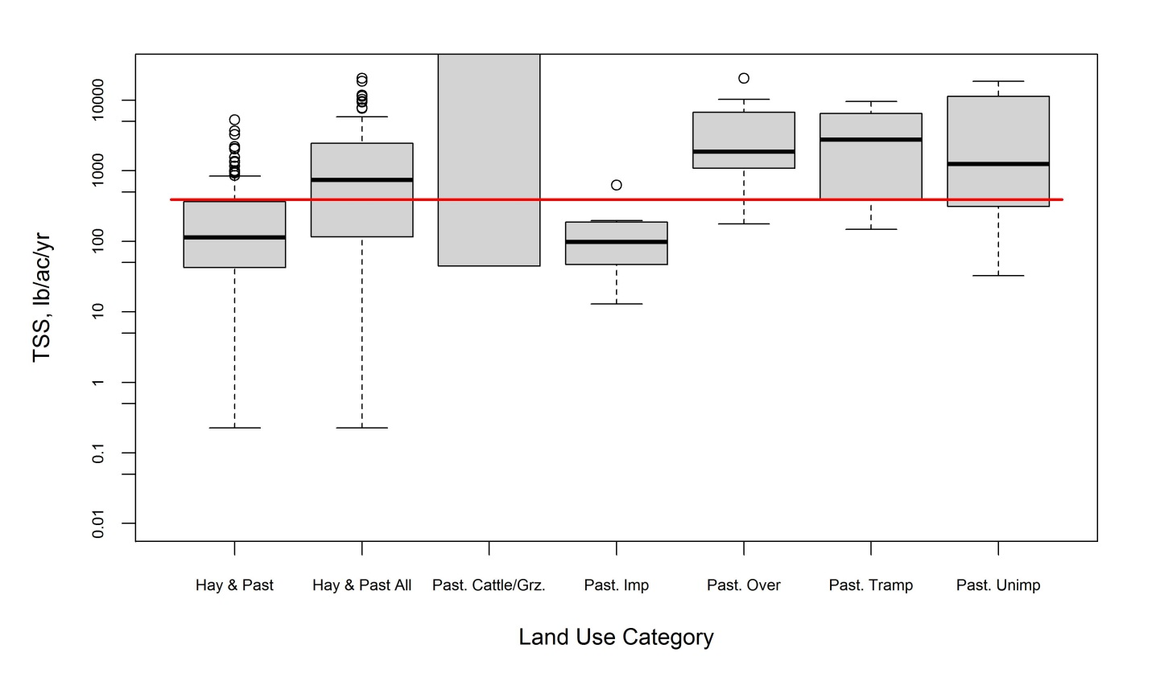
Figure 44. TSS box plots from TMDL review for hay and pasture land uses.

Table 46. TSS loading rate statistics from TMDL review for all agricultural land uses (EoF)
Land Use | Count | Loading Rate (lb/acre/yr)
Land Use | Count | Minimum | Average | Maximum | 25th percentile | Median | 75th percentile
AFO/CAFO | 15 | 580 | 16423 | 60800 | 3240 | 14060 | 24520
Hay and Pasture | 15 | 640 | 3607 | 6360 | 1600 | 4000 | 5160
High Till (with manure) | 2 | 11220 | 13430 | 15640 | * | 13430 | *
High Till (without manure) | 2 | 112220 | 13430 | 15640 | * | 13430 | *
High Tillage | 19 | 2520 | 14183 | 24840 | 5940 | 15780 | 21020
Low Till | 8 | 1500 | 6795 | 13140 | 1965 | 5630 | 11940
Low Till (with manure) | 7 | 4900 | 10334 | 14900 | 6720 | 9460 | 14900
Nursery | 13 | 580 | 17618 | 60800 | 4090 | 16160 | 24520
Pasture–Trampled | 15 | 580 | 16423 | 60800 | 3240 | 14060 | 24520
Pasture | 17 | 60 | 1878 | 6400 | 440 | 1700 | 2770

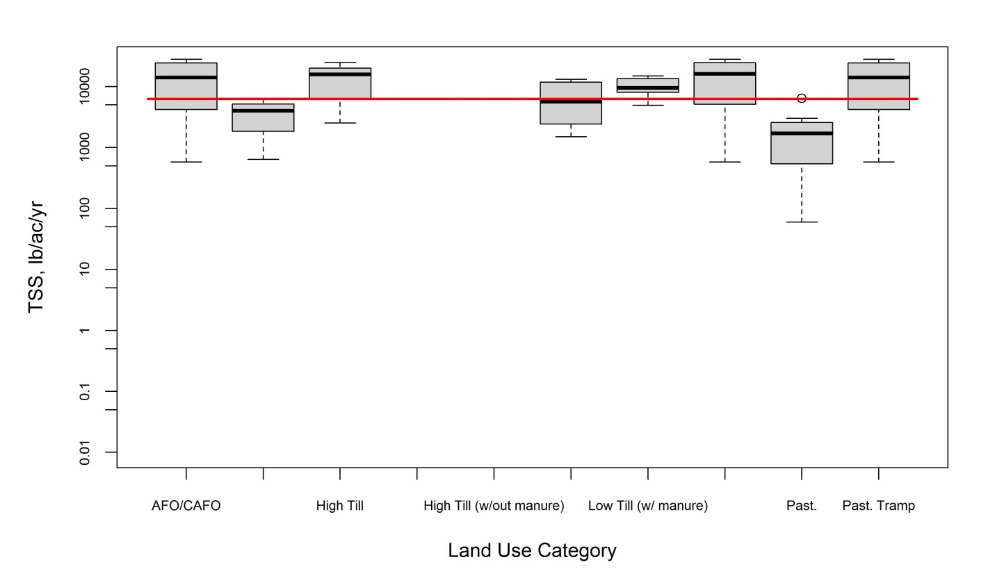
Figure 45. TSS box plots from TMDL review for all agricultural land uses (EoF).

Table 47. TP loading rate statistics from TMDL review for all agricultural land uses (EoF)
Land Use | Count | Loading Rate (lb/acre/yr)
Land Use | Count | Minimum | Average | Maximum | 25th percentile | Median | 75th percentile
AFO/CAFO | 7 | 20 | 401 | 1494 | 24 | 383 | 417
Cropland All | 113 | 0.16 | 5.42 | 488.24 | 0.43 | 0.78 | 1.43
Hay and Pasture All | 139 | 0.008 | 0.961 | 58.970 | 0.150 | 0.249 | 0.485
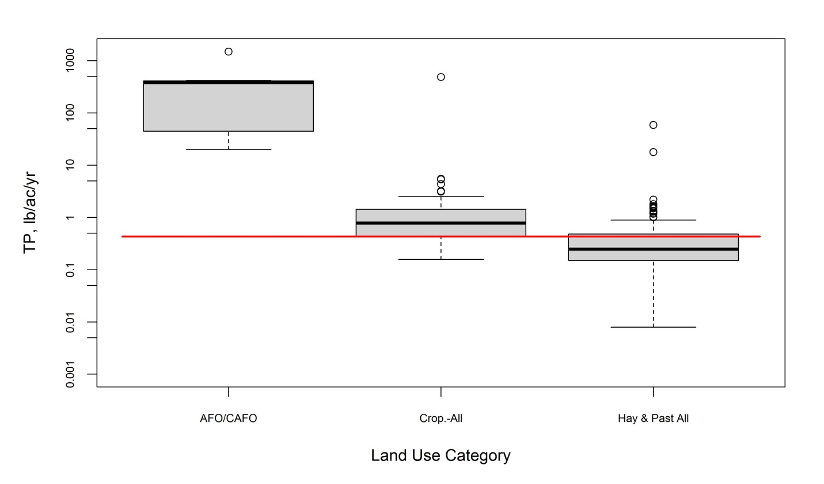
Figure 46. TP box plots from TMDL review for all agricultural land uses (EoF).

Table 48. TSS loading rate statistics from TMDL review for all agricultural land uses (EoF)
Land Use | Count | Loading Rate (lb/acre/yr)
Land Use | Count | Minimum | Average | Maximum | 25th percentile | Median | 75th percentile
AFO/CAFO | 15 | 580 | 16423 | 60800 | 3240 | 14060 | 24520
Cropland All | 32 | 1500 | 11400 | 24840 | 5770 | 11370 | 15640
Hay and Pasture All | 47 | 60 | 7071 | 60800 | 1440 | 3000 | 6360
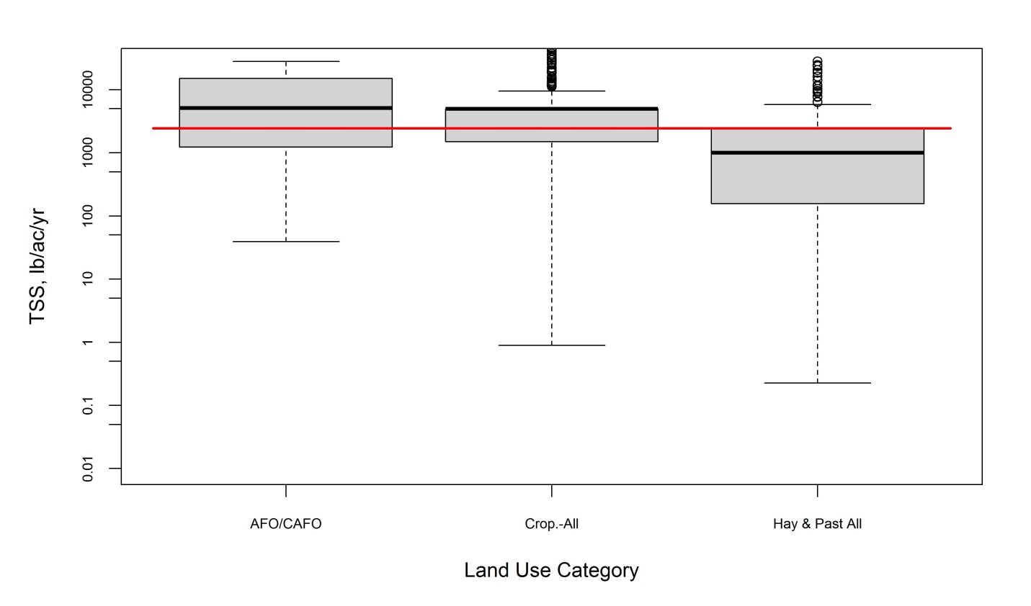
Figure 47. TSS box plots from TMDL review for all agricultural land uses (EoF).

Table 49. TSS loading rate statistics from TMDL review for hay and pasture land uses (EoF)
Land Use | Count | Loading Rate (lb/acre/yr)
Land Use | Count | Minimum | Average | Maximum | 25th percentile | Median | 75th percentile
Hay and Pasture | 15 | 640 | 3607 | 6360 | 1600 | 4000 | 5160
Hay and Pasture All | 47 | 60 | 7071 | 60800 | 1440 | 3000 | 6360
Pasture–Trampled | 15 | 580 | 16423 | 60800 | 3240 | 14060 | 24520
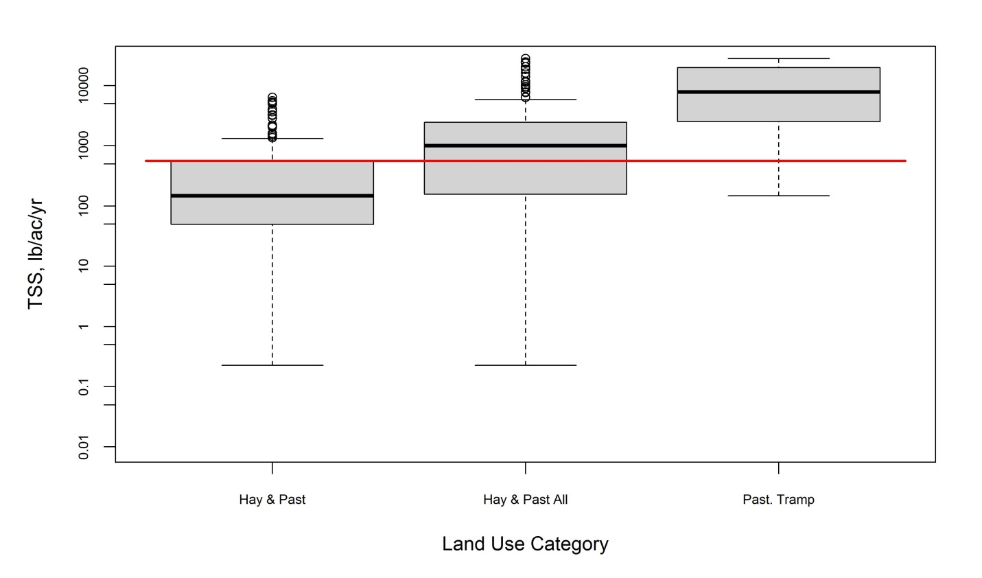
Figure 48. TSS box plots from TMDL review for hay and pasture land uses (EoF).

Attachment E: Histograms
Attachment E.1: Forestry Loading Rate Histograms from Literature Review

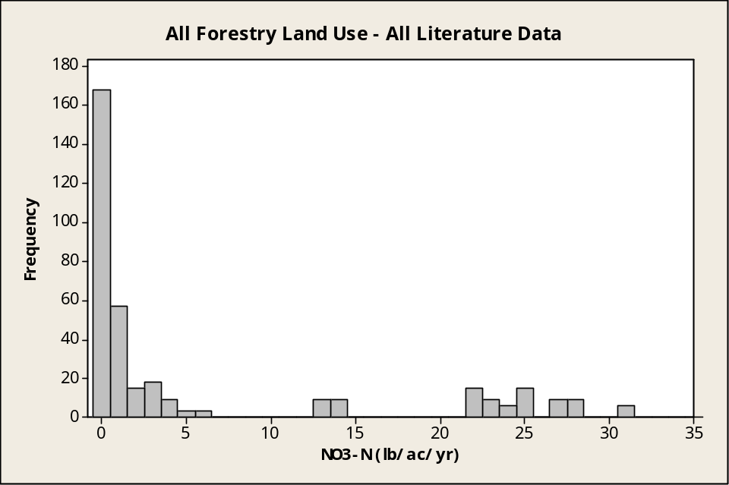
Figure 49. Frequency of NO₃ counts per loading rate range from literature review for all forestry land uses.

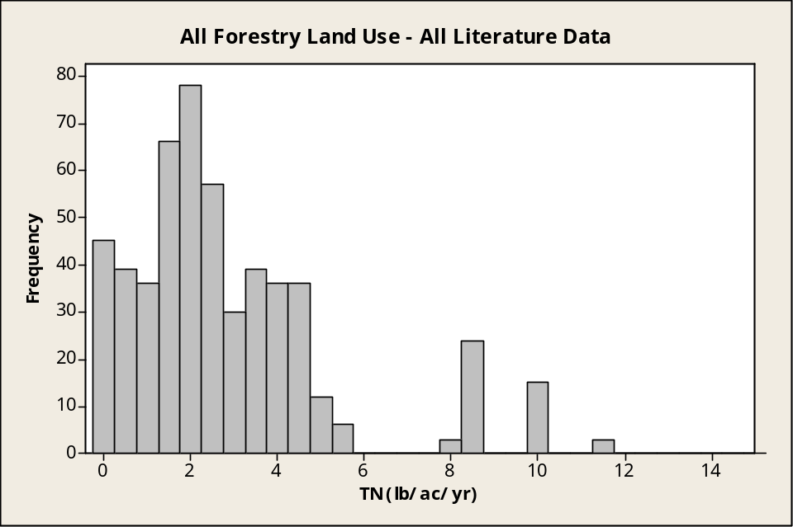
Figure 50. Frequency of TN counts per loading rate range from literature review for all forestry land uses.

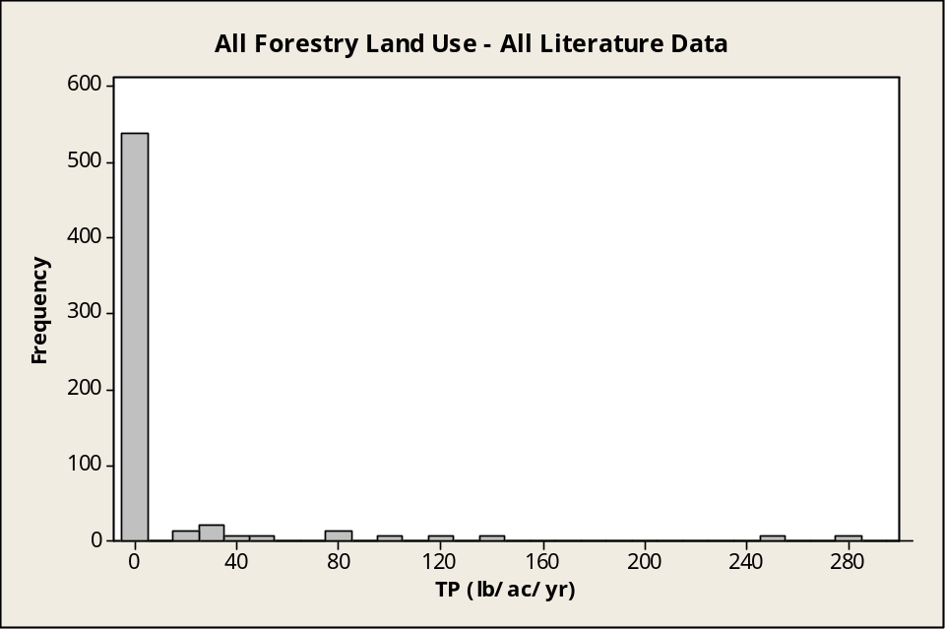
Figure 51. Frequency of TP counts per loading rate range from literature review for all forestry land uses.

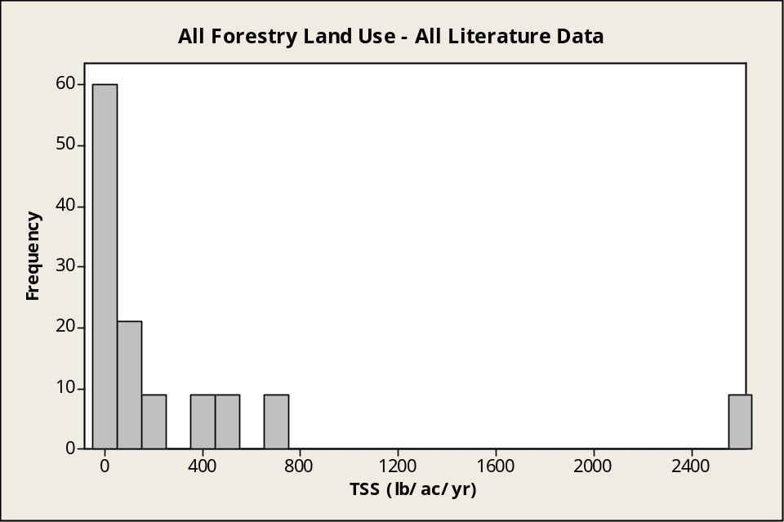
Figure 52. Frequency of TSS counts per loading rate range from literature review for all forestry land uses.

Attachment E.2: Forestry Loading Rate Histograms from TMDL Reviews

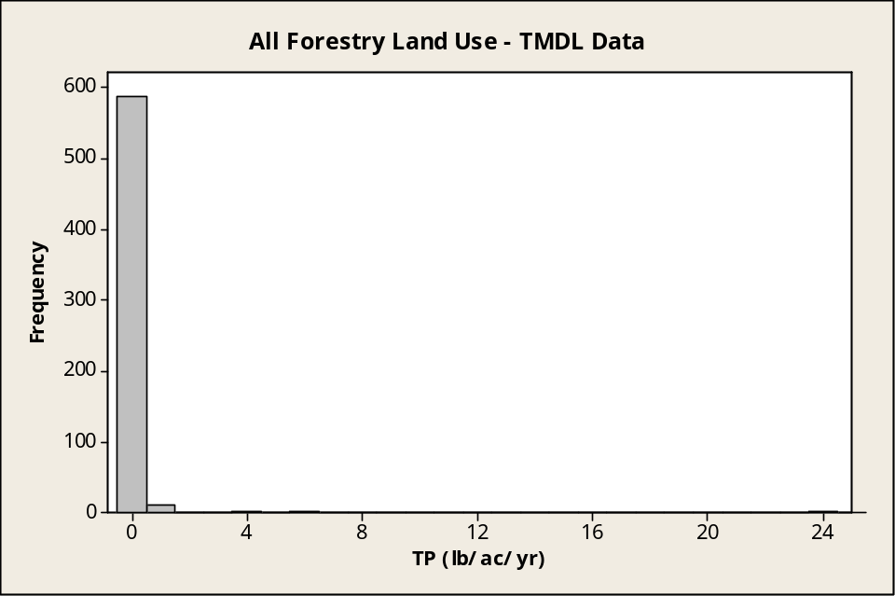
Figure 53. Frequency of TP counts per loading rate range from TMDL review for all forestry land uses.

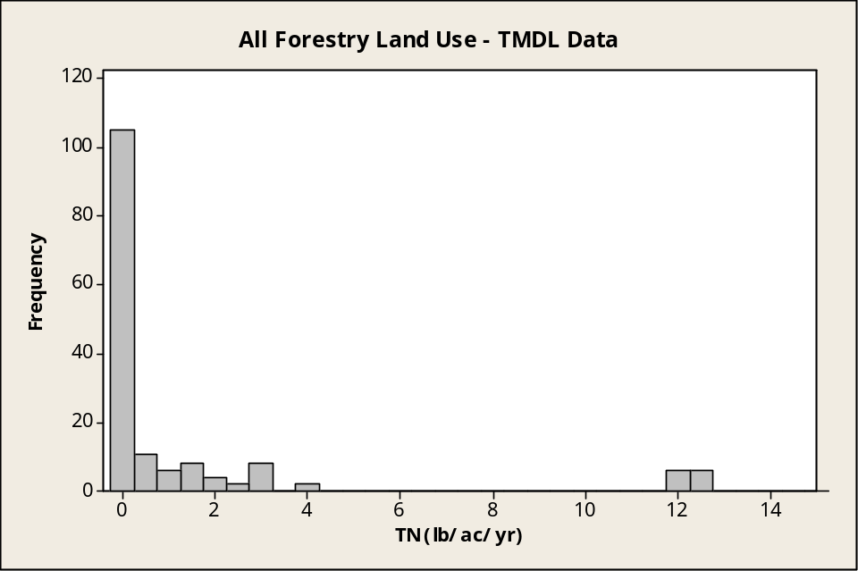
Figure 54. Frequency of TN counts per loading rate range from TMDL review for all forestry land uses.

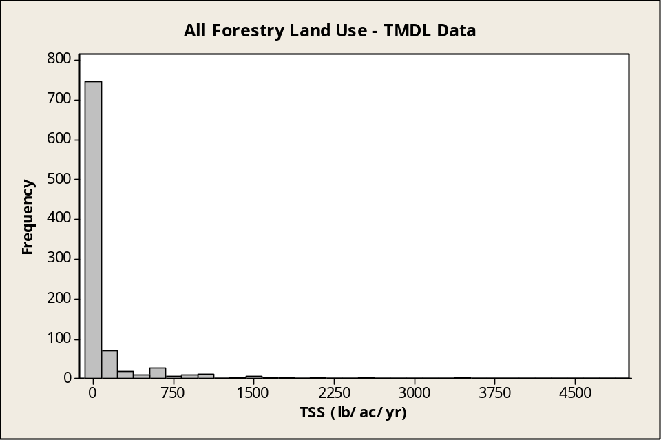
Figure 55. Frequency of TSS counts per loading rate range from TMDL review for all forestry land uses.

Note: Data extend beyond the limit used here (5,000 lb/ac/yr). Figure 56 includes full range.

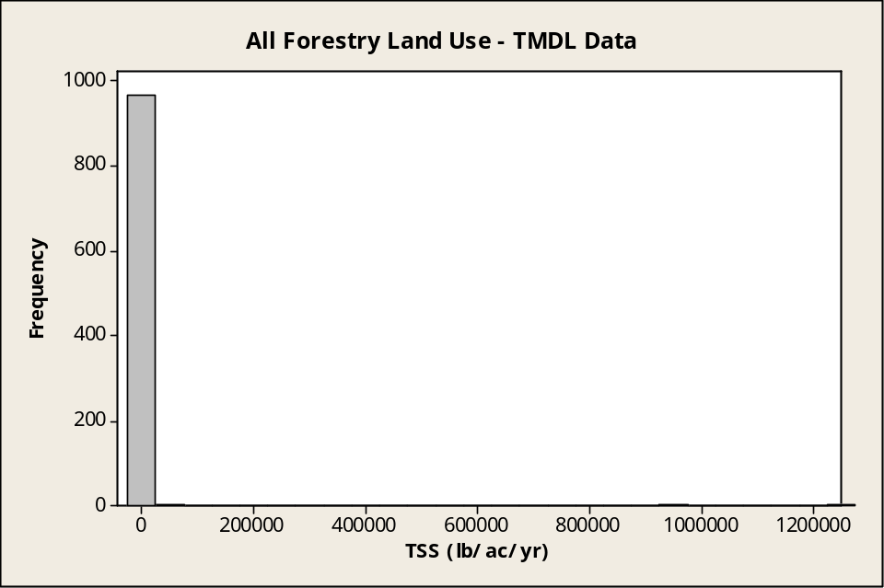
Figure 56. Frequency of TSS counts per loading range from TMDL review for all forestry land uses.
Note: This plot includes full range of TSS data.

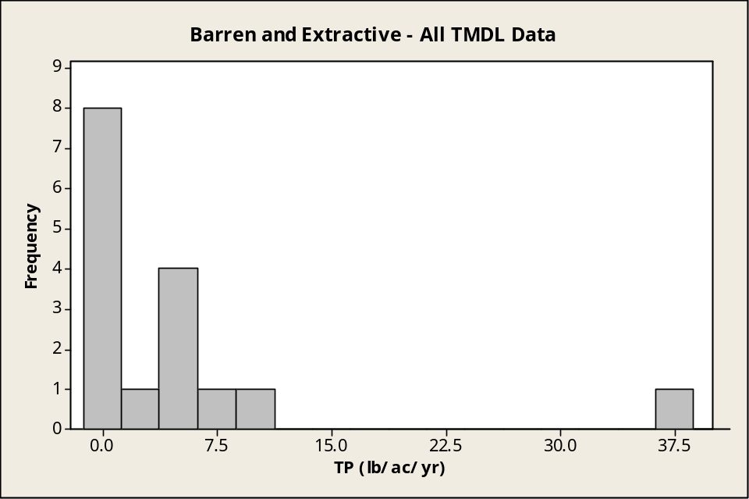
Figure 57. Frequency of TP counts per loading rate range from TMDL review for all barren and extractive land uses.

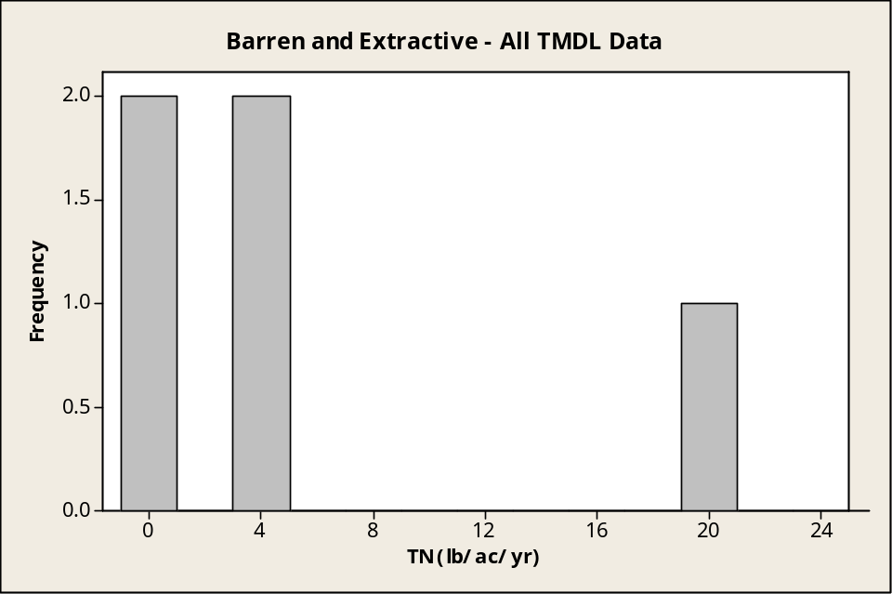
Figure 58. Frequency of TN counts per loading rate range from TMDL review for all barren and extractive land uses.

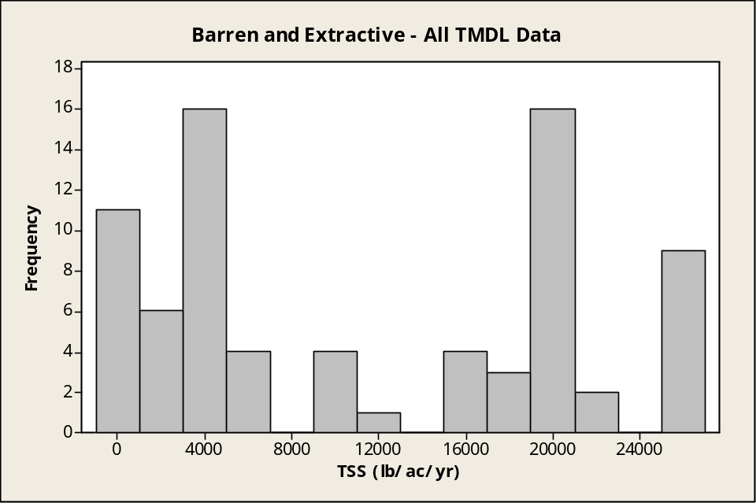
Figure 59. Frequency of TSS counts per loading rate range from TMDL reviews for all barren and extractive land uses.

Attachment E.3: Agricultural Loading Rate Histograms from Literature Review
See Attachment B for land use category definitions.

All Data
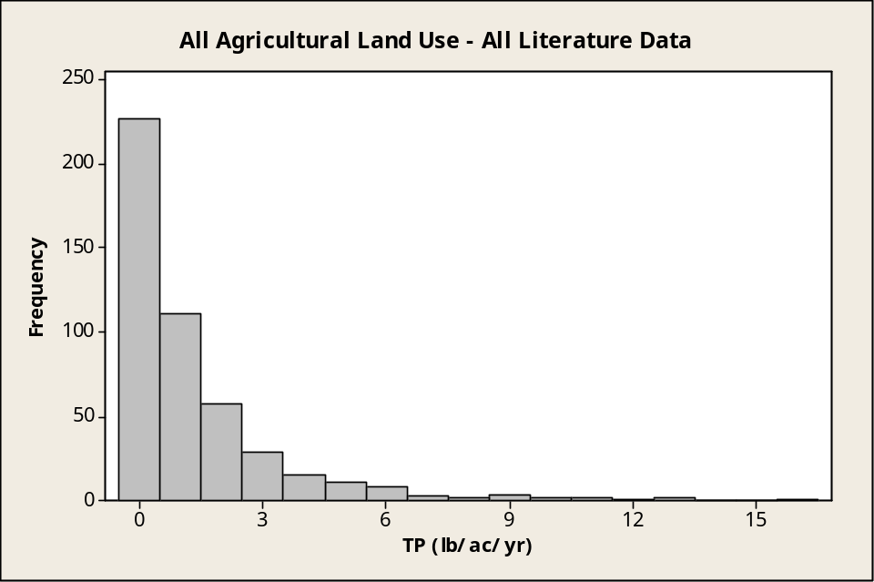
Figure 60. Frequency of TP counts per loading range for all pathways from literature review for all agricultural land uses.

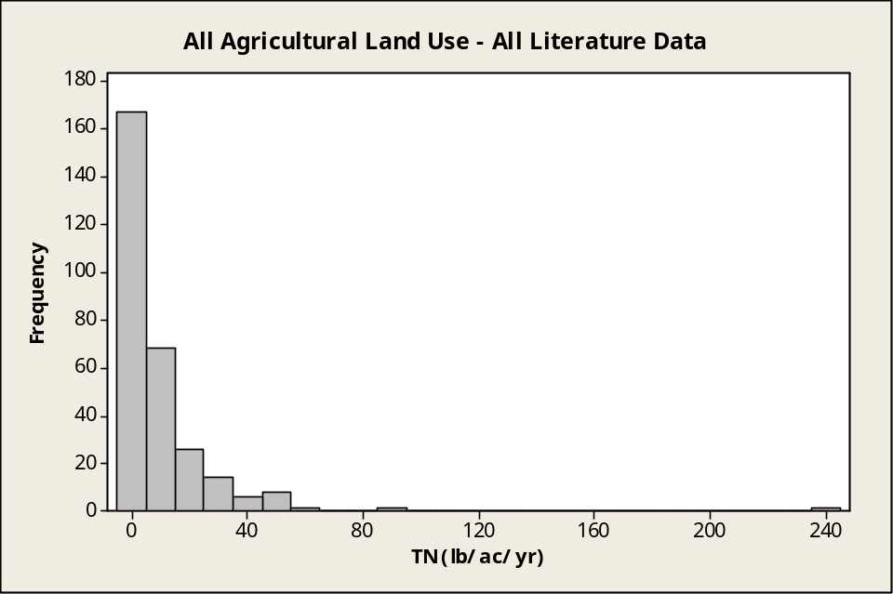
Figure 61. Frequency of TN counts per loading range for all pathways from literature review for all agricultural land uses.

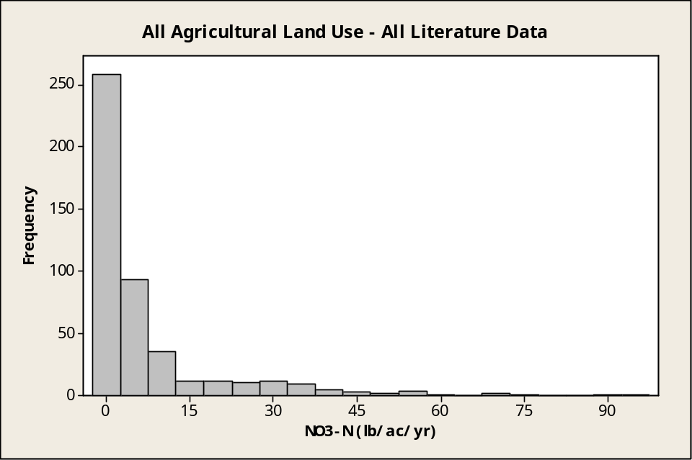
Figure 62. Frequency of NO₃ counts per loading range for all pathways from literature review for all agricultural land uses.

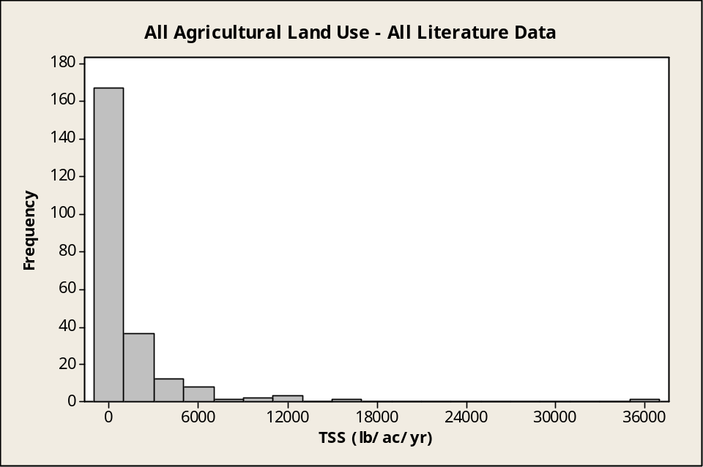
Figure 63. Frequency of TSS counts per loading range for all pathways from literature review for all agricultural land uses.

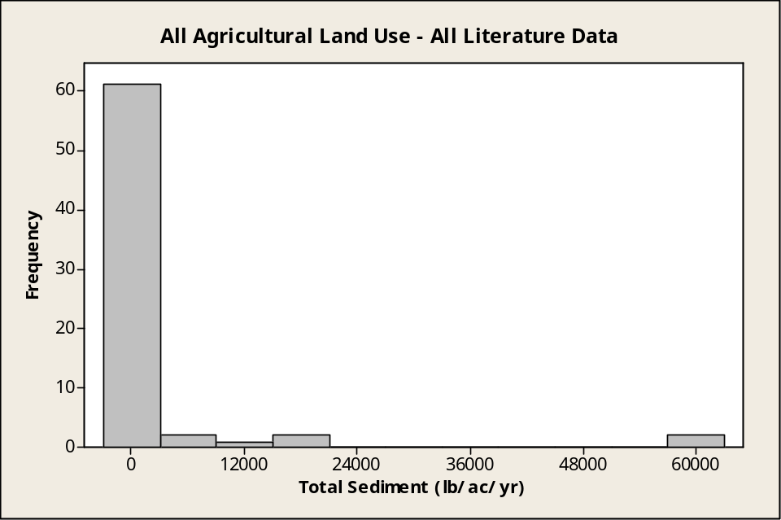
Figure 64. Frequency of total sediment counts per loading range for all pathways from literature review for all agricultural land uses.

By Pathway
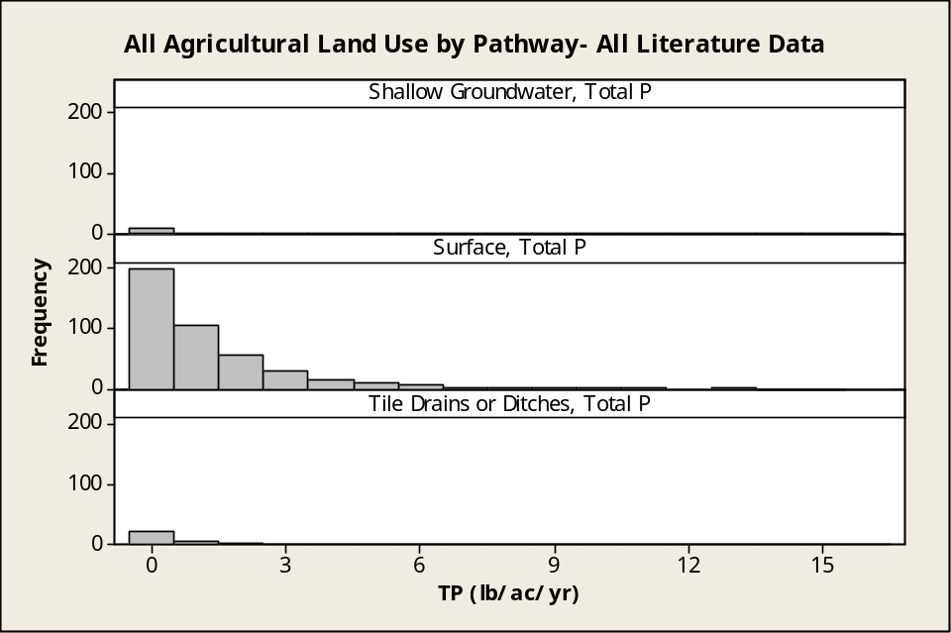
Figure 65. Frequency of TP counts per loading range by pathway from literature review for all agricultural land uses.

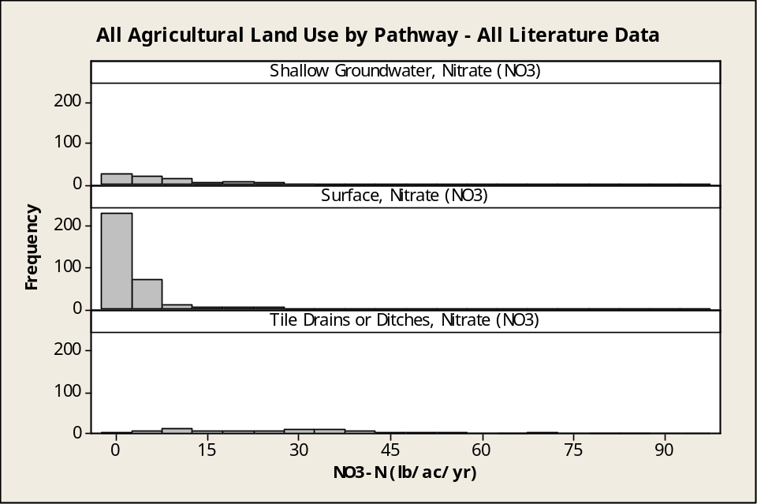
Figure 66. Frequency of NO₃ counts per loading range by pathway from literature review for all agricultural land uses.
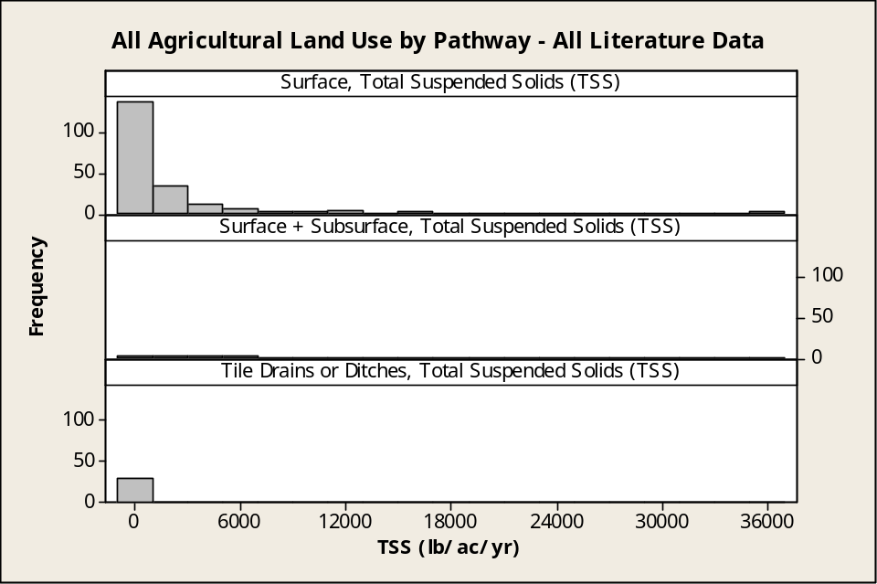
Figure 67. Frequency of TSS counts per loading range by pathway from literature review for all agricultural land uses.

By Category

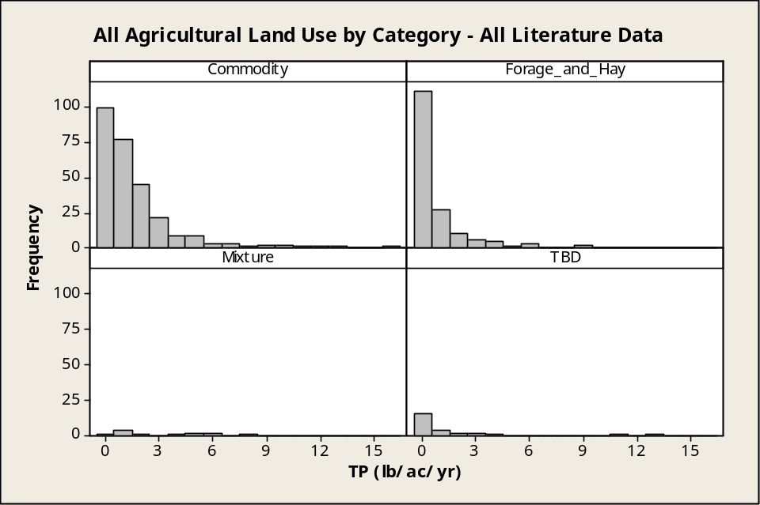
Figure 68. Frequency of TP counts per loading range by land use category from literature review.

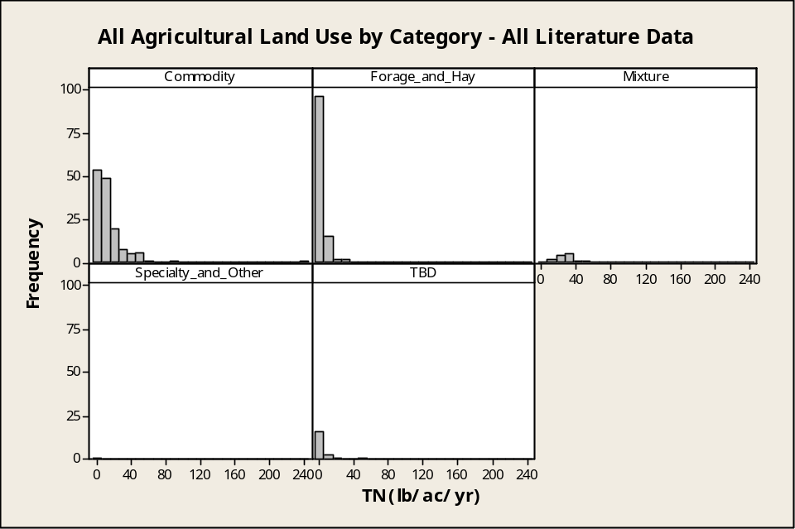
Figure 69. Frequency of TN counts per loading range by land use category from literature review.

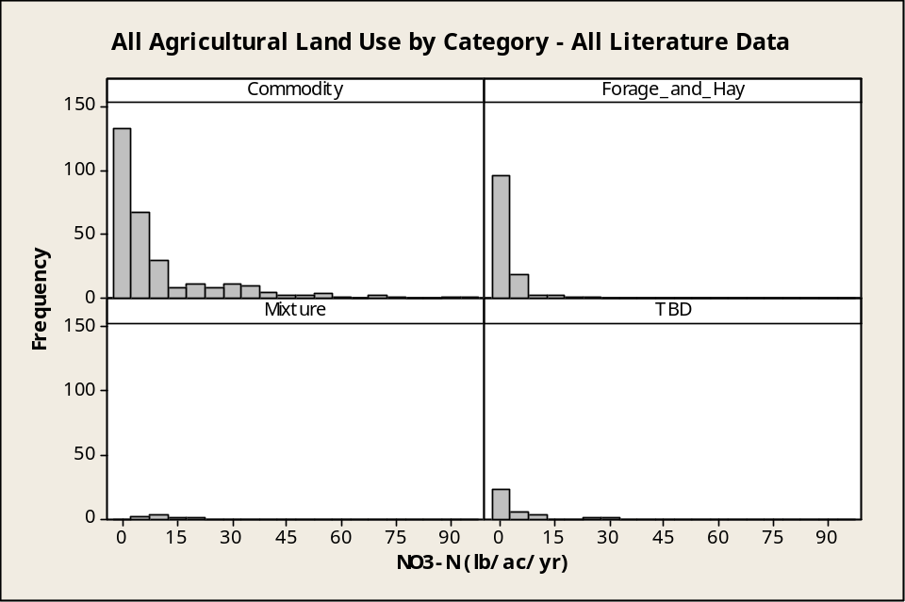
Figure 70. Frequency of NO₃ counts per loading range by land use category from literature review.

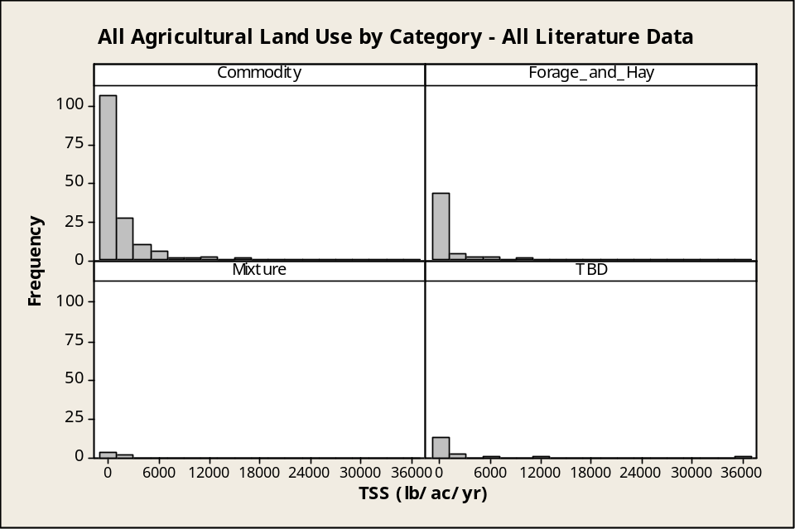
Figure 71. Frequency of TSS counts per loading range by land use category from literature review.

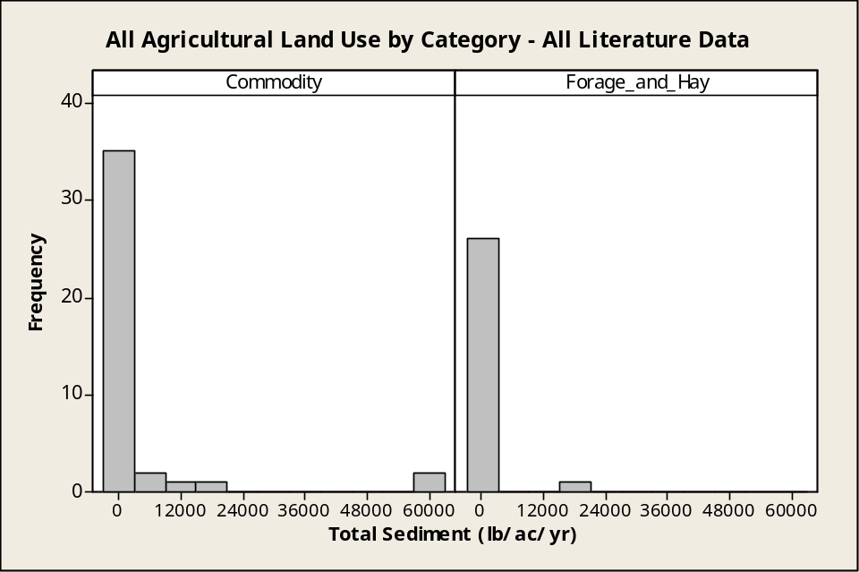
Figure 72. Frequency of total sediment counts per loading range by land use category from literature review.

By Land Use Subcategory

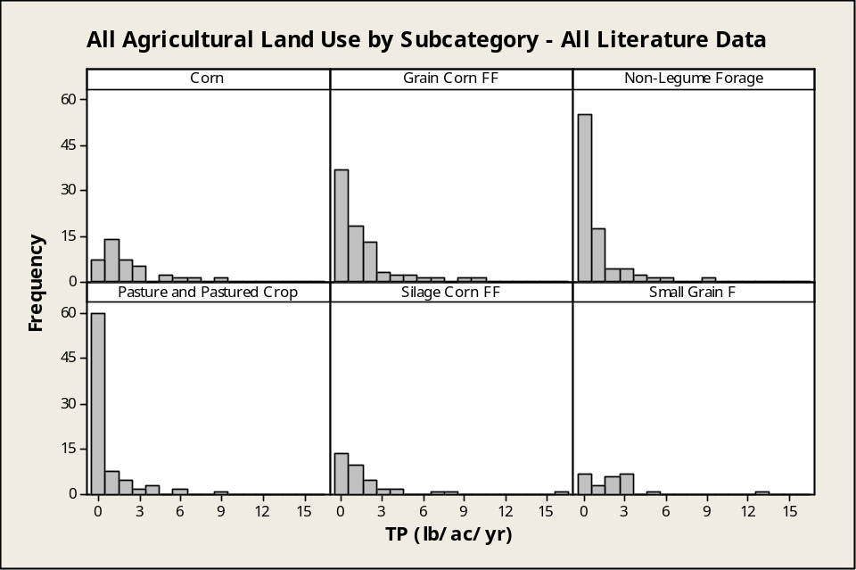
Figure 73. Frequency of TP counts per loading range by land use subcategory from literature review.

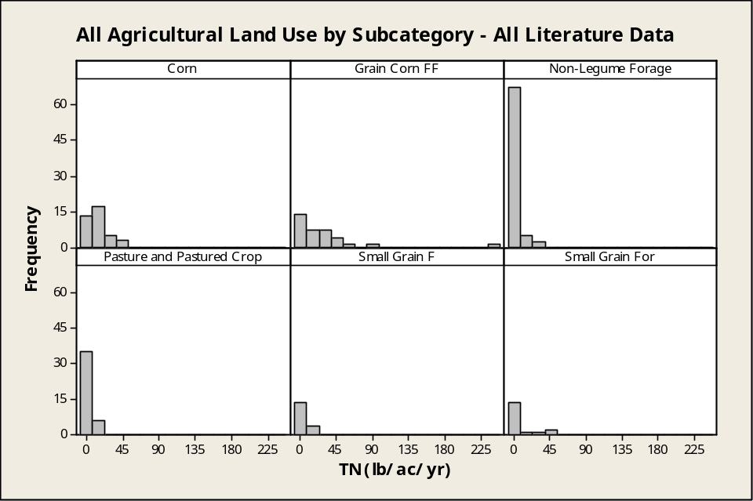
Figure 74. Frequency of TN counts per loading range by land use subcategory from literature review.

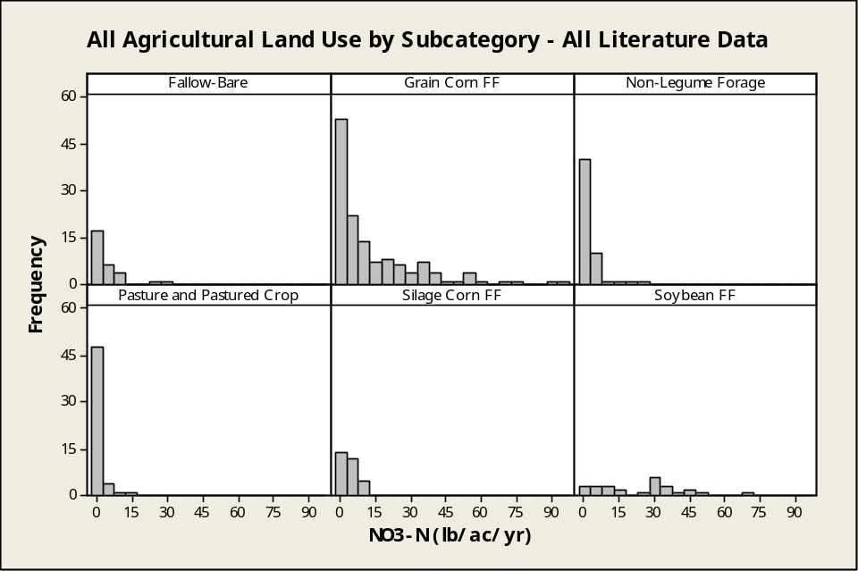
Figure 75. Frequency of NO₃ counts per loading range by land use subcategory from literature review.

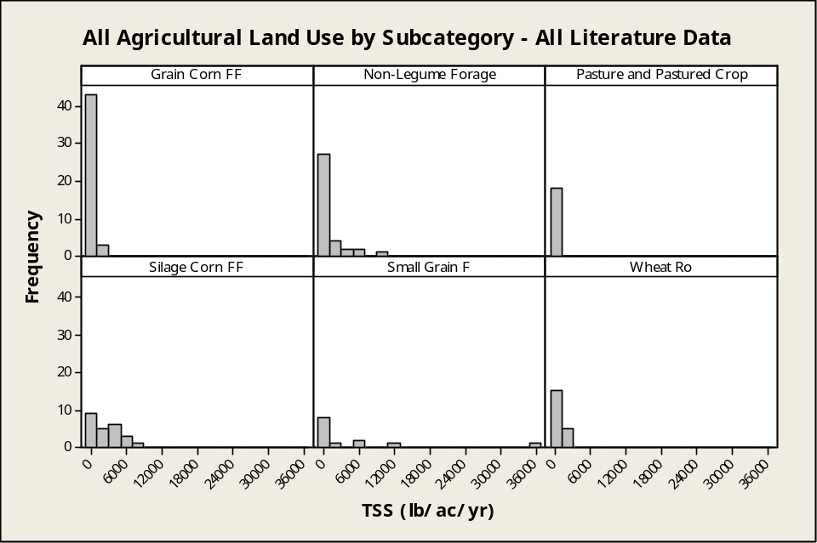
Figure 76. Frequency of TSS counts per loading range by land use subcategory from literature review.

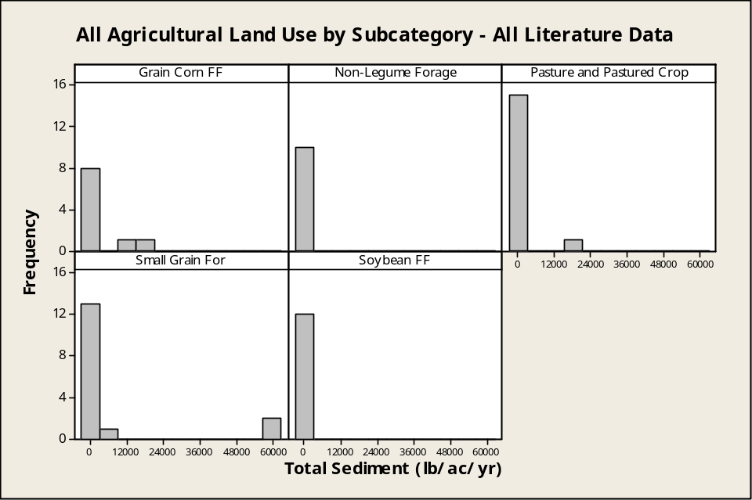
Figure 77. Frequency of total sediment counts per loading range by land use subcategory from literature review.

By Soils

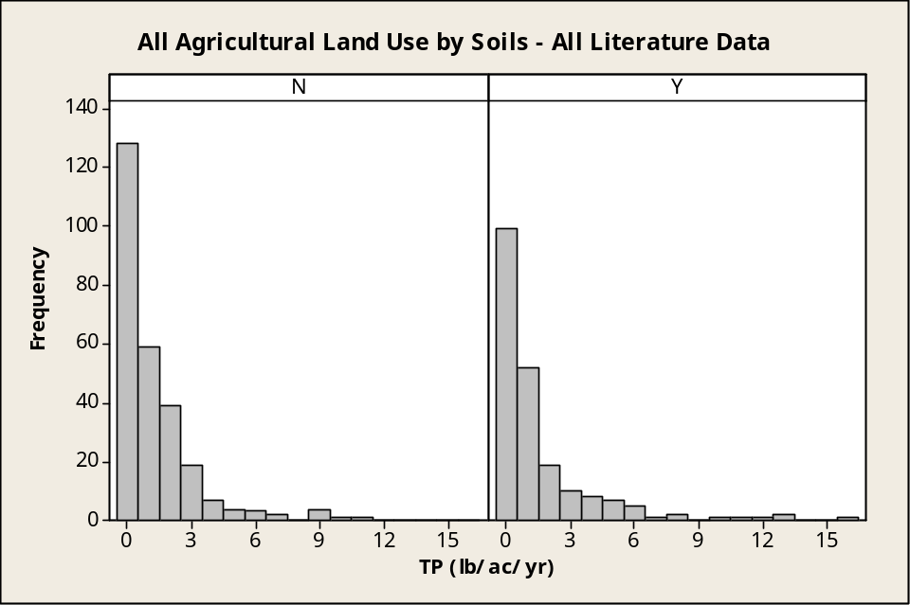
Figure 78. Frequency of TP counts per loading range by soils (Y=CBW, N=outside CBW) from literature review.
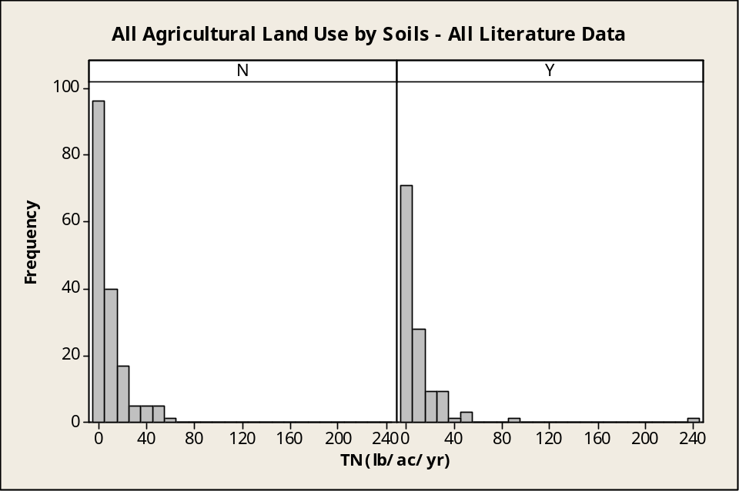
Figure 79. Frequency of TN counts per loading range by soils (Y=CBW, N=outside CBW) from literature review.

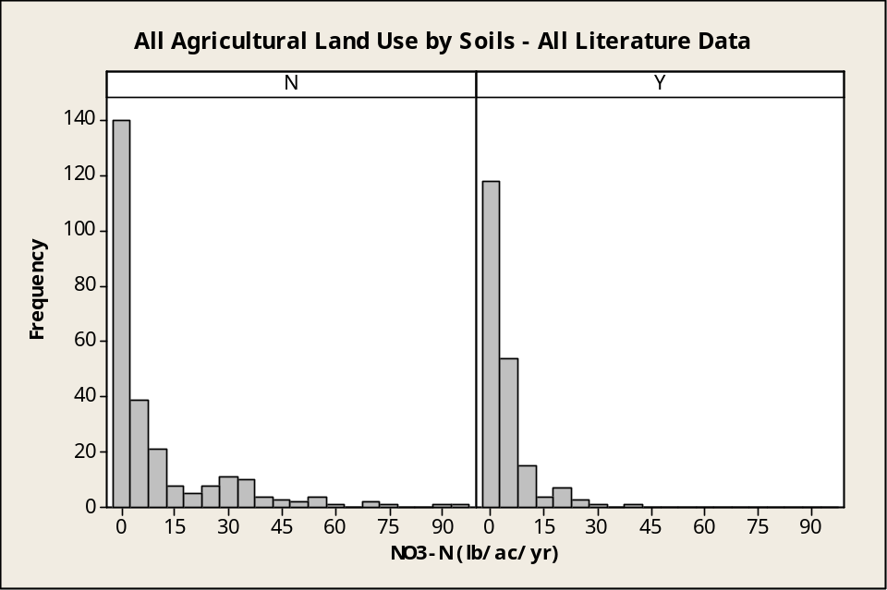
Figure 80. Frequency of NO₃ counts per loading range by soils (Y=CBW, N=outside CBW) from literature review.

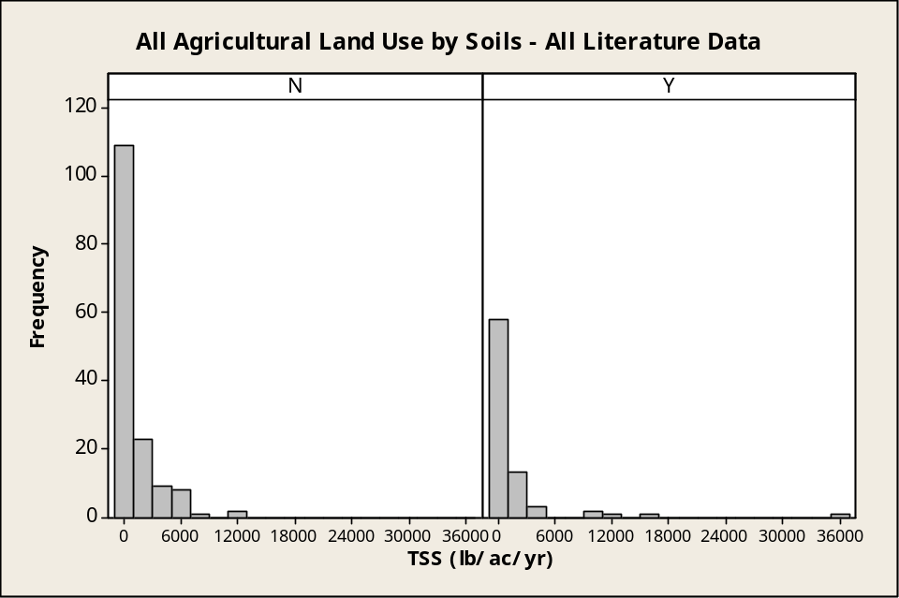
Figure 81. Frequency of TSS counts per loading range by soils (Y=CBW, N=outside CBW) from literature review.

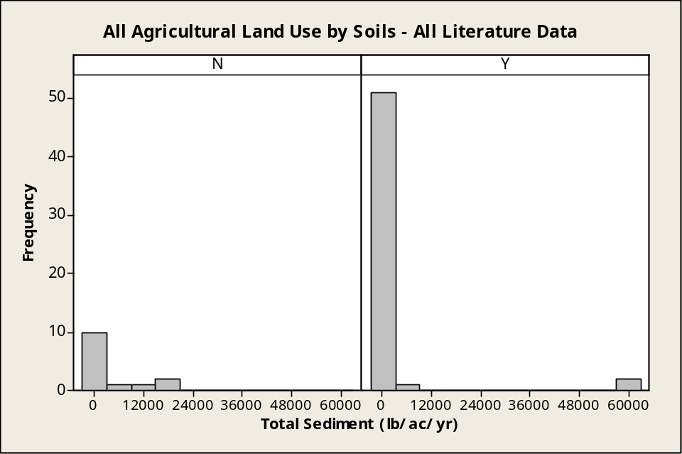
Figure 82. Frequency of total sediment counts per loading range by soils (Y=CBW, N=outside CBW) from literature review.

By Other Factors
The following series of histograms for TP illustrate the general pattern of distribution for all monitoring parameters. Distributions were less skewed than illustrated in Figure 83 in only a few cases.

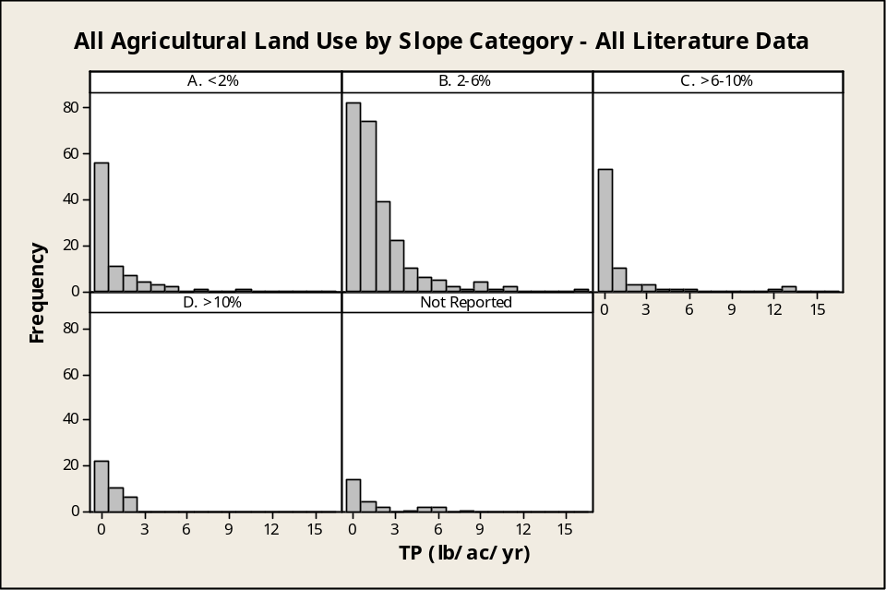
Figure 83. Frequency of TP counts per loading range by slope category from literature review.

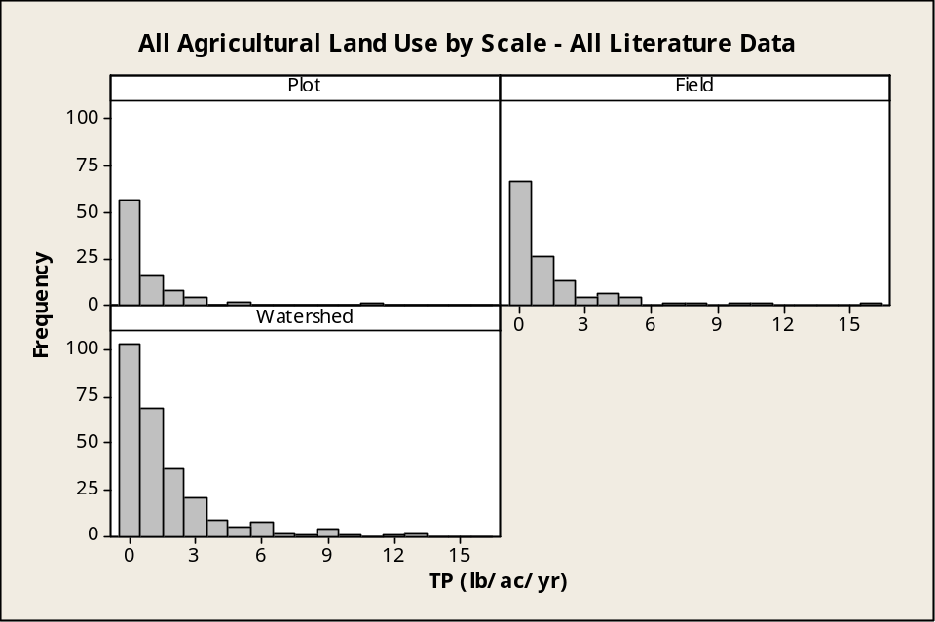
Figure 84. Frequency of TP counts per loading range by study scale from literature review.

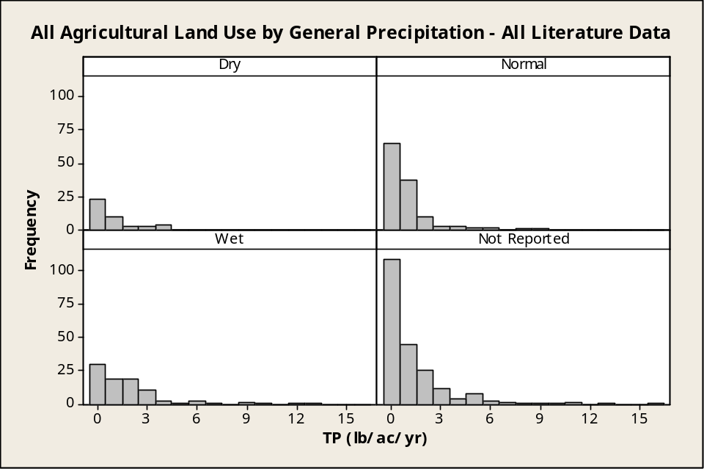
Figure 85. Frequency of TP counts per loading range by general precipitation from literature review.

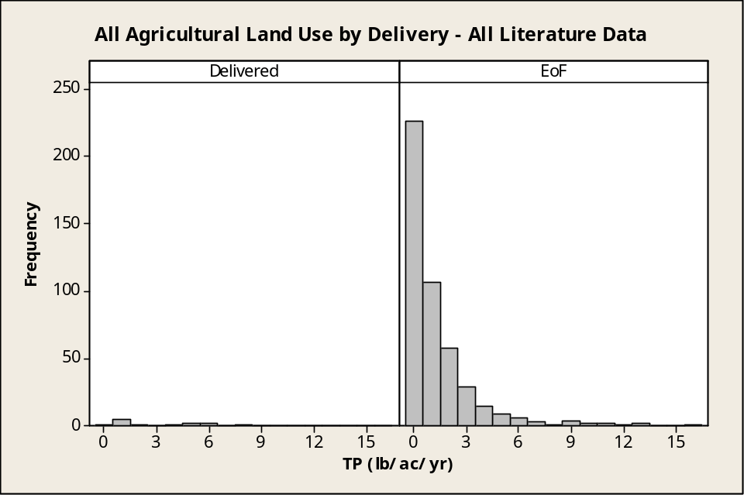
Figure 86. Frequency of TP counts per loading range by delivery from literature review.

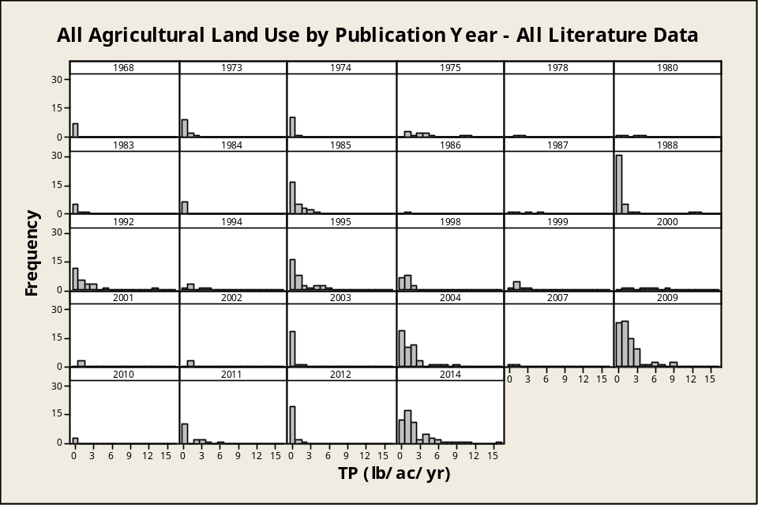
Figure 87. Frequency of TP counts per loading range by publication year from literature review.

Attachment E.4: Agricultural Loading Rate Histograms from TMDL Review
All Data

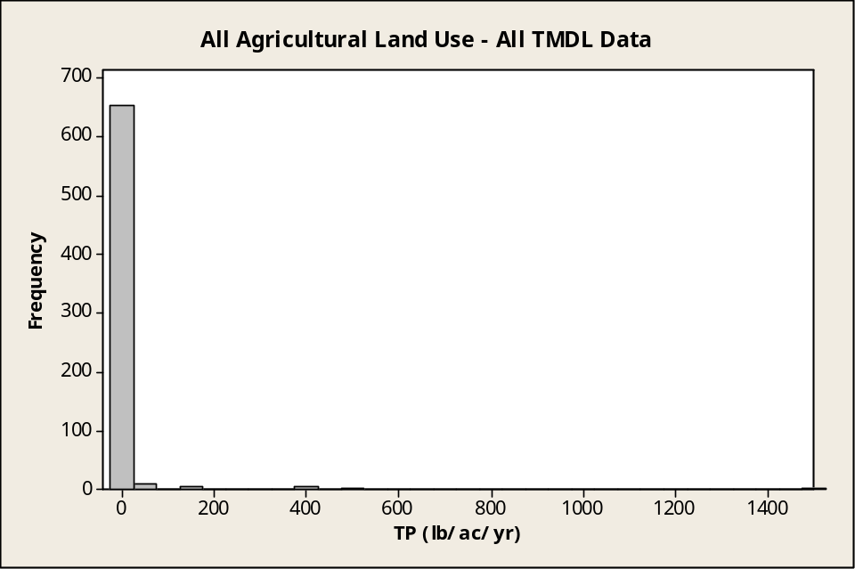
Figure 88. Frequency of TP counts per loading range from TMDL review for all agricultural land uses (full range).

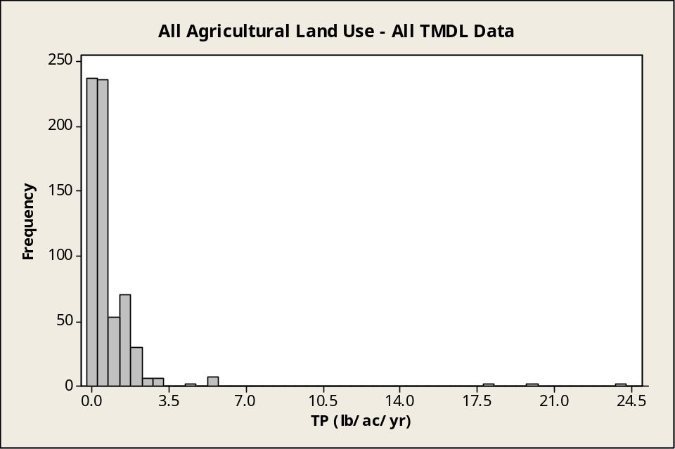
Figure 89. Frequency of TP counts per loading range from TMDL review for all agricultural land uses (scale capped at 25 lb/ac/yr).

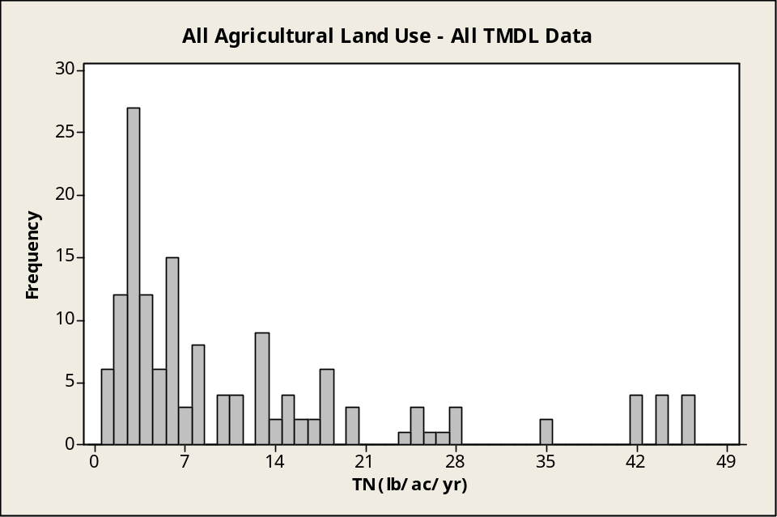
Figure 90. Frequency of TN counts per loading range from TMDL review for all agricultural land uses.

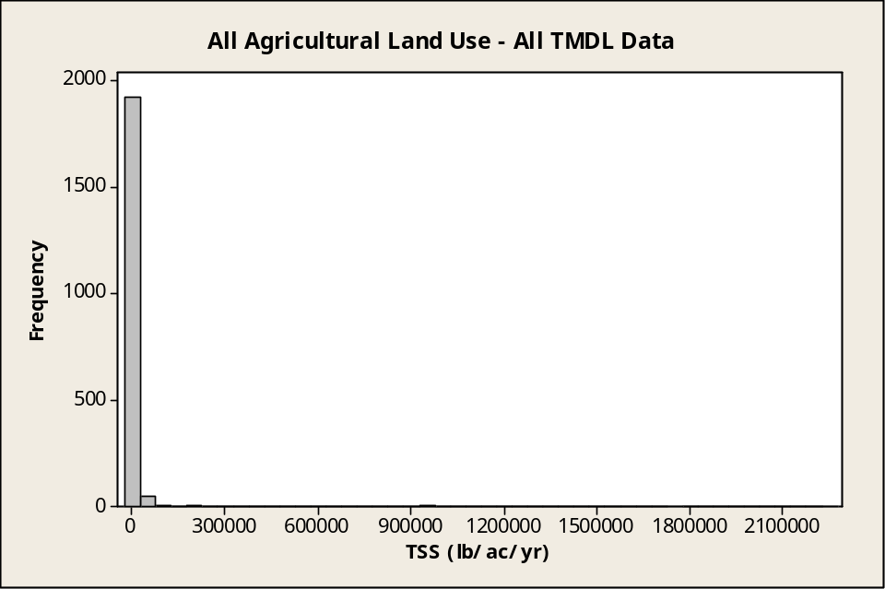
Figure 91. Frequency of TSS counts per loading range from TMDL review for all agricultural land uses (full range).

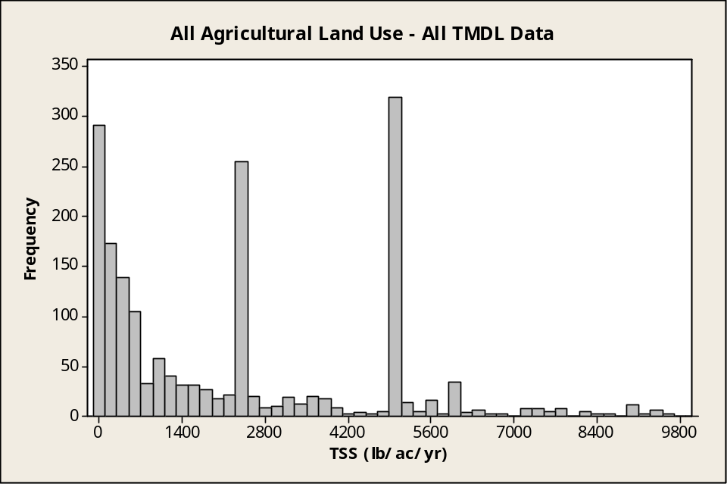
Figure 92. Frequency of TSS counts per loading range from TMDL review for all agricultural land uses (scale capped at 10,000 lb/ac/yr).

