Narrative Analysis

[insert outcome name and date of quarterly progress meeting]

The narrative analysis summarizes the findings of the logic and action plan and serves as the bridge between the logic and action plan and the quarterly progress meeting presentation. Based on what you learned over the past two years from your successes and challenges, you will describe whether the partnership should make adaptations or change course.

Use your completed pre-quarterly logic and action plan to answer the questions below. After the quarterly progress meeting, your responses to these questions will guide your updates to your logic and action plan. Additional guidance can be found on ChesapeakeDecisions.

otes

Examine your red/yellow/green analysis of your management actions. What lessons have you learned over the past two years of implementation?

Summarize what you have learned about what worked and what didn’t. For example, have you identified additional factors to consider or filled an information gap?

Regardless of how successful your short-term progress has been over the past two years, indicate whether we are making progress at a rate that is necessary to achieve the outcome you are working toward. The example graph below illustrates this concept.

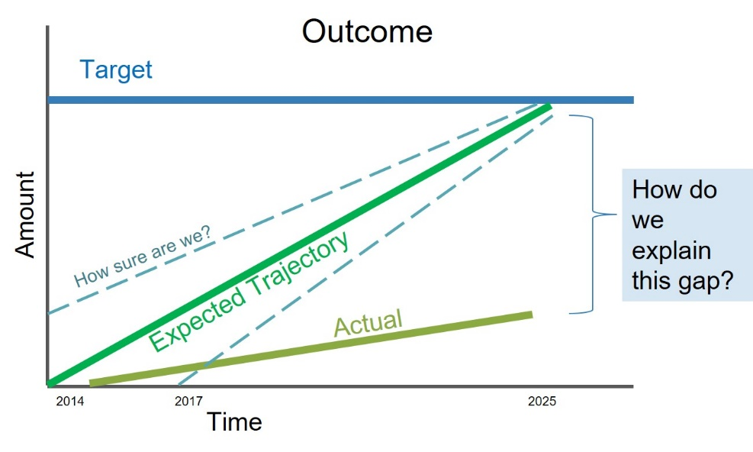

Use the editable graph below (or your own chart) to illustrate your progress. Explain any gap(s) between our actual progress and our anticipated trajectory.

What scientific, fiscal and policy-related developments will influence your work over the next two years?

This may include information learned at the previous biennial SRS meeting or more specific information about your outcome such as an increase or decrease in funding, new programs that address gaps, and new scientific data or research. Describe how these developments are likely to impact your recommended measure(s) of progress, the factors you believe impact your ability to succeed, and newly created or filled gaps. These changes should be reflected in the first three columns of your revised logic and action plan after your quarterly progress meeting.

Based on your response to the questions above, how will your work change over the next two years?

Describe the adaptations that will be necessary to more efficiently achieve your outcome and explain how these changes will lead you to adjust your management strategy or the actions described in column four of your logic and action plan. Changes that the workgroup, GIT or Management Board consider significant should be reflected in your management strategy.

What, if any, actions can the Management Board take to help ensure success in achieving your outcome?

Please be as specific as possible. Do you need direct action by the Management Board? Or can the Management Board direct or facilitate action through other groups? Can you describe efforts the workgroup has already taken to address this issue? If this need is not met, how will progress toward your outcome be affected? This assistance may include support from within a Management Board member’s jurisdiction or agency.

