Chesapeake Bay Program Indicator Framework
Reporting Level Indicators
Indicator and Data Survey

A. Category/Name/Source/Contact

(1) Category of Indicator
___ Factors Impacting Bay and Watershed Health
___ Restoration and Protection Efforts
___ Watershed Health
_X_ Bay Health

(2) Name of Indicator: Tidal Wetland Abundance Indicator

(3) Data Set Description:

- For what purpose(s) were the data collected? (e.g., tracking, research, or long-term monitoring.) To determine the abundance of tidal wetlands in acres within the Chesapeake Bay Watershed Estuarine Drainage Area (EDA) Non-Shore line version: (G:\GIS\Working\Tidal Wetlands Abundance\CCAP_2010_Update_in_2014\commondata\wetlands\NOAA_EDA_NoShore.shp) .

- Which parameters were measured directly? Which were obtained by calculation? NOAA/CCAP delivered a new “2010 edition” of CCAP for years 1992 – 2010. CCAP data used to develop this indicator is derived from satellite imagery at 30m resolution. The 2010 edition of the data is a result of the NOAA CCAP application of an algorithm to evaluate the likelihood of Omission and Commission for the earlier, 2006 and previous, version of these data. Information from the chief NOAA investigator, Nate Herold, on the 2010 update methodology is as follows.
All four years have been updated using a new methodology.
Makes a substantially different dataset
Can well account for 3K drop in EWL for all years
A drop in the first year is likely carried through for following years.
Method:
- Create a Wetland Potential Layer using:
  - National Wetlands Indicator (NWI)
  - National Hydrologic Data (NHD)
  - Soils Data
  - Elevation Data

- Pass these data through a rule set
- Create a Wetland Likelihood layer ranging 0-8 (low to high likelihood).
- Find areas of low likelihood (0-2) called Wetland and flip to another class as appropriate
- Find areas of High likelihood (7-8) not classified as Wetlands and change classes as appropriate (e.g., not if Agriculture, Developed, etc.

This method resulted in a drop in Tidal Wetlands by about 3K acres in each year.

(4) Source(s) of Data: The Coastal Change Analysis Program (C-CAP) is a nationally standardized database of land cover and land change information, developed by NOAA, using remotely sensed imagery for the coastal regions of the U.S. C-CAP products inventory coastal intertidal areas, wetlands, and adjacent uplands with the goal of monitoring these habitats on a one-to-five year cycle.

- Is the complete data set accessible, including metadata, data-dictionaries and embedded definitions? If yes, please indicate where complete dataset can be obtained. Yes: Visit Data Source at: http://www.csc.noaa.gov/digitalcoast/data/ccapregional/

(5) Custodian of Source Data (and Indicator, if different): Source Data: Nate Herold (NOAA) Nate Herold - NOAA Federal [nate.herold@noaa.gov] Indicator: Fred Irani - USGS [firani@chesapeakebay.net]

(6) CBPO Contact: Fred Irani - USGS CBPO [firani@chesapeakebay.net], Peter Claggett, USGS CBPO [pclagget@chesapeakebay.net],
B. Communication Questions (complete either part 1, 2, or 3)
1. Restoration and Protection Efforts indicators only
(7a) How much has been completed since 1985 (or baseline year)? How much has been completed since 2000?
(8a) How much was done last year?
(9a) What is the current status in relation to a goal?
(10a) What is the key story told by this indicator?
(11a) Why is it important to report this information?
(12a) What detail and/or diagnostic indicators are related to this reporting level indicator? (Detail and diagnostic indicators can be spatially-specific, parameter-specific, temporally-specific information, etc.)
- Bay Health or Watershed Health indicators only
(7b) What is the long-term trend? (Since start of data collection) data collection is on a one-to five year cycle: 1992, 1996, 2001, 2005, and 2010 are available to date. Overall slight decline in wetland acres (See 8b) with a recent small rebound in 2010.
(8b) What is the short-term trend? (10-year trend) There is a negative trend in tidal wetland abundance from 1992 -2006 with a slight uptick in 2010. (See 11b).
(9b) What is the current status in relation to a goal? N/A

(10b) What is the key story told by this indicator? Although the changes are not significant on a Bay-wide scale, there are some significant changes on a local scale. Aerial photography in specific locations around the Bay, such as Blackwater National Wildlife Refuge in Maryland’s eastern shore, has been used to visually document significant loss of wetlands (see Figure 1.). The blue pixels overlain on the aerial photograph represents the acres of wetlands lost between 1996 and 2005. Acres Gained between 2001 and 2006 were generally scattered across the EDA. Figure 1 shows the locations of such increases only. The size of these locations has been exaggerated for visualization purposes only; otherwise the actual locations would be too small to see at this scale.

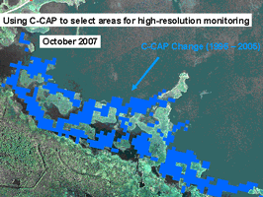
Figure 1. '96-'05 Local Wetland Increase

(11b) Why is it important to report this information? Status and trends, in relation to a goal or target: According to NOAA’s Coastal Change Analysis Program data from tidal regions of the Bay, there were 283,857 acres of tidal wetlands in 1992, 283,595 acres in 1996, 283,311 acres in 2001, 281,002 acres in 2005 and 282,291 acres in 2010 (Figure 2). This indicator is not associated with a goal, but it will inform the development of a wetland protection goal.

Figure 2. Tidal Wetland Abundance Indicator Change.

(12b) What detail and/or diagnostic indicators are related to this reporting level indicator? Wetland Restoration Indicator.
3. Factors Impacting Bay and Watershed Health indicators only
(7c) What is the long-term trend? (since start of data collection)
(8c) What is the short-term trend? (3 to 5 year trend)
(9c) What is the current status? (10c) What is the key story told by this indicator?
(11c) Why is it important to report this information?
(12c) What detail and/or diagnostic indicators are related to this reporting level indicator?

C. Temporal Considerations

(13) Data Collection Date(s): (1992, 1996, 2001, 2006 2010)

(14) Planned Update Frequency (e.g. - annual, bi-annual):
(a) Source Data: one-to five year cycle
(b) Indicator: Every 5 Years

(15) For annual reporting, month spatial data is available for reporting:

D. Spatial Considerations

(16) Type of Geography of Source Data (point, line polygon, other): Raster Land Cover data derived from Satellite Imagery.

(17) Acceptable Level of Spatial Aggregation (e.g. - county, state, major basin, tributary basin, HUC): N/A

(18) Are there geographic areas with missing data? No
If so, where?

(19) The spatial extent of this indicator best described as:
(a) Chesapeake Bay (NOAA Chesapeake Bay Estuarine Drainage Area (EDA))
(b) Chesapeake Bay Watershed
(c) Other (please describe)

Please submit any appropriate examples of how this information has been mapped or otherwise portrayed geographically in the past.

(20) Can appropriate diagnostic indicators be represented geographically? In a generalized, 30 meter resolution, form.

E. Data Analysis and Interpretation: (Please provide appropriate references and location of documentation if hard to find.)

(21) Is the conceptual model used to transform these measurements into an indicator widely accepted as a scientifically sound representation of the phenomenon it indicates? (i.e., how well do the data represent the phenomenon?) Yes

(22) What is the process by which the raw data is summarized for development and presentation of the indicator? See G. Below

(23) Are any tools required to generate the indicator data (e.g. - Interpolator, watershed model) ArcMap or similar Geographic Information Analysis Software.

(24) Are the computations widely accepted as a scientifically sound? Yes

(25) Have appropriate statistical methods been used to generalize or portray data beyond the time or spatial locations where measurements were made (e.g., statistical survey inference, no generalization is possible)? No spatial or temporal projections were applied.

(26) Are there established reference points, thresholds or ranges of values for this indicator that unambiguously reflect the desired state of the environment? (health/stressors only) Possibly

F. Data Quality: (Please provide appropriate references and location of documentation if hard to find.) CIMS Server at CBPO. Directory:
G:\GIS\Working\FIrani\Tidal_non_Tidal_Wetlands\Tidal_Wetland_Update_2014

(27) Were the data collected according to an EPA-approved Quality Assurance Plan? See G. Below
(28a) Are the sampling design, monitoring plan and/or tracking system used to collect the data over time and space based on sound scientific principles? See G. Below

(28b) What documentation clearly and completely describes the underlying sampling and analytical procedures used? See G. Below

(28c) Are the sampling and analytical procedures widely accepted as scientifically and technically valid? See G. Below

(28d) To what extent are the procedures for quality assurance and quality control of the data documented and accessible? See G. Below
(29) Are the descriptions of the study or survey design clear, complete and sufficient to enable the study or survey to be reproduced? Yes

(30) Were the sampling and analysis methods performed consistently throughout the data record? Yes
(31) If datasets from two or more agencies are merged, are their sampling designs and methods comparable? N/A

(32) Are uncertainty measurements or estimates available for the indicator and/or the underlying data set? See G. Below

(33) (Do the uncertainty and variability impact the conclusions that can be inferred from the data and the utility of the indicator?

(34) Are there noteworthy limitations or gaps in the data record? See G. Below

G. Additional Information (optional)
(35) Please provide any other information about this indicator you believe is necessary to aid communication and any prevent potential miss-representation

Proposed Tidal Wetlands Abundance Indicator
Chesapeake Bay Program Monitoring and Analysis Subcommittee
Advance Briefing Materials for the December 18-19, 2007 meeting

BACKGROUND
The most recent Estuarine (Tidal) Wetland update was derived from NOAA Coastal Change Analysis Program (CCAP 2010 land cover data for the area contained within the NOAA Estuarine Drainage area (EDA) for the Chesapeake Bay (see Figure 3).
In summer of 2006, the Wetlands Evaluation Task group (WET) considered options on how to report the status of tidal wetlands throughout the Bay by utilizing the most comprehensive data available. Several options were discussed but one (UMCES’ Marsh Condition Index) provided the most detail through a basin-wide, peer reviewed and field validated approach. In early 2007, this option was reviewed and discussed among WET, the Living Resources Subcommittee (LRSC), MASC and approved by IC pending analysis of additional years’ data; however such analysis was cost prohibitive (estimated at $200,000).

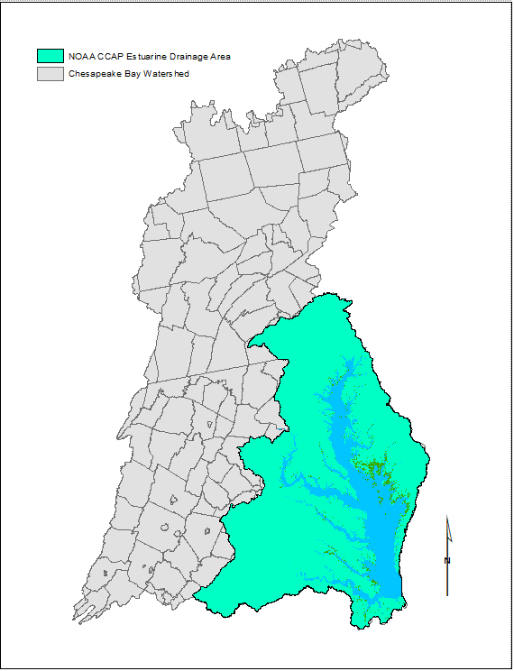
Figure 3 NOAA CCAP Estuarine Drainage Area in Green

OPTION / RECOMMENDATION
The Coastal Change Analysis Program (C-CAP) is a nationally standardized database of land cover and land change information, developed by NOAA, using remotely sensed imagery for the coastal regions of the U.S. C-CAP land cover change data consists of change maps, which identify the location of changes that have occurred, and a change database that records the quantity and category of these conversions.
This model provides LRSC with the following option:
- Utilize continuous source of C-CAP data available for the Chesapeake Bay region to determine the abundance of tidal wetlands in acres. C-CAP products inventory coastal intertidal areas, wetlands, and adjacent uplands with the goal of monitoring these habitats on a one-to-five year cycle.

ISSUES
- Defining Tidal Wetlands: When using the C-CAP data, estuarine scrub/shrub, estuarine forested, and estuarine emergent wetlands are all included in the definition of tidal wetlands.
- Defining Area of analysis: NOAA’s estuarine drainage area (see Figure 3.)
- Mapping Tidal Wetlands: The C-CAP satellite imagery is on 30m resolution and may not detect small changes over large areas. The C-CAP program is, however, moving toward incorporating high resolution imagery to improve and validate their assessments. Until that is available, a more detailed geographic breakdown of wetland area could help to convey the change in tidal wetland abundance.
- Mapping Change: The changes that occur in most areas are so small that they are difficult to visually perceive in the satellite images.
- Data Accuracy: C-CAP data categorization of estuarine emergent wetland has a confidence/ accuracy of 95%. This accuracy may have been improved by the 2010 data edition created via the methodology described in A.(3) above.
- Cost: There are other methods for mapping wetland trends, but few of these, if any, could be applied cost effectively across a landscape as large as the Chesapeake Bay watershed. NOAA and USGS have already funded the C-CAP data collection and plan to continue to fund it in future years. The Chesapeake Bay Program Office is fully funding a new Landscape Analyst position which will be responsible for future analysis, therefore no additional funds will be required to populate this indicator.
- Establishing a Baseline: The baseline for the indicator will be set when the analysis of the 1984 and 1992 data has been completed (likely in 2008). [Unknown whether this has been completed or not. -FMI-2014]

INTERPRETATION
The data show that there is a negative trend in tidal wetland abundance in the Chesapeake Bay. According to the land change statistics there was a between 1992 and 2005, with a slight rebound in acres in 2010, according to the 2010 CCAP data edition. However, this change is not statistically significant at the Bay-wide scale due to limitations of the data. This indicator is not intended to speak to the quality or health of the wetlands being analyzed; it is simply a quantitative tool.

Although the changes are not significant on a Bay-wide scale, there are some significant changes on a local scale. Aerial photography in specific locations around the Bay, such as Blackwater National Wildlife Refuge in Maryland’s eastern shore, has been used to visually document significant loss of wetlands (see Figure 1.). The blue pixels overlain on the aerial photograph represents the acres of wetlands lost between 1996 and 2005.
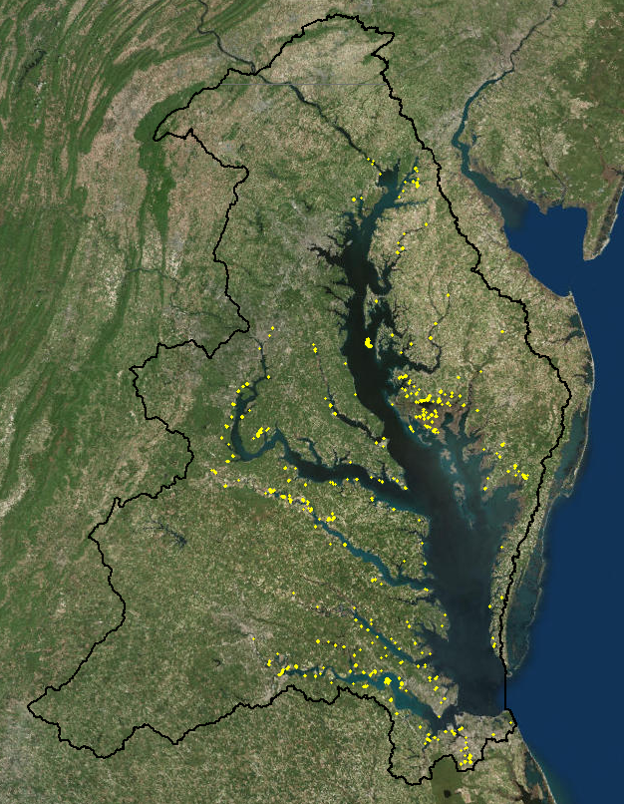
Fig. 3: New 2010 Tidal Wetland Locations

FUTURE ACTIONS
The continued use of CCAP data is planned for the near future. There is also an effort underway by NOAA to analyze data 1985 which we will be able to include in the indicator once available. Ultimately, the CBP partners hope to use this indicator as a tool to target management approaches in areas shown to be the most vulnerable to tidal wetland loss and conversion.

INFORMATION ABOUT THE NEW INDICATOR
- Name of indicator: Tidal Wetland Abundance
- Status and trends, in relation to a goal or target: According to NOAA’s Coastal Change Analysis Program data from tidal regions of the Bay, there were 283,857 acres of tidal wetlands in 1992, 283,595 acres in 1996, 283,311 acres in 2001, 281,002 acres in 2005 and 282,291 in 2010. In next year’s assessment, we will be able to provide comparable data for 1992 and 1984. This indicator is not associated with a goal, but it will inform the development of a wetland protection goal.

- Narrative information and data
- Please refer to attached spreadsheet.
- Additional information about this indicator is included in a presentation provided to the LRSC on November 29, 2007 (http://www.chesapeakebay.net/pubs/calendar/LRSC_11-29-07_Presentation_3_8480.ppt).
- Source of data: The Coastal Change Analysis Program (C-CAP), NOAA Coastal Services Center
- Indicator contact information: Peter Claggett, USGS CBPO pclaggett@usgs.gov, and Krystal Freeman, Living Resources Subcommittee Staff freeman.krystal@epa.gov

DECISION REQUESTED:

Support the recommended approach to fill this Indicator gap in the Health and Restoration Assessment.

