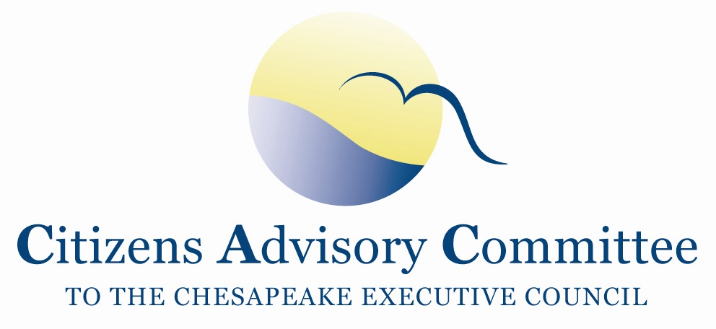

Tidewater Inn
101 East Dover Street
Easton, MD 21601
May 31- June 1, 2012

Agenda

Thursday, May 31- Crystal and Colonial Meeting Rooms

11:00 a.m. Call to Order…………………………………………………………..…...Nikki Tinsley, Chair Welcome and Introductions

11:10 a.m. Citizen Engagement
Updates from a Citizens Advisory Committee member………………………….Charlie Stek

12:10 p.m. Lunch- Oxford Room

1:00 p.m. Chesapeake Bay Water Quality Nutrient Trading
The Economics of Trading…………………………………………………......….Ann Swanson
Chesapeake Bay Commission, Executive Director

2:00 p.m. Program Accountability and Federal-Led Action
Chesapeake Bay Program updates and discussion…………………………….….Jim Edward
Deputy Director, EPA Chesapeake Bay Program Office
Discussion Items:
- Jurisdictions’ Watershed Implementation Plans and the 2012-2013 Two-Year Milestones
- Nutrient Trading
- Executive Order report and action plan
Updates:
- Chesapeake Bay TMDL litigation

2:55 p.m. Break

3:00 p.m. Program Accountability and State-Led Action
MD Watershed Assistance Collaborative…………………………..…...…...Brent McCloskey
Chesapeake and Coastal Services, MD Department of Natural Resources

3:45 p.m. Development and Environmentally Sensitive Design Practices
Tour the Easton Village Housing Community………………………………Karen McJunkin,
CAC Member and Elm Street Development
Mike Burlbaugh, Elm Street Development
4:45 p.m. Committee Discussion

5:30 p.m. Meeting Recess

7:00 p.m. Dinner- Scossa

Members will continue to discuss meeting topics and issues during in an informal setting.

Friday, June 1- Crystal and Colonial Meeting Rooms
Please check-out of the Inn prior to the meeting.

Breakfast will be provided in the Oxford Room from 7:30 am- 8:30 am.

8:30 a.m. Call to Order……………………………...………………………..………Nikki Tinsley, Chair
8:35 a.m. Federal Actions- Clean Water Authorities and other Legislation
Choose Clean Water Coalition Updates…………………………Hilary Harp Falk, Director
- Update on Federal Bills
  - 2012 Farm Bill
  - The Chesapeake Bay Program Reauthorization and Improvement Act (Rep. Goodlatte R-VA)
- Main Themes for the Coalition’s Conference

9:30 a.m. Opportunities for Public/Private Partnerships………………………….…….Joanne Throwe
Director, Environmental Finance Center

10:30 a.m. Program Accountability- Chesapeake Bay Program partnership
CBP Goal Implementation Team Decision Framework………………………..Carl Hershner
Virginia Institute of Marine Science
Chair, Decision Framework Implementation Workgroup
GIT 6 (Enhance Partnering and Leadership)

11:15 a.m. Business Meeting and Committee Discussion………………..…………Nikki Tinsley, Chair
- Approval of March 2012 meeting minutes
- Member and staff updates
- Suggestions for September agenda items

12:15 p.m. Adjourn

Next Meeting is September 6-7, 2012
Pennsylvania

