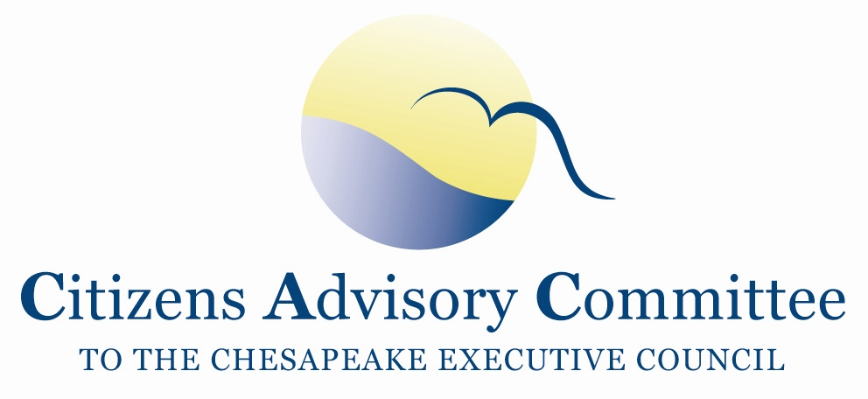

Vandiver Inn
301 South Union Avenue
Havre de Grace, MD 21078

Draft Agenda
Thursday, November 29

10:30 a.m. Call to Order…………………………………………………………..…...Nikki Tinsley, Chair Welcome and Introductions

10:45 a.m. Carpool to Conowingo Dam Plant
2569 Shures Landing Road
Darlington, MD 21034
410-457-2410

11:30 a.m. Tours in groups of 10 begin

1:00 p.m. Lunch at Visitor’s Center

2:00 p.m. Meeting Reconvenes at the Visitor’s Center
Conowingo Dam Panel discussion
Members will learn about the relicensing process for the Conowingo Dam and some of the water quality and watershed interests in the Dam.
    - Mary Helen Marsh, Director of Environmental Programs, Exelon
    - Shawn Seaman, MD DNR Power Plant Research Program
    - Anna Compton, US Army Corps of Engineers
    - Andrew Dehoff, Susquehanna River Basin Commission
    - Michael Helfrich, Lower Susquehanna Riverkeeper

4:00 p.m. Depart for Vandiver Inn

4:30 p.m. Arrive at Inn, Check-in

5:45 p.m. Meeting De-Brief and Reception

7:00 p.m. Dinner- Onsite

Friday, November 30
Breakfast will be provided in the parlor from 6:30am – 10:00am.

8:30 a.m. Call to Order……………………………...………………………..………Nikki Tinsley, Chair

8:35 a.m. CAC Business Meeting
- Officer Elections
- Approval of CAC September 2012 meeting minutes
- Discussion on CAC 2013 Meetings (Jessica and Al Todd)
- Approval of 2013 CAC meeting dates
- Updates from Members and Staff

10:00 a.m. BMP verification: Gauging Levels of Certainty in Agricultural Best Management Practices
Presentation by Mark Dubin, University of MD
Coordinator for the Chesapeake Bay Program Agricultural Workgroup

10:30 a.m. Break

10:45 a.m. Chesapeake Bay Program Updates………..….Jim Edward, EPA Chesapeake Bay Program
Deputy Director

11:00 a.m. Engaging Younger Generations in Chesapeake Bay Restoration
Presentation by the CAC Young Delegates
Elizabeth Burdick and Adam Thompson

11:30 a.m. Meeting Wrap-up
- Action Items and Next Steps
- Discussion of upcoming CAC agenda topics for 2013

12:00 p.m. Adjourn

Have a wonderful holiday season and see you in 2013!

