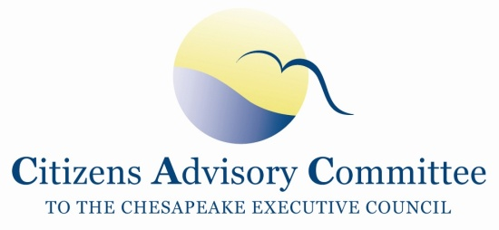

TO: Citizens Advisory Committee

FROM: Nominating Committee

DATE: November 15, 2012

SUBJ: 2013 Officers

The Nominating Committee is pleased to propose the following slate of

officers for 2013:

Chair - John Dawes

Vice Chair - Charlie Stek

Respectfully submitted,



Jim Elliott

Chair, CAC Nominating Committee