Conference Line Access Info:
DC Conference Line #2
(866) 299-3188
Conference Code
267-985-6222
http://chesapeake1.na4.acrobat.com/managementboardmeeting/

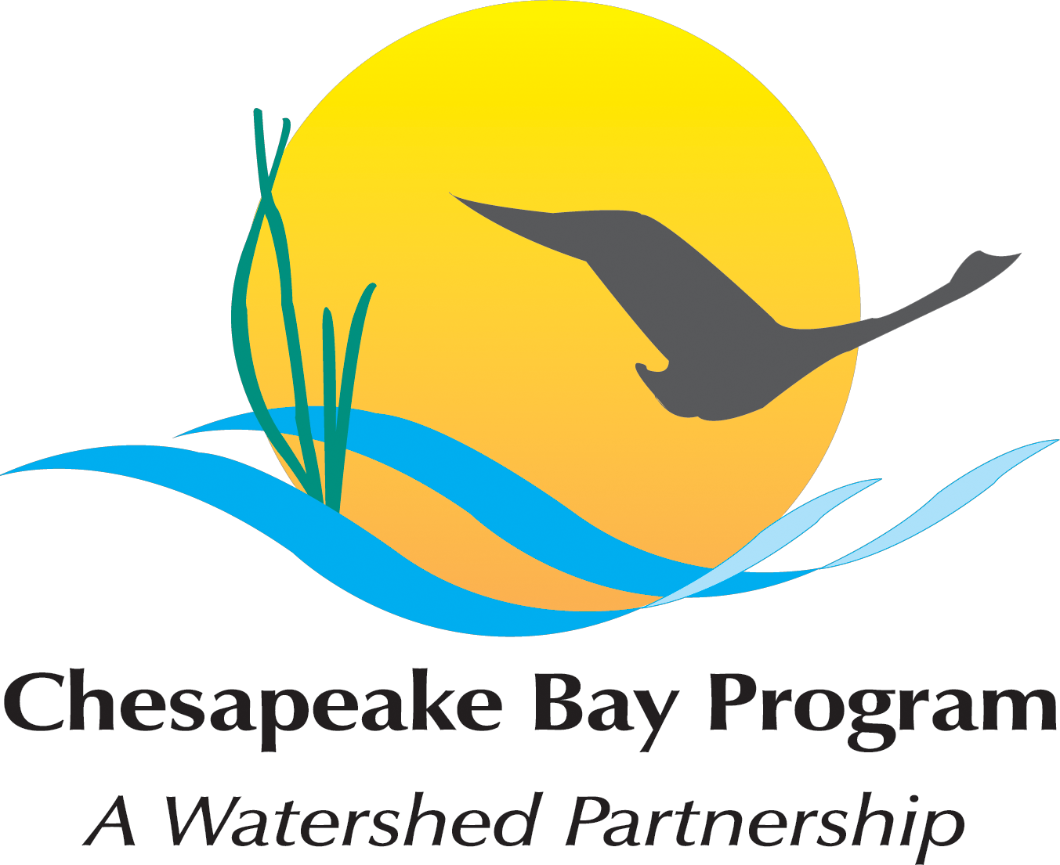
Chesapeake Bay Partnership
Meeting of the Principals’ Staff Committee
Hall of States
444 N. Capitol Street, NW, Washington, DC 20001
Room 383/385

February 16, 2012
10:00 a.m. – 3:00 p.m.

Agenda

- Welcome, Introductory Remarks and Program Updates (10:00 a.m. – 10:20 a.m.)
- Shawn Garvin, PSC Chair, will open the meeting, take roll call and make introductory remarks.
- Director’s Program Update - program updates and review of action items from last meeting. Nick DiPasquale, CBP Director
Materials:
    - Attachment I a: Actions from May 2011 PSC meeting
    - Attachment I b: Program Update

- Chesapeake Bay TMDL Path Forward (10:20 a.m. – 10:40 a.m.)
Briefing on next steps for the Draft Phase II Watershed Implementation Plans and the 2012-13 Two-Year Milestones for Jurisdictions and Federal Agencies.
  - Presenter: Shawn Garvin

- Management Board recommendations on the National Academies of Science report, Achieving Nutrient and Sediment Reduction Goals in the Chesapeake Bay: An Evaluation of Program Strategies and Implementation (10:40 a.m. – 12:00 p.m.)
- Briefing on Management Board recommendations and request for feed-back on planned response to report and CBP structural changes to address report’s criticisms
  - Presenters: Nick DiPasquale, Rich Batiuk, Mark Bennett, Jeff Horan
  - Decision Requested: PSC approval of Management Board’s recommendations on each of the four key challenge areas:
    - BMP Effectiveness and Verification Process (Rich Batiuk)
    - Adaptive Management Recommendations (Carin Bisland)
    - Modeling Laboratory (Mark Bennett)
    - Ongoing Function of the Independent Evaluator (Jeff Horan)
    - Finalize CBP Partnership’s Formal Response
Materials:
    - Attachment III a: Presentation
    - Attachment III b: Recommendations Memo from Management Board to PSC
    - Attachment III c: Partner suggested responses to NRC Report (table), November 17, 2011
    - Attachment III d: Key Challenges

- Lunch Break (12:00 p.m. – 12:30 p.m.)

- Progress on CBP Alignment (12:30 p.m. – 1:30 p.m.)
- Briefing on the Partnership’s progress toward Coordinating Chesapeake Bay Program and Federal Leadership Committee Goals, Outcomes, and Actions
  - Review progress on Stage 1 of PSC-approved alignment plan and expectations for stage 2; update on Management Board approvals of CBP decision framework implementation guide (“Enabling Effective Adaptive Management in the Chesapeake Bay Program”) and Communicating Assessment information to the public.
  - Presenter: Carin Bisland
  - Materials:
    - Attachment V a: “Coordinating Chesapeake Bay Program and Federal Leadership Committee Goals, Outcomes, and Actions”
    - Attachment V b: “Enabling Adaptive Management in the Chesapeake Bay Program” (approved by PSC 5/10/11)

- The CBP Decision Framework in Action – a report from the Goal Implementation Team (GIT) Chairs meeting and a demonstration of GIT 2 (SAV Workgroup) as an example of how the new decision framework looks in action.
  - Presenter: Jeff Horan, US Fish and Wildlife Service
  - Materials:
    - Discussion of SAV Workgroup review using ChesapeakeStat

- Executive Order Action Plan and Progress Report – a brief overview of the 2011 EO Progress Report and 2012 Action Plan
  - Presenter: Peyton Robertson, Chair, Federal Office Directors

- Sustainable Fisheries Goal Implementation Team (1:30 p.m. – 2:00 p.m.)
- Briefing on newly developed oyster metrics for evaluating ecological restoration efforts throughout the Bay. These metrics were developed by a team that included representatives from MD and VA state agencies, NOAA and the Army Corps, and academic scientists from both UMCES and VIMS. The presentation will highlight how the metrics are being used for restoration planning and implementation in Harris Creek,
MD and to evaluate restoration work done in the Great Wicomico River, VA.
There will also be a brief update on a new policy on invasive catfish adopted by the Sustainable Fisheries Goal Implementation Team (GIT 1).
  - Presenter: Peyton Robertson, GIT 1 Chair or (Stephanie Westby)
  - Materials:
    - Attachment VI a: Presentation
    - Attachment VI b: “Restoration Goals, Quantitative Metrics and Assessment Protocols for Evaluating Success on Restored Oyster Reef Sanctuaries” (December 2011)
    - Attachment VI c: Invasive Catfish Policy

- Local Government Advisory Committee (LGAC) Membership Issues (2:00 p.m. – 2:20 p.m.)
- Discussion regarding a change being considered by LGAC to their bylaws to allow for appointments of local government representatives from headwater states to participate in LGAC.
  - Presenter: Mary Ann Lisanti, Harford County Council/Local Government Advisory Committee Chair

- Planning for the Executive Council Meeting (2:20 p.m. – 2:50 p.m.)
- Discuss formation of a planning committee and possible themes for the FY 2012 meeting of the Executive Council
  - Presenter: Jeff Corbin
  - Decision Requested: Approve formation of planning team, identify jurisdiction representatives and discuss possible meeting themes.
    - Possible themes: Local actions for local benefits; Building sustainable communities through local initiatives; Healthy Watersheds-Healthy America; America values healthy watersheds

- Review of Action Items and Decisions (2:50 p.m. – 3:00 p.m.)
- Summary of action items and decisions and request for future meeting agenda topics (solicit assistance for free meeting space for April/May meeting)

