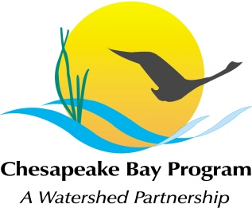
Maintaining Healthy Watersheds Conference Call
Friday, May 11, 9:00-11:00 AM
Call-in#: 866-299-3188, Code: 410-267-5731
Adobe Link: https://epa.connectsolutions.com/git4/

9:00 Welcome, Introductions, and Announcements Bryer
Update on Management Board guidance on Decision Frameworks for adaptive management

9:15 Summary of STAC Workshop Johnston
Matt Johnston will summarize the March STAC workshop for the GIT and provide the status of the workshop report. The purpose of the workshop was to explore the scientific basis for improving Bay watershed model estimation of the nutrient processing capacity of natural landscape features.

9:30 Communications Update Keech
Donnelle Keech will update the GIT on the status of Communications actions for 2012, and brainstorm ideas for the Chesapeake Watershed Forum and the Key Messages Package.

10:00 Healthy Watersheds Tracking Project Fritz/ Burnett
Review and discuss a straw-man outline of the objectives and timeline for GIT 4’s Healthy Watersheds Tracking Project. Brainstorm plans for an initial project workshop – see handout.

10:45 Next Steps

11:00 Adjourn Bryer

