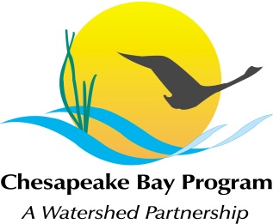
AGENDA
Maintain Healthy Watersheds Goal Implementation Team
Conference Call
January 17th, 10:00-12:00
Call-in#: 866-299-3188, code: 410-267-5731
Adobe Link: https://epa.connectsolutions.com/git4/

10:00 Welcome, Introductions Mark Bryer

10:15 GIT 4 Strategy Discussion
  - Focus on getting consensus for a small set of “collective” GIT 4 priority activities
  - Candidate activities (see GIT4 2013 Strategy):
  - Healthy watershed ID completion and publication (begun in 2012)
  - Compile existing or, as needed, develop new threat/vulnerability/protection assessments and publish them
  - Develop/ publish protection outcome metrics
  - Develop and implement educational and advocacy communications for key target audiences (e.g., local governments)
    - Develop video as communication tool to reach target audiences

11:30 Prioritize 2013 Agenda Topics Bryer/ Fritz
- Threat/vulnerability assessments – review of existing state assessments; identification of gaps and strategies to close gaps
- Communications – collaboration to refine and deliver key messages for key decision makers for healthy watershed protection (e.g., local governments)
- Eastern Brook Trout Joint Venture – potential as a pilot to implement healthy watershed identification, threat/vulnerability assessment, protection adequacy assessment; and to develop protection recommendations and communications.
- TNC/William & Mary Project on local protection support
- Potential use of CWA 319 grant program funding for healthy watershed protection
- Presentations on healthy watershed protection strategies and methods in states outside the Chesapeake Bay watershed (e.g., California, Tennessee)
- Field Trips to visit protected healthy watersheds – e.g., Dragon Run, VA

12:00 Adjourn and next steps

