Conference Line Access Info:

DC Conference Line
(866) 299-3188
Conference Code
267-985-6222

https://epa.connectsolutions.com/communications/

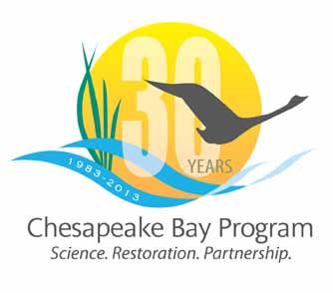

Communications Workgroup
Monthly Meeting

May 9, 2013
9:45-11a.m.

Room 305 at CBP offices in Annapolis

Agenda

- Round Robin / GIT Updates 9:45-10:15
– Ongoing: Fill in 2013 Calendar with Partner news, events, restoration efforts that CBP Comm. can help you communicate?

- Social media release update 10:15-10:25
- Margaret Enloe

- TMDL message clarification 10:25-10:30
- Tom Wenz

- Video Intern/Web Evaluator 10:30-10:40 - Steve Droter / Margaret Enloe

- 30 Year Celebration update - CBP PSA & other comm. items 10:40-10:50
- Steve/Margaret
Note: EC pushed back to October

- New CBP Brochure 10:50-11

