Conference Line Access Info:

DC Conference Line
(866) 299-3188
Conference Code
(410)267-5731
https://epa.connectsolutions.com/comm/
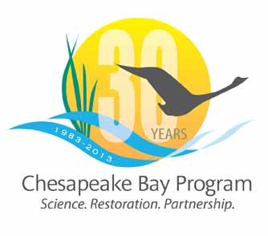

Communications Workgroup
Monthly Meeting

June 13, 2013
9:45-11a.m.

Room 303 at CBP offices in Annapolis

Agenda

- Round Robin / GIT Updates 9:45-10:15
– Ongoing: Fill in 2013 Calendar with Partner news, events, restoration efforts that CBP Comm. can help you communicate?

- Executive Council/Agreement 10:15-10:30
- Communication strategy
- 30th Anniversary celebration

- Video Intern/Web Evaluator 10:30-10:40

- “Lessons Learned” - STAR and Eco Check 10:40-11 - How do we communicate this to interested public?

