Conference Line Access Info:

DC Conference Line #2
(866) 299-3188
Conference Code
(267)985-6222
https://epa.connectsolutions.com/comm/
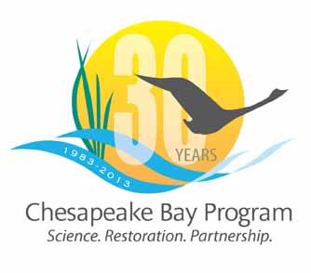

Communications Workgroup
Monthly Meeting

September 5, 2013
9:45-11a.m.

NPS Suite at CBP offices in Annapolis

Agenda

- Round Robin / GIT Updates 9:45-10:15
– Ongoing: Fill in 2013 Calendar with Partner news, events, restoration efforts that CBP Comm. can help you communicate?

- CBP News/Story Planning (Catherine to update next week) 10:15-10:20
- New Water Quality Indicator – Nita Sylvester 10:20-10:30

- PRESS: September: Capital Gazette series 10:30-10:40

- Agreement/Executive Council Meeting 10:40-10:50
- EC - Planning
- Agreement – communications strategy for next comment period
- 30th Anniversary Celebration – update/products
- CBP Releases Pending 10:50-11:00
- Lessons Learned Report (UMCES/STAR) – Press Release & Event – Thurs 9/19 10:00 am (TENT.)
- NFWF Annual Grant Awards release – Press Event - Oct 2 or 8
- Wetlands Restored Indicator – TBD
- New WQ Indicator
- Forest Buffers – Social media release – late October?
- 2012 Bay Barometer – proposing a release in end Oct/early Nov (latest)

