Conference Line Access Info:

DC Conference Line #2
(866) 299-3188
Conference Code
(267)985-6222
https://epa.connectsolutions.com/comm/
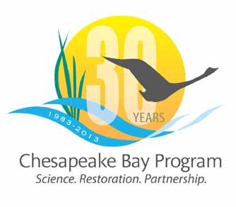

Communications Workgroup
Monthly Meeting

November 9, 2013
9:45-11a.m.

NPS Suite at CBP offices in Annapolis

Agenda

- Round Robin / GIT Updates 9:45-10:15
– Ongoing: Fill in 2013 Calendar with Partner news, events, restoration efforts that CBP Comm. can help you communicate?

- Editorial Calendar + Social Media Campaigns 10:15-10:20
- Beards for the Bay
- Halloween Candy

- Bay Barometer 10:20-10:30
- Indicator icons/changes/highlights

- Agreement update 10:30-10:40

- Executive Council Meeting: Planning and Information 10:40-10:50

- Lessons Learned Report 10:50-11:00

