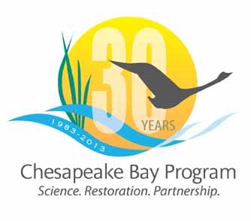
Chesapeake Bay Partnership
Conference Line:
1-866-299-3188
Conference Code
267-985-6222

Web conference:
https://epa.connectsolutions.com/cbp/

Meeting of the
Goal Team Chairs/Vice Chairs

June 6, 2013
9:00 a.m. – 12:00 p.m.

Agenda

- Welcome (9:00 a.m. – 9:15 a.m.)
CBPO Director, Nick DiPasquale

- 2013 Chesapeake Bay Program Partnership Agreement (9:15 a.m. – 11:30 a.m.)
Overview of the new Agreement development process, schedule and expectations for the Goal Teams during the development process.
- Preamble, Mission, Vision, Principles and Operation Commitment
- Recap of MB recommendations of Goals
- Progress on Outcomes
- Identified Gaps: Toxic Contaminants, Climate Change
- Development of Management Strategies and workplans

- CBP Report to Congress (11:30 a.m. – 11:40 a.m.)
Overview of the current outline and timeline for development of the 2013 Report to Congress on the Chesapeake Bay Program progress.

- 30th Anniversary Celebration (11:40 a.m. – 11:50 a.m.)
Overview of plans for a 30th Anniversary Celebration of the Chesapeake Bay Program

- GIT Chairs Retreat (11:50 a.m. – 12:00 p.m.)
Discuss plans for a full-day GIT Chairs retreat in July or August and topics for consideration.

- Wrap up and Review Actions

