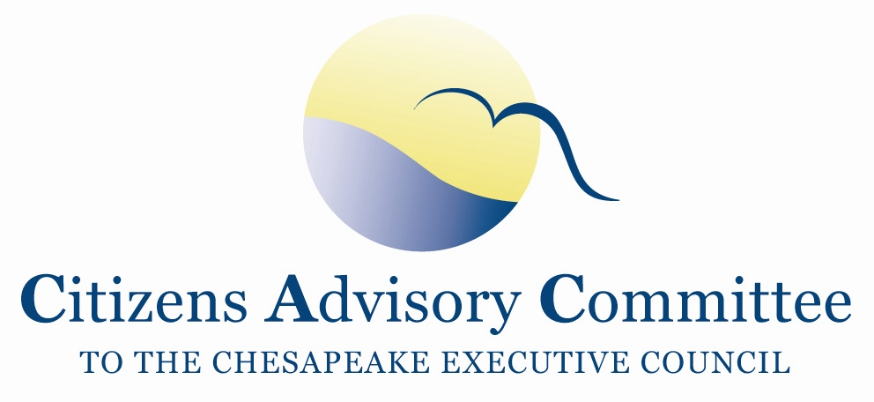

Citizens Advisory Committee
Meeting Agenda
February 27-28, 2014

_______________________________________________________________________________________________________________________________________

Hampton Inn & Suites Baltimore Inner Harbor
131 E. Redwood Street
Baltimore, MD 21202

Thursday, February 27- Fidelity Room

11:00 a.m. Call to Order…………………………………………………………….…...John Dawes, Chair Welcome and Introductions
Welcome new VA CAC member, Hobey Bauhan

11:05 a.m. Maryland Updates……………………………Joseph Gill, Secretary, MD Natural Resources
Frank Dawson, Deputy Secretary, MD Natural Resources
- Perspectives on the Chesapeake Bay Agreement
- Leadership of the Chesapeake Executive Council
- Conowingo Dam relicensing and recent study on sediment impact
- Key bills in the Maryland Legislative Session

12:15 a.m. Lunch – Second Floor Upper Lobby

1:00 p.m. Bay Program Updates………………………..………….…………………………Jim Edward,
Deputy Director, EPA Chesapeake Bay Program
- Report to Congress
- Executive Order Action Plan
- Draft Bay Agreement- timeline and comments to date
- 2014 CBP Priorities
  - FY14 EPA CBP budget Status Report
  - 2-Year Milestones Progress Reports
  - Homeowner BMP Verification Work
  - Midpoint Assessment of TMDL and 2-Year Milestones Progress

2:00 p.m. Environmental Education in Baltimore
Living Classrooms Foundation………………………………………………….....Scott Rainer Pride of Baltimore student trips………………………………………..…Captain Jamie Trost

3:05 p.m. Break

3:15 p.m. New Insights Report: Science-based evidence of water quality improvements, challenges, and opportunities in the Chesapeake …………………………….………………Bill Dennison
Vice President for Science Applications,
University of Maryland Center for Environmental Studies (UMCES)
Case studies from across Chesapeake Region illustrate successes and challenges in restoring local healthy waters

4:00 p.m. History of Bay Agreements: Perspectives from the Chesapeake Bay Commission…………...
Ann Swanson,
Executive Director, Chesapeake Bay Commission (CBC)
- Past Chesapeake Bay Agreements- What legislation did they prompt?
- The Current Bay Agreement - What is missing?
- Broader CBC work priorities for the near term

5:00 p.m. CAC Business Meeting
- Approval of CAC December 2013 meeting minutes
- Updates from Members and Staff
  - Report on the Executive Council Meeting on Dec 12, 2013
  - Brief discussion on Inclusion/Environmental Justice as a CAC priority
  - Jurisdictions’ legislative briefings

5:30 p.m. Meeting Recess

7:00 p.m. Dinner- Brio
Members will continue to discuss agenda topics and issues of importance in the Bay Watershed.

Friday, February 28- Fidelity Room
Breakfast is served starting at 6:00 am on the Second Floor Upper Lobby where lunch was served yesterday.

8:00 a.m. Call to Order……………………………...………………………..…Charlie Stek, Vice Chair

8:05 a.m. Chesapeake Bay Programs Public Service Announcement Video: What does it take to restore and protect the Chesapeake Bay?

CAC Member Presentations and Discussion on potential CAC 2014 priorities

9:50 a.m. Break

10:00 a.m. Call into the Principals’ Staff Committee meeting for discussion and decisions on governance in the Bay Agreement

12:00 p.m. Meeting Wrap-up

12:15 p.m. Adjourn

Next CAC Meeting is May 15-16, 2014

