Conference Line Access Info:

DC Conference Line #2
(866) 299-3188
Conference Code
(267) 985-6222
https://epa.connectsolutions.com/comm/
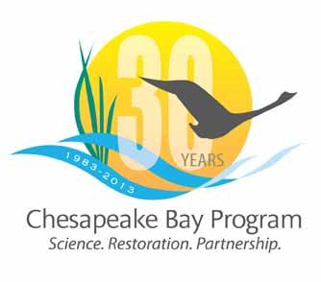

Communications Workgroup
Monthly Meeting

January 30, 2014
10:00AM-1:00PM

National Park Service - Chesapeake Bay Program Office Suite

Agenda

- Round Robin / GIT Updates 10:00-10:40

- New Watershed Agreement 10:40-11:10
- Public listening sessions
- Comment period

- Communications Workgroup Membership 11:10-11:20

- How can we work together to support each other? 11:20-11:50
- Conferences
- Strategic planning
- Social media

- “What Does it Take to Restore the Chesapeake Bay” Video 11:50-12:05
- Viewing and promotion

- Chesapeake Bay Program’s editorial calendar review 12:05-12:40

- New Insights report 12:40-1:00

