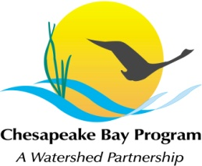
Stream Health Workgroup Meeting
Friday, February 14, 2014
9:00AM-12:00PM
Chesapeake Bay Program Office
Joe Macknis Memorial Conference Room (Fish Shack)
Conference Line: 866-299-3188 Code: 410-267-5731
Adobe Connect: https://epa.connectsolutions.com/streamhealthwg/ (Note: Enter as Guest)

9:00 Welcome, Introductions (Rich Starr, FWS)

9:10 Review and Approve Workgroup Scope and Purpose (Rich Starr, FWS)

9:40 Updates
- Stream Restoration Verification Guidance (Bill Stack, CWP)
- Stream Restoration Expert Panel Report Recommendations (Bill Stack, CWP)
- STAC Workshop (Bill Stack, CWP)
- Brook Trout Work in Shenandoah National Park (Than Hitt, USGS)

10:30 Next Steps for the Workgroup

11:00 Member Updates

12:00 (or earlier) Adjourn

