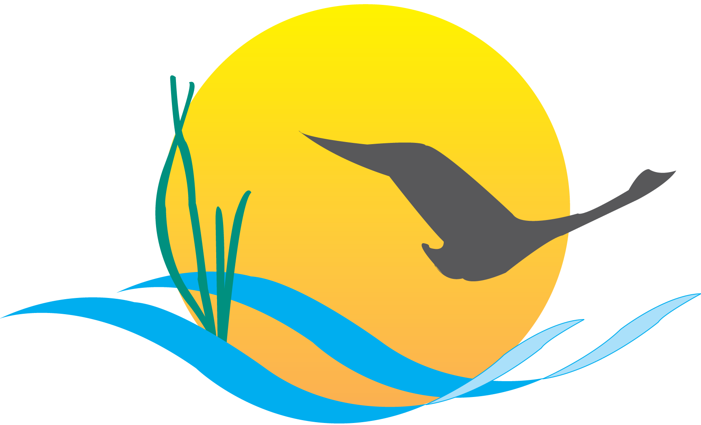
Conference Line Access Info:

DC Conference Line #1
(866) 299-3188
Conference Code
(410)267-5731
https://epa.connectsolutions.com/comm/

Communications Workgroup
Monthly Meeting
February 20, 2014
9:45AM-11:15PM

National Park Service
Chesapeake Bay Program Office
Suite 314

Agenda

- Round Robin / GIT Updates 9:45-10:05

- New Insights Report 10:05-10:25
- Review release plans
- Brainstorm how to use this report’s information over the next couple of months

- Executive Council Meeting 10:25-10:40
- Comm. Workgroup’s participation in planning
- PSC meeting 2/28: Each PSC jurisdiction will designate its EC Planning team representative

- 2014 RAE Summit 10:40-10:50
- 1st week of November at the Gaylord Hotel /National Harbor
- Concurrent session on communications? (Deadline for proposals is 2/28 – see program.estuaries.org )
- ½ Day Communications Workshop?

- Liaison 10:50-11:00
- Review roles
- Representatives to support GITs 2 & 4?

- Upcoming meetings 11:00-11:15
March:
- Invasive catfish communications/outreach in early April
- Chesapeake Bay Watershed Agreement
- Developing a CBP communications strategic plan based on the Agreement goals/strategies
- Indicators – review proposed plan for handling “extinct” indicators
April:
- Agreement and Executive Council plan
- Executive Council signing event – what should the media event look like?
- How do we ensure the best possible turnout by Executive Council members at the meeting and signing?
- What is our post-signing communications strategy?
- BMP Verification Update
- Outreach/communications strategy refresh

