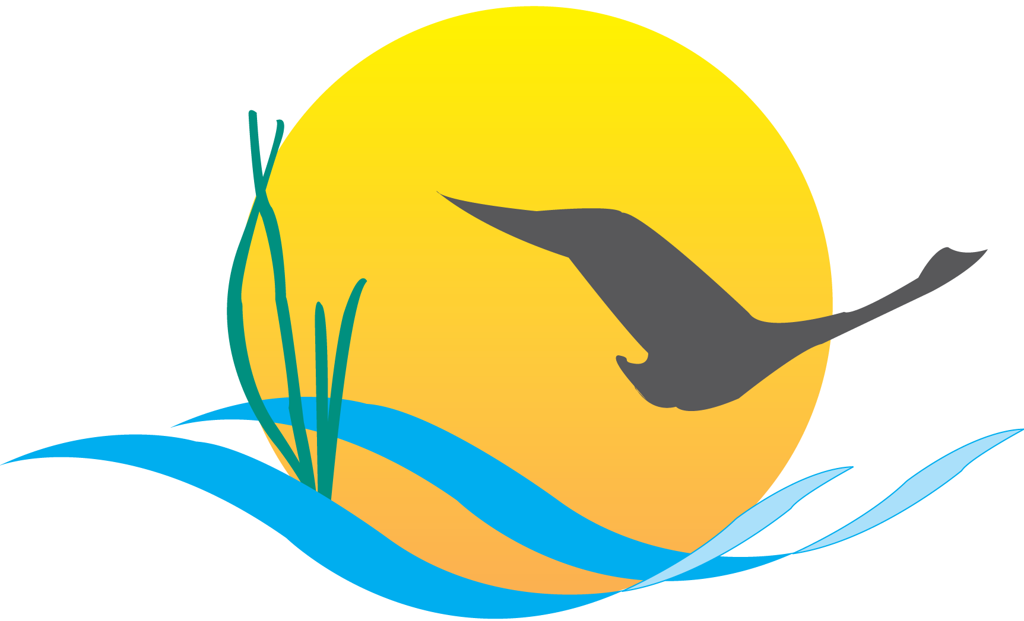
Conference Line Access Info:

DC Conference Line #2
(866) 299-3188
Conference Code
(267) 985-6222
https://epa.connectsolutions.com/comm/

Communications Workgroup
Monthly Meeting
March 6, 2014
9:45AM-11:15PM

Conference Room 305a
Chesapeake Bay Program Office

Agenda

- Round Robin / GIT Updates 9:45-10:05

- Invasive Catfish Communication (Kim Couranz) 10:05-10:20
- Outreach in early April

- Chesapeake Bay Watershed Agreement (State Representatives) 10:20-10:30
- Public listening sessions/update

- CBP Communications Strategy (Margaret Enloe) 10:30-10:50
- Develop a strategic plan based on the Agreement goals/strategies
- PSC request: Strategy for keeping stakeholders informed about GIT efforts
on management strategies.

- Indicators (Nita Sylvester) 10:50-11:10
- Review proposed plan for handling “extinct” indicators

- Upcoming meetings 11:10-11:15
April:
- Agreement and Executive Council plan
- Executive Council signing event – what should the media event look like?
- How do we ensure the best possible turnout by Executive Council members at the meeting and signing?
- What is our post-signing communications strategy?
- BMP Verification Update
- Outreach/communications strategy refresh

