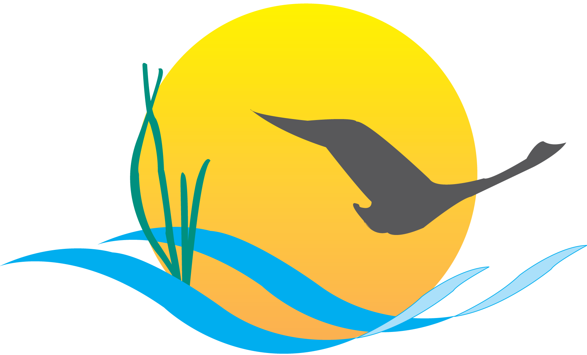 Communications Workgroup
Monthly Meeting
April 03, 2014
9:45AM-11:00AM
Attendees:

Mike Land, NPS (Chair) Jenna Valente, CRC, CBP
Samantha Kappalman, MDE (Vice Chair) Steve Droter, Alliance, CBP
Margaret Enloe, Alliance, CBP (Coordinator) Matt Ellis, STAC
Hannah Hamilton, USGS Andrew Zemba, PA DEP
Catherine Krikstan, Alliance, CBP Phillip Miller, DNREC
Tom Wenz, EPA Andrew Stacy, WVCA
Guy Stephens, UMCES, CBP Jessica Blackburn, CAC
Kim Couranz, NOAA Cindy Chance, NPS
Leila Mitchell, NY DEC Nita Sylvester, EPA

- Round Robin

CBP Communications:
- Upcoming indicator releases:
  - Shad release: April 15
  - SAV abundance press conference call: April 21

EPA:
- Reviewing progress runs and milestone assessments
- Milestones are due out at the end of May or early June
- April 15: relaunch of the “How’s My Waterway?” app – accompanied by a press release and blog posts
- New updates to the app include color coded view of waters by condition, information on local watersheds, a link to the Surf Your Watershed: Drinking Water and Source Water information, and more

NOAA:
- DNR invasive catfish sign release will be at General Smallwood State Park on April 10 following the Management Board meeting.
- Will be posting an article on NOAA Chesapeake Bay Field Office site about the event and NOAA funded research on invasive catfish

UMCES/ CBP Web Team:
- Continuing to look at the Chesapeake Stat research to figure out what the next steps are
- Recruiting a couple of positions for the web team

PA DEP:
- Put out a press release last week regarding agriculture. It’s called the Regional Agricultural Watershed Assessment Program
- It’s a continuing effort to go out and work with agriculture, visit farms and talk about BMPs – this has been a fairly large initiative
- It is a state-wide initiative but there will be efforts in sub-watersheds that fall within the Chesapeake Bay watershed

DNREC:
- Continuing to host viewings for the stormwater webinar series
- Still moving along with the Reclaim Our River: Nanticoke Series – recently completed a wildlife habitat workshop and a rain barrel building workshop
- Right in the middle of the rain barrel painting competition; the winning barrel will be announced on Earth Day and installed at the Governor’s mansion

MDE:
- New members of Reclaim the Bay initiative
- Gearing up for Earth Month and beyond with new campaigns
- Earth Month will include:
  - A cleanup in Annapolis on Earth Day
  - Teaming up with MD DNR for the Maryland Green Poster Contest – award ceremony will be during Earth Week
  - Western Maryland tree planting
  - School visits

WVCA:
- Nutrient management workshop planned for April 22 in the Potomac Basin area
- 18 community tree plantings scheduled for the spring

CAC:
- CAC is working on a letter expressing concern about termination of funding for NOAA BWET in 2015
- The BWET program is largely used to help with MWEEs
- It is typically funded at $2.5 million/year and generates around $18 million in matching support
- CAC feels that it is really important to continue this program because the new Bay Agreement has explicit environmental education goals and programs like BWET will need that federal funding to reach them

STAC:
- Distributed the Coastal Habitats report on March 31
- M3.2 Multiple Management Models final report should come out in mid-April
  - Planning on releasing a Multiple Management Models fact sheet by the end of April
- Four workshops were approved at the last STAC quarterly meeting for fiscal year 2014:
  - Behavioral Economics
  - Forage Fish Assessment
  - Comparison of Shallow Water Models for Use in Management Decision Making
  - Improving Roadside Ditch Management to Meet TMDL Water Quality Goals
USGS:
- Getting clearance through the NOAA process for new release about the Potomac River Estuary
Action: Once report is completed it will be shared with the Communications Workgroup

NY DEC:
- The first week of May marks the annual Water Week celebration
- This year’s theme is Water Recreation: Linking Water Quality to Water Recreation

NPS:
- Collaborating with Maryland Tourism Development about a trail relaunch event at Bladensburg Waterfront Park
- The potential date for the relaunch event June 5 at 10AM – two days before National Trails Day
- Event will focus on recreational opportunities along the trail
- This even will launch not only the trail but all of the events in the culminating bicentennial year for the war of 1812

- Agreement Communications Strategy:
- Information sharing: need to brainstorm ideas on how to share information with stakeholders/interested parties about the Agreement
- Suggestions:
  - Add a section to the weekly e-newsletter (Bay Brief) that refers and links to the Agreement webpage and will give updates on Agreement decisions/meetings
  - Agreement page is no longer used to capture public comments- since it already exists we could use it to post updates on Agreement
  - Talk to Karl about a regular section/feature in Bay Journal on updates to keep those without computers informed
- Who are our audience?
  - Interested, savvy individuals
  - Interested media
  - We need to make the information easily accessible to these people
- Send e-mail to media officials informing them to come to our page
- Action: send any other info sharing ideas to Margaret Enloe
- Outreach:
- The GITs will be charged with doing the outreach work – we aren’t sure that outreach has been clearly defined to everyone so there is some confusion about what is being asked of everyone
- We need to discuss with GIT chairs/PSC what their needs are and how we can help/areas where they need help
- Action: Mike Land will address the PSC – it is on agenda for the afternoon of Monday 14th on the PSC agenda to have a brief conversation about how to push info out and gain clarity on the outreach process (includes understanding audiences)
- Won’t be able to provide a one size fits all strategy for outreach but we can come up with core guidelines to help decision making processes
- The goal is to get stakeholders involved the development of the management strategies and get the word out about the agreement
- We need to talk to the GITs and PSC about what outreach means to them
- At certain points the Bay Program will make management strategies open to public comment – might be good idea to mirror the style of the Agreement comment period
- Action: Need to start with “this is what we think we heard” then confirm what the actual intent is at the PSC meeting
- CAC feels like we need to engage a broader scope of audience in order to be able to meet our restoration goals. If we create a mechanism now, we are doing ourselves a favor
- Communications Strategy Planning:
- With new agreement, there will be new goals set, and that gives us an opportunity to create a proper, written communications strategy to outline vision, mission, goals and tactics
- What is our vision for the next two years?
- CBP Communications could add line in the editorial calendar for Agreement specific content
- Action: Margaret will pull vision statements together and share with the workgroup to comment/edit
- When communications strategy is finished it should be promoted to MB
- How are the indicators tracking going to be involved/evolved to dovetail with the agreement?
- Vision: Realign restoration efforts to the outcomes in the new agreement
- Vision: Continue to provide information on Bay health and watershed health even if they aren’t completely related to an outcome –public still might be interested in it – for example outcomes related to menhaden/striped bass – we need to continue to be responsible for that kind of information on our public pages
- What should stories look like? (powerpoint)
- We need to address the issue of partners not feeling like they are part of the partnership (need to make everyone feel involved and included)
- Vision: draw on people internally that are deeply involved to help reach external audience
- Action: Margaret will combine stickies into categories and draft vision and mission statement for next meeting for comment
- BMP verification update for next meeting

