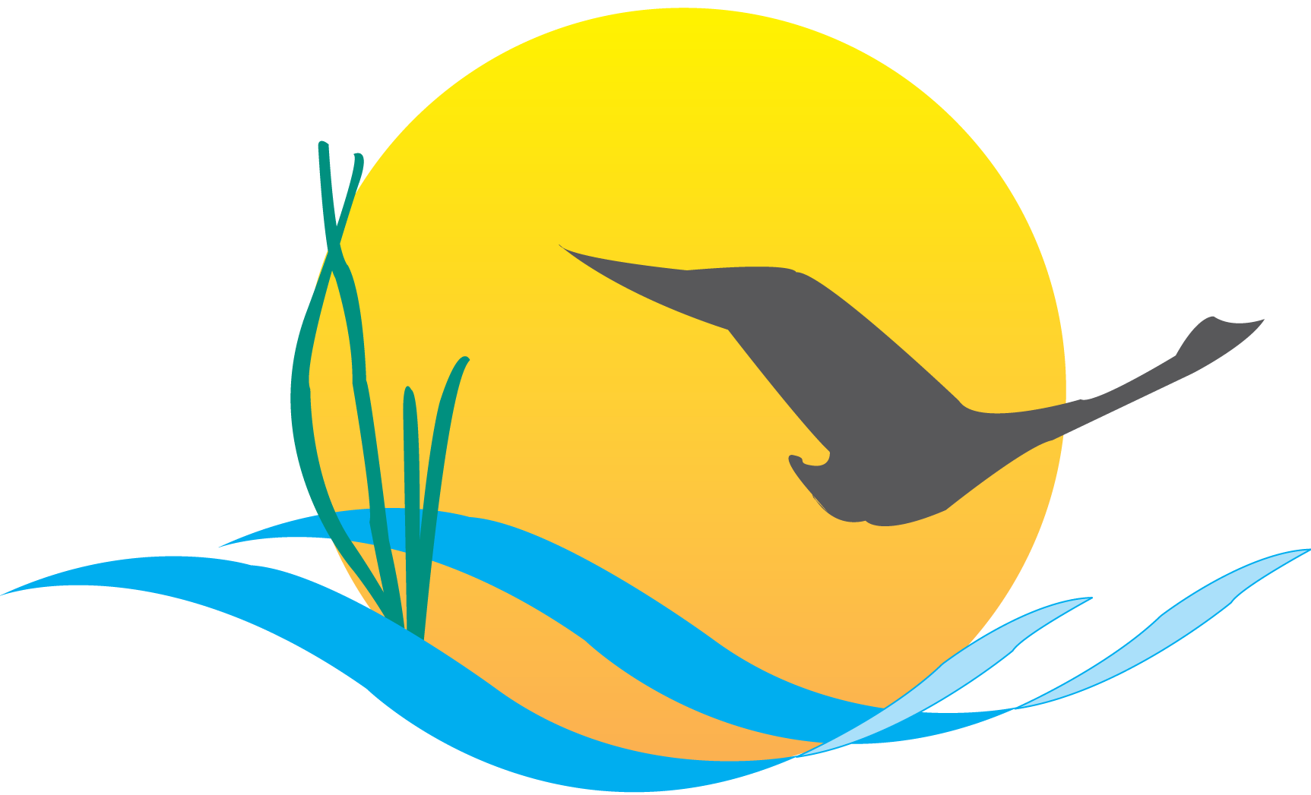

Communications Workgroup
Monthly Meeting
May 1, 2014
9:45AM-11:00AM

Attendees:
Mike Land, NPS (Chair) Max Tucker, MDE
Margaret Enloe, Alliance, CBP (Coordinator) Phil Miller, DNREC
Jenna Valente, CRC, CBP Matt Ellis, STAC
Catherine Krikstan, Alliance, CBP Mary Gattis, LGAC
Tom Wenz, EPA Jessica Blackburn, CAC
Nita Sylvester, EPA Cindy Chance, NPS
Kim Couranz, NOAA Chris Becraft, MD DNR

- Round Robin / GIT Updates
(major points only, as next item will require significant time)

CBP Communications:
- Looking for a multimedia intern to do archival work.
- Action: Please spread the word. Deadline is May 19th
- Indicators: there are still a few 2013 indicators that have not been updated - Catherine and Margaret will handle them
- EC planning team meetings are on Wednesday afternoon
- EC meeting will be in the reception room of the State House with lunch in the Governors house
- Date is still set for June 16
- Rich Batiuk will join the Communications Workgroup to speak about homeowner BMP verification protocol in the coming months
- CBP Communications has two news releases planned for May:
1. Wetlands Restored on Agricultural Land
2. Public Access
- Released two news releases last month:
1. SAV
2. American shad abundance
- SAV release got a lot of views on our site and a lot of press coverage
- State of the Program (SOTP) report has been completely redesigned and is on track to be released at the EC meeting
- Video on American black ducks will be up shortly

NOAA:
- Invasive catfish sign launch was a success
- Keep your ears open for news about an oyster project in the Choptank area over the coming weeks

EPA:
- Working to support the new Agreement and EC meeting
- Final evaluations on progress run and two-year milestone evaluations for each jurisdiction should be final around June 25
- A slew of CBP indicators have been updated:
- Population
- Nitrogen, Phosphorus and Sediment loads
- River flow
- Forest buffers
- Public access
- Striped bass
- Menhaden
- Wetlands have not been updated yet

STAC:
- M3.2 report is in final STAC review and should be ready for final distribution sometime in mid-May
- Onsite Septic Systems report: first draft complete and should be released in late-May or early-June
- Workshop next week: Stream Restoration on May 6-7

CAC:
- Meet in Richmond on May 15-16 to hear from Russ Baxter on insights on the Agreement and get an overview of the public comment period and what changes have been made since then
- Heard about BMP verification and asked rich to give update on BMP communications strategy for that

LGAC:
- May 5-6 meeting in Harrisburg PA about BMP verification
- Discussion will be about monitoring and indicators
- Focus on engaging elected officials in the areas where they meet

DNREC:
- Recently wrapped up three days of rain barrel sales in each county
- Reclaim Our River series is moving along – workshops have been popular
- Nanticoke River Park Festival will include rain barrel exhibits and sales
- Rain barrel painting competition is underway - winning barrel will be installed at the Governor’s house
- DNREC received awards from Associated Press for stormwater videos
- Action: Phil will share videos with the Communication Workgroup

MD DNR/MDE:
- MDE/DNR participating Senator Cardin’s field hearing next week at Conowingo visitors center
- Zero-waste plan is out for public comment
- Part of GHG reduction plan and will be out until May 23

NPS:
- June 5: Bladensburg waterfront park to interest D.C area media in final year of bicentennial celebration
- Event will launch the Anacosita Watertrail – map and guide, free kayak rides
- Governor O’Malley will be attending
- Event is from 10-12

- Executive Council Communications
- CBP would like to do the overall press on the EC tbigger and differently than other/past press releases
- Action: CBP Communications would like to hear everyone’s ideas and input on how to go about constructing expanding on above mentioned media
- Would like to do something other than just a media advisory and press release
- How to we build buzz?
- Social media plans should be used by every watershed state to promote this
- First messaging point would be to announce when the EC meeting is
- Partners could do their own press release (NOAA, NPS, FWS…)
- 6-8 original copies will be printed of the Agreement but nice unofficial copies should be included in the press kit and available to hand out at events/to public.
- Need to prepare and think through some of the questions that are going to be asked by the press (opt in, opt out questions)
- Highlight that we are going to have management strategies that will involve public comment and be transparent – a way to show that everything in this Agreement is going to be measurable
- Suggestion: Pull out actual things that are already happening throughout watershed to show that we are already on the ground and have begun implementing this agreement – bring back stories from the past year and previous year.
- Action: LGAC would like to work with CBP to craft press releases that can be used in meetings with local government officials – tie it to local challenges, problems and actions
- Communicate it in the light of what the local issues are – target each jurisdiction
- Action: suggest a discussion at PSC meeting next week about how to handle how other watershed groups are going to respond to the Agreement signing – we all want to be on the same page
- We need to make it clear that environmental groups will be involved in development of management strategies
- Messaging needs to make it clear that this agreement is more than just a renewal of the partnership - we will actually be committing to developing management strategies
- Action: Margaret will circulate media plan ideas
- Is it worth creating an action team within the Comm. Workgroup to delve deeper into EC strategies?
- Action: contact the communications members on EC planning team meeting
- Action: Margaret will put a call out to people to try to work through this: will meet either in one long meeting or a couple shorter ones to continue to sort through/figure out best messaging around EC meeting
- Suggestion: Aim messaging to diverse communities – offer our products in other languages?
Upcoming Meetings:
- JUNE – EC & Agreement communications strategy (Cont’d)
- JULY - BMP Verification
- Update – Rich Batiuk (tent)
- BMP Verif. Outreach/communications strategy - refresh
- CBP Recognition for Homeowner BMP Programs

