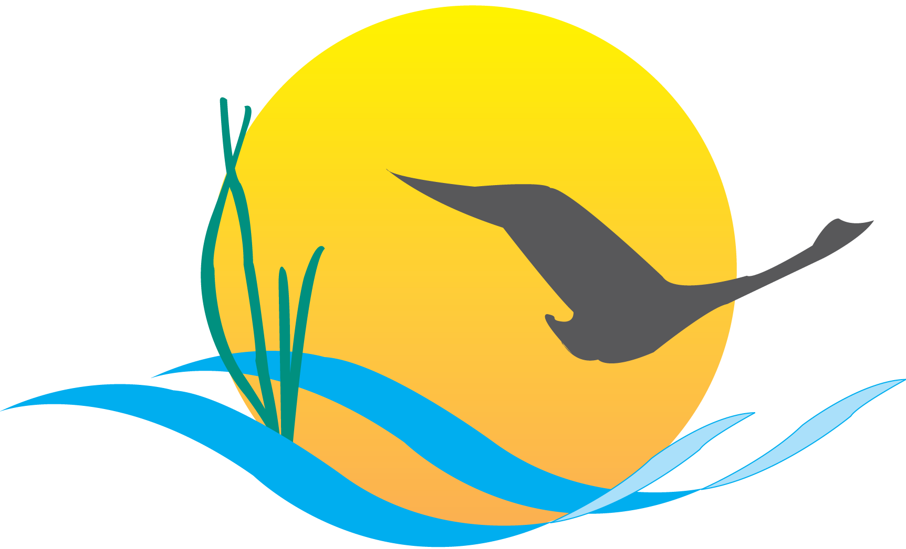

Communications Workgroup
Monthly Meeting
June 5, 2014
9:45AM-11:00AM

Conference Room 305a
Chesapeake Bay Program Office

Agenda
Attendees:
Samantha Kappalman, MDE (Vice Chair) Phil Miller, DNREC
Margaret Enloe, ACB (Coordinator) Steve Droter, ACB
Tom Wenz, EPA Darlene Pisani, MD DNR
Kim Couranz, NOAA Matt Ellis, STAC
Jenna Valente, CRC Catherine Krikstan, ACB
Guy Stephens, UMCES

- Round Robin / GIT Updates
(major points only, as next item will require significant time)

MDE:
- MDE has been doing a lot of work with the new EPA carbon emissions announcement.
- As a result, we should expect to see a nitrogen reduction as well as a carbon reduction in the Chesapeake Bay.

DNREC:
- Reclaim Our Rivers: Nanticoke series is still under way
- Last month there was a rain barrel sale at the Nanticoke River Park Festival
- This month there is an eco-kayak and canoe paddle that will include a pre-paddle barbecue where thoughts about water quality from all partner organizations will be shared.
- The event will also include a guided tour that will identify areas that could benefit from projects like living shorelines
- Rain barrel building video was launched this week
- Video on stormwater is set to be filmed next week
- Preparing to do a mailing announcement about a pump out and inspection program for select areas in the Chesapeake Bay.

STAC:
- Recently distributed the Oyster Nutrient Removal Fact Sheet as well as the Criteria for Science Based Restoration and Management Fact Sheet.
- M3.2 report and fact sheet will be distributed within next 2 weeks.
- Onsite Septic System report is currently going through final STAC review – estimated distribution date is 2 weeks from 6/5.
- Aciton: Keep CBP Communications informed about all STAC report release dates.

EPA:
- Working on the two-year milestone evaluations – the final evaluations will be released during the last week of June.
- Currently preparing a roll out plan for the milestones.
- June 23rd is the estimated date for the press release and the milestones will be released on June 26th.

NOAA:
- Sustainable Fisheries GIT is having it’s full biannual meeting at VIMS on 6/4-6/5.
- CBSAC annual blue crab advisory report recommendations will be released slightly after EC meeting – date will be announced once it’s solidified. (Still pending as of 6/17)

CBP Web Team:
- Just finished the hiring process for the web team. New members include a developer, designer and a Cloud computing architect.
- Focused on web support for the Agreement
- Working with NPS to revamp the Bay Backpack site
- Continuing to work through research needs of ChesapeakeStat and where to go with that product.

CBP Communications
- Summer multimedia intern has begun and will help with archiving and photo projects.
- Steve Droter is leaving to take a new position on June 18th,so CBP Communications video projects will be on hold until new multimedia person is on board –job posting will be up this week. (POSTED AT www.chesapeakebay.net/jobs)
- BMP verification will be focus of the July 10 meeting – important meeting to attend because we will have to begin communicating about it.
- Action: send BMP verification materials in advance
- Action: send e-mail to reschedule meeting from July 3 to July 10

- Executive Council Communications
  - Agreement/EC update
- EC meeting is one week away on June 16, 2014 in Annapolis, MD.
- Action: Please RSVP on the EC webpage if you plan to attend either the public meeting or press conference and make sure anyone else you know does the same.
- RSVPing does not guarantee you a seat and there will be an overflow room prepared just in case the main room fills up.
- The Editorial Board had a 3 hour call on 6/4 where final edits were sorted out – both a clean and track changes version of the document have been sent to the people to need to see them and will be reviewed by the PSC on Monday (6/9) afternoon.
- The goal is to have the revised final Agreement complete by next Thursday 6/12.
- There will be two digitally printed versions for the EC to sign
- Extra copies will be made for staff to have
- We will get any signatures from EC members who cannot attend after the EC meeting

  - EC update
- The only unconfirmed members EC members at this point are NY and WV but O’Malley will be personally calling them this week.
- There will be three components to the day that take place between:
  - 10-12: Public Meeting
  - 12-1:30: Private Lunch
  - 1:30 til: Press Conference

- The EC Planning Team has invited four students to speak at the event.
- Advisory Committee reports will be given
- The morning meeting will be in the Governor’s reception room – seating will be reserved for PSC members and goal team/ advisory committee chairs.
- There will be space for standing room in addition to the seating in the overflow room.
- Action: If you plan to sit, get there early.
- Private lunch is just for the Governors and a few staff members and will be held in the dining room of the Governor’s house.
- The physical document signing will be happening at the lunch before any food is served.
- They will then walk from the state house to City Dock at Susan B Campbell Park at the Annapolis waterfront for the press conference.
- Each EC member will speak then sign a poster sized version of the Agreement before introducing the next speaker
- Media advisory will go out today 6/5
- Action: Start promoting the Agreement via social media if you have not yet
- Rain location is at the State House – the Mayor is still welcome to attend but will not welcome everyone to the State House.
- Action: Retweet and share CBPs social media campaign about the Agreement on and after the 16th and leading up to it
- Draft media release will have quotes from the EPA Administrator, Governor O’Malley and Nick DiPasquale
- There will be a separate quote sheet for localized press releases – CBP is still waiting to hear back from DC, NY, DE and MD

  - Agreement web page update
- To locate the Agreement webpage you go to www.ChesapeakeBay.net >Track progress >What Guides Us> Watershed Agreement
- Or www.chesapeakebay.net/watershedagreement
- Once the Agreement is signed there will be a direct link on the homepage
- There will be a public friendly version of the Agreement and 10 major top-level goals.
- Each goal page will link to a description of the outcomes and a page about the management strategies.
- There will also be a dashboard summary of how far along each management strategy is and how they are being developed.
- From the dashboard you can navigate to a more detailed page about the strategy that will tell you relevant contacts and goal team information.

  - Outcomes Documents Discussion
- -Public friendly outcomes document explanations will be available on the Agreement webpage once the Agreement is signed – these will not be provided at the EC meeting but can be used as web resources as PDFs.

- CBP Editorial Calendar Update
- Will be postponed until next month’s meeting so more people will be able to offer input over the phone.
- Action: Let CBP Communications know if there are any major reports coming out between now and July 10 so we can help promote them.
Upcoming Meetings:
- JULY – Proposed meeting date: July 10
BMP Verification
- Update – Rich Batiuk
- BMP Verif. Outreach/communications strategy - refresh
- CBP Recognition for Homeowner BMP Programs
Editorial Calendar Update:
- 6 month overview – Catherine Krikstan

