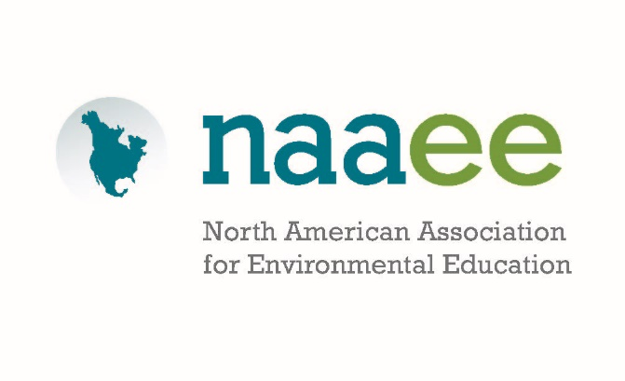

Environmental Education in the Every Student Succeeds Act (S.1177)
Background
On December 10, 2015, President Obama signed the bipartisan Every Student Succeeds Act (ESSA) into law, reauthorizing the Elementary and Secondary Education Act (formerly, No Child Left Behind).
Thanks in large part to many years of advocacy and outreach on the part of NAAEE, its Affiliates, and numerous partners (including environmental education providers, conservation organizations, businesses, sportsman’s groups, health care workers, school administrators and others) ESSA includes language making environmental education explicitly eligible for federal education funding for the first time.

EE Language
The key language sits in Title IV of the Every Student Succeeds Act—21st Century Schools:
- Title IV, Part A: Environmental education is an enrichment activity called out as eligible for funding under a new $1.65B (authorized) grants program that includes enrichment programs and student health and safety programs.
  - Under the law, these funds are block granted to the states using the Title I formula; 95% of the state funds are then block granted to Local Education Agencies (LEA), also according to formula
  - LEAs receiving more than $30,000 must use at least 20% of the grant to support one or more of the enrichment activities and at least 20% on one or more of the student safety programs (eg. bullying prevention, mental health, etc)

- Title IV, Part B: Environmental literacy programs are now eligible for funding as part of the existing $1B (authorized) 21st Century Community Learning Centers program
  - These funds are also block granted to the states according to the Title I formula; states award competitive grants to LEAs, schools, and/or community partners for after-school activities

- The prioritization of STEM activities including “hands-on learning” and “field-based or service learning” to enhance understanding of STEM subjects may provide additional opportunities for environmental science education programs
Overwhelming support
- The Every Student Succeeds Act passed the House on December 2, 2015 with a vote of 359-64.
- It passed in the Senate on December 9, 2015 with a vote of 85-12.
Next Steps
While we are celebrating this advance for EE after many years of hard work, there is a great deal that will need to happen at the state and local levels to fully leverage the opportunity. This bill represents significant changes for state and local education agencies and it will take time to fully understand the shape of the Title IV grant programs. In the year ahead, NAAEE, its Affiliates and partners will work to:
- Support robust funding for Title IV, Part A of ESSA to ensure school systems have maximum resources for providing all students with a well-rounded education
- Develop fact sheets and messages that provide state and local education agencies and their partners important information about how ESSA funds can be used to support essential environmental education programs and implementation of environmental literacy plans
- Provide professional learning for EE providers on the new legislation and how to position programs and develop partnerships to maximize use of funds for systemic EE
- Identify and disseminate best practices and models for the use of U.S. Education grant funds to support effective environmental education in K-12 schools

NAAEE will continue to monitor the implementation and progress of ESSA and develop communications to inform affiliates, EE providers, and state and local education agencies how the law may benefit their environmental literacy work. NAAEE continues to work closely with Senator Reed and Congressman Sarbanes to assess additional opportunities to strengthen federal support for EE.

